Derivation of Third Equation of Uniformly Accelerated Motion by Graphical Means
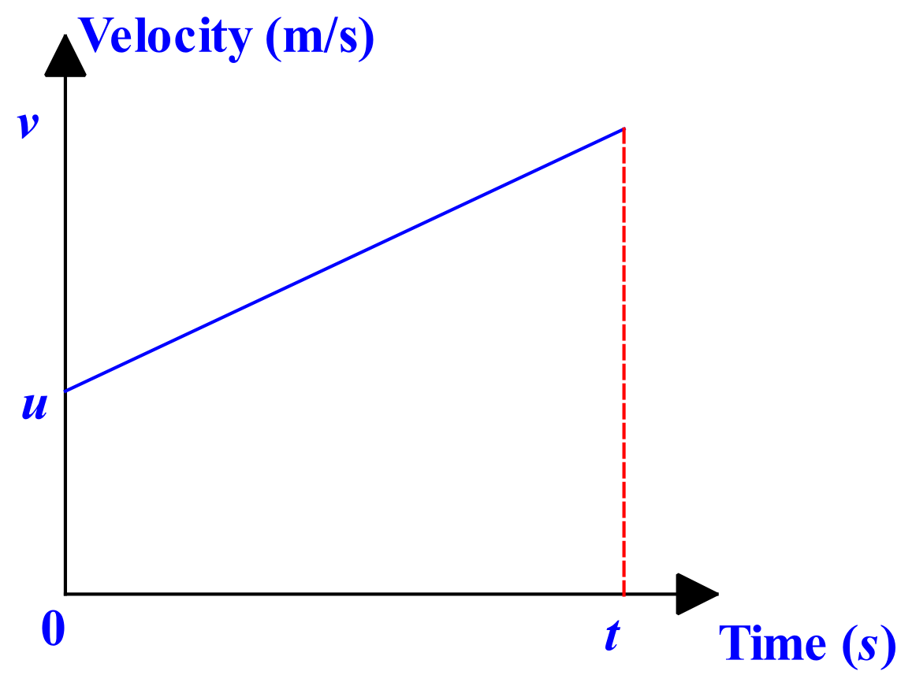

The object has an initial velocity of, u, and undergoes constant acceleration, a, for a time, t, at which its final velocity is, v.
Area under graph = displacement, s
Area of trapezium, A = ½ (x + y) h, where x & y are the lengths of the parallel sides and h is the height.
Therefore, area, A = ½ (u + v) t – equ 1
We know that by definition, a = (v – u) / t
So, t = (v – u) / a
Substitute for t in equ 1
s = ½ (u + v) (v – u) / a
s = (v² – u²) / 2a
v² = u² + 2 a s
QED

PS – this may look just as long as the algebraic derivation of this formula that we did in Module 1. Trust me – when you get used to this method, you only need to write down two or three lines.

