FORCES, ACCELERATION AND ENERGY (Extension Topic)

Tensions In Strings
The following section is probably not essential to the Syllabus. It is however a very good section to do with students if time permits. It gives students an opportunity to expand their understanding of both the usefulness of vectors in Physics and how to analyze objects under the influence of gravity in different situations.
Consider a mass, m, supported by a thin, inextensible string of negligible mass. The two forces acting on the mass are T, the tension in the string acting upwards and mg, the weight force acting downwards on the mass.
The vector equation describing the net force acting on the mass is best studied in three separate cases.
Case 1: The mass is supported by the string and there is no acceleration. The mass could be at rest or could be moving up or down at constant velocity. In each case the net force equation is the same. The tension upwards is exactly balancing the weight force downwards.
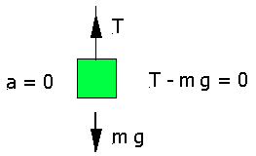

Case 2: The mass is accelerating downwards with net acceleration, a. The tension upwards in the string is not sufficient to fully balance the weight force downwards.

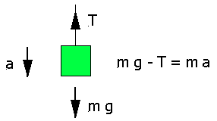

Clearly, with the mass accelerating downwards, the tension, T = m ( g – a ).
Case 3: The mass is accelerating upwards with net acceleration, a. Here, the tension upwards in the string is doing two jobs. It is fully balancing the weight force downwards and supplying the required force upwards to accelerate the mass with the net acceleration of a.

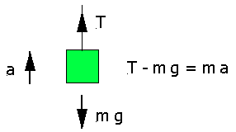
Clearly, with the mass accelerating upwards, the tension, T = m ( g + a ).
Many problems in Physics can be solved by applying the knowledge summarized above. Consider the following two examples.

EXAMPLE 1: Two masses X of 10kg and Y of 24kg are connected by a light inextensible string.

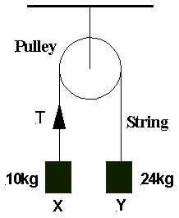

X and Y hang on opposite sides of a frictionless pulley as shown above. Determine:
(a) the net acceleration of the system of masses
(b) the magnitude of the tension, T, in the string.
Assume that the acceleration due to gravity is 9.8 ms⁻².

SOLUTION: There are two slightly different approaches possible.

Solution 1: The Intuitive Approach
Firstly, determine the net force on the system, the total mass of the system and then obtain the net acceleration from F = ma. Once the net acceleration of the system is known the tension in the string can be found by realising that the tension upwards on the left side of the pulley must balance the weight force down on the mass & supply sufficient force to accelerate the mass upwards with the net acceleration of the system.
(a) Force of gravity on 10kg mass = 10 x 9.8 = 98N down on left side of pulley.
Force of gravity on 24kg mass = 24 x 9.8 = 235.2N down on right side of pulley.
Thus, the net force, F, applied to the system of two masses by gravity:
F = 235.2 – 98 = 137.2 N down on right side of pulley.
Total mass of system upon which this net force acts = 10 + 24 = 34kg.
Therefore, from F = ma, the net acceleration of the system of two masses is:
a = F / m = 137.2 / 34 = 4.035 ms⁻².

Note that as you get used to using this method, it really only takes a couple of lines of working at the most.

(b) Once the acceleration is known the tension can be calculated from either mass. Let’s use the 10kg mass first. Clearly, the tension in the string on this side of the pulley must be sufficient to balance the acceleration due to gravity down on the 10kg mass and to accelerate the 10kg mass upwards at 4.035 ms⁻². Therefore,
Tension, T = (10 x 9.8) + (10 x 4.035) = 138.35 N upwards.

OR if we decided to use the 24kg mass instead - the tension in the string on the right side of the pulley must be sufficient to balance the acceleration due to gravity down on the 24kg mass less the 4.035 ms⁻² that the mass is being permitted to accelerate downwards already. Therefore,
Tension, T = (24 x 9.8) – (24 x 4.035) = 138.36 N upwards.
This is the same (to one decimal place) as the answer we obtained using the other mass. This must be the case. It does not matter which mass you use to calculate the tension, you must get the same answer in both cases because there is only one string and can therefore be only one tension.
The tension in the string is therefore 138.4 N to one decimal place. Any discrepancy in the above answers after the first decimal place is simply due to rounding off the (137.2 / 34) calculation for the net acceleration in the first place.
Again, I stress that the whole solution (parts a & b) I have demonstrated here would normally take no more than four to five lines of calculation. It is the explanation I have made during the solution that has greatly increased the space used.

Solution 2: The Mathematical Approach
(a) First we write down the two vector equations of motion for the masses.
For mass X: T – m_{x}g = m_{x}a - (1)
For mass Y: m_{y}g – T = m_{y}a - (2)
Now, we solve these equations simultaneously. So, adding equation 1 and 2 together we have:
a = (m_{y}g – m_{x}g) / (m_{x} + m_{y} ) = (24 x 9.8 – 10 x 9.8) / (10 + 24)
= 4.035 ms⁻²

(b) Then from either equation 1 or 2, we can calculate the value of T.

From equation 1: T = (10 x 9.8) + (10 x 4.035) = 138.35 N

This second solution is probably the more mathematically pleasing to the eye. For my liking though, the previous solution is the more physically intuitive method. Both solutions are equally acceptable and in the end it’s really only the setting out that differs. Suit yourself as to which one you use. You will find the more mathematical approach is safer as the problems become more complex.
EXAMPLE 2: Three masses of 2kg, 4kg and 6kg are connected by three light inextensible strings, X, Y and Z as shown below. The masses are supported from the roof of a lift of mass 1000kg. The lift is accelerating downwards with a net acceleration of 3 ms⁻².

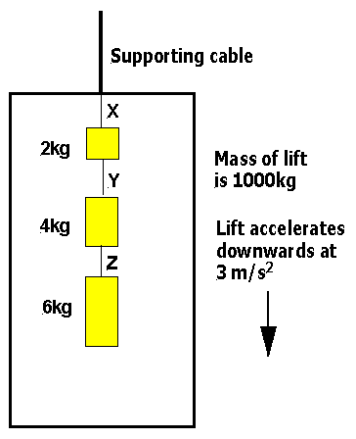

Determine:
a) The tension in string X.
b) The tension in string Y.
c) The tension in string Z.
d) The tension in the supporting cable.
SOLUTION:
Note that since the lift is accelerating downwards at 3 ms⁻², we can write for any string supporting a mass inside the lift or indeed for the supporting cable itself that:
T = m (g – a), see Case 2 in the notes above.

(a) Tension in X = 12 x (9.8 – 3) = 81.6 N upwards
(b) Tension in Y = 10 x (9.8 – 3) = 68 N upwards
(c) Tension in Z = 6 x (9.8 – 3) = 40.8 N upwards
(d) Tension in the supporting cable = 1012 x (9.8 – 3) = 6881.6 N

