PHYSICS COURSE – YEAR 12

MODULE 6: ELECTROMAGNETISM

Discoveries about the interactions that take place between charged particles and electric and magnetic fields not only produced significant advances in physics, but also led to significant technological developments. These developments include the generation and distribution of electricity, and the invention of numerous devices that convert electrical energy into other forms of energy.

Understanding the similarities and differences in the interactions of single charges in electric and magnetic fields provides students with a conceptual foundation for this module. Phenomena that include the force produced on a current-carrying wire in a magnetic field, the force between current-carrying wires, Faraday’s Law of Electromagnetic Induction, the principles of transformers and the workings of motors and generators can all be understood as instances of forces acting on moving charged particles in magnetic fields.

The law of conservation of energy underpins all these interactions. The conversion of energy into forms other than the intended form is a problem that constantly drives engineers to improve designs of electromagnetic devices.

CHARGED PARTICLES, CONDUCTORS AND ELECTRIC AND MAGNETIC FIELDS

Inquiry Question: What happens to stationary and moving charged particles when they interact with an electric or magnetic field?

ELECTRIC FIELDS

As you will remember from Module 4, a “field” in physics is a region of influence of some kind. If a stationary charge experiences a force in a particular region of space, we say that there is an electric field present in that region.

The magnitude of the electric field strength at a particular point in space is defined as the force per unit charge at that point.

where E = electric field strength, q = size of the charge and F = force experienced by q at the point in question. The arrows above E and F indicate that these quantities are vectors and thus, must be specified in terms of size and direction.

The SI units of electric field strength are NC⁻¹.

The direction of the electric field at any point is defined as the direction in which a positive test charge would move if placed in the field at that point.

The relative strengths and directions of different electric fields may be represented diagrammatically by using lines of force. The spacing of the lines of force indicates the strength of the field. The closer the lines are together, the stronger the field. The direction of the field at a given point is indicated by the direction of the tangent to the lines of force at the point in question. Lines of force, also called field lines, are always drawn as emanating from positive charges and as terminating at negative charges.

You should also be familiar with the following examples of electric fields around various objects.

A dipole consists of a positive and negative charge separated by a short distance.

Note that in (c) the field is uniform between the plates but non-uniform towards the edges.

POTENTIAL DIFFERENCE

Consider a charge of + q coulombs in a uniform electric field as shown below:

To move charge +q from A to B back against the field direction, we must do work. The amount of work, W, that we must do is found from:

where F = the force applied to move the charge & d = displacement moved by the charge in the direction of the applied force. The SI unit of work is the joule (J).

In the E field, the force, F, on the charge is given by . Therefore, we have:

as the work done on the charge.

Since we have done work on q to move it from A to B, we can say that we have increased its potential energy (ie its ability to do work for us).

Further, we can say that there is a difference in potential between points A and B, in the E field. In general, we can say that there is a potential difference between any two points in an electric field, whenever we have to do work to move a charge from one point to the other. By definition:

That is, the potential difference between A and B, V_{AB}, equals the work done in moving the charge from A to B, W_{AB}, divided by the size of that charge, q. Since the work done is the change in potential energy of the charge, we can say that the potential difference between two points is the change in potential energy per unit charge moving from one point to the other.

As you know, another term often used for potential difference is “voltage”. The SI unit of potential difference is the volt (V). 1V = 1JC⁻¹.

Clearly, if we release the positive charge q from B, it will accelerate in the direction of the electric field due to the force qE acting on it. When it reaches A, all the potential energy it gained in being moved from A to B, will have been transformed into kinetic energy (K = ½ mv²). Then we will have that:

So, if we needed to know the velocity of the charge at A, we could use the above equations to calculate it. Likewise, if we wanted to determine the acceleration of the charge q due to the electric field, we could use the fact that in the field both of the following equations apply:

$\vec{F}$ = m$\vec{a}$ and $\vec{F}$ = q$\vec{E}$

So, we have:

Recall also, that two oppositely charged parallel metallic plates separated by a distance, d, can be used to produce an electric field as shown below.

Note that the strength of the field is uniform between the plates but non-uniform towards the edges.

From previously, the work, W, done in moving a positive charge from one plate to the other, back against the direction of the field is:

And the potential difference, V, between the plates is given by:

So, therefore, the magnitude, E, of the electric field between the plates is given by:

where d is the distance between the plates. This gives alternate SI units for E as Vm⁻¹.

TRAJECTORIES OF CHARGED PARTICLES IN ELECTRIC FIELDS

Let us consider qualitatively what the trajectory of a charged particle in an electric field might look like. Consider the E field between two charged, parallel plates.

A positive charge entering the uniform electric field area, will experience a constant force, in this case vertically downward, toward the negative plate. This force is supplied by the electric field. There is no force on the charge in any other direction. (Obviously, the force due to gravity will act vertically downward on the charge as well, but in all real cases will be very much smaller than the electric force – so we will not consider it here.)

Where have you come across this sort of trajectory before? If you are thinking projectile motion, you are right. A charged particle in a uniform electric field is analogous to an uncharged particle in a uniform gravitational field. Like the uncharged particle, the charged particle experiences a constant force in one direction and no force in any other direction. It will move in a parabolic trajectory.

Can we prove this quantitatively? The acceleration of a charge caused by a uniform electric field is constant. We derived this previously:

All quantities on the RHS of the equation are constant. We can imagine a positively charged particle entering the uniform electric field area shown below, at right angles to the field direction.

Once inside the field, it experiences constant acceleration vertically (y-direction) as shown. It has no acceleration horizontally (x-direction). The displacement of the particle at any time t can be determined using the equations of uniformly accelerated motion.

In the x-direction, the position x at time t is:

where u_{x} is the constant horizontal velocity of the particle.

In the y-direction, the position y at time t is:

The minus sign appears because acceleration is acting downward. If we now eliminate t from these parametric equations, we obtain:

As a and u_{x} are constant, clearly the trajectory of the particle in the electric field is a parabola. This is the same trajectory exhibited by an uncharged particle falling in a uniform gravitational field.

If the charge enters the field at an angle other than 90º to the field lines, it can be shown easily that the trajectory is still parabolic. We just use the same maths as we used in describing projectile motion in Module 5.

Note that if the charge enters the field parallel to the field lines, it will simply travel in a straight line. If it is travelling in the direction of the field, the positive charge will accelerate and gain velocity in its direction of travel. If the positive charge is initially travelling opposite to the field direction, it will be retarded by the field until its velocity is zero and then accelerated in the direction of the field.

For completeness, but not required by the current syllabus, if the charge enters a non-uniform electric field, the path can be shown to be either elliptical or hyperbolic. For instance, an alpha particle (positive helium nucleus) fired at a positive nucleus of gold in a linear accelerator, would encounter the radial field of the positive nucleus and be deflected in a hyperbolic path.

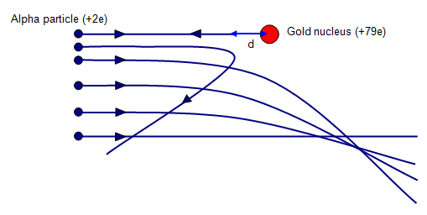

Diagram From: Wikimedia Commons

Understanding how charged particles move in electric fields enables scientists to use electric fields to control charged particles in electric and electronic devices.

MOVING CHARGES IN MAGNETIC FIELDS

Magnetic Flux Density Vector
Recall from Module 4 that one measure of the strength of a magnetic field is the Magnetic Flux Density Vector, B. This is also called the Magnetic Induction Vector. The higher the value of B, the stronger the magnetic field. The direction of the B vector at a point in space is the direction of the magnetic field at that point. The SI Unit for B is called the tesla (T). Most magnetic fields are much smaller than 1T.

Moving Charges
A moving electric charge carries with it an associated magnetic field. Thus, an electric charge moving through a magnetic field experiences a force, due to the interaction of the two magnetic fields present. The magnitude of this force is given by:

F = q v B,

Where q = size of charge, v = velocity of charge perpendicular to the field and B = magnetic flux density vector.

If the charge enters the field at an angle θ to the field direction, instead of perpendicular to it, we must use the component of v that is at right angles to the field direction. Thus, the formula becomes:
F = q v B sin θ.

Clearly, the force on the charge is maximum when the charge enters the field at right angles to the field direction (θ = 90º) and is minimum (zero) when the charge travels parallel or antiparallel to the field lines (θ = 0º or 180º). A stationary charge (v = 0) does not experience a force due to a magnetic field since a stationary charge has no magnetic field of its own.

The direction of the force on a charge in a magnetic field may be determined by using Fleming’s Left-Hand Rule (LHR). Hold the thumb, first finger and second finger of the LEFT hand mutually at right angles. Point the first finger in the direction of the magnetic field. Point the second finger in the direction of conventional current flow (ie in the direction of flow of positive charge). The thumb then points in the direction of the force on the charged particle.

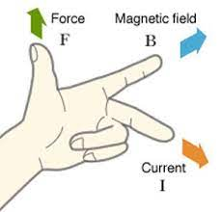

Fleming’s Left-Hand Rule - Diagram From: Wikimedia Commons

Recall from Module 4 that a current is a flow of charge and that the direction of conventional current is the direction of flow of positive charge. When deciding which way to point the current finger, when only considering a single charged particle, the direction of the current is the direction in which a positive charge would move. So, if you are considering a negative charge moving in a given direction, the current direction will be in the opposite direction to that in which the negative charge is moving.

Clearly, the force acting on a charged particle entering a magnetic field is in a direction at right angles to both the magnetic field and the velocity of the charge. Thus, the acceleration experienced by a charged particle travelling through a magnetic field is in a direction perpendicular to both the field and the velocity of the particle.

What will the trajectory of such a charged particle be? We can get an idea of the trajectory by considering a charged particle entering a magnetic field such as that below and using Fleming’s Left-Hand rule to plot the path of the particle.

As the charge enters the field, the LHR has our left index finger pointing down into the page (field direction) and the second finger of our left hand pointing to the right (current direction). The force on the charge is therefore up toward the top of the page. So, the charge will start to accelerate in that direction in response to the force.

As the velocity direction changes, the force direction will change so that it is perpendicular to the velocity once more. As the velocity continues to change direction, the force direction will continue to change so that it always perpendicular to the velocity. This situation creates circular motion, as this force is acting as a centripetal force, like the tension in a rope used to swing a ball around your head or the force of gravity that holds satellites in orbit around the Earth.

Once the charge leaves the field, it once again travels in a straight line in the direction in which it emerges from the field.

Knowing how charged particles move in magnetic fields enables scientists to use magnetic fields to control charged particles in electric and electronic devices.

Comparison of Charges in Uniform E & B Fields
A uniform electric field exerts a force on a stationary or moving charge that is directed along the field lines. The resulting trajectory of the particle is parabolic or parallel or antiparallel to the field. A magnetic field exerts a force only on a moving charge and then only if the charge has some component of its velocity perpendicular to the field. This force is directed perpendicular to both the field and the velocity of the charge. The trajectory of the charge is circular.

Radius of Circular Path of Charged Particle in Magnetic Field
We have seen that charged particles execute circular motion in response to the force acting on them as they travel in a magnetic field. If the field is sufficiently strong, it can capture the charged particle.

In particle physics it is often necessary or useful to calculate the radius of orbit of a charge in a magnetic field. We do so, as follows.

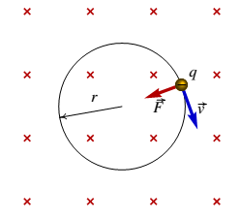
Negative charge executing circular motion in B-field
Diagram From – Wikimedia Commons

The force acting on the moving charge q is due to the magnetic field and is centripetal in nature. So, we have:

Thus, we can calculate the radius of the circular path of the charged particle. The same equation can be used to find the mass or velocity of the particle, depending on what quantities are already known.

THE MOTOR EFFECT

Inquiry Question: Under what circumstances is a force produced on a current-carrying conductor in a magnetic field?

MAGNETIC FORCE ON CURRENT-CARRYING CONDUCTORS

Consider a conductor of length l, sitting in a magnetic field of flux density B and carrying a current I, as shown below:

Clearly, a current is simply a flow of charge and since all moving charges experience a force when travelling through a magnetic field, a conductor carrying a current through a magnetic field will also experience a force. The size of this force can be shown mathematically to be:

F = I l B sin θ,

where θ is the angle made by the conductor (current) with the magnetic field. See below.

Note that the magnitude of the force on a current-carrying conductor depends on:

- The strength of the magnetic field in which it is located (indicated by the size of the magnetic flux density vector);
- The magnitude of the current in the conductor;
- The length of the conductor sitting in the external magnetic field; and
- The angle between the direction of the external magnetic field and the direction of the length of the conductor (or direction of the current).

The direction of the force on a current-carrying conductor sitting in a magnetic field is found by Fleming’s Left-Hand Rule, as previously described. The force on a current-carrying conductor sitting in a magnetic field is always perpendicular to the directions of the field and the current.

It should also be clear that neither a charge travelling parallel to a magnetic field nor a current-carrying conductor lying parallel to a magnetic field will experience any force due to the field, since for both, θ = 0º and sinθ = 0.

The maximum force on the conductor occurs when the conductor is lying perpendicular to the magnetic field. Then θ = 90º, sinθ = 1 and F = IlB.

Just as an aside – please be careful when using terms in physics. The writers for this module of the syllabus have made a common but serious mistake. They refer to the “magnetic field strength” as one of the variables involved in the formula F = IlB. The vector B is called either the magnetic flux density or the magnetic induction. While it serves as a useful measure of the strength of a magnetic field, it should never be referred to as the magnetic strength vector. That vector is designated H (magnetic field strength or magnetic intensity). B and H are two different vectors. B is the one we are dealing with here – the magnetic flux density or the magnetic induction vector. I have now finished my little rant – sorry – but terminology is important and students should be taught the correct terminology from the very beginning. You will come across the vector H if you do physics at university.

PARALLEL CURRENT-CARRYING CONDUCTORS

Recall from Module 4, the right-hand grip rule, for determining the direction of a magnetic field around a current-carrying conductor. You will need this.

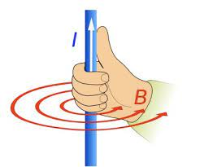

Right-Hand Grip Rule – Diagram From: Wikimedia Commons

Consider two very long, straight, parallel, current-carrying conductors as shown below:

The magnetic field produced by the current flowing through conductor 1 will pass through conductor 2. Thus, all the charges flowing through conductor 2 will be flowing through a magnetic field and will thus experience a force. The same argument can be applied to deduce that conductor 1 will also experience a force.

The size of the force F acting on each of the conductors is given by:

where k = μ₀/2π = 2 x 10⁻⁷ SI Units, I₁ & I₂ are the currents in conductors 1 & 2 respectively, d is the distance between the conductors and l is the common length of the conductors. (μ₀ is the permeability of free space and is a measure of the ability of free space to support a magnetic field.)

Fleming’s LHR can be used to show that:

- When the currents in the conductors are in the SAME direction, the force between the conductors is ATTRACTIVE.
- When the currents in the conductors are in OPPOSITE directions, the force between the conductors is REPULSIVE.
Make sure you can show this. You need both the right-hand grip rule and Fleming’s left-hand rule to do this. The direction of the field passing through conductor 2 due to the current in conductor 1 is determined by the right-hand grip rule applied to conductor 1. Then Fleming’s LH rule applied to conductor 2 indicates the direction of the force on that conductor due to the presence of conductor 1. Then, you do the same process to determine the direction of the force on conductor 1 due to the presence of conductor 2.

Definition of the Ampere
As you know, the ampere is the unit for electrical current in the SI system. The formal definition of the ampere is based on the interaction between two parallel current-carrying conductors. It states that: One ampere is the constant current which, if maintained in two straight, parallel conductors of infinite length, of negligible circular cross-section, and placed one metre apart in vacuum, would produce between those conductors a force equal to 2 × 10⁻⁷ newtons per metre of length. Using the formula above:

This experimental definition of the ampere is an application of Newton’s Third Law of Motion which states: In a two-body system, if body A exerts a force on body B, then body B exerts a force on body A that is equal in magnitude, but opposite in direction. In the experimental set-up that produces the standard ampere, each conductor produces a force in the other conductor that is equal in magnitude but opposite in direction.

Note that the syllabus requires that you conduct a quantitative investigation to demonstrate the interaction between two parallel current-carrying wires. Your teacher should provide you with the resources and time to do this.

Torque in Current Loops in a Magnetic Field
A torque is defined as the turning moment of a force. The torque about an axis of rotation is the product of the perpendicular distance of the axis from the line of action of the force and the component of the force in the plane perpendicular to the axis. See the diagram below.

For the situation above, the torque τ (tau) on the bar about the pivot is:

SI Units of torque are Nm.

Consider a rectangular coil of wire carrying a current I and sitting in a magnetic field of flux density B, with its plane parallel to the field direction, as shown below:

For this coil:

- force on AB is down into the page by Fleming’s LHR
- force on CD is up out of the page by Fleming’s LHR
Therefore, the coil turns under the action of an applied net torque, with CD coming up out of the page and AB going down into the page. Once the coil has passed through the position where its plane is perpendicular to the field direction, the direction of the net torque is reversed. (Use Fleming’s LHR to verify this for yourself – remember the current direction in the coil stays the same throughout.) Thus, the coil will eventually stop and then turn in the opposite direction. And so, the motion will continue.
This tendency of a current-carrying loop to turn whenever it sits in a magnetic field is called the “motor effect”. Clearly, the motor effect is due to the force acting on the current-carrying conductor as it sits in the magnetic field.
The size of the torque on a coil of n turns of wire may be shown to be:
- = B I A n cosθ

where B = magnetic flux density of the field, I = current flowing in coil, A = area of coil, n = number of turns of wire in coil and θ = initial angle made by plane of coil and the B field direction. SI Units of torque are Nm.

Note that when θ = 90º (coil perpendicular to field direction), no torque exits since then F and d are both in the same plane.

Note that the formula for torque above contains a cosθ term, rather than the sinθ term shown in the syllabus for this formula. The cosθ term is there because I defined θ as the angle between plane of coil and the B field direction. This is the usual way this equation is stated. The sinθ term arises if we define θ as the angle between the perpendicular to the plane of the coil and the field direction. As long as you are careful to use the right θ, you can use either cos or sin in this formula. Be careful.

ELECTROMAGNETIC INDUCTION

Inquiry Question: How are electric and magnetic fields related?

MAGNETIC FLUX

The entire group of field lines that flow out of the N pole of a magnet constitute the flux of the magnet, represented by φ (phi). The SI Unit of magnetic flux is the weber (Wb). Most magnets have flux values in the microweber range (μWb).

Two magnets are of equal strength if they have the same flux (the same total number of lines emerging from their N poles). But if the area of the pole face of one magnet is half that of the other, then the concentration of lines of force must be twice as great in the magnet with the smaller pole face. This degree of concentration of flux is what we called earlier the flux density, B. So clearly B = φ /A.

Thus, if a uniform magnetic flux density B, extends over an area A, the magnetic flux is given by:

φ = B A

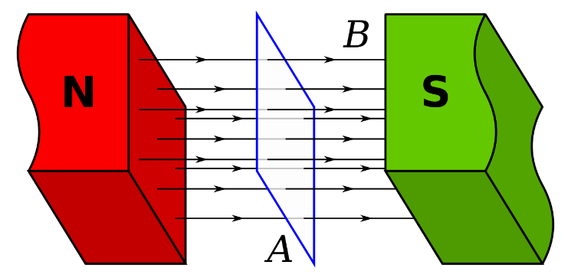

Diagram From: Wikimedia Commons

Often the field will slice through an area at an angle, as below.

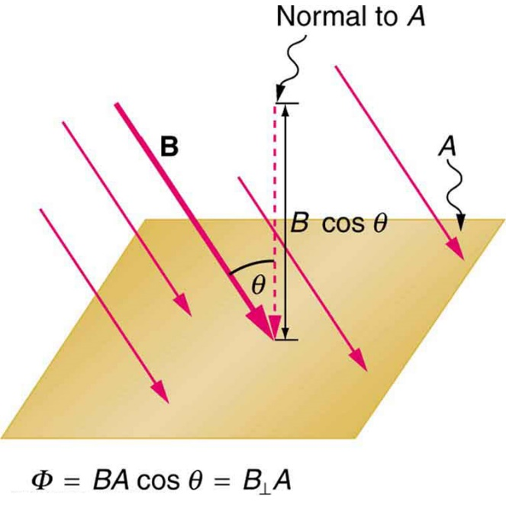
Diagram From: Wikimedia Commons

In such cases, the magnetic flux is given by:

where θ is the angle between the field lines and the perpendicular to the area.

(The syllabus states that it is the component of B parallel to the area that appears in this formula, B||. That is not correct. It must be the component of B perpendicular to the area, as shown.)

Clearly, if either the magnitude or direction of the magnetic field or the area through which it is passing changes, the magnetic flux through the area will change. Such a change could be caused for instance by rotating the coil shown in the first diagram in this section of notes or the area shown above.

THE DISCOVERY OF ELECTROMAGNETIC INDUCTION

The term “electromagnetic induction” refers to the creation of an electromotive force (emf or voltage) in a conductor moving relative to a magnetic field. The effect was discovered by the British scientist Michael Faraday (1791-1867).

In 1831, Faraday discovered that moving a magnet near a wire induces an electric current in that wire. In one experiment he showed that when a permanent magnet moved towards a coil of wire connected to a sensitive galvanometer, a current was induced in one direction in the coil. When the magnet was stationary or inside the coil, no current flowed through the coil. When the magnet was removed from the coil, another current was induced in the coil, this time in the opposite direction to the original induced current. Faraday reasoned that the presence of an induced current implied the presence of an induced electromotive force (emf) that caused the current.

In further experiments Faraday showed that an induced emf and a corresponding induced current was produced whenever there was relative motion between the magnet and the coil. He also showed that this induced emf & current were proportional to:

- The relative velocity of the magnet and coil;
- The strength of the magnet;
- The number of turns of wire per unit length.

In the same year Faraday demonstrated the induction of one electric current by another.

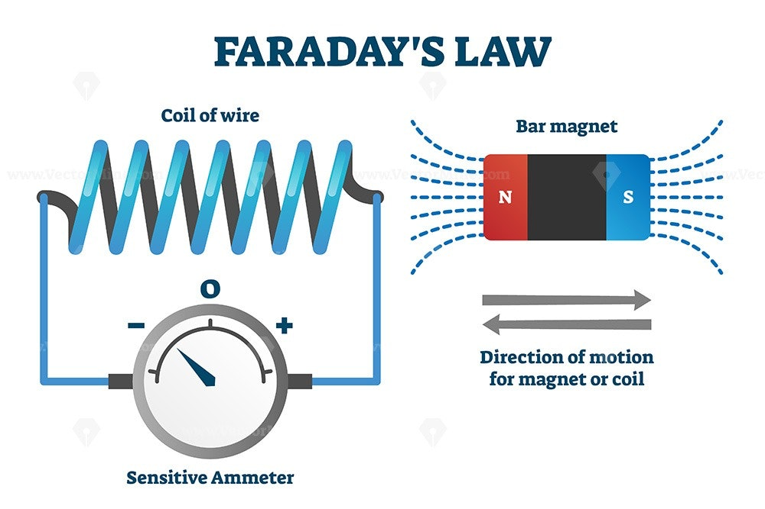
Diagram From: Wikimedia Commons

As the magnet or coil move relative to one another, the change of flux with time causes an emf across the ends of the coil, which in turn induces a current in the coil. The presence of the current is indicated by the movement of the ammeter needle.

Faraday’s Law of Electromagnetic Induction
Faraday eventually deduced from his experiments that an emf was induced in the coil, only when magnetic field lines were being cut by the coil. Faraday’s Law of Electromagnetic Induction states that: An emf is induced whenever a coil or circuit experiences a change of magnetic flux with time and the magnitude of the emf depends on the rate of change of the magnetic flux through the coil or circuit.

Mathematically, for a conductor of N turns of wire, cutting through a magnetic flux of Δφ in a time of Δt, the emf ε, induced across the ends of the conductor is:

Origin of Induced emf
Let us now consider how an induced emf originates. The diagram below shows a magnetic field directed down into the plane of the page. A copper wire is being moved to the right through this magnetic field at a constant velocity v.

Since the copper wire contains many free electrons, these electrons are literally moving to the right through the magnetic field. Therefore, we have a situation where charged particles, electrons, are moving through a magnetic field. We know from our earlier work that whenever this happens the charged particles experience a force. The size of this force is given by F = qvB.

Fleming’s Left-Hand Rule gives the direction of this force. Applying this rule to the motion of the electrons we have field direction (index finger) down into the page, conventional current direction (2nd finger) to the left of the page (since the electrons are moving to the right) and therefore the direction of the force on the electrons (indicated by the thumb) is down towards the bottom of the page, as indicated by the arrow inside the copper wire in the above diagram.

Thus, in the above situation, electrons will move down to the bottom end of the wire making that end negatively charged and leaving the top end of the wire positively charged. It is this charge separation between the ends of the wire that creates the emf or potential difference between the ends of the wire. If the wire were moved through the field whilst being attached to an external circuit, it would act as a battery for the circuit, supplying current that would flow around the circuit.

Direction of Induced emf – Lenz’s Law
Lenz’s Law states that the direction of an induced current is always such that the changes causing the induction are opposed. In other words, an induced emf always opposes the changes that caused it.

To remind us of this fact, a minus sign is included in the equation for induced emf:

Lenz’s Law is really a consequence of the conservation of energy law, since if the induced emf did not oppose the changes that caused it, then it would be possible to create a self-perpetuating energy supply. The Second Law of Thermodynamics proves that such an energy supply is impossible.

Some Thinking
Let us use the diagram on the previous page to demonstrate how this law works. In the conductor shown, the induced conventional current is in a direction up the page since the electrons (-ve charges) are moving down the page. Using the right-hand grip rule, we can deduce that the magnetic field around the conductor points down into the page on the right-hand side of the conductor and up out of the page on the left-hand side of the conductor. Thus, the magnetic field on the right-hand side of the conductor is strengthened and the field on the left-hand side is weakened. This makes it harder to keep pushing the conductor to the right. The induced current is in such a direction that the magnetic field it produces around the conductor opposes the motion of the conductor (the change that caused it in the first place).

This is an example of Lenz’s Law in operation. As we said earlier, it makes sense that this should happen. If it turned out that it became easier to push the conductor to the right, we would keep pushing it to the right, producing higher and higher induced current with less and less effort and this would go on forever. We would have created a perpetual motion machine. Sadly, the universe does not work that way. There is, as they say, no such thing as a free lunch. You don’t get anything for nothing. The price of producing the induced current is that the very action that caused it is opposed.

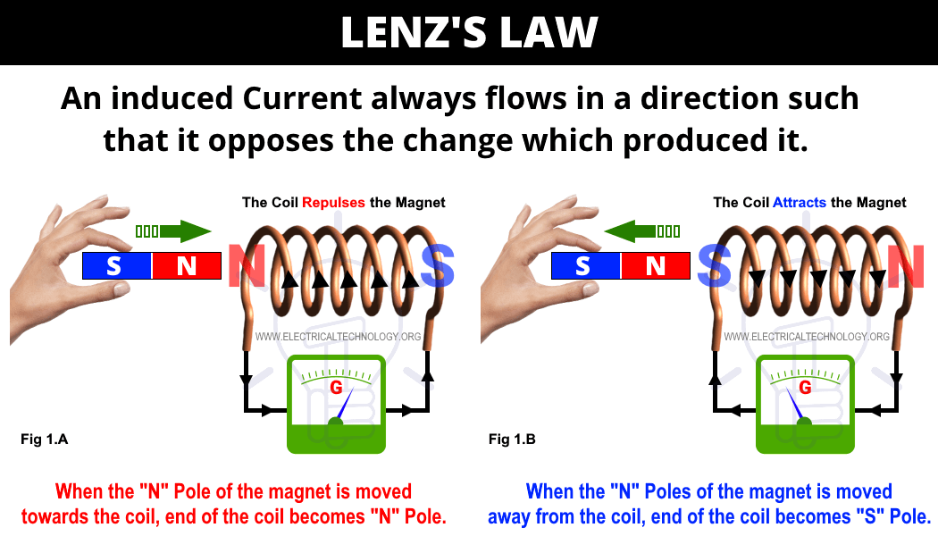

Lenz’s Law applied to a solenoid.
Diagram From: Wikimedia Commons
In the next example, we place two solenoids close together. When we close the switch on the left-hand solenoid, current will flow through that circuit.
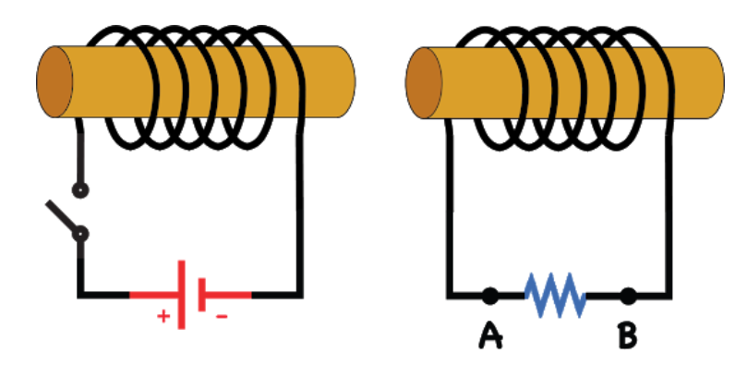
Diagram From: Wikimedia Commons

The direction of the current is down toward the bottom of the page in each of the turns of wire visible at the front of the solenoid.

As the current builds up from zero to its maximum value, it produces a steadily increasing magnetic field around each turn of wire, which creates an increasing magnetic field around the whole solenoid. Using the right-hand grip rule, the direction of the field at the right-hand end of the solenoid is a north pole – field lines come out of that end of the solenoid. That north pole field pushes into the left-hand end of the other solenoid. It is an increasing field, a changing field and therefore produces a change in the magnetic flux threading through the second solenoid. This change in flux with time, by Faraday’s Law, produces an induced emf across the solenoid, which in turn produces an induced current.

By Lenz’s Law, the direction of that induced current must be such as to oppose the change that caused it. That is, it must oppose the north pole field pushing into the end of the solenoid. How does it do that? The induced current in the second solenoid must create an opposing north pole field at that left hand end of the solenoid. Thus, the current in the second solenoid must be up towards the top of the page in each of the turns of wire visible at the front of the solenoid. The right-hand grip rule shows that this will produce a north pole at the left end of the second solenoid.

Note that this induced current will be very short lived since we are using direct current in the first solenoid circuit. The induced current only exists while there is a changing magnetic flux threading through it. Once the current in the first solenoid reaches maximum value, the magnetic field is steady and there is no longer a changing flux in the second solenoid.

We could replace the direct current with alternating current. Then the current & field would continue to change. We could add a galvanometer or microammeter in series with the resistor in the second circuit and we would then see that as the AC current flows in the first circuit, the needle on the meter swings backward and forward between positive & negative values in the second circuit.

This example describes the phenomenon called mutual induction. Mutual induction occurs when changing current in one conductor causes a change in magnetic flux with time in a second nearby conductor, thus producing an emf in the second conductor, which in turn produces an induced current in the second conductor. Mutual induction is a very useful physical phenomenon as we shall see very soon.

Your teacher should provide you with demonstrations and time for you to experiment with the principle of electromagnetic induction. Moving magnets near and into solenoids, viewing the effect of speed of motion, of reversing the motion of the magnet, of different strength magnets, etc is the best way to get your head around the nature of this wonderful physical phenomenon.

Eddy Currents
Eddy currents are a fascinating example of electromagnetic induction. When a solid conductor is placed in a region of changing magnetic flux, circular eddy currents are induced in the conductor. Lenz’s Law can be used to explain the direction of flow of eddy currents in particular cases. Consider the case below. A uniform magnetic field is set up by placing a magnetic north pole above the plane of this page and a south pole below the plane of the page. The magnetic field direction is therefore down into the page as shown. Next a copper sheet originally sitting stationary in the magnetic field is pulled out of the field in the plane of the page as shown below. By Faraday’s Law, eddy currents will form where there is a change of flux with time, that is along the right-hand edge of the field where the metal sheet is leaving the field.

By Lenz’s Law, the induced eddy currents must oppose the change that caused them. That is, they must oppose the relative motion between the conductor and the magnetic field. The easiest way to determine the direction of the currents is to ask which direction of the current around the loop would produce a magnetic field that will oppose the motion of the conductor.

Clearly, the clockwise direction of the eddy currents as shown in the diagram would produce a south pole inside the loop on this side of the metal sheet and a north pole inside the loop on the other side. The south pole on this side of the metal sheet would be attracted to the north pole of the magnet (on this side of the sheet) producing the original field. Likewise, the north pole created by the eddy currents on the other side of the sheet will be attracted towards the south pole of the magnet on the other side of the sheet. The net effect is that there is an attractive force that acts on the copper sheet and opposes the motion of the sheet to the right.

As usual in Physics there are many ways to reach the same conclusion. A variation on the above is to realize that as the conductor is pulled out of the field, the magnetic flux passing through the conductor at the right-hand edge of the field changes from a particular value to zero. Ultimately then, the change at work here is the disappearance of field lines along the right-hand edge of the field, as the conductor is pulled out of the field. So, the eddy currents will be in such a direction as to create a magnetic field that strengthens the original field by putting new field lines in to replace those that are disappearing. Thus, the direction of the eddy currents must be clockwise as shown above.

We can easily verify the direction of the eddy currents in the above example by using Fleming’s LHR. Clearly, if the eddy current in the magnetic field is moving up towards the top of the page and the field direction is down into the page, by Fleming’s LHR, the force on the metal sheet is towards the left, opposing its motion to the right. Thus, the eddy currents are in a direction such that the changes causing them are opposed.

Note that while the methods used in the example above can be applied to solve most cases, there are several other ways to determine the direction of eddy currents. Another one using Lenz’s Law as a starting point is as follows.

Pick a point on the metal surface in the magnetic field but close to where the field ends. Since the eddy current must oppose the motion of the metal sheet (by Lenz’s Law), the eddy current will cause a force on the sheet in the opposite direction to the motion of the sheet. So, the force is back towards the left, the field is down into the page & therefore by Fleming’s LHR, the eddy current must move up towards the top of the page. Since the eddy current forms at the boundary of the magnetic field (ie where the magnetic flux changes from a particular value to zero), the eddy current will form in a clockwise direction in this case, as shown. In other words, the circle must come out of the field, not go further back into the field.

Note that since eddy currents oppose the motion of the conductor in which they flow, they can be used for electromagnetic braking purposes. Examples include the EM braking used in the manufacture of electronic balances and in Theme Park rides such as The Giant Drop at Dreamworld on the Gold Coast. Eddy currents can also be used to produce heat in induction cooktops and induction heaters.

TRANSFORMERS

A transformer is a device in which an input alternating current produces an output alternating current of different voltage. A step-up transformer results in an increased voltage. A step-down transformer results in a decreased voltage.

The transformer itself consists of two separate coils, a primary and a secondary, usually wound around a soft iron core, to intensify the magnetic field in the primary. The transformer works on the principle of mutual induction. An alternating current flows in the primary, thus creating a changing magnetic field that threads through the secondary. Thus, there is a changing magnetic flux in the secondary coil, which produces an emf across that coil. This emf induces a current in the secondary coil. Since the magnetic field is changing at a given frequency, the current induced in the secondary coil is also an alternating one.

If the secondary coil contains more turns of wire than the primary, the transformer will be a step-up one. If the secondary coil contains less turns of wire than the primary, the transformer will be a step-down one. The diagram below shows a step-up transformer.

Mathematically:

where V_{P} = primary voltage, V_{S} = secondary voltage, N_{P} = number of turns of wire in primary coil and N_{S} = number of turns of wire in secondary coil.

EXERCISE: It is a useful exercise to derive this last formula. Hint: By the principle of self-induction, the changing B field in the primary also gives rise to a back-emf and a back current in the primary that by Lenz’s Law opposes the original voltage. The induced current in the secondary coil has an alternating magnetic field associated with it, which strengthens the back-emf in the primary coil. Have a think about how you might derive the above formula before reading on. Start by writing formulae for the emf induced across the primary and secondary coils.

Derivation of Transformer Equation
The emf (voltage) in the secondary coil is given by the Faraday’s Law equation:

The changing flux in the primary coil due to the constantly changing AC current, produces an emf across that coil. This emf opposes the change that caused it by producing a back current in that coil. This is called self-induction, since the flux change is inducing a current in the primary coil itself, the coil that gave rise to the changing magnetic field in the first place. So, we have:

Dividing the equation for the primary voltage by the equation for the secondary voltage, we have:

the transformer equation.

LIMITATIONS OF THE IDEAL TRANSFORMER

In an ideal transformer no energy is lost and so the energy input is the same as the energy output per unit time. We can write this as:

Power in = Power out

V_{P} I_{P} = V_{S} I_{S}

From which we have:

This formula implies that in a step-up transformer, although the output voltage is higher than the input voltage, the output current is lower than the input current. This is a direct consequence of the conservation of energy law. Clearly, if the output current did not decrease compared to the input current, V_{S} I_{S} would be greater than V_{P} I_{P} and energy would have been created from nothing. Similarly, for step-down transformers, the output voltage is lower than the input voltage but the output current is higher than the input current.

From a practical point of view, transformers need to be designed carefully. In reality, there is no such thing as an ideal transformer. There are many sources of potential energy losses in transformers:

- Magnetic leakage also called incomplete flux linkage - Some of the magnetic field generated by the primary coil is lost and does not entirely pass through the secondary coil. This is resolved by designing the coils so that their geometry maximizes the flux linkage in the secondary coil.
- Resistive heat losses in the coils – this is caused by the resistance of the copper wires through which the currents flow. As a current passes through the wires, they heat up, resulting in energy (and power) being lost in both the primary and secondary coils.
- Heat losses in the core due to eddy currents - The changing magnetic field passing through the iron core creates eddy currents. This results in energy loss as heat. To reduce the effect of eddy currents, the core is made of layers called laminations separated by thin insulating layers, rather than being one solid block of metal. See diagram below.

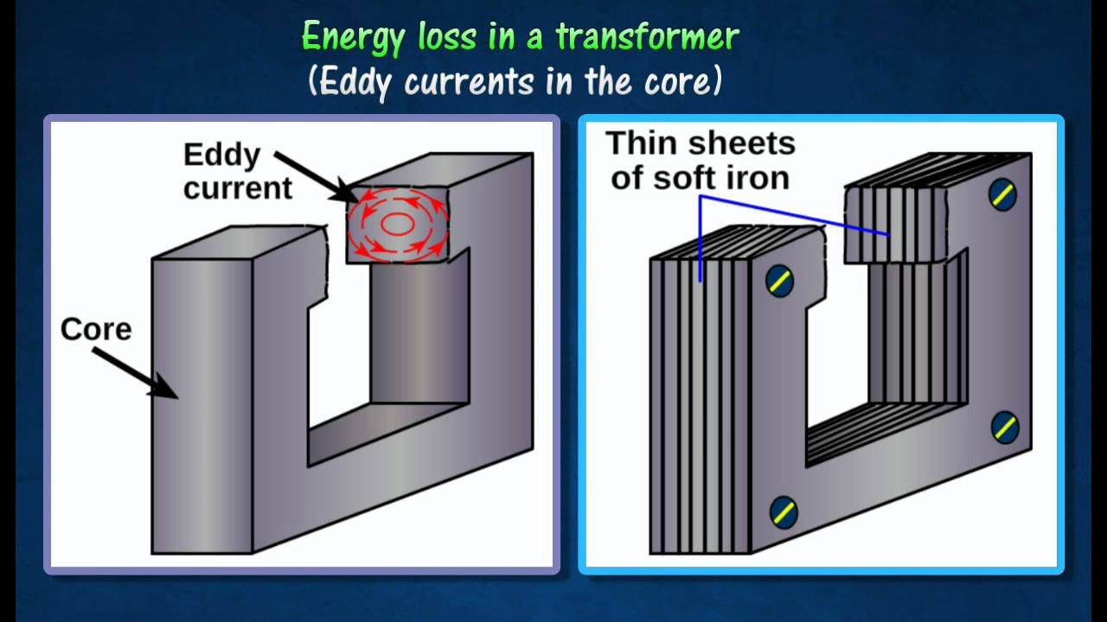
Diagram From: Wikimedia Commons
- Not required by current syllabus, but important – Hysteresis losses caused by the friction of the molecules of the core material (iron) against the flow of the magnetic lines of force required to magnetize the core. This loss can be reduced by astute choice of material for the core. High grade or silica steel is often used.

APPLICATIONS OF TRANSFORMERS

Modern transformers operate with around 99% efficiency and have many practical applications. Perhaps the most important application is in the transfer of electrical energy from a power station to its point of use.

As current flows through transmission lines, some electrical energy is transformed into heat due to the resistance of the lines. Energy losses in power transmission lines can be shown to be proportional to I²R. Clearly, the lower the current, the lower the energy loss in the line. For this reason, the 240 V power produced by the generators at a power station is stepped up by transformers to very high voltages (220 kV to 500 kV) before being transmitted from the power station. In this way the current flowing in the transmission lines is very low and energy loss in the lines is minimized. (Also, lower currents mean that smaller diameter transmission lines can be used, which leads to savings in materials and construction costs.)

To be used by the various consumers, the voltage needs to be stepped down to the required value. This happens at electricity sub-stations, where transformers step the high voltage down to 240 V for domestic use or other particular values for industry and public transport (eg electric trains).

The diagram below provides a simple summary of this process.

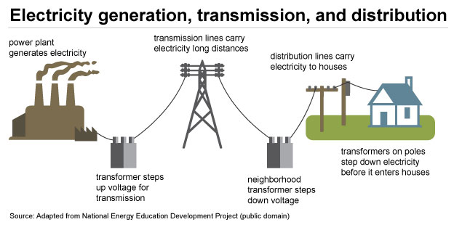

Diagram From: Wikimedia Commons

Transformers are also used in certain electrical appliances in the home that are connected to the mains domestic power supply. For example, transformers in the 1 to 100 watt power level are often used as step-down transformers to couple electronic circuits to loudspeakers in radios, television sets, and Hi-Fi equipment. In many electronic devices several different voltages are required for normal operation. Transformers are used to convert the 240 V mains supply voltage to the required voltage. This can be achieved by having several secondary coils wrapped around the primary or by having one secondary coil and tapping into it after the appropriate number of turns of wire.

Transformers have had a major positive impact on society. Transference of electrical energy with low levels of loss, over huge distances between power stations and consumers is only possible due to the existence of transformers. If electrical energy could not be transmitted efficiently over large distances many more power stations would be necessary to supply power to their local areas. This would lead to more expense and in the case of fossil-fuel power stations, added pollution and global warming implications.

Transformers enable power from the one power station to be used in many different applications. Sub-stations can step the power down in stages to the various levels required by households, industry, public transport and so on. Without transformers, different industries requiring different voltages would have to build generators to produce those specific voltages.

The existence of transformers has enabled the construction of many of the electronic labour-saving and entertainment devices we take for granted. TV’s, computers, mobile phones, MP3 players, stereos, radios, electronic clocks, many kitchen appliances and countless other electronic devices require transformers for their operation.

APPLICATIONS OF THE MOTOR EFFECT

Inquiry Question: How has knowledge about the Motor Effect been applied to technological advances?

THE DC ELECTRIC MOTOR

One simple application of the motor effect is the DC electric motor. A simple electric motor consists of a current-carrying loop situated in a magnetic field, with its plane initially parallel to the field direction. When the current starts to flow through the coil, the two sides of the coil lying perpendicular to the field lines experience forces of F = IlB in the directions indicated by Fleming’s left-hand rule and shown in the diagram below. The coil starts to turn in the direction of the forces.

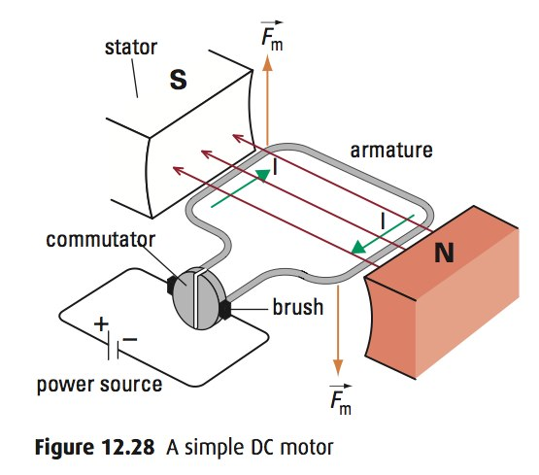

Diagram From: Wikimedia Commons

Clearly, for the loop to continue to rotate in one direction, the current running through the loop must reverse direction just as the loop reaches the position where its plane is perpendicular to the field direction. A split ring commutator is used to achieve this reversal of the current direction.

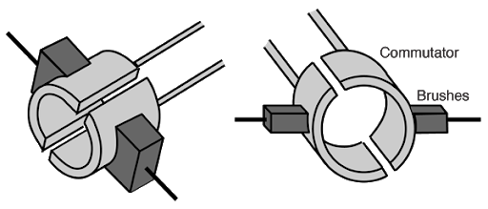

Split Ring Commutator - Diagram From: Wikimedia Commons

The split ring commutator is attached to the loop and conducts current into the loop by rubbing against the brushes. The brushes are usually carbon rods that carry current from the external power source to the commutator.

The split ring is arranged so that each half of the commutator changes brushes just as the loop reaches the position where its plane is perpendicular to the field direction. Changing brushes reverses the current in the loop. As a result, the direction of the force on each side of the loop is reversed and the loop continues to rotate in the same direction. This process is repeated each half-turn. Thus, the loop spins in the magnetic field.

In practice, electric motors have several rotating loops. Together they make up the armature (or rotor) of the motor. The magnetic field in which the armature sits is called the field structure (or stator) of the motor. This can be produced either by permanent magnets as in the simple case shown above or more usually by current-carrying coils called field coils wound around iron cores called pole pieces. These sit opposite one another inside the motor frame.

One of the common practical tasks that students often get asked to do is to make a model electric motor. The following pic is of one such model. On the Electromagnetism webpage there are a couple of video clips of this motor in action. If you wish to pursue building your own, have a look at http://www.youtube.com/watch?v=h6Ev64h49wg which shows a very well-designed working DC electric motor in action.

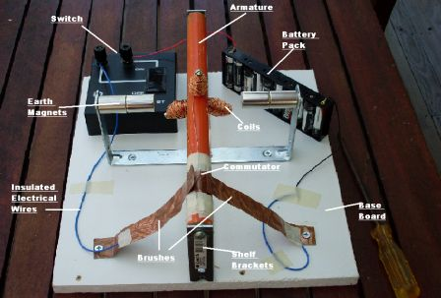

Back emf in Motors
Lenz’s Law can be used to explain an interesting effect in electric motors. In an electric motor, a current supplied to a coil sitting in a magnetic field causes it to turn. As we know, this is called the motor effect. However, while the coil of the motor is rotating, it experiences a change in magnetic flux with time and by Faraday’s Law an emf is induced in the coil. By Lenz’s Law this induced emf must oppose the supplied emf driving the coil. Thus, the induced emf is called a back emf. As the coil rotates faster, the back emf increases and the difference between the constant supplied emf and the back emf gets smaller. Clearly, this difference between the two emf’s is equal to the potential difference across the motor coil and hence determines the actual current in the coil.

It is worth emphasizing that back emf is a consequence of the Law of Conservation of Energy. If the current induced in the coil of the motor was in the same direction as the current supplied by the battery, the forward current in the coil would build rapidly and eventually it would be possible to switch the battery out of the circuit and the motor would continue running on the induced current. Thus, we would have produced a perpetual motion machine. Apart from the initial kick to get it going, no input energy would be required to run this sort of motor. (I’m reminded of a Simpson’s episode – Season 6, Episode 21.) In fact, if we did not eventually switch the battery out of the circuit, so much current would be flowing that the motor would burn out. So, the induced emf must oppose the supplied emf driving the coil.

It is interesting to note that when the motor is first turned on and the coil begins to rotate, the back-emf is very small, since the rate of cutting flux is small. This means that the current passing through the coil in the forward direction is very large and could possibly burn out the motor. To ensure that this does not happen, adjustable starting resistors in series with the motor are often used, especially with large motors. Once the motor has reached its normal operating speed, these starting resistors can be switched out, since by then the back emf has reached a maximum and has thereby minimised the current in the coil.

Note also that if the load on the motor is increased at some time, the motor will slow down, reducing the back-emf and allowing a larger current to flow in the coil. Since torque is proportional to current, an automatic increase in torque will follow an increase in load on the motor.

Back emf is very significant in the working of a DC motor. The presence of back emf makes the DC motor a self-regulating machine. Back emf ensures the motor draws as much armature current as is just sufficient to develop the torque required by the load. Our universe is a wonderful place.

THE DC & AC GENERATORS AND THE AC INDUCTION MOTOR

The AC Generator
An important application of electromagnetic induction is in the generation of electric current. AC generators produce an electric current via the motion of coils in a magnetic field or by rotating a magnet within a stationary coil. The term alternator is also often used interchangeably with the term electric generator. Strictly speaking, an alternator refers to an electromagnet rotating inside a fixed coil, such as is the case in most power stations. Consider the diagram of a simple AC generator shown below.

Clearly, the main components of a generator are:

- The armature – a coil wound around a metal core and mounted between the poles of an electromagnet.
- The electromagnet consisting of an iron core surrounded by a set of coils called the field windings. A steady current flows through these coils to produce the required magnetic field.
- The slip rings – each end of the armature coil is connected to a metal ring. These rings are mounted on the armature shaft but are insulated from it and from each other.
- The graphite brushes – these connect the slip rings to an external circuit and conduct the current induced in the armature coil to the external circuit.

The armature is mechanically driven by a steam turbine or a belt & pulley system or by hydroelectric means. As the armature turns, one side moves up through the magnetic field and the other side moves downwards. The coil thus experiences a change of magnetic flux with time. The result is that an emf is induced in one direction in one side of the coil and in the other direction in the other side of the coil. Thus, these emf’s act in the same sense around the coil. The ends of the coil are connected to slip rings against which rest graphite brushes. When these brushes are connected across an external circuit, the induced emf produces an electric current.

Each time the coil passes through the position where its plane is perpendicular to the magnetic field lines, the direction of the emf in the coil is reversed. Hence an alternating current is produced at a frequency equal to the number of revolutions per second of the armature.

Note that if we need to determine the direction of the induced current in the coil at any time, we simply apply Lenz’s Law followed by Fleming’s left-hand rule. So, at the start of the motion in the diagram above, the left-hand side of the coil begins to move upward, as indicated by the direction of mechanical rotation in the diagram. Therefore, by Lenz’s Law, the induced current in that side of the coil must oppose the motion that caused it and therefore must produce a force downward on that side of the coil. Fleming’s left-hand rule then indicates that the current must flow in the direction toward the top right-hand corner of the page.

As an aside, and it is an optional extra, there is another hand rule that can be used when dealing with induced emf’s and currents. This is called the Right-Hand Induced Current Rule. You hold the thumb, first finger and second finger of the RIGHT hand mutually at right angles. If you point the thumb in the direction of motion of the coil or conductor and the first finger in the direction of the magnetic field, then the second finger points in the direction of the induced current.

If you choose to use this rule, please be careful not to mix it up with Fleming’s LH Rule. The Right-Hand Induced Current Rule is only used when dealing with induced currents. The thumb points in the direction that the coil or conductor is moving. Try it out in the case we just considered and check that you get the same direction for the induced current in the coil above, as we did, using the other method.

The DC Generator
An alternating current generator may be converted to a direct current generator in a couple of ways:

- By using a split ring commutator instead of slip rings. The split ring commutator is mounted on the armature shaft but is insulated from it. The commutator reverses the connections of the coil to the external circuit each time the current in the coil reverses. Thus, a DC output is achieved from the AC generator.
- By using a bridge rectifier circuit. This is an arrangement of electronic components (diodes) that converts the AC output from the generator to a DC output.

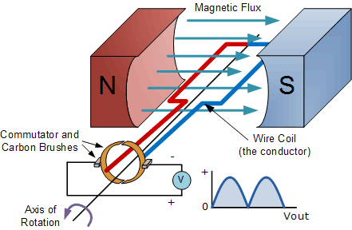

DC Generator – Diagram From: Wikimedia Commons

Note that in an electric current generator, mechanical energy is transformed into electrical energy. In an electric current motor, electrical energy is transformed into mechanical energy.

The AC Induction Motor
The single-phase AC induction motor is the most common AC motor in use today. It is called “single-phase” because it runs on only one phase of the three phases produced at power stations & distributed to the community. As houses are almost always only connected to one phase of the three available, the single-phase AC motor can be used for household purposes. Three-phase AC induction motors also exist. These are usually used in industry rather than in households because they are more powerful than the single-phase motors.

The AC induction motor consists of two main parts – the stator and the rotor. As the names suggest, the stator is the stationary part of the motor and the rotor is the part that turns and enables us to harness the useful work of the motor.

In both single-phase and three-phase AC induction motors, a changing magnetic field in the stator induces an AC current in the rotor. The current in the rotor produces its own magnetic field, which then interacts with the magnetic field of the stator, causing the rotor to turn. Clearly, the name induction motor comes from the fact that no current is fed directly to the rotor from the mains supply. Current is induced in the rotor by the changing magnetic field of the stator.

The rotor of an induction motor consists of a cylindrical arrangement of copper or aluminium conducting bars attached to two end rings at either end of the bars. These end rings short circuit the bars and allow current to flow from one side of the cylinder to the other. This type of rotor is usually referred to as a squirrel cage, owing to its resemblance to the cage or wheel that people use to exercise pet squirrels or mice. See diagram below.

The squirrel cage fits into a laminated iron core or armature, which is mounted on the shaft of the motor. See diagram below.

The stator consists of several coils of wire wrapped on laminated iron cores. You can see those in the diagram of a three-phase AC induction motor below. The three pairs of coils are arranged opposite one another, indicated in the diagram by using a different colour for each pair. Each pair is connected to one another electrically. Each pair is also connected to a different phase of the three-phase mains electrical supply.

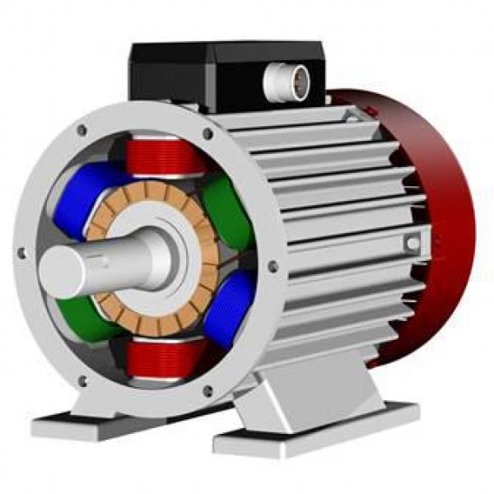

Three-Phase AC Induction Motor
Diagram From: Wikimedia Commons

The stator surrounds the rotor, which you can see as well in the diagram above. The three-phase AC supply progressively changes the polarity of the stator poles in such a way that their combined magnetic field rotates. The magnetic field inside the stator rotates at the same frequency as the mains supply, 50 Hz. The changing stator magnetic field threads through the rotor. This changing magnetic field induces an alternating current in the rotor by Faraday’s Law, which in turn sets up its own changing magnetic field. This magnetic field, by Lenz's law, opposes the rotating magnetic field of the stator, by rotating as well. The rotor rotates in the same direction as the stator field.

Let’s have a closer look at how the field of the stator causes the rotor to rotate. Examine the diagrams below. R.M.F refers to rotating magnetic field.

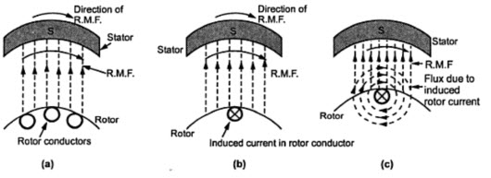

In (a), the rotating stator field passes clockwise (to the right) over the stationary rotor conductors in the cage. This is equivalent to the conductors moving in the opposite direction through a stationary magnetic field. Using the Right-Hand Induced Current rule, the thumb of the right-hand points in the direction of motion of the conductors – that is to the left – and the first finger in the direction of the field – that is up the page. The second finger then indicates that the current induced in the conductor is into the page, as shown in (b). By Fleming’s Left-Hand rule, the force on the conductors, due to the induced current and the magnetic field is to the right. This makes sense as the change that caused the induced current was the conductors moving to the left.

In diagram (c), we see by the Right-Hand Grip rule, the field around the conductor due to its induced current. This field also confirms that the force on the conductor must be to the right. The net result of the field from the conductor interacting with the stator field is to weaken the field to the right of the conductor and strengthen it to the left, making it easier to move the conductor to the right.

It is worth reflecting that if the conductors of the cage were to rotate at the same rate as the stator field, there would be no relative movement between the conductors and the field and there would be no induced current and no force. There must be relative movement if the cage is to experience a force. When operating under a load, the retarding force supplied by the load slows the cage down so that it is moving slower than the field. The difference in rotational speed between the cage and the field is known as the slip speed. This means that the rotor is always travelling at a slower speed than the magnetic field of the stator when the motor is doing work.

A three-phase induction motor has a wide variety of applications in both commercial and industrial sectors. Here are some of the most common applications:
- Compressors
- Air conditioners / Heat pumps
- Fans and air handling units
- Industrial machinery
- Pumps

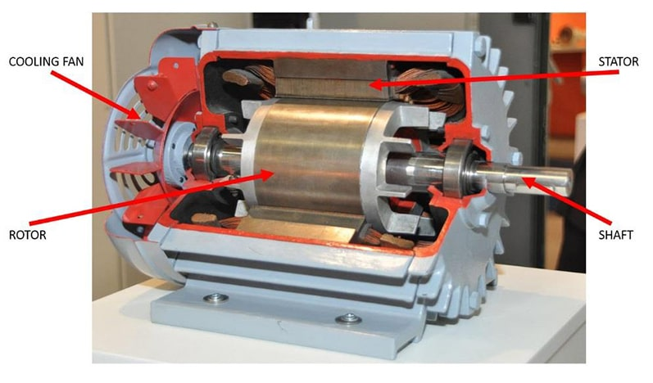
Cut-Away of Three-Phase AC Induction Motor - Diagram From: Wikimedia Commons

Single phase AC induction motors are low-powered and used in applications such as power tools (drills, saws, sanders etc), electric kitchen implements (beaters, food processors etc) and other household appliances (hair dryers, fan heaters etc).

In single-phase AC induction motors, the stator field pulsates rather than rotates. Various special techniques beyond the scope of this course are used to ensure that the changing magnetic field produced by the stator rotates and drags the magnetic field of the rotor around with it.

Moving Coil Meters

A moving coil meter (eg a galvanometer) is an example of an application of the motor effect. Consider the diagram of a moving coil meter as shown below.

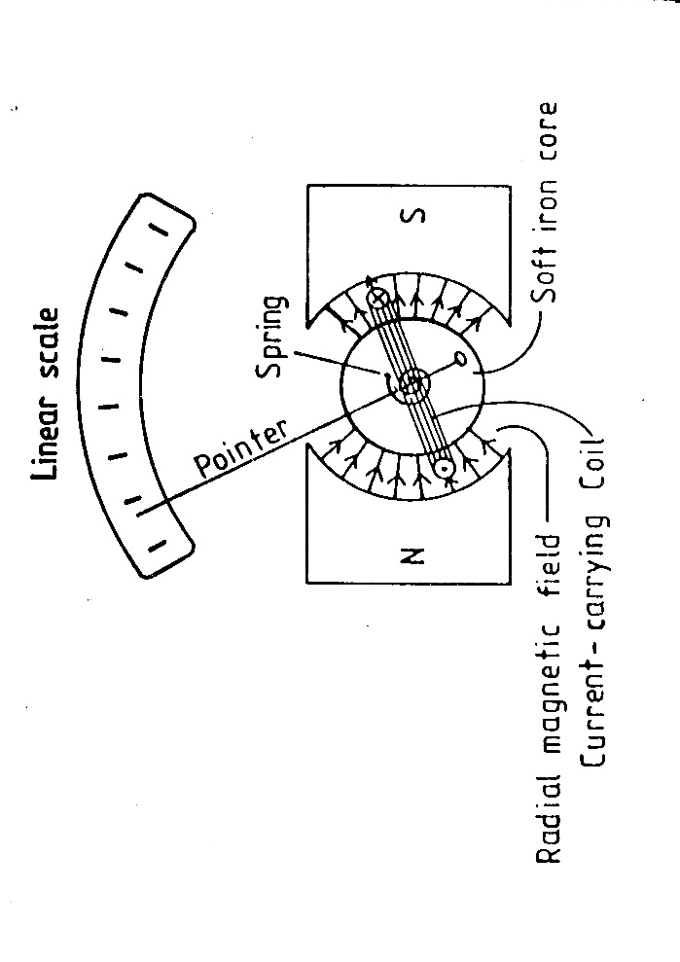
Diagram of Moving Coil Meter from 1984 HSC Exam Paper Q.24

A galvanometer is a device used to measure the magnitude and direction of small direct currents. The coil consists of many loops of wire and it is connected in series with the rest of the circuit so that the current in the circuit flows through the coil.

When the coil carries a current, the magnetic field of the current interacts with the magnetic field of the magnet. This produces a force which causes the coil to rotate. As the coil rotates it winds up a spring, until the force provided by the current and external magnetic field is balanced by the force provided by the spring. The pointer then indicates the value of the current in the coil.

Note that the soft iron core around which the coil is wound intensifies the magnetic field. The magnet is shaped to produce a radial magnetic field. The advantage of such a field over a non-radial field is that the angle θ between the plane of the coil and the plane of the B field is always zero. This produces a constant torque on the coil.

Since the torque on the coil is proportional to the current, the scale of the meter will be linear.

Galvanometers form the basis of both ammeters and voltmeters.

Magnetic Braking
An eddy current brake, also known as an induction brake or a magnetic brake, is a device used to slow or stop a moving object by dissipating its kinetic energy as heat. Recall how eddy currents are produced – see pages 23-24. Examine the diagram below.

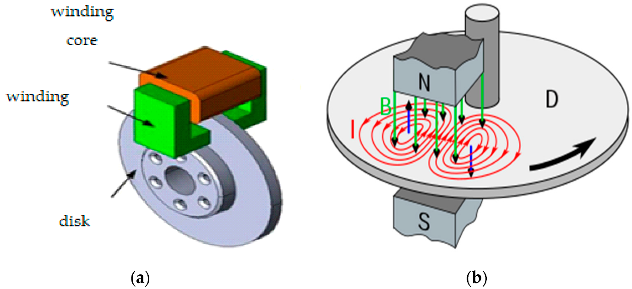

A Magnetic Brake – Diagram From: Wikimedia Commons

Eddy currents can be used as a smooth braking device on say a train or tram wheel. When the driver applies the brake, an electromagnet is turned on, creating a magnetic field that passes through the metal wheel. Diagram (a) above shows how this would be done. The metal wheel is now passing through an area of magnetic field and therefore experiences a change in magnetic flux as each part of the wheel enters and then leaves the magnetic field area. By Faraday’s Law, eddy currents are induced in the metal where the wheel enters and leaves the field. See Diagram (b).

By Lenz’s Law, these eddy currents must be in a direction that opposes the change that caused them – that is, parts of the wheel continuously entering and leaving the magnetic field. As we have said before, this is a direct consequence of the Law of Conservation of Energy. If the induced eddy currents sped the wheel up instead of slowing it down, we would have created a perpetual motion machine. For as long as the brake was applied, and the electromagnetic field persisted, the wheel would continue to gain speed. Clearly, this does not happen and by the Second Law of Thermodynamics cannot happen.

For completeness, let us consider what is happening in Diagram (b). As each part of the wheel enters the field from the left-hand side of the electromagnet, it encounters an increasing magnetic flux down into the surface. To oppose this, the induced eddy current is anti-clockwise, producing its own magnetic field pointing up out of the surface (Right-Hand Grip rule). This strengthens the field just inside the magnetic field supplied by the electromagnet and makes it harder for the wheel to push into that area. We can use Fleming’s Left-Hand rule to show that at that edge of the field, the force on the wheel due to the induced eddy current is back toward the left, opposing the motion of the wheel.

Likewise, as each part of the wheel leaves the field from the right-hand side of the electromagnet, it encounters a decreasing flux down into the surface. To oppose this, the induced eddy current is clockwise, producing its own magnetic field, directed down into the surface, trying to restore the field lines that are disappearing as it leaves the field. Again, Fleming’s Left-Hand rule shows that at that edge of the field, the force on the wheel due to the induced eddy current is back toward the left, opposing the motion of the wheel.

BIBLIOGRAPHY

- Mayfield, J.M., Parham, R.T. & Webber, B.J. (1981). Fundamentals of Senior Physics Book One, Richmond, Victoria, Heinemann Educational Australia Pty Ltd
- Christian, D. & Crossley, W. (1982). Essential Physics Book One, Strathfield, Australia, Sapphire Books Pty Ltd
- Cooper, M. & Vella, G. (1987). Physics The Core, Melbourne, Victoria, Brooks Waterloo
- Giancoli, D.C., (2008). Physics for Scientists & Engineers – Volume II, USA, Pearson Education Inc.
- Halliday, D. & Resnick, R. (1966). Physics Parts I & II Combined Edition, New York, Wiley

APPENDIX A
Statement of Syllabus Content Covered in these Notes

The following indicates the specific content from the Stage 6 Physics Syllabus that has been covered in the notes, worksheets & practicals provided on the Electromagnetism Module web page.

The resources on this website are meant to supplement the work you do in class NOT replace it. The notes will always provide you with a comprehensive and accurate set of notes on the Module under study. The worksheets will provide some introduction & practice to appropriate problem-solving skills for the topic. You will need to do much more problem-solving practice than just what is provided on this website. The practicals section will provide some experiments relevant to the topic but again you will need to do more than just what is suggested here. Your teacher should provide you with much more problem-solving & practical experience than you will find on this website.

The content statements that are ticked have been covered. Those left without a tick have either not been covered at all or have been only partially covered. These are mainly content statements requiring practical work of some kind.

Content

Charged Particles, Conductors and Electric and Magnetic Fields
Inquiry question: What happens to stationary and moving charged particles when they interact with an electric or magnetic field?

Students:
- investigate and quantitatively derive and analyse the interaction between charged particles and uniform electric fields, including: (ACSPH083)
  - electric field between parallel charged plates $E=\frac{V}{d}$
  - acceleration of charged particles by the electric field ${\vec{F}}_{net}=m\vec{a}, \vec{F}=q\vec{E}$
  - work done on the charge $W=qV, W=qEd, K=\frac{1}{2}mv^{2}$
- model qualitatively and quantitatively the trajectories of charged particles in electric fields and compare them with the trajectories of projectiles in a gravitational field
- analyse the interaction between charged particles and uniform magnetic fields, including: (ACSPH083)
  - acceleration, perpendicular to the field, of charged particles
  - the force on the charge $F=qv_{⊥}B=qvBsinθ$
- compare the interaction of charged particles moving in magnetic fields to:
  - the interaction of charged particles with electric fields
  - other examples of uniform circular motion (ACSPH108)

The Motor Effect
Inquiry question: Under what circumstances is a force produced on a current-carrying conductor in a magnetic field?

Students:
- investigate qualitatively and quantitatively the interaction between a current-carrying conductor and a uniform magnetic field $F=lI_{⊥}B=lIBsinθ$ to establish: (ACSPH080, ACSPH081)
  - conditions under which the maximum force is produced
  - the relationship between the directions of the force, magnetic field strength and current
  - conditions under which no force is produced on the conductor
- conduct a quantitative investigation to demonstrate the interaction between two parallel current-carrying wires (to be done as prac work/demonstration in class)
- analyse the interaction between two parallel current-carrying wires $\left.\frac{F}{l}=\frac{μ_{0}}{2π}\frac{I_{1}I_{2}}{r}\right.$ and determine the relationship between the International System of Units (SI) definition of an ampere and Newton’s Third Law of Motion (ACSPH081, ACSPH106)

Electromagnetic Induction
Inquiry question: How are electric and magnetic fields related?

Students:
- describe how magnetic flux can change, with reference to the relationship $Φ=B_{∥}A=BAcosθ$ (ACSPH083, ACSPH107, ACSPH109) NOTE: The syllabus states in this dot point that it is the component of B parallel to the area that appears in this formula, B||. That is not correct. It must be the component of B perpendicular to the area.
- analyse qualitatively and quantitatively, with reference to energy transfers and transformations, examples of Faraday’s Law and Lenz’s Law $ε= -N\frac{ΔΦ}{Δt}$, including but not limited to: (ACSPH081, ACSPH110)
  - the generation of an electromotive force (emf) and evidence for Lenz’s Law produced by the relative movement between a magnet, straight conductors, metal plates and solenoids
  - the generation of an emf produced by the relative movement or changes in current in one solenoid in the vicinity of another solenoid
- analyse quantitatively the operation of ideal transformers through the application of: (ACSPH110)
  - $\frac{V_{p}}{V_{s}}=\frac{N_{p}}{N_{s}}$
  - $V_{p}I_{p}=V_{s}I_{s}$
- evaluate qualitatively the limitations of the ideal transformer model and the strategies used to improve transformer efficiency, including but not limited to:
  - incomplete flux linkage
  - resistive heat production and eddy currents
- analyse applications of step-up and step-down transformers, including but not limited to:
  - the distribution of energy using high-voltage transmission lines

Applications of the Motor Effect
Inquiry question: How has knowledge about the Motor Effect been applied to technological advances?

Students:
- investigate the operation of a simple DC motor to analyse:
  - the functions of its components
  - production of a torque$τ=nIA_{⊥}B=nIABsinθ$
  - effects of back emf (ACSPH108)
- analyse the operation of simple DC and AC generators and AC induction motors (ACSPH110)
- relate Lenz’s Law to the law of conservation of energy and apply the law of conservation of energy to:
  - DC motors and
  - magnetic braking

