EXTENSION PROBLEM – CIRCULAR MOTION
A bowl containing water is rotating at a rate of 100 rpm (revolutions per minute). The radius of the bowl is 0.1 m. At what angle to the horizontal is the water near the edge of the bowl rotating?
(Answer: 48°)

Some Useful Information
This is an interesting problem. You need to know a couple of important facts about liquids before starting on this one.
- The surface tension of a liquid is a force that resists breakage of the surface. It arises due to cohesive interactions between molecules in the liquid. So, even when the liquid is rotated, the surface holds together.
- The surface of a liquid in a rotating container takes the shape of a parabola. As the liquid spins, there are two forces acting on each particle of mass on the liquid surface. The normal force acting on the mass provides the centripetal force which keeps the mass rotating in a circle. There is also the weight force acting on each particle of mass.

Watch the following YouTube videos which will hopefully give you a good understanding of the phenomenon. The first two videos are worth a look. The third is very good also but only if you wish to look at the situation a bit more mathematically.
- Spinning Water – The Experiment: https://www.youtube.com/watch?v=RdRnB3jz1Yw
- Spinning Water – The Conceptual Explanation: https://www.youtube.com/watch?v=MSLLE21DYdo
- Spinning Water – The Mathematical Explanation: https://www.youtube.com/watch?v=1F5yPSalXb8

Please let me know if any of these links do not work.
Once you have finished watching the videos, have a go at the problem. Draw a diagram first, pick a mass particle on the surface and draw in the forces acting on it. Then analyse the situation.
Solution appears on the next page.
Solution To Extension Problem
Consider the following diagram.

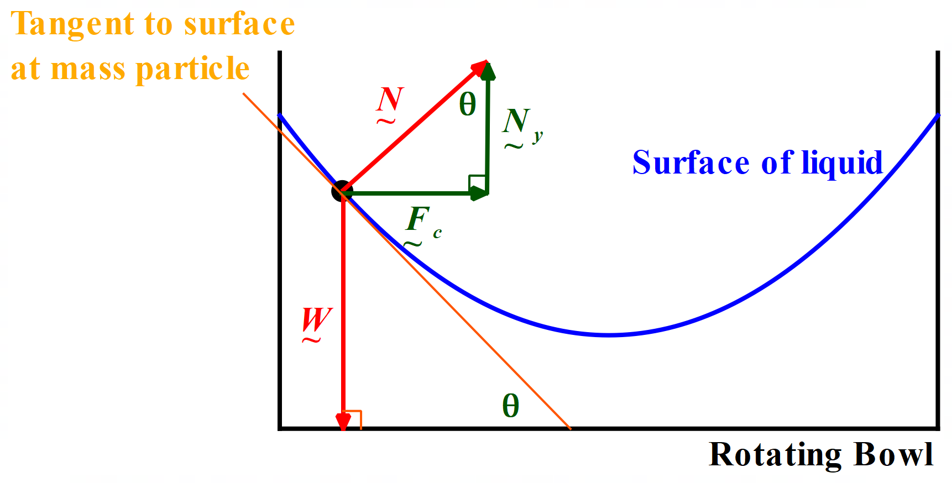

In the diagram above, I have selected one particle of water of mass, m, in the surface, near the edge of the bowl. I have given myself room away from the wall of the bowl so that my diagram is not too cluttered. Realistically my mass point would be extremely close to the wall, even touching the wall.
I have drawn in the two forces acting: the normal force to the surface, N, and the weight force, W, acting on the particle. To draw the normal force, I first drew the tangent to the surface at the mass particle. The angle θ between the tangent and the horizontal is the angle we are trying to calculate.
Next, we resolve the normal force into two rectangular components. The horizontal component supplies the necessary centripetal force to keep the particle in circular motion. The vertical component supplies the force upwards that balances the weight force downwards acting on the particle.
You should recognize that this situation is like the case we studied of objects moving on banked tracks.
Now we are ready to analyze the situation mathematically.

For a mass particle in the water surface near the edge of the bowl, the angular velocity is 100 rpm, and the radius of the circular path is 0.1 m.

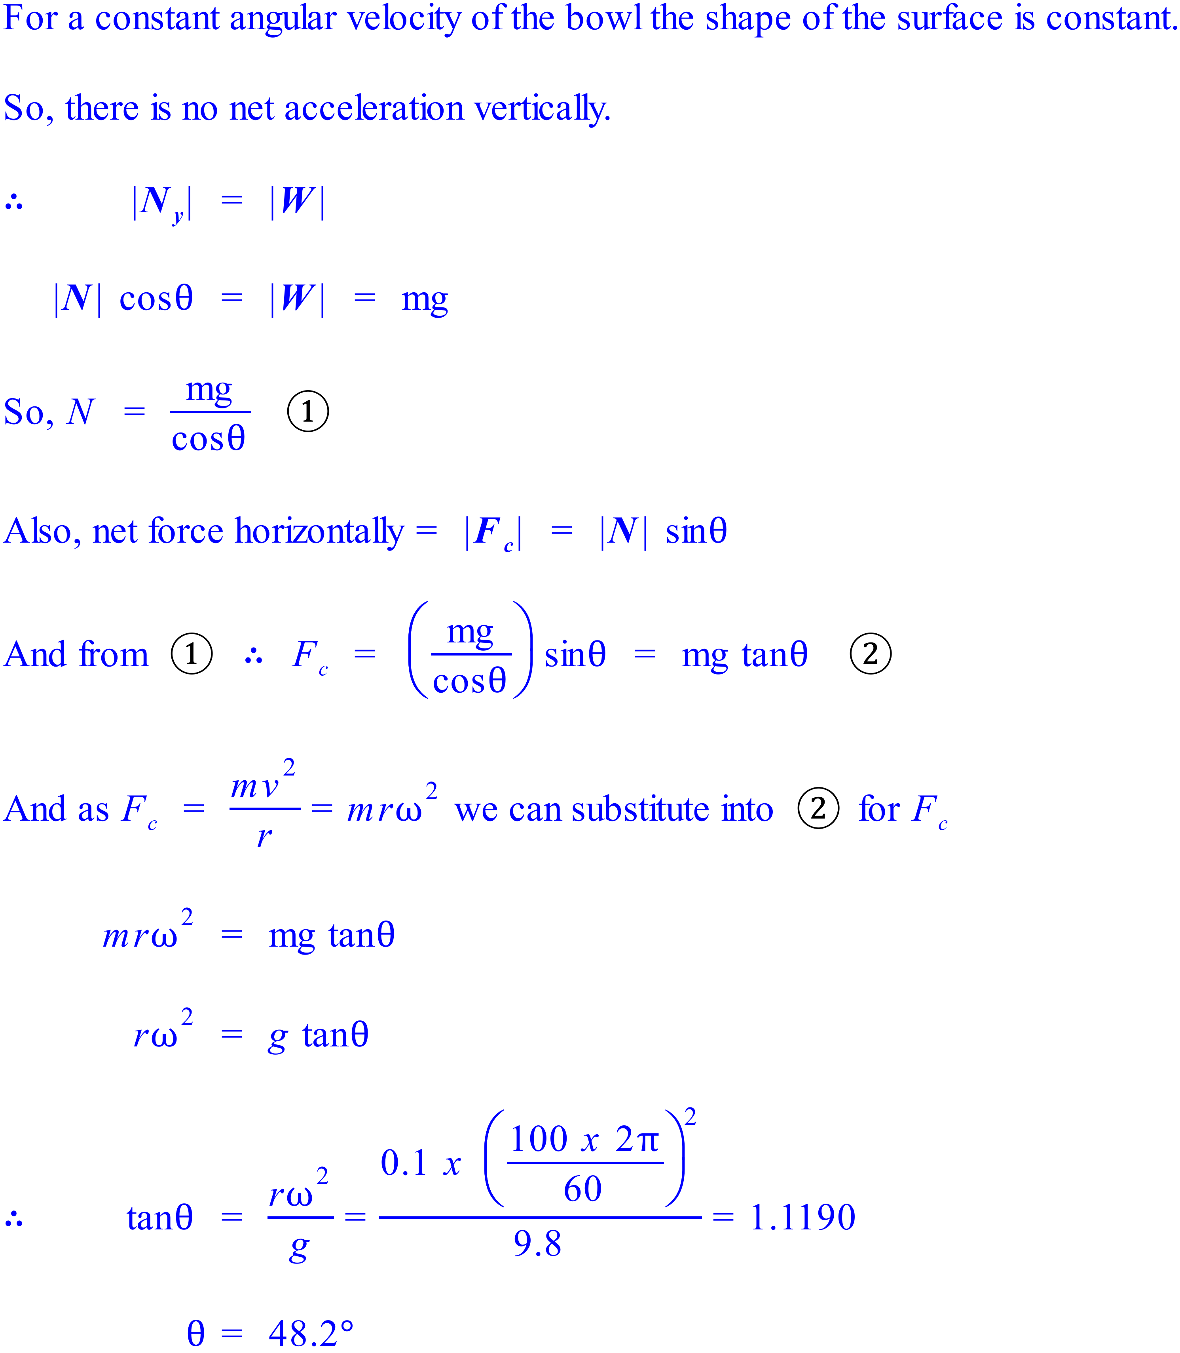

Thus, the water near the edge of the bowl makes an angle with the horizontal of 48°.

