PHYSICS COURSE 2005

9.7 ASTROPHYSICS

INTRODUCTION:

Astrophysics is one of the most exciting fields of scientific research. It draws on knowledge, understanding and skills from almost every other branch of Physics. The wonders of the universe are revealed through technological advances based on tested principles of Physics. Our understanding of the cosmos draws upon models, theories and laws in our endeavour to seek explanations for the myriad of observations made by various instruments at many different wavelengths. Techniques such as imaging, photometry, astrometry and spectroscopy allow us to determine many of the properties and characteristics of celestial objects. Continual technical advancement has resulted in a range of devices extending from optical and radio telescopes on Earth to orbiting telescopes, such as Hipparcos, Chandra and the Hubble Space Telescope (HST).

Explanations for events in our spectacular universe based on our understandings of the electromagnetic spectrum, allow for insights into the relationships between star formation and evolution (supernovae), and extreme events such as the high gravity environments of a neutron star or black hole.

This module increases students’ understanding of the nature and practice of Physics and the implications of Physics for society and the environment.

NOTE: Numbers appearing in parentheses at the end of sentences or paragraphs refer to the references provided in the Bibliography at the end of these notes.

OBSERVATIONAL ASTRONOMY

A BRIEF HISTORICAL COMMENT
From time immemorial human beings have looked to the heavens in awe and tried to explain what they have seen. Observational astronomy or at least some rudimentary form of it, has played a part in many of our ancient cultures – Mesopotamia, Egypt, India, China, the Celts, the Mayans and the Aztecs to name a few. Modern astronomy is generally considered to have had its roots in the ancient Greek tradition of natural philosophy. It was the Greeks, through Pythagoras (550 BC) and others, who developed the mathematical approach to the study of the universe that has continued through to the present day. Socrates, Plato and Aristotle, the many great scholars of the Alexandrian period (300BC-200AD), the many great Islamic scholars of the 8th to 13th Centuries and people such as Nicolaus Copernicus (1474-1543AD), Tycho Brahe (1546-1601AD), Johannes Kepler (1571-1630AD), Galileo Galilei (1564-1642AD), Isaac Newton (1642-1717) and Albert Einstein (1879-1955) have been some of the huge number of people who have made great contributions to science and astronomy and thereby to our knowledge and understanding of the universe. (1 & 2)

GALILEO’S TELESCOPE

In 1609, Galileo Galilei, an Italian natural philosopher, changed the world of observational astronomy forever. After hearing of the basic principle of the telescope, Galileo built a telescope of his own that had a magnification of about 10. The potential of this instrument for military and commercial purposes so impressed the Venetian Senate that they funded the building of another larger telescope. This time Galileo constructed a telescope with an aperture of about 5 centimetres and a magnification of about 20. Galileo then used this telescope to make a series of astronomical observations that stunned the scientific world. (2)

By his own account, Galileo first observed the Moon on November 30 1609. He observed the large dark patches that can be observed with the naked eye. He also observed several smaller dark patches that could not be seen with the naked eye. Over several weeks of observations, he noted that in these smaller spots, the width of the dark lines defining the spots varied with the angle of solar illumination. He watched the dark lines change and he saw lighter spots in the unilluminated part of the Moon that gradually merged with the illuminated part as this part grew. The conclusion he drew was that the changing dark lines were shadows and that the lunar surface has mountains and valleys. Galileo also observed that the moon was not perfectly spherical in shape. (4) Also check out the following link: http://galileo.rice.edu/sci/observations/moon.html

Galileo’s use of the telescope to identify features of the moon was ground-braking science in several ways. Firstly, although Galileo was not the first person to study the heavens with a telescope, he was the first to do so in a systematic way and to record and interpret his observations and publish them for others to read. Secondly, Galileo demonstrated the usefulness of the telescope as an astronomical instrument that enhanced observation beyond what was possible with the unaided eye. In both of these ways he set an excellent example for other scientists to follow and earned the title of “the father of modern observational astronomy” (1).

Thirdly, Galileo’s assertion that there were features on the moon was a good example of the power of deductive reasoning from careful observation. Galileo could not see the mountains and valleys – his telescope was not that good. He deduced their presence from careful observation of the borders between the light and dark patches on the surface, eventually deciding that the dark lines were shadows and therefore that there had to be mountains and valleys in order for the shadows to be cast the way they were.

Fourthly, Galileo’s telescopic observations provided clear evidence that the Aristotelian view of the universe was inaccurate. Aristotelian doctrine stipulated that celestial bodies were perfectly smooth and spherical. Clearly, this was not true for the moon and so the Aristotelian doctrine needed some amendment. Further, since the moon had features, clearly the Earth was not unique in this respect and perhaps other heavenly bodies would also be found to have features. Further still, if heavenly bodies could have features and therefore be imperfect, perhaps the Earth is a heavenly body too.
Galileo made many other observations with the aid of telescopes. References 1, 2 & 3 give good accounts of these.

A BRIEF NOTE ON TELESCOPES

Telescopes are devices that help astronomers overcome the limitations of the human eye. Since Galileo’s day, telescopes have become essential instruments in the study of astronomy. Large telescopes can make images that are far brighter, sharper and more detailed than the images made by our eyes. Telescopes have also been developed that can observe the universe at wavelengths outside the visible range. Our present comments, however, will be restricted to optical telescopes, the most commonly used of all telescopes.

There are two basic types of optical telescope – the refracting and the reflecting. Although the current Syllabus does not require you to know specific details about these telescopes, it is essential for any student of astronomy to have at least a rudimentary understanding of these very important instruments. Therefore, we shall examine each very briefly here.

THE REFRACTING TELESCOPE

A convex lens is one that is fatter in the middle than at the ends. When light rays pass through the lens, refraction causes the rays to converge to a point called the focus. If the light rays entering the lens are all parallel, the focus occurs at a special point called the focal point of the lens. The distance from the lens to the focal point is called the focal length of the lens. Since the light coming from astronomical objects is coming from so far away, the light rays are essentially parallel. So when light from an astronomical object is allowed to enter a convex lens, it is brought to a focus at the focal point. Objects with a small angular size (eg a star) produce an image that is just a single bright dot. Objects of large angular size (eg the moon) produce an extended image that lies in the focal plane of the lens.

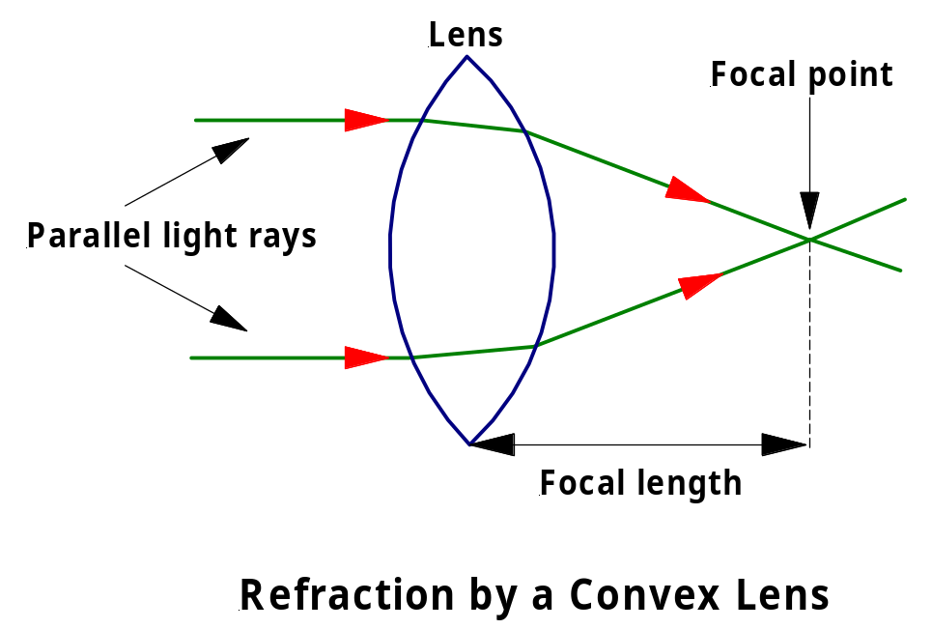

A refracting astronomical telescope consists of a large diameter, long focal length, convex objective lens at the front of the telescope and a small, short focal length, convex eyepiece lens at the rear of the telescope. The objective lens forms the image and the eyepiece lens magnifies this image for the observer. See the diagram below.

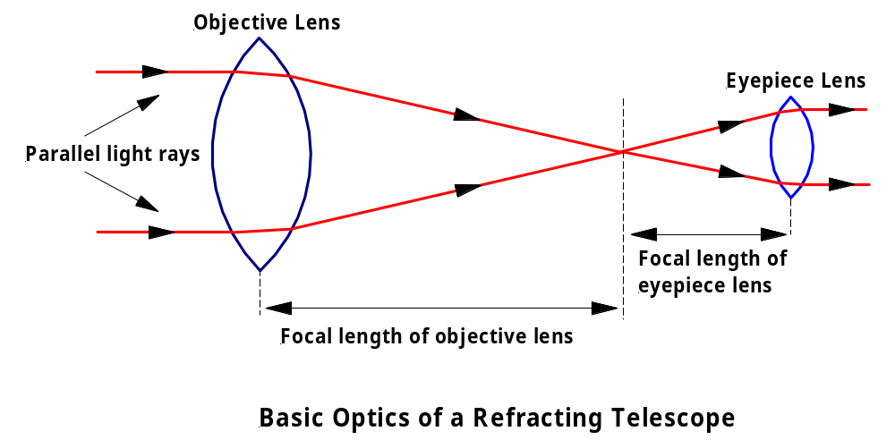

Refractors are considered ideal for observing the fine, low-contrast details of the moon and planets. They are really not appropriate for observing stars due to their susceptibility to chromatic aberration – a lens refracts different wavelengths by different amounts and so each colour ends up with a different focal point. The result is that stars appear surrounded by fuzzy rainbow-coloured halos. This aberration can be corrected but it is expensive to do so. The main use for refractors today is by amateur astronomers. For numerous reasons, professional astronomers today prefer reflecting telescopes. (1 & 3)

THE REFLECTING TELESCOPE

A concave mirror has a shape as shown in the following diagram. It causes parallel light rays to converge to a focus. The distance between the reflecting surface of the mirror and the focal plane is the focal length of the mirror.

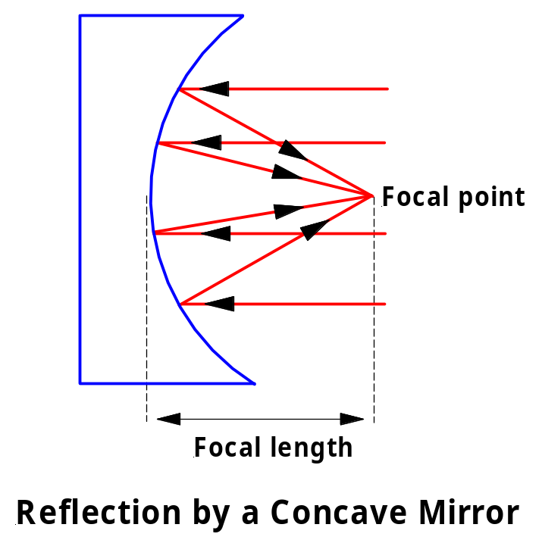

A reflecting astronomical telescope uses either a parabolic or spherical concave mirror as the objective or primary mirror. This produces the image of the object being viewed. How the observer then views this image depends on the exact design of the reflecting telescope.

There are many different reflector designs. The one shown below is called a Newtonian Reflector after Isaac Newton who designed it. This is in common use by amateur astronomers. A small flat mirror is placed at a 45º angle in front of the focal point. This secondary mirror deflects the light rays into an eyepiece lens at the side of the telescope, where the image of the object can be viewed. Other popular designs include: the prime-focus, where an observer or detector is placed at the focal point inside the barrel of the telescope; the Cassegrain focus, where a hole is made in the centre of the primary mirror and a convex secondary mirror is placed in front of the original focal point to reflect light back through the hole; and the coude focus, in which a series of mirrors reflects the light rays away from the telescope to a remote focal point in a coude room (special laboratory) located below the telescope. Both amateur and professional astronomers use the Cassegrain design while almost exclusively it is professional astronomers who use the prime-focus and coude designs. (1 & 3)

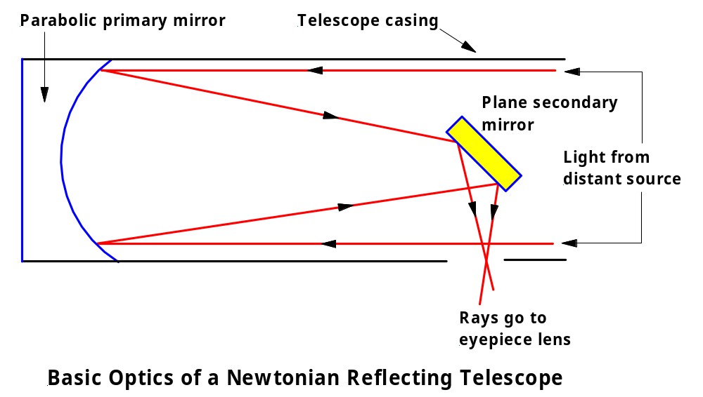

There are many good websites that give details of the different kinds of telescope designs that are available. One that I can suggest is:

http://www.skywatchertelescope.net/EducationTBOD.html

See my Useful Links page for other telescope links.

SENSITIVITY AND RESOLUTION

Many people believe that the main purpose of a telescope is to magnify the object being viewed. In fact, the two main purposes of any kind of telescope are to gather light from faint sources and to resolve those sources clearly. Let us now examine the meaning of the two terms “sensitivity” and “resolution”.

The sensitivity of a detecting system is a measure of the weakest signal discernable by the system (5). So, for an optical telescope, the sensitivity is defined as the light-gathering power of the telescope. The light-gathering power is dependant upon the light-collecting area of the lens or mirror used as the objective. Mathematically, then, the sensitivity of an optical telescope is directly proportional to the square of the lens or mirror diameter. (3)

For example, a human eye that is fully adapted to the dark has a pupil diameter of about 5 mm. By comparison, each of the two Keck telescopes on Mauna Kea, Hawaii, uses a concave mirror of 10 m diameter to collect light. Thus, the ratio of the sensitivity of the Keck telescopes to that of the human eye is (10 000 mm)²/ (5 mm)². That is, the Keck telescopes are 4 million times more sensitive than the human eye.

Clearly, the bigger the telescope, the better the sensitivity (all other things being equal). Astronomers often refer to the light bucket of a telescope. The bigger the bucket, the more light it can hold and the more sensitive the telescope.

The angular (or optical) resolution of a telescope gauges how well fine details can be seen. By definition the angular resolution of a telescope is the minimum angular separation between two equal point sources such that they can be just barely distinguished as separate sources. In simpler language, the angular resolution of a telescope is an angle that indicates the sharpness of the telescope’s image. The smaller the angle, the finer the details that can be seen and the sharper the image. (3)

Note that the term “resolving power” can be used interchangeably with the term “resolution”.

It is worth considering for a moment why there is a limit to the angular resolution we can achieve, even in perfect viewing conditions. When a beam of light passes through a circular aperture such as a telescope it tends to spread out, blurring the image. This phenomenon is called diffraction, as you should remember from the Preliminary Course. The diffraction pattern of a point source of light as seen through a circular aperture is as shown below.

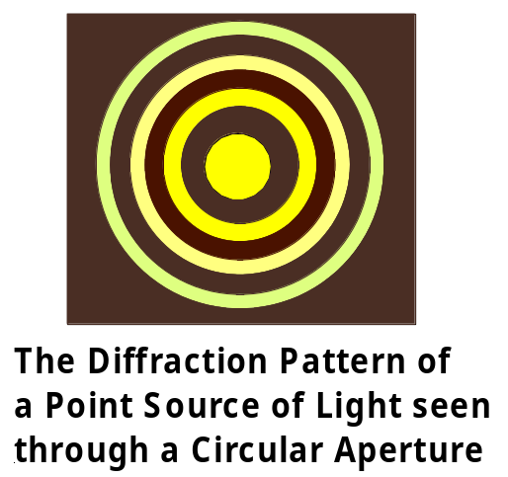

The central bright spot is known as the Airy disk. The maxima (bright bands) become fainter very quickly as you move outward from the centre. If we view two point sources of light (two stars) whose angular separation is greater than the angular resolution of the telescope, the sources can easily be distinguished. (1)

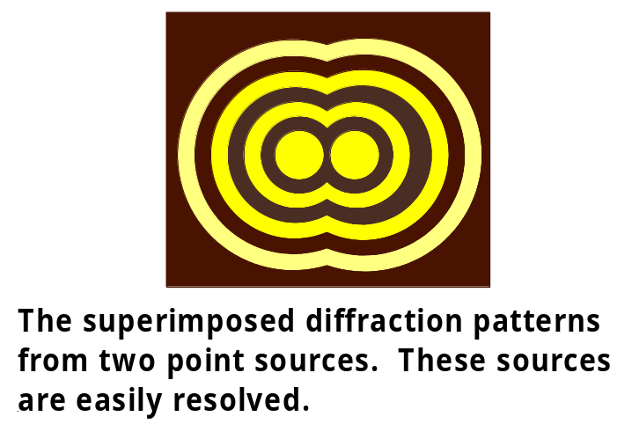

If we view two point sources of light whose angular separation is equal to the angular resolution of the telescope, the two sources can only just be distinguished as separate. If the sources were any closer together, the telescope image would show them as a single source. By definition, two images are said to be unresolved when the central maximum of one pattern falls inside the location of the first minimum of the other. (1)

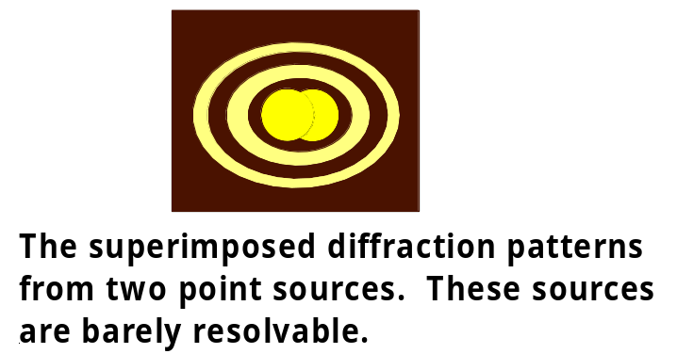

Mathematically, the angular resolution of a telescope can be expressed as:

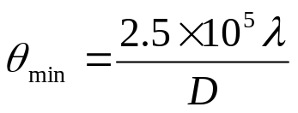

where θ_{min} = the diffraction-limited angular resolution in arcseconds, λ = wavelength of light in metres and D = diameter of telescope objective in metres. Remember that 1º = 60’= 60 arcminutes and 1’= 60” = 60 arcseconds. (3)

The angular resolution can also be expressed in terms of radian measure as:

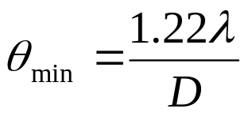

where the only difference is that θ_{min} is expressed in radians. (1)

Clearly, the larger the diameter, D, of the objective, the more sensitive the telescope (ie the larger D²) & the better the resolution (ie the smaller θ_{min}). Resolution is also better when observing shorter rather than longer wavelengths.

Exercise: Calculate the optical resolution in arcseconds of the 3.9 m Anglo-Australian Telescope at Siding Springs when observing starlight of wavelength 540 nm. (Answer: 0.035”)

PROBLEMS WITH GROUND-BASED ASTRONOMY

There are many problems associated with ground-based astronomy. The main problems concern atmospheric distortion and the resolution and absorption of radiation.

EFFECT OF ATMOSPHERIC DISTORTION ON RESOLUTION

It may appear from the equations for angular resolution given above that the resolution can be improved without limit by simply making bigger and bigger telescopes. Unfortunately, this is not true. In practice, the turbulent nature of the atmosphere places a limit on an optical telescope’s resolving power. Local changes in atmospheric temperature and density over small distances create regions where light is refracted in nearly random directions, causing the image of a point source to become blurred. The image appears to undergo rapid changes in brightness and position, a phenomenon known as scintillation. Since almost all stars appear as point sources, even through the largest telescopes, atmospheric turbulence produces the well-known “twinkling” of stars. (1 & 5)

A measure of the limit that atmospheric turbulence places on the resolution of a telescope is called the “seeing disk”. This disk is the angular diameter of the star’s image broadened by turbulence. Astronomers refer to the seeing conditions at a particular observatory on a particular night, since seeing conditions depend on the existing atmospheric conditions. Some of the very best seeing conditions in the world are found at the observatories on top of Mauna Kea in Hawaii, where the seeing disk is often as small as 0.5 arcseconds. (3) Kitt Peak National Observatory near Tucson, Arizona, USA and Cerro-Tololo Inter-American Observatory in Chile are also well known for their excellent seeing conditions (1). Many optical telescopes have been built at both locations (1). In general, most earth-based optical telescopes are limited by seeing to a resolution of no better than 1”, regardless of their theoretical “diffraction limited” resolution (1).

As an aside, it is interesting to note that since the angular size of most planets is actually larger than the scale of atmospheric turbulence, distortions tend to be averaged out over the size of the image and the twinkling effect is removed (1). So, stars twinkle and most planets do not.

ABSORPTION IN THE ATMOSPHERE

Electromagnetic (EM) radiation of all kinds reaches Earth’s upper atmosphere from the universe beyond. Astronomers are keenly interested in examining all this EM radiation, since every bit of it contains information that may help answer some of our questions about the universe. Clearly, then, we have a problem. As you should remember from “The World Communicates” topic in the Preliminary Course, the ability of EM radiation to penetrate Earth’s atmosphere is related to the wavelength of the radiation. EM radiation of different wavelengths is absorbed by different amounts in the atmosphere.

Oxygen and nitrogen completely absorb all radiation with wavelengths shorter than 290 nm. Ozone (O₃) for instance absorbs most of the ultraviolet. EM radiation beyond the near-ultraviolet (300-400 nm) never makes it to the ground. Water vapour and carbon dioxide effectively block out all radiation with wavelengths from about 10 μm to 1 cm. This makes ground observation of infrared radiation impossible with the exception of the near-infrared wavelengths from 1 to 10 μm.

Thus, of all the EM radiation that falls on earth from space, only the visible and radio (& microwave) bands, the near-infrared bands and the near-ultraviolet bands make it all the way to the ground without much absorption taking place on the way down. For all intents and purposes the far-infrared, far-UV, X-ray and gamma-ray wavebands of the EM spectrum are effectively filtered out by absorption in the atmosphere well before they reach the ground.

These wavebands then, are only detectable from space. To this end a number of telescopes have been placed in Earth orbit. The Infrared Astronomical Telescope (IRAS) launched in 1983 and the Infrared Space Observatory (ISO) launched in 1995 have both made valuable discoveries. IRAS for example found dust bands in our Solar System and around nearby stars and discovered distant galaxies, none of which was observable by ground-based optical telescopes. The Space Infrared Telescope Facility (SIRTF) is due for launch in August 2003 (SIRTF Website). During its 2.5-year mission, SIRTF will obtain images and spectra by detecting the infrared energy radiated by objects in space between wavelengths of 3 and 180 μm. Most of this infrared radiation is blocked by the Earth's atmosphere and cannot be observed from the ground. SIRTF will allow us to peer into regions of star formation, the centres of galaxies, and into newly forming planetary systems. Also, many molecules in space, including organic molecules, have their unique signatures in the infrared. Telescopes that observe in the far-ultraviolet, X-ray and gamma ray bands are also currently in operation. (3)

SCATTERING OF LIGHT IN THE ATMOSPHERE

Visible light is scattered in two different ways as it passes through the atmosphere. In Mie scattering, suspended dust particles with sizes similar to the wavelength of the light scatter light by reflection. In molecular or Rayleigh scattering, molecules of air (oxygen or nitrogen) with sizes much smaller than the wavelength of the light scatter light by absorption and re-radiation (5).

Both of these processes effectively decrease the intensity of the light coming from astronomical sources as it passes through the atmosphere. The second process is also responsible for the blue colour of the sky during the day, which effectively blocks our view of stars, planets and other astronomical objects in daytime (3).

OTHER PROBLEMS WITH RESOLUTION

Radio telescopes have angular resolution problems. These are not caused by atmospheric turbulence, as is the case for optical telescopes. The problem for radio telescopes is that angular resolution is directly proportional to the wavelength being observed. The longer the wavelength, the larger the angular resolution and the worse the image (3).

There is a practical limitation on the size of the objective lens for a ground-based refracting telescope. Since light must pass through the objective lens, it can only be supported at its edges. So, when the size and weight of the lens is increased, deformation of its shape occurs due to gravity (1). This affects the resolution of the image.

Be aware that there are other factors that can affect the resolution of lens and mirror systems but all of these can affect space-telescopes just as much as ground-based telescopes. Chromatic aberration in lenses was mentioned earlier. Spherical aberration, coma, astigmatism, curvature of field and distortion of field can occur with both lenses and mirrors (1). Lenses can suffer from defects in the material from which they are made and from deviations in the desired shape of their surfaces (1). All of these effects are compensated for when constructing telescopes.

IMPROVEMENTS IN RESOLUTION AND/OR SENSITIVITY OF GROUND-BASED SYSTEMS

Clever techniques have been developed to improve the resolution and/or sensitivity of ground-based observational systems. The techniques examined here are: active optics, adaptive optics and interferometry.

ACTIVE OPTICS

Deformations in the reflecting surface of a mirror reduce the quality of the image formed. For this reason, before the 1980’s, large diameter primary mirrors in reflecting telescopes had to be made very rigid and very thick, usually about one-sixth the diameter of the mirror. This prevented any change in shape of the mirror due to changes in the force of gravity acting on the mirror as it moved to different positions around the sky. Unfortunately, the resulting mirror was very heavy and took a long time to reach thermal equilibrium each night, reducing the resolution achievable and producing extraneous seeing effects. (6)

Since that time, however, primary mirrors have been made much thinner. The twin 8-metre diameter Gemini telescopes in Hawaii and Chile for example, have primary mirrors that are only 20 cm thick (6). Although these mirrors do change shape as the telescope changes its orientation and experiences changes of temperature, a system of active optics ensures that the image is of very high resolution. An “Active Optics” system is one that compensates for the deforming effects of gravity on a telescope’s mirrors, maintaining their surface accuracy and alignment (5).

As the telescope tracks across the sky, reference stars within the field of view are observed and analysed by an image analysis system to determine any distortions in the observed light wavefronts due to deformations in the primary mirror. A computer then calculates the necessary corrections in the shape of the mirror to eliminate these distortions. If these corrections are determined to be statistically reliable by the telescope operator, they are sent to an array of electromechanical actuators on the back of the primary mirror, which push or pull on a section of the primary to change its shape in the required way. Active optics systems correct the primary mirror shape about once per minute. (5, 6 & 7)

Note that the rapid image distortions due to atmospheric turbulence are ignored by the image analysis system used in active optics systems. Active optics systems are only employed to compensate for the various deformation effects in the telescope structure and the mirrors, and for effects due to inhomogeneities of the air temperature in the dome itself. (7)

The first telescope to use active optics was the 3.58 m New Technology Telescope (NTT) in Chile, which commenced operation in March 1989 (1). The instrument employs 75 adjustable pressure pads on the back of the primary to modify automatically the shape of the mirror when it is in different positions (1).

ADAPTIVE OPTICS

Images of astronomical objects are blurred and degraded by atmospheric turbulence. "Adaptive optics" is a technology for sharpening turbulence-degraded images, by using fast-moving, flexible mirrors to "unscramble" the optical distortion and thereby improve the angular resolution.

The key elements of an adaptive optics system are a wave-front sensor, an adaptive mirror, and a control computer, as shown in the diagram below. Let us talk through this diagram to explain how the system works.

An optical wavefront passing through air is distorted by turbulence. The light is collected by the telescope, and fed to the adaptive optics system.
The wave-front sensor measures the distortion, the control computer calculates the mirror shape needed to remove the distortion, and this correcting shape is applied to the adaptive mirror by a series of fast-acting actuators, to reconstruct the undistorted image. This procedure is repeated about 1000 times per second, to track the rapidly varying turbulence. It is this speed that is the major difference between adaptive and active optical systems.

In correcting the distorted image, the system uses as a reference either a real guide star in the field of view or an artificial guide star created by laser light backscattered off air molecules in the field of view. Images made with adaptive optics are almost as sharp as if the telescope were in the vacuum of space, where there is no atmospheric distortion and the only limit on angular resolution is diffraction. (1, 3 & 5)

The 3.6 m Canada-France-Hawaii Telescope (CFHT) at Mauna Kea Observatory, Hawaii, is an example of a telescope using an adaptive optics system.

Confusion sometimes arises over the difference between active optics and adaptive optics. Adaptive optics can correct for turbulence in the atmosphere by means of very fast corrections to the optics, whereas active optics only corrects for much slower variations. Thus, whereas adaptive optics (as on the CFHT) can reach the diffraction limit of the telescope, active optics (as on the NTT) only allows the telescope to reach the ambient seeing. (7)

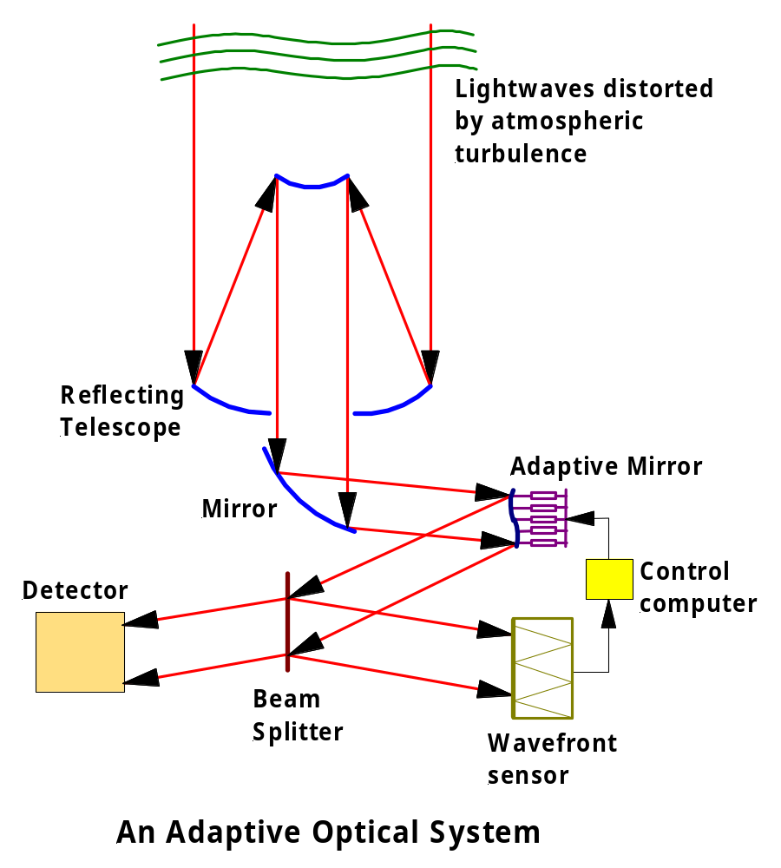

INTERFEROMETRY

As mentioned previously, since angular resolution is directly proportional to the wavelength being observed, radio telescopes have inherently poor angular resolution. Obviously, the resolution can be improved by increasing the diameter of the receiving dish but there is a practical limit to the size of an individual dish. The largest single radio dish in existence is the 300 m diameter dish at the Arecibo Observatory in Puerto Rico (1). The resolution of this radio telescope, when observing at a wavelength of say 21 cm is around 175”, compared to the 1” resolution achievable by optical telescopes.

A technique called interferometry has been used to greatly improve the resolution of radio telescopes. At its most simple, two radio telescopes separated by a large distance observe the same astronomical object. The signals from each telescope are then combined to produce an interference pattern, which can be analysed by computers to reveal details of the object. The effective angular resolution of two such radio telescopes is equivalent to that of one gigantic dish with a diameter equal to the baseline, or distance between the two telescopes. Two telescopes used in this way are called a radio interferometer. (1 & 3)

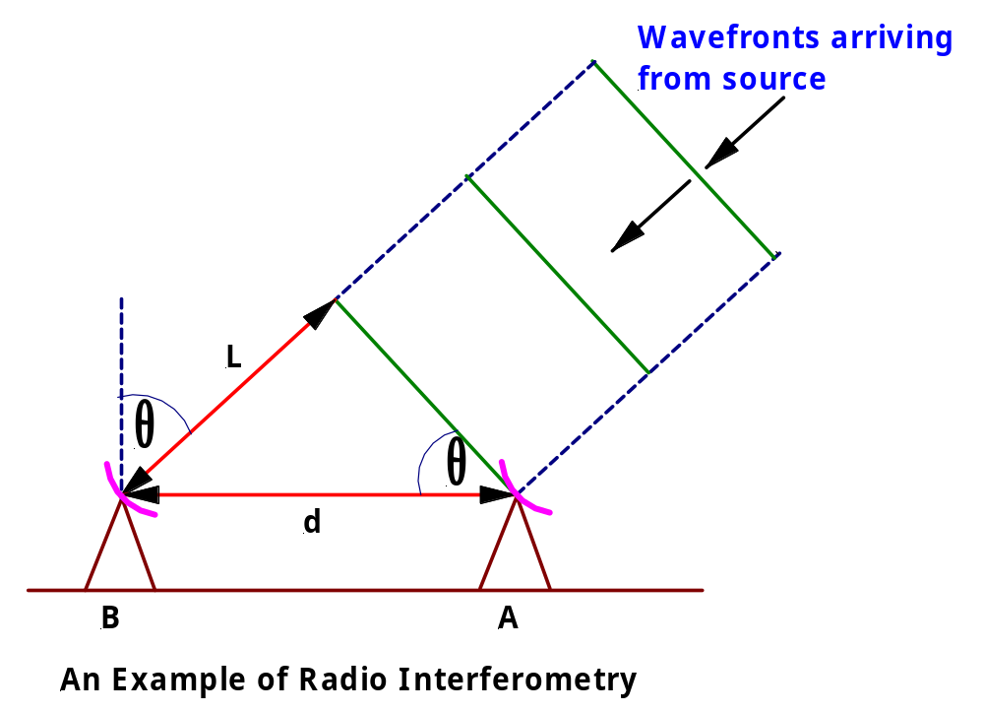

In the diagram above, θ is the pointing angle to the radio source being observed, L is the difference in distance travelled by the radio waves to each of the telescopes and d is the distance between the two telescopes, called the baseline. It can be shown mathematically (1) that:

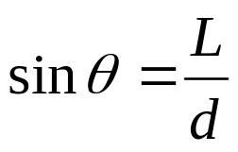

This equation allows the position of the source to be accurately determined using the interference pattern produced by combining the signals from the two telescopes. Obviously, increasing the distance between the telescopes improves the resolution. It is also true that the resolution can be improved by increasing the number of telescopes comprising the interferometer. (1)

The Very Large Array (VLA) located near Socorro, New Mexico, consists of 27 radio telescopes in a moveable “Y” configuration with a maximum configuration diameter of 36 km. Each individual dish has a diameter of 25 m and uses receivers sensitive at a variety of frequencies. The signal from each of the separate telescopes is combined with all of the others and analysed by computer to produce a high-resolution map of the sky. The resolution is comparable to that of the very best optical telescopes. The 27 telescopes combine to produce an effective collecting area that is 27 times greater than that of an individual telescope. (1 & 3)

To produce even higher resolution maps, a technique called very-long-baseline interferometry (VLBI) is used. The Very Long Baseline Array (VLBA) consists of ten 25 m dishes at different locations between Hawaii and the Caribbean. With VLBA, features smaller than 0.001 arcsec can be distinguished at radio wavelengths. This angular resolution is 100 times better than a large optical telescope with adaptive optics. Even better angular resolution can be obtained by adding radio telescopes in space to the array. (1 & 3)

Note that interferometry is also used with optical telescopes. The details of this will not be discussed here. Check out the following link if you like. It details the Very Large Telescope Project, which when completed will be the world’s largest optical telescope array.

http://www.eso.org/outreach/ut1fl/

Just as an aside, the 0.001 arcsec resolution mentioned above is equivalent to being able to distinguish the two headlights on a car located on the moon from the earth (3).

Exercises:

- Calculate the required diameter for a single radio dish to achieve an angular resolution of 1” when observing radio waves of wavelength 21 cm. (Answer: 52.5 km)
- The VLA has an effective diameter of 36 km. Calculate the angular resolution achieved when observing the shortest receivable wavelength of 7 mm. (Answer: 0.05 arcsec. Note that this compares well with optical telescopes in terms of theoretical resolution and in practical terms is actually better, since radio telescopes are not greatly affected by seeing. An angular resolution of 0.05 arcsec is sufficient to see a golf ball held by someone at a distance of roughly 125 km.)
- Determine the diameter of the single radio telescope dish required to achieve the same sensitivity as the VLA. (Answer: 130 m)

ASTROMETRY AND ASTRONOMICAL DISTANCES

There are several different units used in Astronomy to measure distance (3).

- The astronomical unit (AU) is the average distance between the earth and the sun. 1 AU = 1.496 x 10⁸ km. This is used primarily for distances within the Solar System.
- The light year (ly) is the distance travelled by light in one year.
1 ly = 9.46 x 10¹⁵ m = 9.46 x 10¹² km = 63 240 AU. This is used for distances to the stars.
- The parsec (parallax-second, symbol pc) is defined as the distance at which 1 AU perpendicular to the observer’s line of sight subtends an angle of 1 arcsec (1 second of arc). See the diagram below. 1 pc = 3.09 x 10¹³ km = 3.26 ly. This unit is used for distances to the stars.

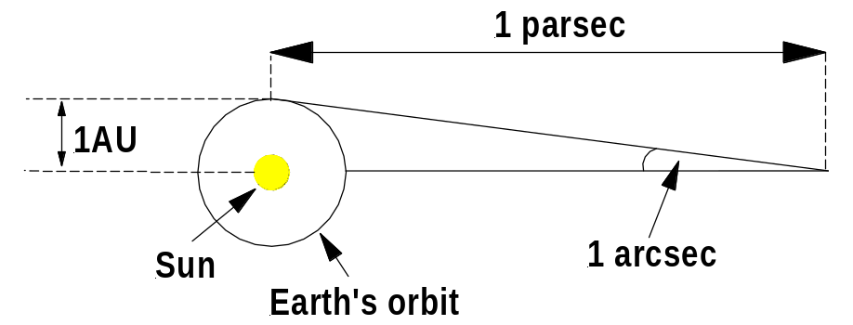

Astrometry is the science of the accurate measurement of the position and changes in position of celestial objects. The change in position of a celestial object can be due to either the real motion of the object itself or the motion of the Earth around its orbit, effectively shifting the point of observation.

As the point of observation shifts, a relatively nearby object appears to move against a set of more distant background objects. This apparent change in the position of a nearby object as seen against a distant background due to a change in position of the observer is called parallax.

The phenomenon of parallax gives rise to an effective method for measuring the distance to nearby astronomical objects. This method is called trigonometric parallax and is based on the method of triangulation used by surveyors. It works in the following way.

We know that the direction of a nearby star from the earth changes as the earth orbits the Sun. The nearby star appears to move against the background of more distant stars. This motion is called stellar parallax. Astronomers measure the parallax shift of the star from opposite sides of the earth’s orbit by making observations of the star six months apart. The parallax shift (or angle) p is half the angle through which the star’s apparent position shifts as the earth moves from one side of its orbit to the other (3). Since this is the maximum possible parallax shift for the star when observed from Earth, this particular parallax shift is often called the star’s annual parallax. See the diagram below.

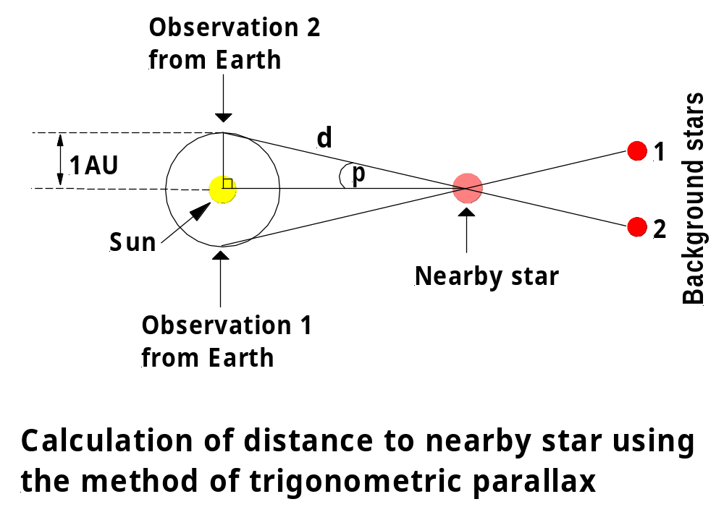

Clearly, then, by using a right-angled triangle, as shown above, the angle p is known as is the length of the side opposite this angle – the radius of the Earth’s orbit. Therefore the distance d to the nearby star can be calculated using trigonometry as follows:

sin p = radius of Earth’s orbit / d

Since, the angle p is very small, we can use the approximation sinθ = tanθ = θ for θ small, and hence we have that the distance, d, in parsecs, to the nearby star is given by:

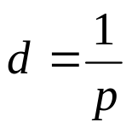

where p = parallax angle (annular parallax) of the star in arcseconds.

Clearly, the larger a star’s annual parallax, the closer the star is to Earth.

Note also that for objects within our own Solar System, it is possible to use trigonometric parallax, with the diameter of the Earth as the baseline to calculate distances to these objects. For such an object, observations of the object are made 12 hours apart to obtain the diurnal (or geocentric) parallax angle and then a similar procedure to that described above is used to determine the distance to the object.

EXERCISE: Barnard’s star has a parallax angle of 0.545 arcsec. Determine the distance from Earth to the star. (1.83 pc)

Limitations of Trigonometric Parallax Measurements

Measuring parallax angles from the ground is very difficult due mainly to the atmospheric blurring discussed earlier. Even with the very best optical telescopes in the world under excellent seeing conditions, parallaxes smaller than about 0.01 arcsec are extremely difficult to measure from the ground (3). Therefore, trigonometric parallax measurements used with ground-based telescopes can give fairly reliable distances only for stars nearer than about 1/0.01 = 100 pc.

In 1989 the European Space Agency (ESA) launched the satellite Hipparcos, an acronym for High Precision Parallax Collecting Satellite, in order to collect much more precise parallax measurements from the perfect seeing environment of space. In over four years of observations, Hipparcos measured the parallaxes of 118 000 stars with an accuracy of 0.001 arcsec. From the data collected, astronomers have been able to determine stellar distances by trigonometric parallax out to several hundred parsecs, and with much greater precision than was possible with ground-based observations (3).
Check out the link to the Hipparcos Web Site on my Useful Links page. There is also a link to the ESA’s GAIA project. This satellite is due to be launched in 2010 and will measure the parallaxes of about 1 billion stars (1% of our Milky Way Galaxy) down to an accuracy of 10 microarcsec, which is about 100 times more accurate than the Hipparcos data.

SPECTROSCOPY – A VITAL TOOL FOR ASTRONOMERS

Spectroscopy is the systematic study of spectra and spectral lines. Spectral lines are extremely important in astronomy, because they provide very reliable evidence about the chemical composition of distant objects, the temperature of objects, the density of objects and the motion through space of objects. Let us now examine the nature of spectra and how they can be used to obtain the information mentioned above.

SPECTRA

When a beam of sunlight is shone through a triangular glass prism, the white light is dispersed, producing a rainbow of colours, which can be displayed on a screen. The rainbow of colours is called a spectrum. In 1814 the German optician Joseph von Fraunhofer discovered that the spectrum of sunlight contains hundreds of fine dark lines, now called spectral lines. Fifty years later, chemists found that they could produce spectral lines in the laboratory and use these lines to analyze the kinds of atoms of which substances were made.

There are three basic types of spectrum: a continuous spectrum, an emission spectrum and an absorption spectrum. Let us now examine each in turn.

CONTINUOUS SPECTRUM

A hot, glowing solid or liquid or a hot, glowing, dense gas produces a spectrum consisting of a continuous series of coloured bands ranging from violet on one end to red on the other (1). In fact, this is just the visible section of the continuous spectrum of blackbody radiation, which we have previously studied in the Cosmic Engine & From Ideas to Implementation topics. Examples of objects that produce continuous spectra include: an incandescent light globe, the inner layers of a star and galaxies.

Recall that a blackbody is a hypothetical body that is a perfect absorber and emitter of electromagnetic radiation. At any temperature above absolute zero a blackbody emits as much energy as it absorbs. The emitted radiation has a continuous distribution of wavelengths and the intensity of the spectrum at any given wavelength depends only on the temperature of the surface of the body (3). A perfect blackbody does not reflect any light at all. This is the reason why any radiation that it emits is entirely due to its temperature (3).

The intensity (energy density) versus wavelength curves for blackbody radiation should by now be very familiar to you. You have copies of these curves in the notes for both the Cosmic Engine & From Ideas to Implementation topics, so they will not be repeated here. The point that does need to be made however is that there is a very close correlation between the theoretical blackbody curves and the observed intensity curves for most stars (3). Since the physics of blackbody radiation is well understood, this correlation allows a great deal of information about stars to be determined by studying their intensity versus wavelength curves. More on this later.

EMISSION SPECTRUM

This is a series of bright, coloured lines on a black background, produced by a hot, glowing, diffuse gas. For example, the spectrum of hydrogen when heated to incandescence by passing an electric discharge through the gas is a series of four spectral lines (violet, blue, green & red) seen on a black background. See diagram below. Other examples of objects producing emission spectra include: Wolf-Rayet stars, emission nebulae such as planetary nebulae and quasars (5).

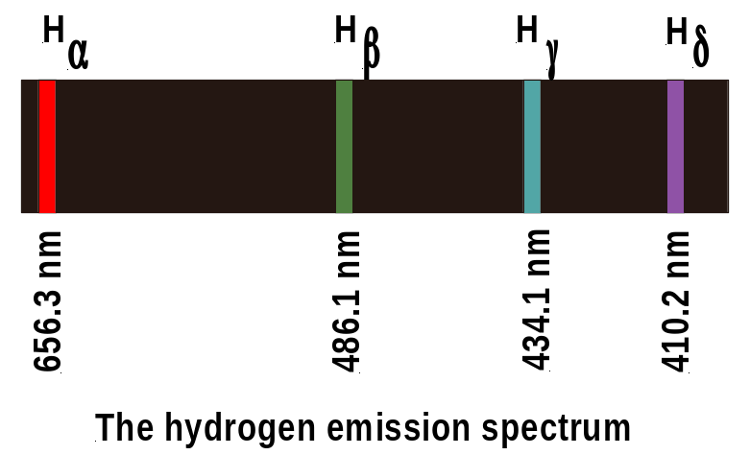

Note that the emission lines in the above diagram are not representative of the exact colour or line thickness of the real hydrogen emission lines. The line thickness varies, with red normally being the broadest line and violet the thinnest.

To account for the production of emission spectra it is convenient to refer to the model of the atom, proposed by Niels Bohr in 1913. In very brief summary Bohr’s model says that: (1) Electrons orbit a central positive, nucleus in certain allowed, circular, orbits called stationary states from which they do not radiate energy; and (2) Electrons only move from one state (orbit) to another by absorbing or emitting exactly the right amount of energy in the form of a photon, whose energy is equal to the difference in energy between the initial & final states, ΔE = hf (Planck’s formula).

It is the second point that concerns us here. This explains how atoms emit and absorb specific frequencies of electromagnetic radiation. An electron in its lowest energy state (called the ground state) can only jump to a higher energy state within the atom when it is given exactly the right amount of energy to do so by absorbing that energy from a photon of EM radiation of the right energy. Once the electron has jumped to the higher level, it will remain there only briefly. As it returns to its original lower energy level, it emits the energy that it originally absorbed in the form of a photon of EM radiation. The frequency of the energy emitted will have a particular value and will therefore be measured as a single emission line of particular frequency and therefore of particular colour if it is in the visible region of the EM spectrum.

In summary then, emission spectra are produced when electrons within an atom make downward transitions from higher to lower orbits. The energy lost by each electron is carried away by a single photon of set frequency and corresponds to a single spectral line in the emission spectrum (1). The visible Balmer series of hydrogen emission lines shown above is produced by electrons dropping from higher orbits to orbit n = 2.

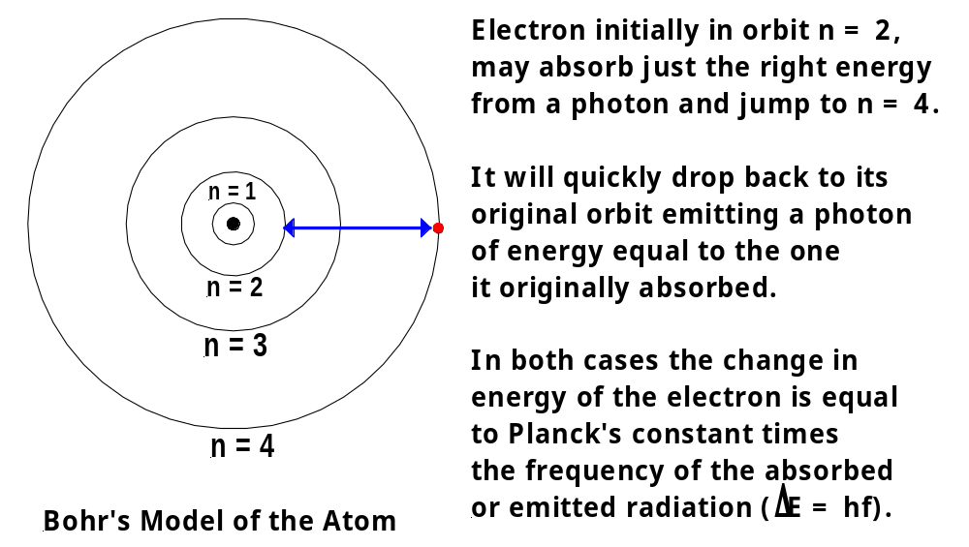

ABSORPTION SPECTRUM

This is a series of dark spectral lines among the colours of the continuous spectrum. These dark spectral lines represent wavelengths that are missing from an otherwise continuous spectrum. Absorption spectra are produced when light from a hot source of continuous spectrum passes through a cooler, non-luminous, diffuse gas. The spectra of normal cool stars such as the Sun fall into this category (5). Note that the dark lines in the absorption spectrum of a particular gas occur at exactly the same wavelengths as the bright lines in the emission spectrum of the same gas.

See the diagram of the hydrogen absorption spectrum shown below. Note that actual colours used in this diagram do not match exactly the colours in the real spectrum. Also, the transitions between colours in the real spectrum are nowhere near as sharp as those depicted in the diagram. The line thickness also varies in the real hydrogen absorption spectrum, with the alpha-line normally being the broadest and the delta-line being the thinnest.

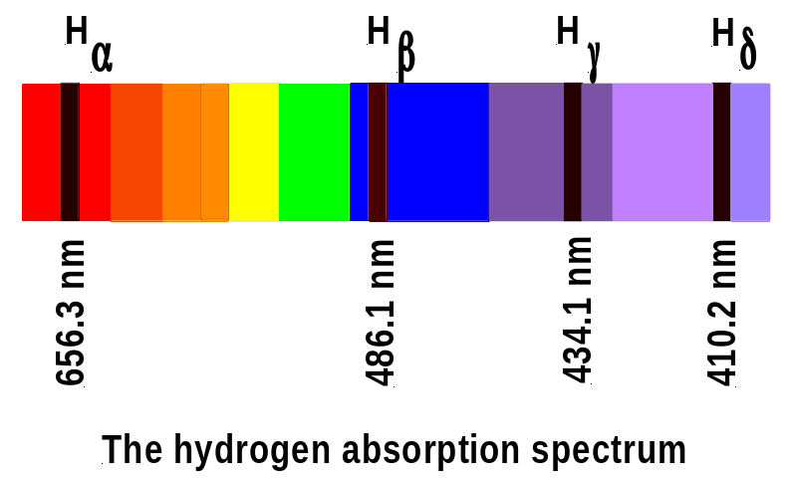

To account for the production of absorption spectra it is again convenient to refer to the Bohr Model of the Atom. Photons from the source of continuous spectrum (eg the Sun) pass through the cool diffuse gas (eg hydrogen) lying between the source and the observer on Earth. The atoms of the gas will absorb those photons whose energies match allowed energy transitions within the atom. The absorbed photons raise electrons within the atom from lower to higher orbits. When these electrons drop back to their original orbits, they emit the energy they originally absorbed but in all directions not just in the original direction of motion of the photons. Therefore these energies with their corresponding frequencies are effectively removed from the continuous spectrum observed on Earth and a series of black lines is seen in their place. The Balmer series of hydrogen absorption lines shown above is produced by atoms absorbing photons that cause electrons to jump from orbit n = 2 to higher orbits.

Try the following website. It allows you to call up the emission and absorption spectra for all the elements in the Periodic Table.

http://jersey.uoregon.edu/vlab/elements/Elements.html

It is also worth noting that although the Bohr Model of the Atom gives a good description of the emission and absorption spectra of hydrogen, a more advanced model is needed to do the same for other elements.

COMPARISON OF EMISSION & ABSORPTION SPECTRA WITH A CONTINUOUS BLACKBODY SPECTRUM

An emission spectrum is clearly very different to a blackbody spectrum. An emission spectrum is a line spectrum with each individual coloured line corresponding to a particular wavelength (or frequency) of emission. Between the lines there is darkness. The blackbody spectrum is a continuous spectrum of colours from red to violet in the visible range.

An absorption spectrum is much closer in appearance to a blackbody spectrum than is an emission spectrum. An absorption spectrum consists of an almost continuous background of colours from red to violet, with the continuity broken by black absorption lines representing wavelengths of radiation that have been absorbed somewhere between the source of radiation and the observer.

As mentioned earlier, a great deal of information about stars and other celestial objects can be obtained by comparing their spectra to blackbody spectra. For example by comparing the intensity versus wavelength curves for real stars with those of a blackbody we can determine the surface temperature of stars. By comparing a star’s absorption spectrum with a blackbody spectrum and noting the differences we can determine the chemical composition of the star.

MEASURING ASTRONOMICAL SPECTRA

The technology required to measure astronomical spectra is an instrument called the spectrograph. This is an optical device that is mounted at the focus of the telescope (3). Its purpose is to diffract light into a spectrum so that the intensity at each wavelength can be recorded by a detector. Spectrographs have been designed for use with various regions of the spectrum, with particular emphasis on the UV, visible and IR regions of the EM spectrum (5).

In a modern spectrograph, light from the telescope objective is focussed onto the entrance slits of the spectrograph. It is then collimated by a mirror to produce a parallel beam and directed onto a diffraction grating. A diffraction grating is a piece of glass onto which thousands of parallel, evenly spaced lines per millimetre have been ruled. The diffraction grating causes the light from the telescope objective to be diffracted into a spectrum by the way in which light waves leaving different parts of the grating interfere with one another. This spectrum is then passed through a corrector lens and focussed onto a charge-coupled device (CCD) that records the image. A CCD is a silicon chip containing an array of light sensitive diodes used for capturing images. The recorded spectrum is called a spectrogram. (1 & 5)

Older spectrographs used a prism to disperse the light and produce a spectrum in place of the diffraction grating. They also used photographic plates rather than CCD’s to record the spectrum (3).

If a photographic plate is used then the result is a spectrum similar to the examples of the hydrogen emission and absorption spectra shown earlier. If a CCD is used the spectrum produced is in the form of a graph of intensity versus wavelength, in which absorption lines appear as depressions on the graph and emission lines appear as peaks. (3)

STELLAR SPECTRA AND THEIR CLASSIFICATION

As astronomers made more and more observations of the absorption spectra of stars during the nineteenth century, they discovered a bewildering variety of different spectra. We know today that this is due to the fact that a star’s spectrum is profoundly affected by its surface temperature (3). Every element has a characteristic temperature range over which it produces prominent absorption lines in the observable part of the spectrum (3). For example, for the Balmer hydrogen lines to be prominent in a star’s spectrum, the star must be hot enough to excite the electrons out of the ground state but not so hot that all the hydrogen atoms become ionized. A stellar surface temperature of around 9000 K produces the strongest hydrogen lines. Different temperatures produce different degrees of excitation or ionization of the various atoms and molecules present in a star. This in turn produces different strength absorption lines (3).

To bring order to the huge variety of different spectra they had found, astronomers grouped stars into a number of spectral classes that summarize features such as colour, surface temperature and chemical composition. The order of these classes from highest to lowest temperature can be remembered using the mnemonic “Oh, Be A Fine Girl (or Guy), Kiss Me”. See the Table below which has been taken from Kaufmann & Freedman p.470 (3).

Spectral  Class | Colour | Temperature | Spectral Line Features | Examples
O | Blue-violet | 28000-50000 | Ionized atoms especially helium | Mintaka  (δ Orionis)
B | Blue-white | 10000-28000 | Neutral helium, some hydrogen | Rigel  (β Orionis)
A | White | 7500-10000 | Strong hydrogen, some ionized metals | Sirius  (α Canis Majoris)
F | Yellow-white | 6000-7500 | Hydrogen, ionized metals (Ca, Fe) | Canopus  (α Carinae)
G | Yellow | 5000-6000 | Both neutral & ionized metals, especially ionized Ca | Sun
K | Orange | 3500-5000 | Neutral metals | Aldebaran  (α Tauri)
M | Red-orange | 2500-3500 | Strong titanium oxide & some neutral Ca | Antares  (α Scorpii)

Note that astronomers use the term “metals” to refer to any element above helium in the Periodic Table (3). Clearly, this is different to the term’s meaning in chemistry.

Each spectral class is further sub-divided into finer steps called spectral types. These are indicated by adding a number from 0 to 9 after the appropriate letter for the spectral class. The “0” is the hottest spectral type and the “9” is the coldest. So we have for example, the spectral class F, which includes spectral types F0, F1, F2, ….. F9.

The modern stellar classification system also includes a luminosity class, which indicates for example, whether a star is a supergiant, giant or dwarf. This is useful, since luminosity can vary widely within a spectral type. See the H-R plot below and Ref.(1) pp.246-250 for more detail.

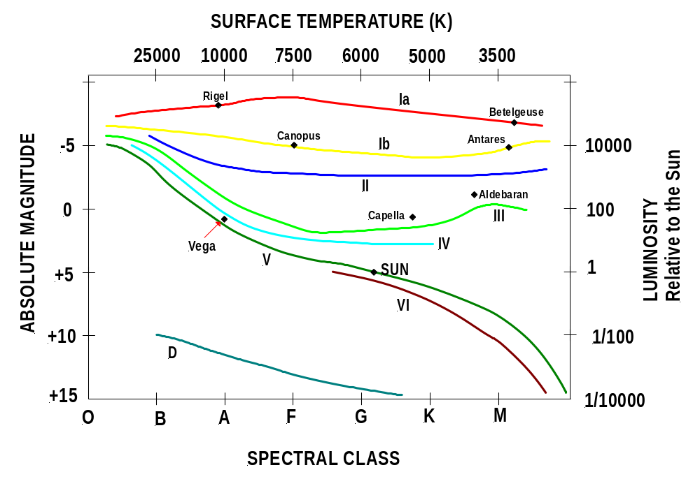

Luminosity classes Ia and Ib are composed of Bright Super Giant stars and Super Giant stars respectively. Luminosity class V includes all main sequence stars. The classes in between provide a useful means of distinguishing giant stars of various luminosities – Class II Bright Giant stars, Class III Giant stars and Class IV Subgiant stars. Class VI consists of Subdwarf stars. There is no luminosity class assigned to white dwarfs, since they represent a final stage in stellar evolution in which no thermonuclear reactions are taking place. Consequently, white dwarfs are referred to only by the letter D (for dwarf). (1 & 3)

On an H-R diagram astronomers describe stars by giving both a spectral class and a luminosity class. The spectral class indicates the star’s surface temperature and the luminosity class its luminosity. For instance, Aldebaran is a K5 III star, which means that it is a red giant with a luminosity around 500 times that of the sun and a surface temperature of about 4000 K. The sun is a G2 V star, which means that it is a main sequence star of luminosity equal to the sun (obviously) and surface temperature of about 5800 K. (3)

This two-dimensional classification scheme enables astronomers to locate a star’s position on the H-R diagram based entirely on the appearance of its spectrum. This is very useful, since once the star’s absolute magnitude has been read from the vertical axis of the H-R diagram, the distance to the star can be calculated using a method called spectroscopic parallax as we shall see later (1).

APPLICATIONS OF STELLAR SPECTRA

Stellar spectra can be used to deduce information about the temperature, chemical composition, density and rotational and translational velocity of stars.

TEMPERATURE

Using a modern spectrograph to record the absorption spectrum of the star in question, a plot of intensity versus wavelength can be obtained for the star. The wavelength, λ_{max}, at which the energy output of the star is a maximum, can then be determined and Wien’s Displacement Law used to calculate the temperature of the star.

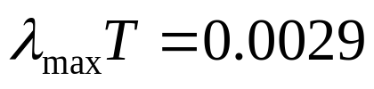

This measurement would also suggest the spectral class and composition of the star – see the Table above.

CHEMICAL COMPOSITION

Each element produces its own unique pattern of spectral lines (3). To identify the elements present in the outer layers of a star astronomers scan the absorption spectrum for that star for the unique patterns of spectral lines that correspond to particular elements. Thus, by analysing a star’s spectrum an astronomer can determine the star’s chemical composition. (3)

DENSITY

To determine the abundance or number densities of the atoms of elements present in a star, astronomers examine the line strengths of each spectral line. This is done from an intensity versus wavelength plot of the star’s absorption spectrum. Such a plot allows astronomers to study the shapes of individual spectral lines. Basically, the line strength of a spectral line depends on the number of atoms in the star’s atmosphere capable of absorbing the wavelength in question. For a given temperature, the more atoms there are, the stronger and broader the spectral line appears. This effect is called pressure broadening – the greater the atmospheric density and pressure, the greater the broadening of the spectral lines. So, by careful analysis of the star’s spectrum, an astronomer can determine the number density of atoms of a particular element in the star’s atmosphere. (1 & 3)

Note that pressure broadening is responsible for the differences observed in spectral line widths between supergiant stars and main sequence stars like the Sun. The narrower lines observed for the more luminous supergiant stars are due to lower number densities in their extended atmospheres. Pressure broadening broadens the lines formed in the denser atmospheres of the main sequence stars, where collisions between atoms occur more frequently. (1)

More specific detail on determining elemental abundances from stellar spectra is available in Ref (1) pp.293-306 and Ref (3) pp.471-472. Most of this is way beyond the scope of the current Syllabus.

THE DOPPLER EFFECT

Before looking at the velocity information that is contained in stellar spectra, it is necessary to understand the Doppler Effect. This is the apparent change in the wavelength or frequency of a light wave when there is relative motion between the observer and the source of light. Imagine that a source, S, of light waves is moving to the right as shown in the following diagram:

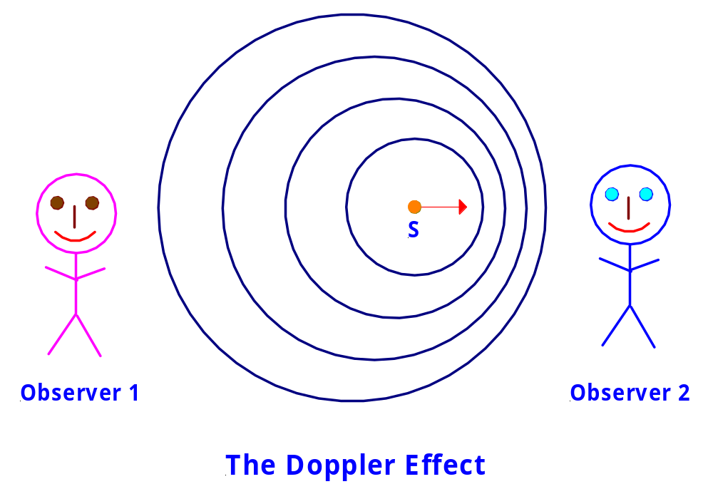

The circles represent the crests of light waves emitted from various positions as the source moves along. Notice that as the source moves, the light waves emitted become crowded together in front of the source and spread out behind the source. Hence, Observer 2 sees more wavelengths reach her in a set time period than would be the case if the source were stationary. So, Observer 2 sees a higher frequency and shorter wavelength than if the source were stationary. This means that the light seen by Observer 2 is bluer in colour than if the source were stationary. So, the spectrum of light from an approaching source is blue shifted, that is all lines in the spectrum are shifted towards the short wavelength (blue) end of the spectrum.

By a similar argument Observer 1 sees a lower frequency and longer wavelength for the light than would be the case if the source were stationary. This means that the light seen by Observer 1 is redder in colour than if the source were stationary. So, the spectrum of light from a receding source is red shifted, that is all lines in the spectrum are shifted towards the long wavelength (red) end of the spectrum.

Note that motion perpendicular to the observer’s line of sight does not affect the wavelength. Also, be aware that there is a mathematical formalism associated with the Doppler Effect that enables velocities of recession or approach to be calculated for sources of light from the observed wavelength shifts. This is beyond the scope of the current syllabus. Details can be found in many texts – eg Ref (3) pp.124-125.

TRANSLATIONAL VELOCITY

Stars can move through space in any direction. To calculate the translational velocity of a star through space (called its space velocity) astronomers measure two quantities. Consider the following diagram as you read on.

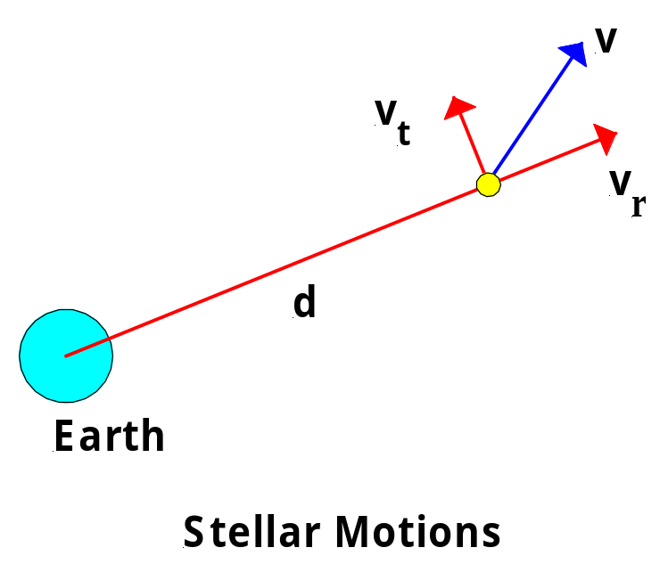
Firstly, astronomers determine the star’s radial velocity v_{r} parallel to our line of sight. This is calculated from measurements of the Doppler shifts of the star’s spectral lines. Secondly, astronomers determine the star’s tangential velocity v_{t} perpendicular to our line of sight – that is across the plane of the sky. This is calculated from knowledge of the distance, d, to the star and the star’s proper motion, which is the number of arcseconds the star appears to move per year on the celestial sphere. (3)

Once the radial and tangential components of the star’s motion are known, the star’s space velocity v can be calculated by simple addition of vectors (3). Note that the space velocity of a star is by definition its velocity relative to the Sun (5). To calculate an accurate value for this, the component of the Earth’s velocity around the Sun that is parallel to our line of sight to the star must be subtracted from the star’s measured radial velocity (1).

ROTATIONAL VELOCITY

To measure the rotational velocity of a star it is first necessary to obtain an intensity versus wavelength plot of the star’s spectrum. As mentioned previously, this enables astronomers to study the shapes of individual spectral lines.

If a star is rotating, light from the side approaching us is slightly blue shifted, while light from the receding side is slightly red shifted. As a result, the star’s spectral lines are broadened in a characteristic fashion. By measuring the shape of the spectral lines astronomers can calculate the speed of rotation of the star.

A different case of rotation involves binary star systems. Where two stars in a binary system have their orbital plane edge on to our line of sight, their speeds of rotation about the centre of mass of the system can be determined from their spectra using the Doppler Effect. As the two stars move around they periodically approach and recede from us. Hence, the spectral lines of the two stars will be alternately blue shifted and red shifted. From the Doppler shifts, the velocities of approach and recession can be calculated and then used to calculate the orbital period and velocities of rotation of the two stars about the centre of mass of the system.

PHOTOMETRY & PHOTOMETRIC METHODS

A photometer is an instrument capable of measuring the brightness of a light source. In astronomy, photometry is the measurement of the apparent brightness of stars and other astronomical objects (3). From such measurements distances to astronomical objects and the luminosities of those objects relative to some standard object (such as the Sun) can be determined. We will focus on the use of photometry to determine the distance to astronomical objects.

APPARENT MAGNITUDE

In Astronomy the magnitude scale is used to denote brightness. Hipparchus invented the scale in the second century BC and modifications over time, especially in the nineteenth century AD, have produced what we now call the Apparent Magnitude Scale. Apparent magnitude is a measure of the light arriving at earth and is directly related to apparent brightness. Apparent magnitude describes how bright an object appears to be when seen by an observer on earth (3). It is dependant on the distance to the object and the luminosity of the object, as well as on the presence of interstellar dust etc, which can make an object appear dimmer than it otherwise would be. Apparent magnitude can be measured either photographically or photoelectrically.

Hipparchus originally defined the brightest stars he could see with his naked eye as first magnitude stars. Stars about half as bright were called second magnitude and son down to sixth magnitude stars, which were the dimmest stars Hipparchus could see with his naked eye. With the invention of telescopes the scale had to be extended to take account of the much dimmer stars that could then be seen. Also, as time went by stars even brighter than first magnitude were discovered. So, Sirius, the brightest star in the night sky, ended up with an apparent magnitude of minus 1.43 (– 1.43).

Be aware that when reading apparent magnitudes, the greater the apparent magnitude, the dimmer the star. A star of apparent magnitude +2 (a second magnitude star) is dimmer than a star of apparent magnitude +1 (a first magnitude star). The limit of vision with the naked eye is about apparent magnitude +6. The Hubble Space Telescope can photograph stars of apparent magnitude +27 (more than 10²⁰ times fainter than the sun) using very long exposure photography. The Sun has an apparent magnitude of minus 26.8 (–26.8).

In the nineteenth century more accurate measurements of the light energy arriving from stars revealed that a first magnitude star is actually about 100 times brighter than a sixth magnitude star. In 1856, this led the English astronomer, Norman Pogson (1829-91), to define the apparent magnitude scale more precisely (5).

Pogson defined that a magnitude difference of 5 corresponds exactly to a factor of 100 in brightness. Therefore, a magnitude difference of 1 will correspond to a factor of (100)^{1/5} = 2.512 in brightness, since each change by 1 in magnitude must correspond to the same relative change in observed brightness (5). So, the factor by which brightness changes each time the magnitude changes by 1 must by definition multiply itself 5 times and give a result of 100. That is 2.512 x 2.512 x 2.512 x 2.512 x 2.512 = 100.

A useful formula for calculating the brightness ratio of any two stars A and B is:

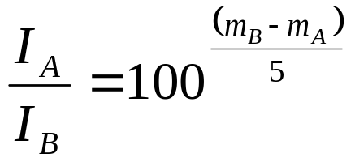
where m_{A} = apparent magnitude of Star A (the brighter star), m_{B} = apparent magnitude of Star B (the dimmer star) and (I_{A} / I_{B}) = brightness ratio of the two stars.

Example Questions

- The Sun is the brightest object in our sky with an apparent magnitude of –26.8. The giant star Canopus (Alpha Carinae) lying 310 light years (ly) from earth is the second brightest star in the night sky. Canopus has an apparent magnitude of –0.74. How much brighter does the Sun appear than Canopus? (Answer: The Sun appears 2.7 x 10¹⁰ times brighter than Canopus.)
- Sirius (Alpha Ursae Majoris) lying 8.6 ly from earth is the brightest star in the night sky with an apparent magnitude of –1.43. How much brighter than Canopus is Sirius? (Answer: Sirius is about 1.9 times brighter than Canopus.)
- Algol is a star with apparent magnitude 2.1. Given that the brightness ratio of Algol compared to Proxima Centauri, the closest star to earth, is 3600, determine the apparent magnitude of Proxima Centauri. (Hint: You may need some help with logs from your Teacher.) (Answer: 11)

ABSOLUTE MAGNITUDE

The absolute magnitude of a star is defined as the apparent magnitude the star would have if it were located 10 parsecs (32.6 ly) from earth (3). This quantity measures a star’s true energy output – its luminosity. Again, the greater the absolute magnitude figure, the less luminous is the star.

Absolute magnitude removes the effect of different distances and allows us to compare the luminosities of stars with each other. For instance, the sun appears to be the brightest object in the sky only because it is so close to us compared to all other stars. As we have seen, it has an apparent magnitude of –26.8. If the sun were placed 10 pc from earth, its apparent magnitude would be +4.8. So, the sun’s absolute magnitude is +4.8. The most luminous objects have absolute magnitudes around –10 and the least luminous around +15.

An important equation that relates a star’s apparent and absolute magnitudes and its distance from us is:

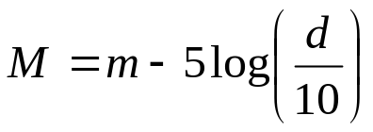

where M = absolute magnitude of star, m = apparent magnitude of star and d = distance of star from Earth in parsecs. The logarithm function used here is logs base 10. This equation is often re-arranged using the basic rules of logarithms to give:

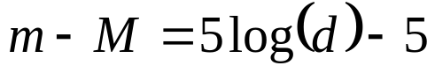

where (m – M) is called the distance modulus. Clearly, if (m – M) is negative, then M > m and the star lies closer to us than 10 pc. If (m – M) is positive, M < m and the star lies beyond 10 pc from Earth.

Example Questions

- The star Epsilon Indi has an apparent magnitude of +4.7. It is 3.6 pc from Earth. Determine the absolute magnitude of this star. (Answer: +6.9)
- The red supergiant Betelgeuse (Alpha Orionis) has an apparent magnitude of 0.5 and an absolute magnitude of –5.2. Calculate the distance from Earth to Betelgeuse. (Answer: 138 pc)
- Given that Betelgeuse has a parallax of 0.0076” re-calculate the distance from Earth to Betelgeuse using the relationship between parallax angle and distance. (Answer: 131.6 pc – which is closer to the accepted value of 131 pc – see p.135 ref.11 or a similar reference.) Note the difference with the answer to question (2). The accuracy of the distance values calculated using the distance modulus formula depend on the accuracies of the apparent and absolute magnitudes substituted into the formula.
- Procyon (Alpha Canis Minoris) has an apparent magnitude of 0.38 and an absolute magnitude of 2.7. Determine the distance from Earth to Procyon. (Answer: 3.44 pc)
- The star Wolf 359 has an absolute magnitude of 16.55 and is located a distance of 2.39 pc from Earth. Determine the apparent magnitude of this star. (Answer: +13.44)

SPECTROSCOPIC PARALLAX

Spectroscopic Parallax is a very powerful technique that uses the Hertzsprung-Russell (H-R) Diagram and the distance modulus formula to determine the approximate distance to a star (3).

Spectroscopic parallax is performed as follows:

- Measure the apparent magnitude of the star using photometric methods (photographic or photoelectric).
- Determine the spectral type and luminosity class of the star from its spectrum.
- On an H-R Diagram locate the appropriate spectral type and luminosity class and then read off the absolute magnitude value for the star from the vertical scale. See the section of your notes on “Stellar Spectra and their Classification” for an example of an appropriate H-R Diagram.
- Substitute the apparent and absolute magnitude values into the distance modulus equation and calculate the distance to the star.

Note that although this method is extremely useful, since it can determine the distance to a star no matter how remote that star happens to be, the distances obtained are only approximate. At best they are accurate to ± 10% (3). This is due to the fact that the luminosity classes on an H-R Diagram are not thin lines but are moderately broad bands. This can lead to large percentage errors in the absolute magnitudes read from the H-R Diagram and corresponding large percentage errors in the distances calculated by this method. It is worth noting, however, that sometimes this is the only method available to astronomers to give a ballpark figure for the distance to a remote star. (3)

Example Question

Use the method of spectroscopic parallax to determine the distance to the star Regulus (Alpha Leonis). Regulus is a B7 V star (a hot, blue Main Sequence star). Regulus has an apparent magnitude of 1.36.

SOLUTION:

Using the H-R Diagram given earlier in these notes, we can determine that the absolute magnitude of Regulus is –0.2. Thus, substituting the apparent & absolute magnitude values into the distance modulus equation, we obtain a distance to Regulus of 20.5 pc. The accepted value for the distance to Regulus is 23.8 pc (p.135 of Ref. 11). So, in this case, the method yields a reasonable approximation (about 14% error). We could have been even more accurate by obtaining a more accurately drawn H-R Diagram.

MEASURING A STAR’S COLOUR

One factor that we have not yet mentioned that does have a bearing on how bright we perceive a particular star to be is the star’s colour. Stars vary greatly in colour. Betelgeuse is clearly pinkish-red to the naked eye while Rigel is clearly bluish. These colours are due to the surface temperatures of the stars. The intensity of light from a cooler star peaks at longer wavelengths, making the star appear red in colour. The intensity of light from a hotter star peaks at shorter wavelengths, making the star appear blue in colour.

Different detectors vary in their sensitivity to the coloured light emitted by stars. The human eye is most sensitive to light in the yellow-green section of the visible EM spectrum. Photographic film is most sensitive to light in the blue-violet region of the spectrum. Thus, a blue star like Rigel for instance does not appear as bright to the human eye as it would appear as an image on photographic film. Historically, the term “visual magnitude” came to be associated with magnitudes of stars determined by the naked eye, while the term “photographic magnitude” came to be associated with magnitudes determined using photographic emulsions.

Eventually, photoelectric photometers, such as CCD’s (charge coupled devices), became available. These are equally sensitive to all wavelengths of the spectrum. A standardised set of coloured filters is used with these photometers. The most commonly used filters are the UBV filters and the technique is called UBV Photometry. This technique is extremely useful for providing an accurate measurement of star colours and a corresponding accurate determination of the surface temperatures of stars. (3)

Each of the three UBV filters is transparent in one of three broad wavelength bands: the ultra-violet (U) centred at 365nm wavelength, the blue (B) centred at 440nm and the central yellow (V, for visual) centred at 550nm in the visible spectrum. The transparency of the V filter mimics the sensitivity of the human eye. The B filter mimics the sensitivity of photographic emulsions. The U filter makes the most of the extra sensitivity of available from modern photometers. (1 & 3)

In UBV photometry the astronomer measures the intensity of the starlight that passes through each of the filters individually. This procedure produces three apparent magnitude values for the star, U, B and V as measured through each of the filters. These apparent magnitude values are called the colour magnitudes of the star. The astronomer then often subtracts one colour magnitude from another to produce what is called a numerical two-colour value that expresses the colour of the star. The most common two-colour value is called the (B – V) colour index. The (B – V) colour index of a star is the difference between the photographic magnitude of the star and the visual magnitude (3).

Colour index = B – V

Such two-colour values are very useful because they produce a numerical scale that expresses the colour of stars in a precise manner. By definition, stars that are of spectral type A0 and luminosity class V (such as Vega) have a colour index of zero (5). These stars have surface temperatures of around 10 000K and are blue-white in colour (3). Red stars, such as Betelgeuse, are brighter through the V filter than through the B filter, so their V magnitude is lower than their B magnitude. Therefore, B – V for a red star is positive. Blue stars, like Rigel, are brighter through a B filter than through a V filter, so their B magnitude is lower than their V magnitude. Thus, B – V for a blue star is negative.

For completeness, realise that there is also the (U – B) colour index, which is the difference between the ultra-violet and photographic magnitudes. The details of this are not required by the current syllabus.

Once an accurate and precise determination of colour is made for a star, an accurate determination of surface temperature can be made.

The following Table gives some idea of the range of the colour index scale and how it correlates with colour, spectral class and temperature. This Table was compiled from Tables in Reference 3 p.470 & Reference 12 p.311.

Colour Index | Colour | Temperature | Spectral  Class
- 0.6 | Blue-violet | 28000-50000 | O
 | Blue-white | 10000-28000 | B
0 | White | 7500-10000 | A
 | Yellow-white | 6000-7500 | F
+ 0.6 | Yellow | 5000-6000 | G
 | Orange | 3500-5000 | K
+ 2.0 | Red-orange | 2500-3500 | M

The Table below gives some UBV magnitudes and colour indices for a number of stars. This Table was taken from Reference 10 p.17.

 | Magnitudes |  |  | Colour Index
STAR NAME | V | B | U | B – V | U - B
Altair | + 0.77 | + 0.99 | + 1.07 | + 0.22 | + 0.08
Arcturus | - 0.06 | + 1.17 | + 2.44 | + 1.23 | + 1.27
Bellatrix | + 1.64 | + 1.41 | + 0.54 | - 0.23 | - 0.87
Capella | + 0.08 | + 0.87 | + 1.32 | + 0.79 | + 0.45
Regulus | + 1.36 | + 1.25 | + 0.89 | - 0.11 | - 0.36

Example Questions

- The stars Sirius and Betelgeuse have (B-V) colour indices of 0.0 and +0.86 respectively. Explain which star has the lower surface temperature.
- Stars X, Y and Z have (B-V) colour indices of + 1.23, 0.0 and – 0.11 respectively. Arrange the stars in order of increasing surface temperature and state which star could have a surface temperature of around 10 000 K. Give reasons for your answers.

Answers

- Lower temperature stars tend to be redder in colour than higher temperature stars. Red stars have (B – V) colour indices that are positive. Betelgeuse has a more positive colour index than Sirius and is therefore redder in colour and lower in surface temperature.
- (B – V) colour indices range from negative values for hotter stars through to positive values for cooler stars. The more positive the value, the cooler is the star. Therefore the stars in order of increasing temperature are: X, Y and Z. Star Y must have a surface temperature around 10 000K, since by definition stars with a (B – V) colour index of zero have surface temperatures of 10 000K.

ADVANTAGES OF PHOTOELECTRIC TECHNOLOGIES

As mentioned previously, photometry can be performed photographically or photoelectrically. Photographic photometry uses photographic film to record the section of sky under study. Photoelectric photometry uses filters in combination with CCD’s (charge coupled devices) or photomultiplier tubes to detect light signals and convert these into electrical signals that can be multiplied, digitised, analysed and stored electronically. The advantages of photoelectric devices in photometry are:

- A greater range of wavelengths to which they are sensitive than is the case for photographic film;
- When used with appropriate filters they can detect intensities over broad wavelength bands, as in UBV photometry, or over very narrow bands, as when searching for a particular element in an astronomical object; and
- They are more sensitive to faint light sources than is photographic film;
- They can be controlled remotely;
- They can feed the data obtained straight into a computer for immediate viewing and analysis. (3)

BINARY STARS AND DETERMINATION OF STELLAR MASSES

The only direct way to determine the mass of a star is by studying its gravitational interaction with other objects. Binary stars, two stars in orbit around a common centre of mass, provide an ideal opportunity to do just that. At least half of all the “stars” in the sky are actually multiple star systems. Analysis of the orbital parameters of such systems provides vital information about a variety of stellar characteristics, including mass. (1)

The methods used to analyse the orbital data depend on the geometry of the system, its distance from the observer and the relative masses and luminosities of each component. As a consequence, binary star systems are classified according to the means by which they are detected. (1)

There are six main types of binary systems: visual, spectroscopic, eclipsing, astrometric, spectrum and optical (1). The first four of these are required for study by the current syllabus. Let us now describe these four different types of binary star systems.

VISUAL BINARIES

When astronomers can actually see the two stars orbiting each other, the binary is called a visual binary. The brighter star in the pair is called the primary star and is denoted by the letter A after its name, while the other star is called the secondary and is denoted by the letter B. For example, the alpha star in the constellation of the Southern Cross is actually a visual binary consisting of Alpha Crucis A and Alpha Crucis B, both of which are easily discernable through a small telescope (3 inch or 75mm objective).

Many years of careful observation are often necessary to ensure that the two stars are actually in orbit around each other. If the stars do form a binary system, each star will follow an elliptical orbit around the centre of mass of the system. The star with the larger mass will stay closer to the centre of mass of the system and will therefore have the smaller orbit. This makes sense – just think of two children on a seesaw. To balance, the child with the greater mass must sit closer to the fulcrum.

SPECTROSCOPIC BINARIES

Some binary systems are detected due to a periodic shift in spectral lines. These are called spectroscopic binaries and are detected using the Doppler Effect. If two stars in a binary system have some component of their orbital motion along the observer’s line of sight, then as the stars move around their orbits, they periodically approach and recede from the observer. Thus, the spectral lines of the two stars are alternately blueshifted and then redshifted. (1 & 3)

Through a telescope such a star system may appear to be one single star. However, an examination of the spectra coming from “the star” will reveal two sets of spectral lines, one set from each star, each of which will display Doppler shifts. The two overlapping spectra shift relative to each other due to the Doppler Effect. When the spectrum of each star in the binary system is visible, the binaries are called double-line spectroscopic binaries. If, however, one star in the pair is much more luminous than the other, the spectrum of the less luminous companion may be overwhelmed and only a single set of spectral lines will be seen. In this case, the spectral lines shift back and forth due to the Doppler Effect and therefore still reveal the binary system. This type of binary is called a single-line spectroscopic binary. (1 & 3)

Consider the diagram below, adapted from Reference 1 p.204.

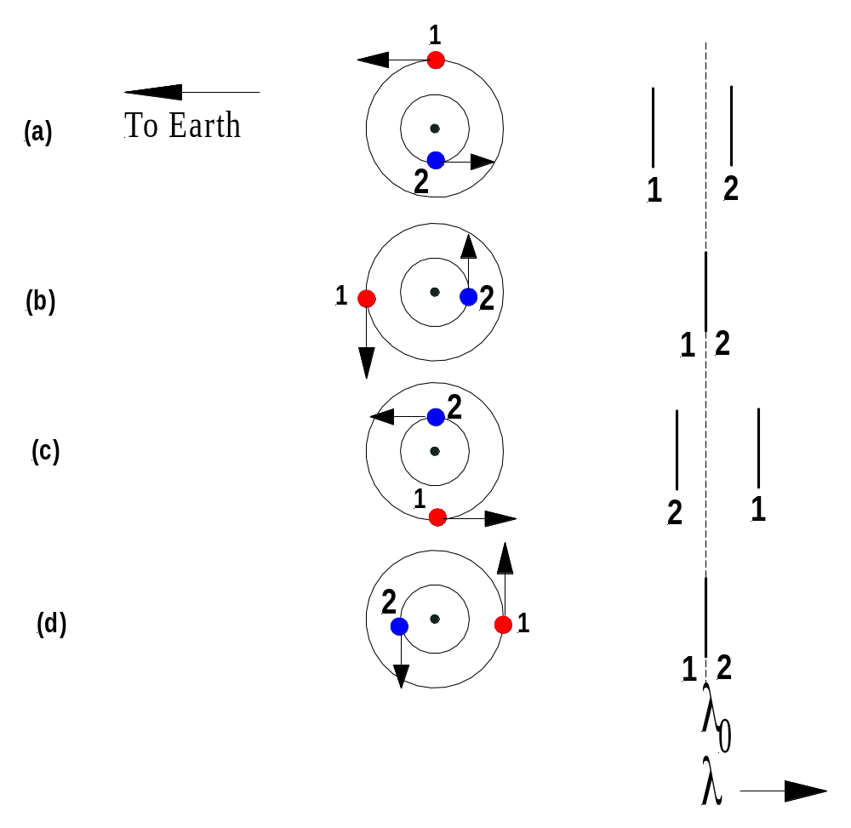

The diagram above shows the periodic shift in spectral features of a double-line spectroscopic binary. For simplicity, only one spectral line from each star is shown. Note that λ₀ is the non-Doppler shifted wavelength of the lines and wavelength increases to the right of that position. The relative wavelengths of the spectra of stars 1 and 2 are shown at four different phases during orbit: (a) star 1 is moving towards Earth while star 2 is moving away; (b) both stars have velocities perpendicular to the line of sight; (c) star 1 is receding from Earth and star 2 is approaching Earth; and (d) again both stars have velocities perpendicular to the line of sight of the observer on Earth.

Note that the spectroscopic detection of binaries is most likely if the period of the motion is short and the orbital speeds of the stars are high. So, most spectroscopic binaries are close binary systems. (3)

ECLIPSING BINARIES

Some binaries have their orbital planes oriented approximately along the line of sight of the observer. In this case, one star may periodically pass in front of the other, blocking light from the eclipsed star. Such a system is called an eclipsing binary and is recognized by regular variations in the amount of light received at the telescope (1). Light curves (plots of apparent visual magnitude versus time or orbital phase) can be recorded for eclipsing binaries using an appropriate photometer. Such curves can reveal enormous amounts of information about the binary system. For example, light curves can confirm the presence of two stars. The ratio of surface temperatures can be determined from how much their combined light is diminished during eclipse. The duration of the eclipse provides information on the relative radii of the stars and their orbits. (3)

Further to this, if the eclipsing binary also happens to be a double-line spectroscopic binary, an astronomer can calculate the actual mass and radius of each star in the system from the light curves and the velocity curves. (3)

Examine the light curve shown below. It is typical of a binary system consisting of small hot star and a large cool star with the orbital plane edge-on to our line of sight. Note that the smaller star is travelling from left to right across the front of the larger star. This diagram was adapted from Reference 12 p.323.

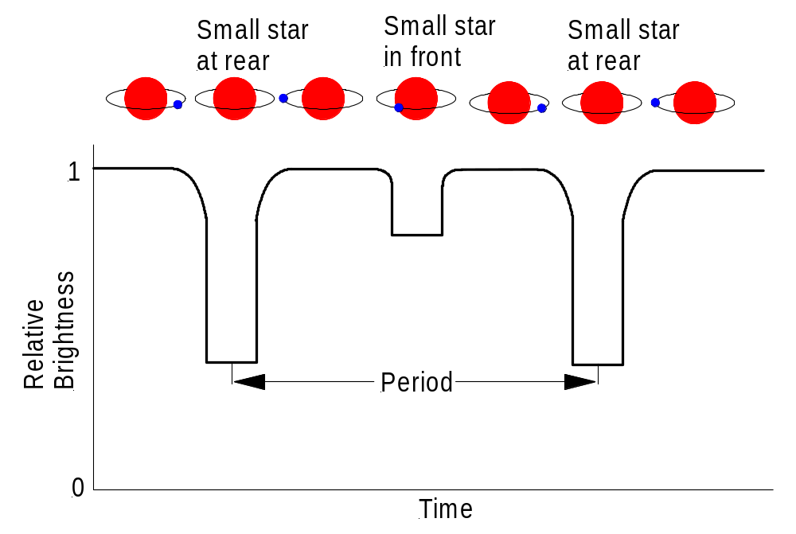

Note: Try out this java applet, which allows you to model the light curves of eclipsing binaries using a computer simulation (Syllabus point 9.7.5, column 3, dot point 1).

http://instruct1.cit.cornell.edu/courses/astro101/java/eclipse/eclipse.htm#example

ASTROMETRIC BINARIES

Sometimes one member of a binary is significantly brighter than the other and may be the only one of the pair visible through a telescope. In such a case the existence of the unseen member may be deduced by observing the oscillatory motion of the visible star (1). This reveals itself as a detectable “wobble” in the star’s proper motion (5). Since Newton’s First Law requires that a constant velocity be maintained by a mass unless an external unbalanced force is acting upon it, such oscillatory motion requires that another mass be present. Such a binary star system is called an astrometric binary. (1)

DETERMINATION OF STELLAR MASSES

As mentioned previously binary stars are very important in determining the masses of stars. Binary stars orbit each other in accordance with Kepler’s Third Law – the Law of Periods. For any binary system we can write:

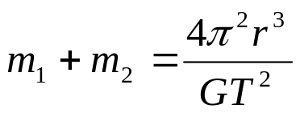

where m₁ = mass of star 1, m₂ = mass of star 2, r = average distance of separation of the two stars, T = orbital period of the binary system and G = the Universal Gravitational Constant = 6.673 x 10⁻¹¹ SI.

This equation is known as Newton’s form of Kepler’s Third Law. Clearly, for any binary system if we can determine the orbital period and the average distance of separation of the stars in the system, we can determine the total mass of the system (m₁ + m₂).

For visual binaries we can usually determine the orbital period, although in some cases observations over more than one lifetime may be needed. If the distance from Earth to the binary can be calculated from parallax measurements or using spectroscopic parallax, then the angular separation between the stars in the binary can be translated into the physical distance between the stars. Astronomers must also take into account the angle of tilt of the binary’s orbit to our line of sight. Substituting into Kepler’s Third Law equation then allows us to calculate the total mass of the binary system. (1 & 3)

By plotting the individual orbits of the two stars in the system, the centre of mass of the system can be determined. Then, comparing the relative sizes of the two orbits around the centre of mass enables the ratio of the masses m₁ / m₂ of the two stars to be determined. Having both the sum of the masses and the ratio of the masses then allows the calculation of the individual masses of the two stars to be achieved. (1 & 3) See Ref. 1 pp.205-208 for a detailed analysis.

For spectroscopic binaries the wavelength shift of each star’s spectral lines is measured and then this data is used to calculate the radial velocity of each star from the relevant Doppler shift formula. Remember that radial velocity is velocity along our line of sight. This radial velocity data is then used to plot a radial velocity curve (radial velocity versus time) for each star. The ratio of the masses of the stars in the binary is obtained from this curve, along with the orbital period of the binary.

Kepler’s Third Law and Newtonian mechanics are then used to relate the sum of the masses of the stars to the orbital period of the binary, the orbital speeds of the stars and the angle of tilt of the binary’s orbit to our line of sight. If all of these details are known, then again the individual masses of the two stars can be determined. Often, however, the angle of tilt is not known accurately and therefore stellar mass determinations from spectroscopic binaries are often uncertain. (1 & 3) See Ref. 1 pp.208-211 for a detailed analysis.

There is one case in which the angle of tilt is known and that is when the spectroscopic binary is also an eclipsing binary. The orbital plane of the binary must then lie edge-on to our line of sight. Clearly, with this knowledge and with values for the orbital period of the binary and the orbital speeds of the component stars, the sum of the masses of the stars can be determined. Then, since both the sum of the masses and the ratio of the masses are known, the individual masses of the two stars can be determined. (1 & 3) See Ref. 1 pp.211-214 for a detailed analysis.

Note that in the case of astrometric binaries, it is usually possible to measure the orbital period of the binary and the average distance of separation of the two stars. Thus, using Newton’s form of Kepler’s Third Law we can get an estimate of the total mass of the binary system. It is usually not possible to determine the masses of the individual stars.

Example Questions

- An astrometric binary is observed to have a period of 44.5 years and an orbit with an average distance of separation between the component stars of 100 AU. Determine the sum of the masses of the stars in this binary. (Data: 1AU = 1.5 x 10¹¹ m) (Answer: 1.012 x 10³³ kg)
- An eclipsing binary has a period of 44.5 years and an average distance of separation between the component stars of 3.9 AU. Determine the combined mass of the binary system. (Answer: 6.0 x 10²⁸ kg)

CLASSIFICATION OF VARIABLE STARS

A variable star is one that varies in brightness (5). As at January 2004, the total number of designated variable stars was 38622 according to the “General Catalogue of Variable Stars”, 4th Edition, by P N Kholopov et al, Moscow (1985) and its published updates (also available on the Internet). There are two broad categories of variable star: (a) Extrinsic Variables, which vary in brightness for some reason external to the star; and (b) Intrinsic Variables, which vary in brightness due to changes in the star itself. Certain stars may vary in brightness due to both of these reasons. (5)

EXTRINSIC VARIABLES:

As mentioned above, Extrinsic Variables vary in brightness for some reason external to the star. Such reasons include rotation, orbital motion or obscuration. Examples of common types of extrinsic variables include:

  - Rotating variables, in which either the star’s ellipsoidal shape or the presence of large cooler or hotter areas on the star’s surface change the star’s brightness as it rotates. BY Draconis stars are examples of the latter.
  - Eclipsing Binaries, which as discussed previously, consist of orbiting stars that periodically eclipse each other. Algol (Beta Persei) is an example of an eclipsing binary system about 100 light years from Earth.

INTRINSIC VARIABLES:

Intrinsic Variables vary in brightness due to actual changes in the luminosity of the star itself not due to external processes such as rotation or eclipses. The majority of variable stars fall into this broad category. Intrinsic variables are further sub-divided into non-periodic or periodic variables.

NON-PERIODIC VARIABLES:

These are intrinsic variables that show irregular variations in brightness. Examples of such variables include:

- Novae – A nova is a star that undergoes a sudden, unpredictable increase in brightness typically of 11 to 12 orders of magnitude (5). The sudden increase in brightness is accompanied by an explosive loss of a relatively small amount (about 10⁻⁵) of the mass of the star. The outer atmosphere is blown away to form an expanding shell of gas around the star that can often still be seen many years after the explosion. Nova Cygni, which flared up in 1975 by about 19 magnitudes is an example. (10)
- Supernovae – A supernova is a violently exploding star, which may become over a billion times brighter than the Sun, and for many weeks may outshine the entire galaxy in which it lies (5). The explosion completely destroys the star and throws most of its matter into space at high speeds, leaving behind either a tiny, very dense, collapsed remnant called a neutron star or in some cases a black hole. SN1987A is a supernova observed in the Large Magellanic Cloud in 1987. The Crab Nebula is the remnant of a supernova explosion in the constellation Taurus in 1054. (10)
- R Coronae Borealis Stars – These stars are sometimes referred to as “reverse novae” since they decrease in brightness by as much as 10 magnitudes before returning to normal. They are supergiants with carbon-rich atmospheres. The sudden minima are due to the accumulation of clouds of carbon dust, which are then blown away and allow the star to return to its normal brightness. The decreased brightness phase may last from months to years. (5 & 10)
- Flare Stars – These stars are red dwarfs that exhibit intense outbursts of energy (flares) from small areas of their surface. Examples include UV Ceti stars and certain BY Draconis stars. (5)
- T-Tauri Stars – These are very young protostars. They are less than 10 million years old, with masses similar to or less than that of the Sun and with diameters several times that of the Sun. They are still contracting. They exhibit irregular variability ranging from ultraviolet flares on a time scale of minutes to optical variations on time scales of days to years. The prototype, T Tauri itself, lies within Hind’s Variable Nebula and varies irregularly between 8th and 13th magnitudes. (5 & 3)

PERIODIC VARIABLES:

These are intrinsic variables that show regular variations in brightness. These variables are also known as pulsating variables. A pulsating variable undergoes a periodic cycle of contraction and expansion as the star oscillates between a state where the inward acting gravitational force is dominant and another where the outward acting radiation pressure is dominant. The periodic contraction and expansion produces the observed periodic variation in brightness. As the star contracts, the increase in luminosity caused by the temperature increase exceeds the decrease caused by the contraction in radius, so the star becomes brighter. As the star expands, the luminosity and therefore the brightness decrease. (9 & 10).

The types of periodic variables can be categorized by the period and amplitude of their light curves. The period is simply the amount of time between one occurrence of maximum (or minimum) brightness and the next. The amplitude is the difference in magnitude between maximum and minimum brightness. Examples of periodic variables include:

- Cepheid Variables – These are the best-known examples of pulsating variables and are named after Delta Cephei, the first star of this type to be discovered. Cepheids are very luminous yellow giant or supergiant stars. Their brightness usually varies by about one magnitude with a period of between 1 and 60 days, while their radius typically varies by 10 to 20 percent. We will say a little more about these very important stars later. They are extremely useful as a means of distance measurement. (5 & 10)
- Mira Stars (also called Red Variables) – These are the most common pulsating stars. They are long period pulsating red giants and supergiants. They take their name from the star Mira (Omicron Ceti) which lies about 250 ly from Earth. Mira stars have periods of about 80 to 1000 days and have an amplitude of 2.0 to 10 magnitudes. (5 & 10)
- RR Lyrae – These are the second most common type of variable. They are old yellow giants. Most have periods between 0.2 and 1.2 days and amplitudes of 0.2 to 2.0 magnitudes. One of the two types of RR Lyrae star (the RRAB type) all have approximately the same absolute magnitude of +0.5, making them valuable distance indicators. (5 & 10)
- RV Tauri – These are highly luminous, yellow supergiants. The light curves have overall amplitudes of 3 to 4 magnitudes. The period lies in the range from 30 to 150 days. (5)

NOTE: The above classification of variable stars is the one required by the current HSC Astrophysics Syllabus. This classification scheme is based on the form of the light curve for the star, its amplitude and periodicity or lack of it. This classification scheme has been superseded. I do not know why the Syllabus Committee decided to go back to the old system. The new classification scheme adopted by the “General Catalogue of Variable Stars”, 4th Edition, is based on the physical mechanisms that underlie the different forms of variation or the physical structure of the stars themselves. This new classification scheme allocates variable stars to one of seven classes: Eruptive, Pulsating, Rotating, Cataclysmic (explosive nova-like), Close Binary Eclipsing Systems, Optically Variable X-Ray Sources and finally Unique Variables (for mistakes and variables no-one has figured out yet).

When trying to remember the classification scheme for variable stars, a simple flow chart like the following can be of great assistance. This particular flowchart appears in Ref.12 on p.326. A similar one is shown in Ref.9 on p.46.

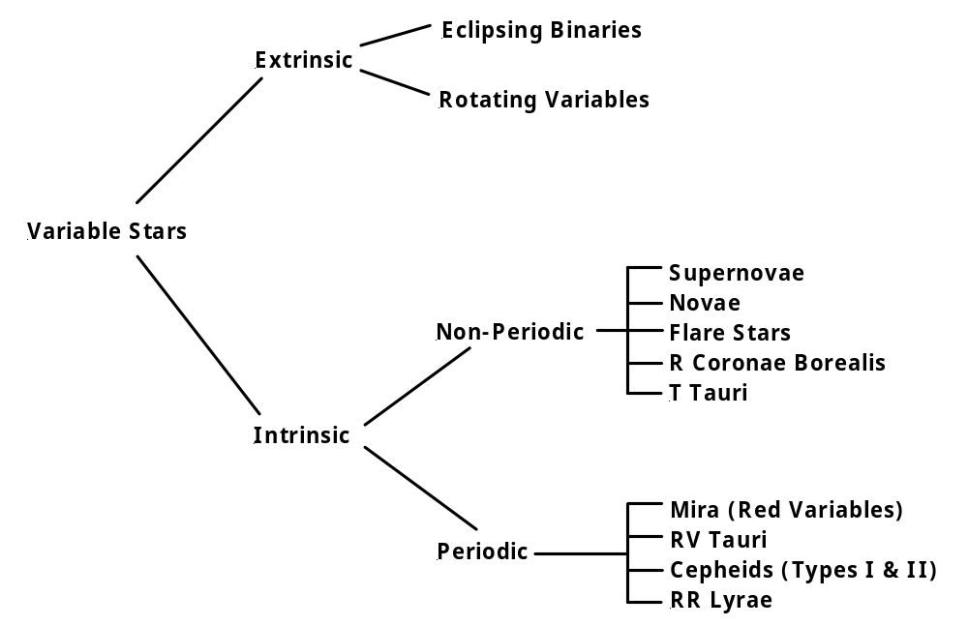

The following figure shows where certain types of variable stars are found on the H-R Diagram. Cepheid variables and RR Lyrae variables are located in the cepheid instability strip (between the dotted lines on the diagram), which occupies a region between the main sequence and the red giant branch. A star passing through this region along its evolutionary track becomes unstable and pulsates. (3)

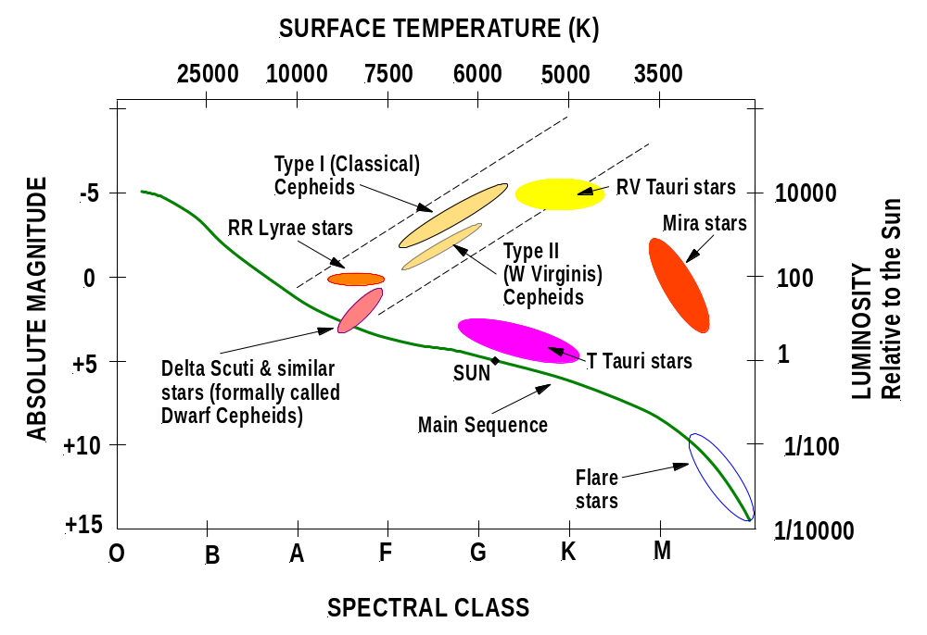
The diagram above is an amalgamation of similar diagrams from Ref. 3 p.530, Ref. 12 p.327 and Ref. 9 p.47.

PERIOD-LUMINOSITY RELATIONSHIP

In 1912, American astronomer Henrietta Leavitt reported her important discovery of the period-luminosity relationship for Cepheid variables. Leavitt studied numerous Cepheids in the Small Magellanic Cloud, a small galaxy near our own Milky Way. Leavitt found that the periods of these Cepheids were directly related to their average luminosities. The longer the Cepheid’s period, the greater is its luminosity. (3 & 9)

This period-luminosity relationship is very important in astronomy because it can be used to determine distances to objects in the universe (3). The process is as follows.

Cepheid variables vary in a regular and characteristic way, increasing in brightness rather more rapidly than they decrease (10). Cepheid variables therefore have very distinctive light curves, which are plots of brightness versus time. A typical light curve appears as below.

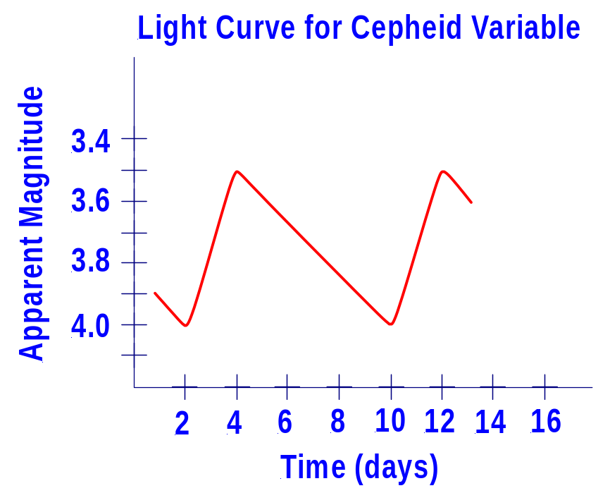

From this light curve we can determine both the period of the Cepheid variable under study and its average apparent magnitude. In this case the period is 8 days – the time between one occurrence of maximum brightness and the next. The average apparent magnitude is (4.0 + 3.5)/2 which equals 3.75. Using the period we can then determine the average absolute magnitude of the Cepheid variable from the appropriate period-luminosity curve (see the next graph). Once the average absolute magnitude is known we can use the distance modulus formula to calculate the distance to the required Cepheid variable.

Note that initially Leavitt and others thought that all Cepheids could be described by the same period-luminosity relationship. This, however, was not the case. We now know that there are two different types of Cepheid variable, each with its own period-luminosity relationship. Type I or Classical Cepheids are the brighter, massive, metal-rich, young second generation stars, while Type II or W Virginis Cepheids are the dimmer, small, metal-poor, old, red, first generation stars (10 & 12). Astronomers examine a star’s metal content from its spectrum in order to classify it as either a Type I or Type II Cepheid (3). The period-luminosity relationship for both types of Cepheid variable is shown in the following graph.

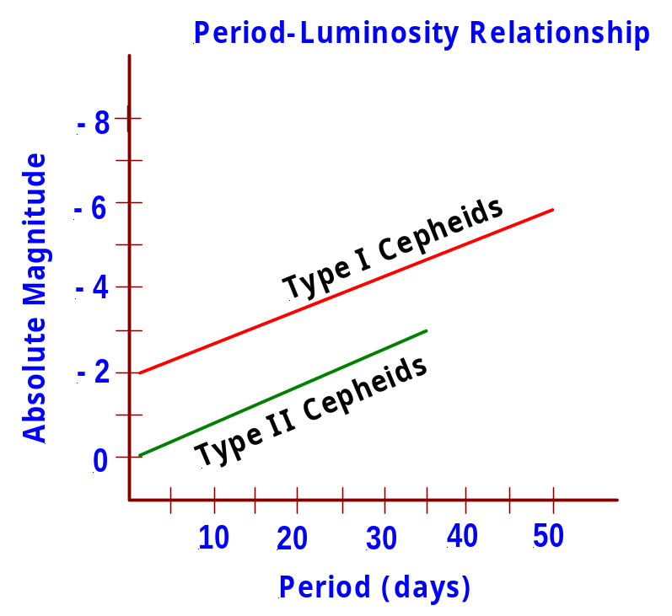

This graph is an adaptation of the graph shown on p.49 of Ref.9. Note that the relationship for Type I Cepheids has only been drawn up to a period of 50 days. In reality, Type I Cepheids can have periods up to 135 days. Remember too that the straight lines in the graph are simply showing general trends that are seen in the data. The actual period-luminosity graphs recorded by astronomers consist of bands of stars plotted on and around these lines. See Ref.1 Fig.14.4 on p.545 for example.

Now continuing with our example of how to determine the distance to a Cepheid, let us assume that the Cepheid in question has been identified as a Type I Cepheid. So, using the known period of 8 days, we can read off the period-luminosity relationship that the absolute magnitude of our Cepheid is –2.5.

The final step is to use the distance modulus formula to calculate the distance to the Cepheid.

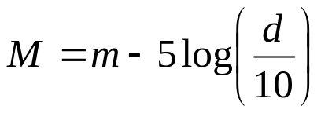

So, on re-arrangement we have: 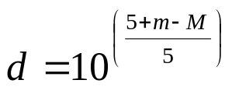

which yields d = 177.8 parsecs, when m = 3.75 and M = -2.5 are substituted into the above equation. Thus, the distance to our Cepheid variable is 177.8pc.

As mentioned previously, this method of using the period-luminosity relationship for determining distances to Cepheids is very important in astronomy. It provides a relatively simple and accurate method of distance calculation. An astronomer identifies a Cepheid as either Type I or Type II from its spectrum. He/she then records the light curve for the Cepheid and from this determines the period and average apparent magnitude of the Cepheid. Using the period, the astronomer then determines the absolute magnitude of the Cepheid from the period-luminosity relationship and finally calculates the distance to the Cepheid using the distance modulus formula. (3)

Cepheid variables are extremely luminous objects. They can be seen even at distances of millions of parsecs. By applying the period-luminosity relationship in this way to Cepheids in other galaxies, astronomers have been able to calculate the distances to those galaxies with great accuracy. Such measurements play an important part in determining the overall size and structure of the universe. (3)

THE PROCESSES INVOLVED IN STELLER FORMATION

Where in our galaxy does star formation occur? The spiral arms of our Milky Way galaxy are laced with giant molecular clouds (GMC), immense clouds of interstellar gas (mainly hydrogen) and dust, so cold that their constituent atoms can form into molecules (3). Particularly dense regions within these clouds form what are called “Dark Nebulae” and within these, stars are formed. Star formation commences in these dark nebulae when a GMC is compressed, which can happen as the cloud passes through one of the spiral arms of the galaxy or as a result of a nearby supernova explosion (3).

A nebula is an interstellar cloud of gas and dust. A dark nebula is a nebula with a relatively dense concentration of microscopic dust grains, which scatter and absorb light very efficiently. The Horsehead Nebula in the constellation of Orion is a very good example of a dark nebula. Dark nebulae partially or completely block our view of any stars that lie behind them. A typical dark nebula has a low temperature of 10 K to 100 K, which is low enough for hydrogen to form molecules, and contains from 10⁴ to 10⁹ particles (atoms, molecules & dust grains) per cubic centimetre. (3)

These characteristics make dark nebulae the only parts of the interstellar medium suitable for star formation. The relatively high density enhances gravitational attraction within the medium and the low temperature ensures a low (outwards pushing) pressure within the medium. (3)

Within a dark nebula, the densest regions of gas and dust may begin to contract under their own gravity. This contraction may also be triggered by the gravity from a passing star or the shock wave from a nearby supernova explosion. The density at the centre of a contracting region increases more quickly than that at the outer edges. Thus, the gravitational attraction at the centre increases more quickly than that at the edges, resulting in the formation of a central core of material surrounded by a more slowly contracting envelope. (3 & 9)

As the core contracts, the gravitational potential energy of its constituent particles is transformed into kinetic energy, heating the core. This heat causes the gas in the core to glow. Convection currents carry the heat outwards, creating an outward-directed pressure that opposes the gravitational contraction of the core. As the core temperature increases, the outward pressure increases until eventually the gravitational collapse of the core is almost balanced by the outward pressure. At this stage the core is called a protostar. Protostars with masses between 0.08 solar masses and 100 solar masses will eventually evolve into main sequence stars. (1 & 3)

Check out the following four star-forming regions:

http://www.aao.gov.au/images/captions/uks008.html - The Orion Nebula (M42), 1500 light years away in the constellation of Orion, is the nearest star-forming region to the Sun (13). It is certainly one of the best examples of such an area in space (13). Several other images of this nebula are located on this same web page.
http://antwrp.gsfc.nasa.gov/apod/ap000111.html - The Rosette Nebula is an impressive star-forming area at a distance of 5500 light years in the constellation Monoceros (The Unicorn). (13)

http://antwrp.gsfc.nasa.gov/apod/ap990511.html - Barnard 68, a dark Bok globule at a distance of 410 light years in the constellation Ophiuchus (The Serpent Holder), is on the point of collapsing into a new star. (13)

http://www.ironmountainobservatory.com/photos/singles/M20TriffidNebula.html - The Trifid Nebula (M20), a star forming region a few thousand light years away in the constellation Sagittarius. (13)

It is worth noting that even though young protostars are quite luminous, they cannot be detected using visible light. This is because the dust in the protostar’s immediate surroundings, called its cocoon nebula, absorbs much of the visible light emitted by the protostar. However, as the dust in the cocoon nebula re-radiates this absorbed heat at infrared wavelengths, the presence of the protostar can be detected using infrared telescopes. Many protostars have been detected in this way. (3)

During the birth process stars both gain and lose mass. Mass loss occurs in a couple of different ways. Protostars less than 3 solar masses go through a T-Tauri phase in which they eject up to a solar mass of material over about 10⁷ years and exhibit irregular variation in luminosity on a time scale of a few days. Protostars more massive than 3 solar masses do not vary in luminosity like T-Tauri stars but do lose mass due to the huge radiation pressure at their surfaces that blows gas into space. Many protostars also lose mass by ejecting gas along two oppositely directed jets in a process called bipolar outflow. The huge stellar winds produced by these mass ejection processes often blow away the remnants of the surrounding cloud and allow the protostar to be seen in visible light. (3)

Protostars gain mass at the same time as they are losing it. As the envelope of material around the protostar contracts, it spins faster and faster and flattens into a disk with the protostar at the centre. Particles orbiting the protostar within the disk collide with each other, causing them to lose energy and spiral inward onto the protostar, adding to its mass. This process is called accretion. (3)

While these processes of mass loss and gain are continuing, so too is the very slow contraction of the protostar itself. There is still insufficient energy flowing outwards from the protostar to completely balance the inward pull of gravity. As the radius of the protostar decreases, its luminosity decreases and its internal temperature increases. Eventually, the internal temperature of the protostar reaches around 10⁷ K, sufficient for thermonuclear reactions to begin converting hydrogen to helium. These reactions eventually produce sufficient heat and internal pressure to stop the star’s contraction. The outward radiation pressure and gas pressure has balanced the inward force of gravity. Hydrostatic equilibrium has been achieved. Also, the rate at which energy is produced in the core has balanced the rate at which energy is transported to the surface of the star and radiated away into space. Thermal equilibrium has been established. The protostar is now said to be a zero-age main sequence star and the processes of stellar formation are complete. (3)

Note that the dark nebulae in which star formation occurs typically contain tens or hundreds of solar masses of gas and dust, enough to form many stars. Thus, young stars tend to form in groups or clusters. Star clusters typically include stars with a range of different masses, all of which began to form out of the parent nebula at roughly the same time. (3)

PRE-MAIN-SEQUENCE EVOLUTIONARY TRACKS

Curves that depict the life histories of stars on the H-R Diagram are called evolutionary tracks (1). The diagram below shows the evolutionary tracks of five protostars of different masses. Each track shows us how the protostar’s appearance changes in terms of its luminosity and temperature because of changes in its interior. Where on the main sequence a given track ends depends on the mass of the protostar. Protostars eject a lot of mass into space as they form, so the mass shown for each evolutionary track is the mass of the final main sequence star. Note that for a star like the Sun, the birth process takes about 50 million years. (This diagram was prepared by Prof. Dale Gary from: http://physics.njit.edu/~dgary/202/Lecture18.html)

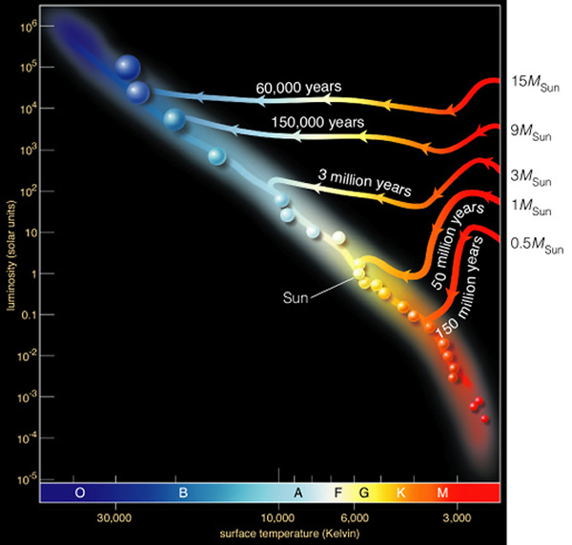

Note that the plot of the main sequence using only stars of zero-age is called the zero-age main sequence (ZAMS) plot (12). It forms the complete diagonal main sequence shape shown on most generic H-R Diagrams (12). Stars on ZAMS have just ended their protostar stage (3).

The theory of how protostars evolve helps explain why the main sequence has both an upper and lower mass limit. A protostar of less than 0.08 solar masses can never develop sufficient pressure and temperature to start hydrogen fusion in its core. Such a protostar becomes a hydrogen-rich brown dwarf – a failed star. A protostar more massive than 100 solar masses rapidly becomes very luminous, resulting in tremendous internal pressures. These pressures overwhelm gravity, expel the outer layers into space and disrupt the protostar. (3)

LIFE ON THE MAIN SEQUENCE

By definition, a main sequence star is one that produces energy by the fusion of hydrogen nuclei (protons) to helium nuclei in its core. This fusion reaction produces energy by the conversion of some of the hydrogen nuclei mass into energy according to Einstein’s equation, E = mc². Note that astronomers are notorious for referring to fusion reactions as “burning”. So they speak of “hydrogen burning” instead of hydrogen fusion and “helium burning” instead of helium fusion, and so on.

Two different fusion mechanisms are responsible for the helium production and consequent release of energy in main sequence stars. Both mechanisms can occur simultaneously in a main sequence star. However, for stars whose core temperatures are below 16 million K the proton-proton chain reaction is the main mechanism, while for stars whose core temperatures are above this, the carbon-nitrogen-oxygen (or CNO) cycle predominates (3). Let us now have a brief look at these two mechanisms.

The Proton-Proton Chain Reaction

This reaction predominates in stars like our Sun. Originally proposed by the American physicist Charles Critchfield, this reaction has three branches (3). Since the primary branch PP I, accounts for the production of 85% of the Sun’s energy, we will consider only this branch of the reaction in detail. PP I consists of three steps:

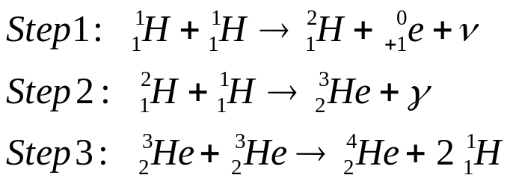

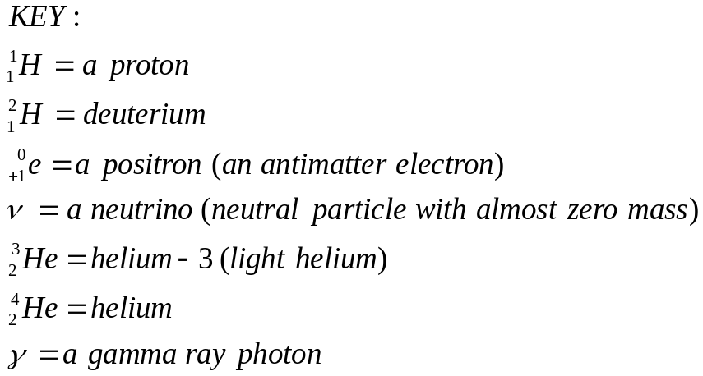

For those not familiar with nuclear equations, refer to the Key above. In step 1, two protons combine to form a deuterium nucleus (an isotope of hydrogen), a positron and a neutrino. In step 2, another proton combines with the deuterium nucleus to form a nucleus of light helium and a gamma ray photon, which carries energy away from the reaction. In step 3, two light helium nuclei combine to produce a nucleus of ordinary helium and two protons. (10)

Thus, the overall reaction is to convert four protons into a nucleus of helium with the release of some energy.

In the PP II and PP III branches of the reaction the light helium produced in step 2 above suffers different fates. Details of these branches can be found in Refs. 1 & 3.

The Carbon-Nitrogen-Oxygen (CNO) Cycle

This reaction mechanism predominates in stars whose core temperatures are above 16 million K. Hans Bethe and Carl von Weizsacker discovered it independently (3). In the CNO cycle the carbon-12 nucleus acts as a catalyst and the following six-step reaction takes place (10).

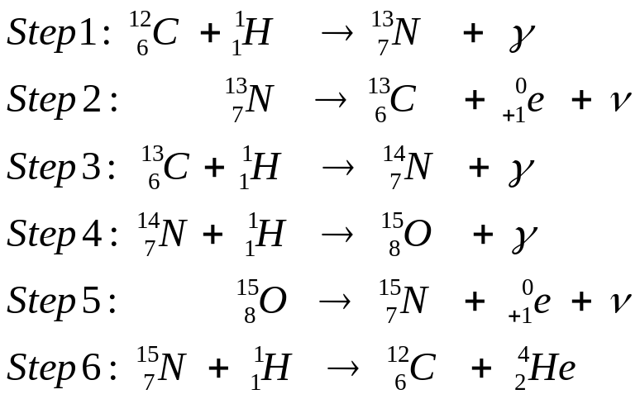

Overall, in this reaction four protons are converted into a helium nucleus, two positrons, two neutrinos and high-energy gamma ray photons (10). Again, for those not familiar with nuclear reactions the following Key is provided.

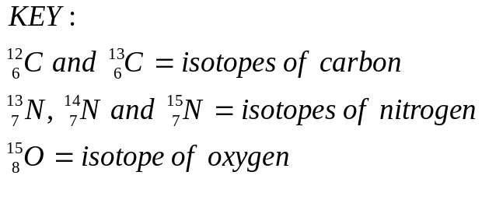
For the CNO cycle to proceed, there must be carbon-12 nuclei present. Obviously, as the carbon-12 is returned at the end of the cycle, it is not actually used in by the reaction.

Throughout the lifetime of the main sequence star, the helium produced by the proton-proton chain reaction and CNO cycle accumulates in the centre of the star, since it is denser than the hydrogen. Also as the main sequence star ages, changes occur in its luminosity, surface temperature and radius (3). Hydrogen burning decreases the total number of atomic nuclei in the star’s core (four hydrogen nuclei are used up to make each single helium nucleus). The resulting decrease in internal pressure causes the core to contract slightly under the weight of the star’s outer layers. In turn, this contraction increases the core’s density and temperature, which effectively raises the pressure in the core to a level higher than it was previously.

The increased core pressure pushes outwards on the star’s outer layers, causing the star’s radius to increase slightly. Also, the increased density and temperature in the core cause hydrogen nuclei in the core to collide more frequently, causing the rate of hydrogen burning to increase. Hence the star’s luminosity increases. Since the star’s surface temperature depends on the star’s luminosity and radius, it changes as well. Thus, as the star ages, its core shrinks and its outer layers expand and shine more brightly. As an example, over the last 4.6 x 10⁹ years, our Sun has become 40% more luminous, grown in radius by 6% and increased its surface temperature by 300K. (3)

As a main sequence star ages and evolves, the increase in energy outflow from its core also heats the material immediately surrounding the core. As a result, hydrogen burning can begin in this surrounding material. This is called shell hydrogen burning since it is happening in the shell surrounding the core. By tapping this fresh supply of hydrogen, a star manages to last a few extra million years on the main sequence. (3)

A star’s lifetime on the main sequence depends critically on its mass. The more massive the star, the shorter its main sequence lifetime. This is because the more massive the main sequence star, the more luminous it is. In order to emit energy so rapidly, these massive stars deplete their hydrogen stocks very much more quickly than less massive stars. High mass O and B stars completely exhaust their hydrogen supplies in only a few million years, whereas low mass M stars take billions of years to use all their hydrogen. A star of around one solar mass will spend roughly 10¹⁰ years on the main sequence. So, our Sun, which has been on the main sequence for about 4.6 billion years, should have about another 5 billion years left to enjoy its main sequence status. (3)

THE RED GIANT STAGE IN THE LIFE OF A STAR

When the hydrogen has been exhausted in the core of a main sequence star, hydrogen burning ceases. This leaves a core consisting almost entirely of helium, surrounded by a shell through which hydrogen burning works its way outward in the star.

When the hydrogen burning stops in the core, the temperature there decreases causing a corresponding decrease in pressure. The core contracts under the weight of the outer layers of the star. As the core contracts it becomes hotter and the heat flows outwards warming the gases around the core and increasing the rate of shell hydrogen burning. Helium produced by these reactions falls back into the core, which continues to contract and heat up as it gains mass. Over the course of hundreds of millions of years, the core of a one solar mass star compresses to about one-third of its original radius, while the core temperature increases from about 15 million K to about 100 million K. (3)

While the core contracts, the hydrogen burning continues to move outwards causing an increase in the star’s luminosity and an increase in the star’s internal pressure. This increase in pressure makes the entire star expand to many times its original radius. This massive expansion of the star’s outer layers causes the star’s surface temperature to decrease. Once the surface temperature has reached about 3500 K, the gases glow with a reddish hue, in accordance with Wien’s Law. The star is then called a Red Giant star. Red Giant stars are stars that have finished their time on the main sequence and have evolved into a new stage of existence. (3)

Examine the evolutionary track for a one solar mass star shown on H-R diagram (a) below. Make sure you can explain the shape of this track in terms of the physical processes described above.

In a moderately low-mass red giant, which the Sun will be in another 5 billion years or so, the dense helium core is about twice the size of the Earth and the star’s bloated surface has a diameter of about 1AU.

When a star first becomes a red giant, the temperature of the contracted helium core is still too low for helium fusion to commence. In time, as the hydrogen burning shell continues to add mass to the helium core, the core contracts even more, further increasing the core temperature. When the core temperature reaches about 100 million K, the fusion of helium (helium burning) begins there. This process, also called the triple alpha process, converts helium to carbon and oxygen. In a high-mass red giant (mass > 2 to 3 solar masses), with a hotter core, helium burning begins gradually whereas in a low-mass red giant (mass < 2 to 3 solar masses), it begins very suddenly, in a process called the helium flash.

Note that for red giants with masses less than about 0.5 solar masses, the core will never reach the temperature required for helium fusion and the core and shell both contract and become hotter until the star has become a white dwarf (9).

The reactions involved in the triple alpha process are as follows:

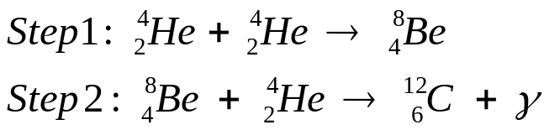

Clearly, in step 1, two helium nuclei combine to form a very unstable isotope of beryllium. In step 2, a third helium nucleus collides with the beryllium nucleus to form a stable isotope of carbon. A gamma ray photon is emitted in this process. Note that the name “triple alpha process” arises from the common name for the helium nucleus – the “alpha particle”.

Some of the carbon produced in the triple alpha process can fuse with another helium nucleus to produce a stable isotope of oxygen, as shown below:

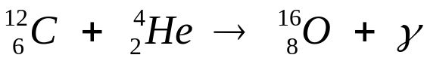

The triple alpha process produces only 10% of the energy per kilogram of fuel compared with hydrogen burning (12). A mature red giant burns helium in its core for about 20% as long as the time spent on the main sequence (3). So, for example, in the distant future our Sun will burn helium for about 2 billion years.

Once the helium burning process has begun in the core of a red giant, the star undergoes further changes. The star’s superheated core expands like an ideal gas. Around the expanding core, temperatures fall, so the hydrogen burning shell reduces its energy output and the star’s luminosity falls. This allows the star’s outer layers to contract and heat up. Thus, after the onset of helium burning, a red giant is less luminous, is hotter at the surface and is smaller than it was before helium burning started.

Study the evolutionary track for a one solar mass star shown on H-R diagram (b) below. In accordance with the physics described above, the track moves toward lower luminosity and higher surface temperature, following a track called the horizontal branch. Stars along the horizontal branch have helium-burning cores surrounded by hydrogen-burning shells.

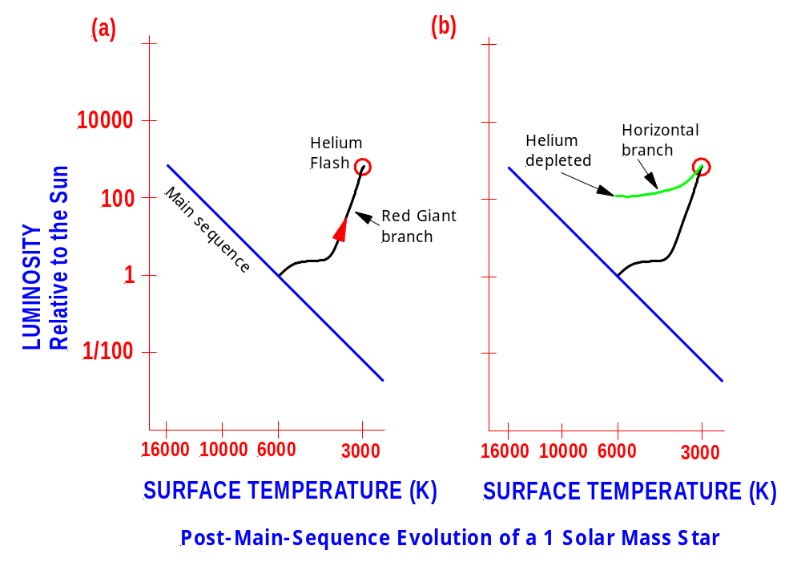

The changes that occur in red giants after the onset of helium burning cause some red giants to become unstable. For instance, the hydrogen burning shell may become sufficiently unstable to cause the star to pulsate as a periodic variable, driven by the changed radiation pressure within (12).

AFTER THE CORE HELIUM-BURNING STAGE

Eventually all the helium in a star’s core is exhausted and core helium-burning ceases. What happens next depends critically upon the ZAMS mass of the star. (1)

STARS LESS THAN 4 SOLAR MASSES

Let us deal first with low mass stars of less than 4 solar masses. The core consists of carbon and oxygen. Around the core is a shell of helium. Surrounding the helium shell is the now dormant hydrogen shell. Without thermonuclear reactions to maintain the core’s internal pressure, the core contracts, releasing heat into the helium shell. Fusion of helium begins in this shell. (3)

The energy released from the shell helium burning causes the outer layers of the star to expand again. Luminosity increases, surface temperature decreases and the star enters a second red giant phase. These stars are called asymptotic giant branch stars (AGB stars) and their evolutionary tracks follow the asymptotic giant branch on the H-R diagram. See below. Stars of less than 4 solar masses in the AGB phase are nearing the final stage in their lives. We will complete their story soon.

Just as an aside, it is interesting to consider why stars of less than 4 solar masses cannot simply start fusing the carbon and oxygen in their cores to produce more energy. The reason is that electron degeneracy pressure stops the cores of such stars from contracting sufficiently to produce the required temperatures for the fusion of carbon and oxygen. The Pauli Exclusion Principle tells us that no two electrons can occupy the same quantum state at the same time. This effectively places a limit on the degree to which a substance can be compressed because eventually the electrons will be so close together that any further compression would violate the exclusion principle. (3)

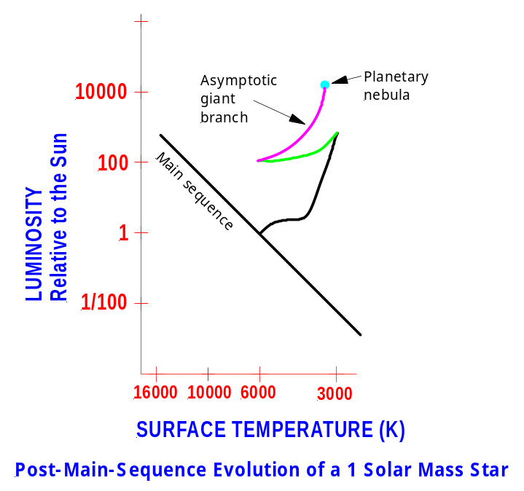

STARS OF 4 OR MORE SOLAR MASSES

Let us now consider what happens to a star of 4 solar masses or more after core helium burning ceases. For such a star, the core is sufficiently massive to continue contracting, increasing the core temperature. When the core temperature reaches 600 million K, carbon burning commences. This fusion process produces oxygen, neon, sodium and magnesium. (3)

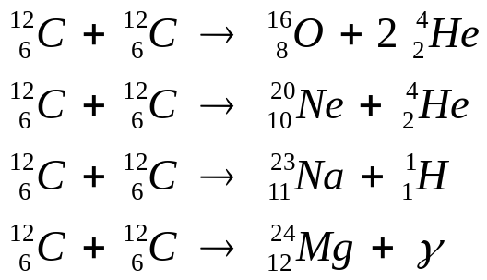
For stars with a ZAMS mass of 8 solar masses or greater, the cessation of carbon- burning results in further contraction and heating of the core. At a core temperature of around 1 billion K neon burning begins, which uses up the neon accumulated from the carbon burning and increases the amounts of oxygen and magnesium in the star’s core.

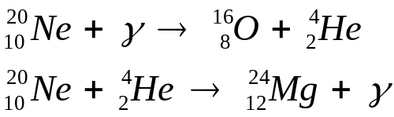

Once the neon burning has finished, the core will contract again and oxygen burning will commence at around 1.5 billion K. This reaction produces sulfur.

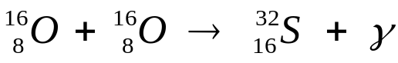

When oxygen burning is complete, the core will contract again and silicon burning commences at around 2.7 billion K. Silicon fusion produces several nuclei from sulfur to iron. (3)

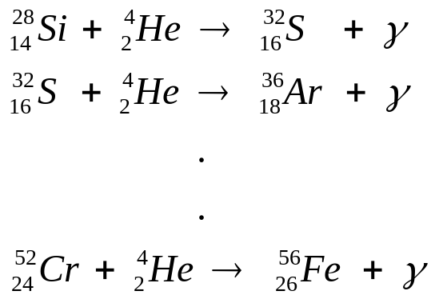

Each new stage of core burning generates a new shell of material around the core. After several such stages, the internal structure of a very massive star (eg a 25 solar mass star) resembles that of an onion as shown in the diagram below. Note that iron is the final element that is produced by the fusion reactions occurring inside the core of a massive star. The fusion of iron or any element heavier than iron consumes energy rather than releasing it. (3)

Between each new stage of core burning comes a period of shell burning and a new red giant phase for the star. This means that the evolutionary tracks of high mass stars go through a series of back-and-forth gyrations on the H-R diagram. See the diagram below showing the evolutionary track for a star of about 10 solar masses. (3)

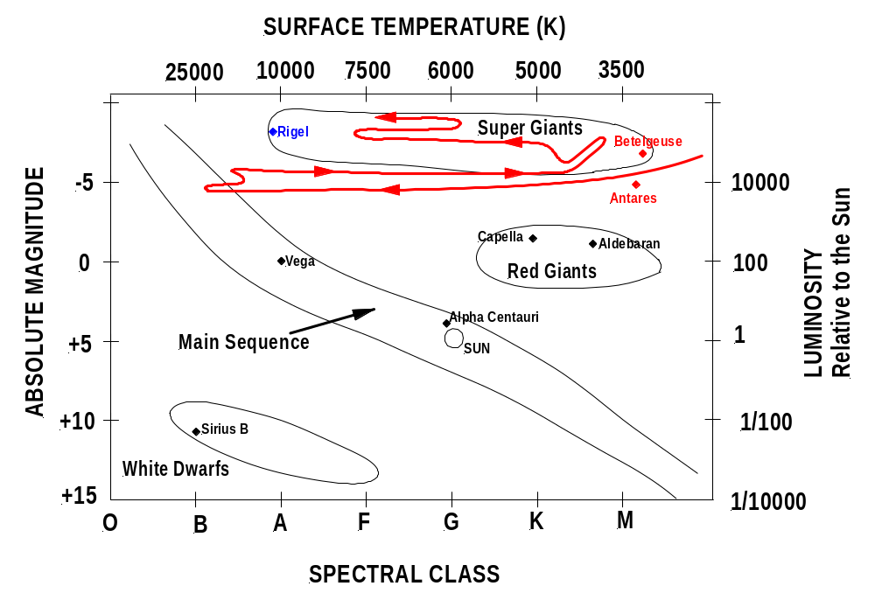

The energy released by the processes described above causes the star’s outer layers to expand greatly. The result is a Supergiant star. The largest supergiants are a thousand times larger than our present-day Sun, with diameters as large as the orbit of Jupiter around the Sun. (3)

Betelgeuse and Rigel in the constellation of Orion and Antares in the constellation of Scorpius are easily observable examples of supergiant stars. Spring/summer is best for observing Orion in Australia and autumn/winter for Scorpius.

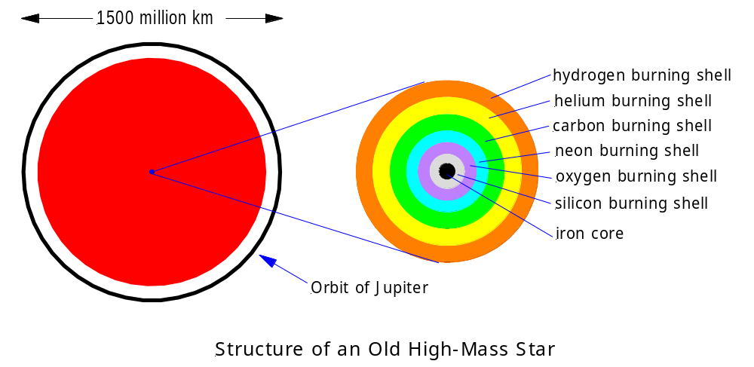

The diagram above has been adapted from Figure 22-13 on p.550 of Ref.3. It shows a high-mass star that has become a supergiant. Its diameter is almost as large as the orbit of Jupiter around the Sun. The star’s energy comes from six concentric burning shells, all contained within a volume roughly the size of Earth. No thermonuclear reactions occur in the iron core, since fusion reactions that involve iron absorb energy rather than releasing it.

NUCLEOSYNTHESIS

Nucleosynthesis is the process of creating elements by nuclear reactions (5). The Syllabus requires that you are able to “discuss the synthesis of elements in stars by fusion”. In the “Cosmic Engine” topic in the Preliminary Course we saw that hydrogen, helium and lithium were created in the Big Bang. We have seen in this topic that hydrogen is fused into helium in main sequence stars, that helium is fused into carbon and oxygen in red giant stars and that all elements up to and including iron can be produced by fusion reactions in the cores of supergiants. Theoretically, you already have sufficient information to successfully answer this Syllabus point, since the remaining elements in the Periodic Table are not produced by fusion reactions.

However, for completeness we will mention the two main processes that are believed to be responsible for the production of the elements heavier than iron. The first of these is the slow neutron capture reaction that occurs in the shells of AGB stars. The s-process, as the reaction is called, involves the capture of neutrons by existing nuclei (eg Fe-56) to form heavier ones. Unstable nuclei formed in this way then undergo the beta-decay process to produce new elements. This process can form elements up to and including lead. Once s-process elements are formed, the AGB star conveniently convects these to the surface, where they may be released either in a stellar wind or in a subsequent supernova explosion. The second process is the rapid neutron capture reaction, also called the r-process. This occurs during type II supernova events and builds on iron to produce all of the heavier elements found in the periodic table. (1 & 15)

Much research continues into the question of how the elements from iron to uranium were made. The rapid proton capture reaction which is believed to be the cause of Nova explosions and X-ray bursts is being investigated as a possible source of heavier elements (15). The possibility that fusion reactions involving iron and progressively heavier elements may be fueled by the huge energy output of a supernova explosion is also being examined (3).

DETERMINATION OF THE AGE OF A STAR CLUSTER

A group of stars formed together from the same giant molecular cloud and held together by gravity is called a cluster (5). There are two main types of cluster – Open Clusters and Globular Clusters. These are distinguished on the basis of appearance, age, size and position in the galaxy. Stars in a cluster are of approximately the same age. (9)

Open clusters contain from a few dozen stars up to a few hundred together with dust and gas from which new stars may be forming. The stars are far enough apart to be resolved by the naked eye or a telescope. Open clusters occur in the galactic plane and are therefore sometimes referred to as Galactic Clusters. Open clusters contain some hot, massive O and B class stars. Since such stars have short lifetimes, open clusters are relatively young. Good examples of easy to find open clusters in the southern hemisphere include the Jewel Box, the Scorpio Clusters M6 and M7 and the Pleiades. (9)

Globular clusters contain from several thousand stars up to several million arranged in spherical-shaped geometries. They contain relatively little dust or gas and no high mass main sequence stars. In fact the stars in them are as old as the galaxy itself. The stars are also very close together, astronomically speaking, and so most stars in the central region of a globular cluster cannot be resolved by earth-based telescopes. Globular clusters are located in the galactic halo region above and below the galactic plane. They are “left-overs” from the formation of the galaxy. There are about 150 known globular clusters in our galaxy and possibly up to about 200 total (14). The brightest example is ω-Centauri, clearly visible with binoculars from Sydney’s latitude all year round. (9 & 10)

The age of a cluster can be determined by plotting an H-R diagram of the cluster. In an H-R diagram for a very young cluster, all the stars lie on or near the main sequence. As time goes by the high-mass, high-luminosity stars are the first to evolve away from the main sequence, as they become red giants. Over the years the main sequence gets shorter and shorter. (1 & 3)

The age of a cluster can be determined from the turnoff point, which is the top of the surviving portion of the main sequence on the cluster’s H-R diagram. The stars at the turnoff point are just completing their hydrogen-burning phase, so their main sequence lifetime is equal to the age of the cluster. Stellar modelling based on the nuclear processes occurring in stars has enabled main sequence lifetimes to be associated with each particular turnoff point. Thus, the age of the cluster can be determined. (1 & 3)

Age determinations have been made for many clusters. The oldest clusters are of course the globular clusters and seem to be almost as old as the universe itself – 12 to 15 billion years. Open clusters are much younger. The Pleiades cluster, for example, is estimated to be about 100 million years old. (12)

Clearly, the accuracy and reliability of the turnoff point determination is paramount. The position of the turnoff point can best be determined by overlaying a theoretical ZAMS (zero-age main sequence) plot drawn to the same scale on top of the H-R diagram for the cluster under study. With the appropriate x-axis scales aligned, the ZAMS plot can then be moved vertically to obtain the best match of the theoretical ZAMS with the observed main sequence on the H-R diagram of the cluster. The turnoff point, where stars are starting to move away from the main sequence, is then usually easy to define.

Be aware that once the turnoff point is identified, there are a few different methods available for determining the age of the cluster depending on what information you have available.

Let us look at an example of the process. Study the colour-magnitude diagram (equivalent to an H-R diagram) for the M55 globular cluster, shown below.

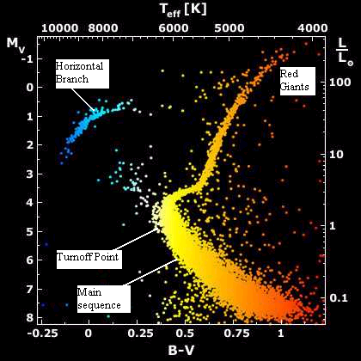

This diagram was adapted from:

http://antwrp.gsfc.nasa.gov/apod/ap010223.html

Each dot in this diagram represents the apparent magnitude (measured through a V filter) and surface temperature (as measured by the colour index, B – V, adjusted for interstellar reddening) of a star in the cluster. Since all of the stars in a cluster are essentially at the same distance from Earth (about 6000 pc in this case), the apparent magnitude (a measure of apparent brightness) is a direct measure of luminosity. (3)

As described above a theoretical ZAMS H-R diagram would be fitted to the main sequence on the H-R diagram of the cluster. This highlights the position of the turnoff point, making it easier to identify. Once this has been done, one could use the B-V value at the turnoff point and some mathematical manipulation to obtain an age for the cluster. Alternatively, one could use the luminosity value at the turnoff point, to calculate the mass of the stars at that point and then use an equation connecting star mass with main sequence lifetime to calculate the age of the cluster.

In the example of the M55 globular cluster, the age of the cluster works out to be between 13 and 15 billion years depending on the method used.

Note that in our study of the age determination of clusters we have stated that the age of the cluster is equal to the main sequence lifetime of stars at the turnoff point. Some could argue that the age of the cluster must be measured from the time of the initial collapse of the molecular cloud (1). Strictly speaking this is true. However, the time taken for the pre-main sequence evolution of the stars at the turnoff point is only a very small fraction of the time spent by those stars on the main sequence (3). Therefore, it is reasonable to approximate by saying that the age of the cluster is equivalent to the main sequence lifetime of stars at the turnoff point.

Extension – Non-Examinable:

The term “Horizontal Branch” appears on the H-R diagram for the M55 cluster. Just for the record, horizontal branch stars are post-helium-flash, low-mass stars with luminosities of about 50 times that of the Sun and in which there is both core helium burning and shell hydrogen burning. These stars will eventually move back toward the red giant region as their fuel is exhausted.

Also for those who are interested, for main sequence stars, the relationships between the luminosity, mass and time on the main sequence are as follows:

Luminosity is directly related to mass:

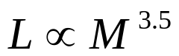

Lifetime on the main sequence, t, depends critically on both mass and luminosity:

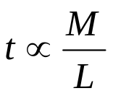

Joining these two equations together we have:

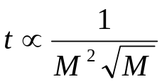

These equations can be used to calculate estimates of main sequence lifetimes.

STELLAR DEATH

“Out, out brief candle! Life’s but a walking shadow, a poor player that struts and frets his hour upon the stage and then is heard no more.” Shakespeare – Macbeth Act 5 Scene 5.

All material things come to an end. As powerful and as majestic as all stars are, eventually they grow old and die. Eventually all stars reach a stage where the material in their cores cannot undergo further fusion. This could be because the core cannot contract any further to reach the temperature required for the next possible set of fusion reactions or it could be that the core consists of iron, which will not fuse to produce energy. Around these dormant cores, fusion continues in the various shells that each star has developed during its lifetime. In their death throes all stars shed their shells into space and undergo core collapse by gravity.

STARS OF 8 SOLAR MASSES OR LESS

Current research indicates that all stars with ZAMS masses of 8 solar masses or less shed a large portion of their mass during the AGB phase of their evolution. During this phase, alternating ignitions of hydrogen and helium burning shells produce the energy in the star. As each new helium-shell-burning episode begins bursts of energy known as thermal pulses spread outwards through the star blowing mass into space. A 1 solar mass star loses about 40% of its mass. The more massive the star, the higher the proportion of its initial mass that is lost. (1 & 3)

During these thermal pulses, the outer layers of the star can separate completely, exposing the hot core. Ultraviolet radiation from the exposed core ionizes and excites the expanding shell of ejected gases. These gases therefore glow and emit visible light, producing a planetary nebula. Over time, perhaps no more than 50 000 years, the planetary nebula disperses, cools and fades from view. Note that the name “planetary nebula” is really a misnomer. It comes from the fact that through a small telescope the expanding shell of glowing gas can look like a planet. (1 & 3)

No more nuclear reactions take place in the exposed core. If it has not already done so, the core collapses under gravity and provided its mass is not greater than 1.4 solar masses, it becomes a degenerate (non-contracting), dense sphere about the same size as the Earth. The star is now called a White Dwarf. The interior of a white dwarf consists mainly of carbon and oxygen atoms floating in a sea of degenerate electrons. The White Dwarf gives off thermal radiation, which causes it to glow. As it cools, it remains the same size, since the degenerate electron pressure does not depend on temperature but becomes less luminous, eventually fading into obscurity as a black dwarf. (1 & 3)

Note that the 1.4 solar mass limit to the size of a white dwarf is called the Chandrasekhar limit, after the Indian-American Physicist Subrahmanyan Chandrasekhar, who did pioneering research on white dwarfs. The Chandrasekhar limit is the maximum possible mass of a degenerate star, above which it will be unable to support itself against the inward pull of its own gravity (5).

It is worth considering at this stage what the evolutionary tracks of stars look like as they become white dwarfs. Starting from the top of the AGB, the track moves horizontally from right to left across the H-R diagram as the temperature increases. In some cases loops appear on the diagram corresponding to thermal pulses. As the planetary nebula and core cool, luminosity decreases and the track turns down towards the lower right hand corner of the H-R diagram. See the excellent H-R diagram below for a 1 solar mass star, taken from the Sloan Digital Sky Survey website at:

http://cas.sdss.org/dr4/en/astro/stars/stars.asp

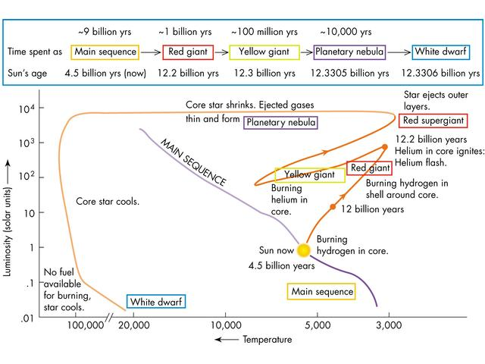

STARS OF MORE THAN 8 SOLAR MASSES

Stars with ZAMS masses of greater than 8 solar masses experience a different death. Stars with more than about 8 solar masses explode as type II supernovae after a lifetime of only a few million years and become neutron stars or black holes. (3)

Such massive stars still experience the large mass loss due to thermal pulses and the core collapse that less massive stars experience. The difference, however, is that with these more massive stars the core is greater than 1.4 solar masses when core collapse begins. So, as the core collapses under its own gravity the electron degeneracy pressure is unable to stop the collapse. In a fraction of a second, the core becomes so dense that electrons and protons are forced to combine to form neutrons. This process releases neutrinos that carry large amounts of energy out of the core, cooling it dramatically. If the mass of the core is less than about 3 solar masses, the neutron degeneracy pressure in the core brings the collapse to a sudden stop. At this stage the density of matter in the core is about 10¹⁷ kg/m³ – the density of nuclear matter. (3 & 5)

Due to the sudden stop of the collapse, the innermost portion of the core bounces back and expands. This causes a powerful pressure wave to spread outwards from the core. At the same time, the dramatic cooling of the core caused by the escaping neutrinos reduces the pressure in the regions surrounding the core and causes the matter in these regions to fall inwards at speeds up to 15% the speed of light. When the inward-falling material hits the rigid iron core, it meets the outward-moving pressure wave. The result is an outward–moving shock wave that totally disrupts the star. The energy released by this shock wave is of the order of 10⁴⁶ joules – a hundred times more energy than the Sun has emitted in its whole lifetime. (3)

The energy spreading throughout the star drives the reactions that produce all the elements heavier than iron. The shock wave blows most of the matter that made up the star out into space as a cloud of expanding gas and dust. This matter will one day seed the formation of new stars. (3)

During this explosion, the luminosity increases up to several billion times as the core is partly exposed and the star appears brighter than an entire galaxy. This increased brightness lasts for several days and fades away over a period of months. This explosive event is called a supernova (plural - supernovae) and the dense, collapsed stellar core left behind is referred to as the supernova remnant. (1 & 3)

As an aside, it is worth mentioning that the event described above is a type II supernova, resulting from the death of a massive star. SN1987A is an example of a type II supernova that was observed in the Large Magellanic Cloud in 1987. The star that exploded in this case is believed to have been a blue supergiant star with a ZAMS mass of about 20 solar masses. Other types of supernova exist. Type Ia supernovae for example result from the catastrophic explosion of a white dwarf star in a close binary system. It is caused by runaway carbon fusion in the white dwarf triggered by mass transfer from its companion red giant star. (3)

The nature of the supernova remnant depends critically on the mass of the core of the progenitor star – the star that exploded. For stellar cores greater than 1.4 solar masses but less than about 3 solar masses a neutron star results. As described above, the matter within such a core has been crushed to nuclear densities and exists as neutrons. The neutron star is protected against further gravitational collapse by the degenerate pressure of neutrons. A typical neutron star with a mass a little greater than the Sun’s would have a diameter of only 30 km and a density such that the mass of the entire human race would occupy the volume of a sugar cube! Neutron stars also possess huge magnetic fields, of the order of 1 x 10⁸ T. Compare this to the magnetic field at the surface of the Sun – around 10⁻⁴ T. (3 & 5)

All neutron stars spin rapidly due to the conservation of angular momentum of the original star. As a star shrinks down to become a neutron star, its rotation must speed up. Charged particles that have been accelerated near the neutron star’s magnetic poles produce two oppositely directed beams of radiation that emanate from the magnetic poles. As the star rotates, these beams sweep through space. If the Earth happens to lie in the path of the beams, we detect radiation that appears to pulse on and off. Such a neutron star is called a pulsar. The radiation it emits can be of varying kinds – radio, optical, X-ray and gamma. See diagram below. The first pulsar was discovered by Jocelyn Bell at Cambridge University in 1967. The Crab Nebula is the remnant of a supernova explosion in the constellation Taurus first observed in 1054. The stellar corpse at its centre is a pulsar. (3 & 12)

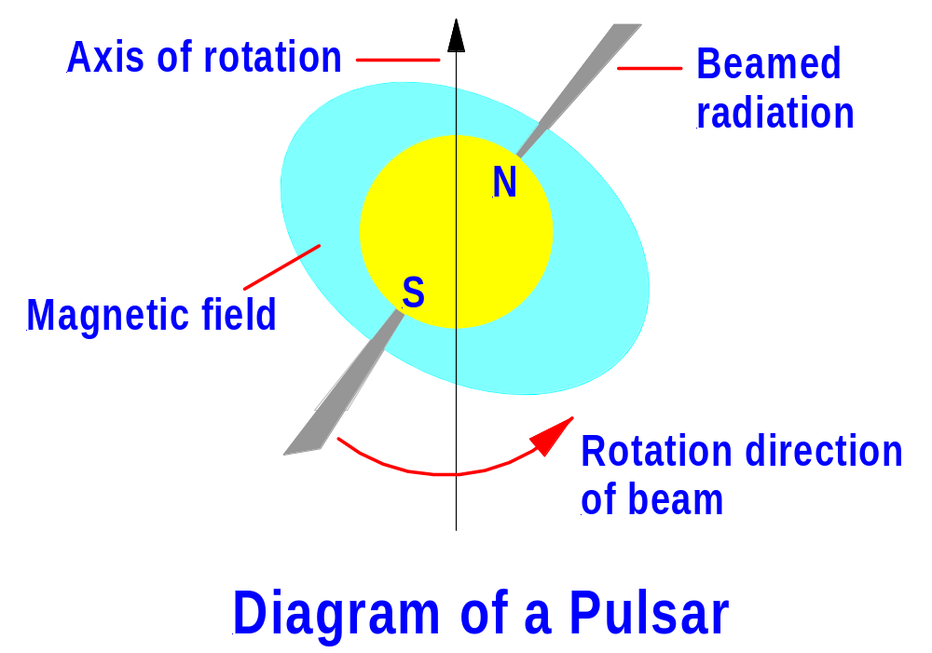

If the core of the exploding star is greater than about 3 solar masses, nothing can stop its gravitational collapse to a black hole. A collapsing star becomes a black hole when its radius has shrunk to a critical size, known as the Schwarzschild radius, at which gravity is so strong that not even light can escape from the surface of the star. The surface having this critical radius is called the event horizon and marks the boundary inside which all information is trapped. Hence, events within a black hole cannot be observed from outside the event horizon. Theory indicates that both space and time become distorted inside the event horizon and that an object collapses to a single point, a singularity, at the centre of a black hole. (3 & 5)

Do black holes really exist? Today, there is compelling astrophysical evidence that they do. Many examples of possible black holes have been found. Cygnus X-1 is a strong source of X-rays in our own galaxy that is believed to be a black hole. Supermassive black holes are believed to lie at the centres of many galaxies including our own. (3)

The following flowchart is a useful summary of stellar evolution.

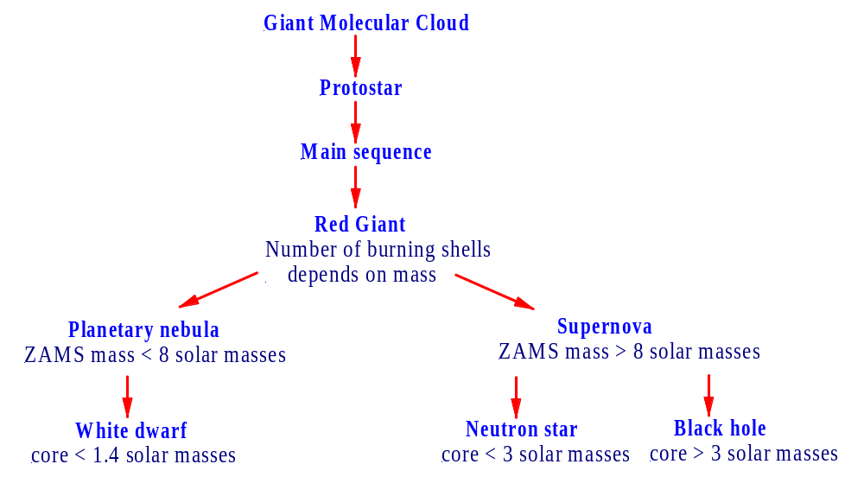
BIBLIOGRAPHY

- Carroll, B.W., & Ostlie, D.A. (1996). An Introduction To Modern Astrophysics, New York, Addison-Wesley Publishing Company Inc.
- Gondhalekar P. (2001). The Grip of Gravity, Cambridge, Cambridge University Press
- Kaufmann, W.J. III, & Freedman, R.A. (1999). Universe, (5th Edition), New York, W.H. Freeman & Company
- Sidereus Nuncius or the Sidereal Messenger. Translated with introduction, conclusion, and notes by Albert Van Helden. Chicago: University of Chicago Press, 1989
- Ridpath, I. (Ed.) (1997). Oxford Dictionary of Astronomy, Oxford, Oxford University Press
- Hollow, R. Why Build Big Telescopes?, paper presented at Science Teachers Workshop 2002
- http://www.eso.org/projects/aot/introduction.html and http://www.ls.eso.org/lasilla/sciops/ntt/telescope/esontt.html
- Eisberg, R. & Resnick, R. (1974). Quantum Physics of Atoms, Molecules, Solids, Nuclei and Particles, Canada, Wiley
- Playoust, D.F., & Shanny, G.R. (1991). An Introduction to Stellar Astronomy, Queensland, The Jacaranda Press
- Bhathal R., (1993). Astronomy for the Higher School Certificate, Kenthurst, Kangaroo Press Pty Ltd
- Dawes, G., Northfield, P. & Wallace, K. (2003). Astronomy 2004 Australia – A Practical Guide to the Night Sky, Australia, Quasar Publishing
- Andriessen, M., Pentland, P., Gaut, R. & McKay, B. (2001). Physics 2 HSC Course, Australia, Wiley
- Schilling, G. (2004). Evolving Cosmos, Cambridge, Cambridge University Press
- http://www.seds.org/messier/glob.html - Globular Star Clusters
- Astrophysics & Cosmology at Florida State University
http://www.physics.fsu.edu/research/Astrophysics/AstroPhysics.html

