Dynamics Worksheet 5 - Momentum

- A 2200 kg car, travelling at 25 m/s south, comes to a stop in 10 s. Calculate (a) the initial momentum of the car; (b) the final momentum of the car; (c) the impulse of the net force applied by the brakes; and (d) the magnitude of the net force applied by the brakes. (55000 kgm/s south, 0 kgm/s, 55000 kgm/s north, 5500 N north)
- A hammer strikes a nail with a force of 55 N for a period of 0.2 s. Calculate the impulse of the force. (11 kgm/s)
- For how long must an explosive force of 3.3 x 10⁴ N act on a stationary bullet of mass 0.15 kg to give it a velocity of 220 m/s? (0.001 s)
- 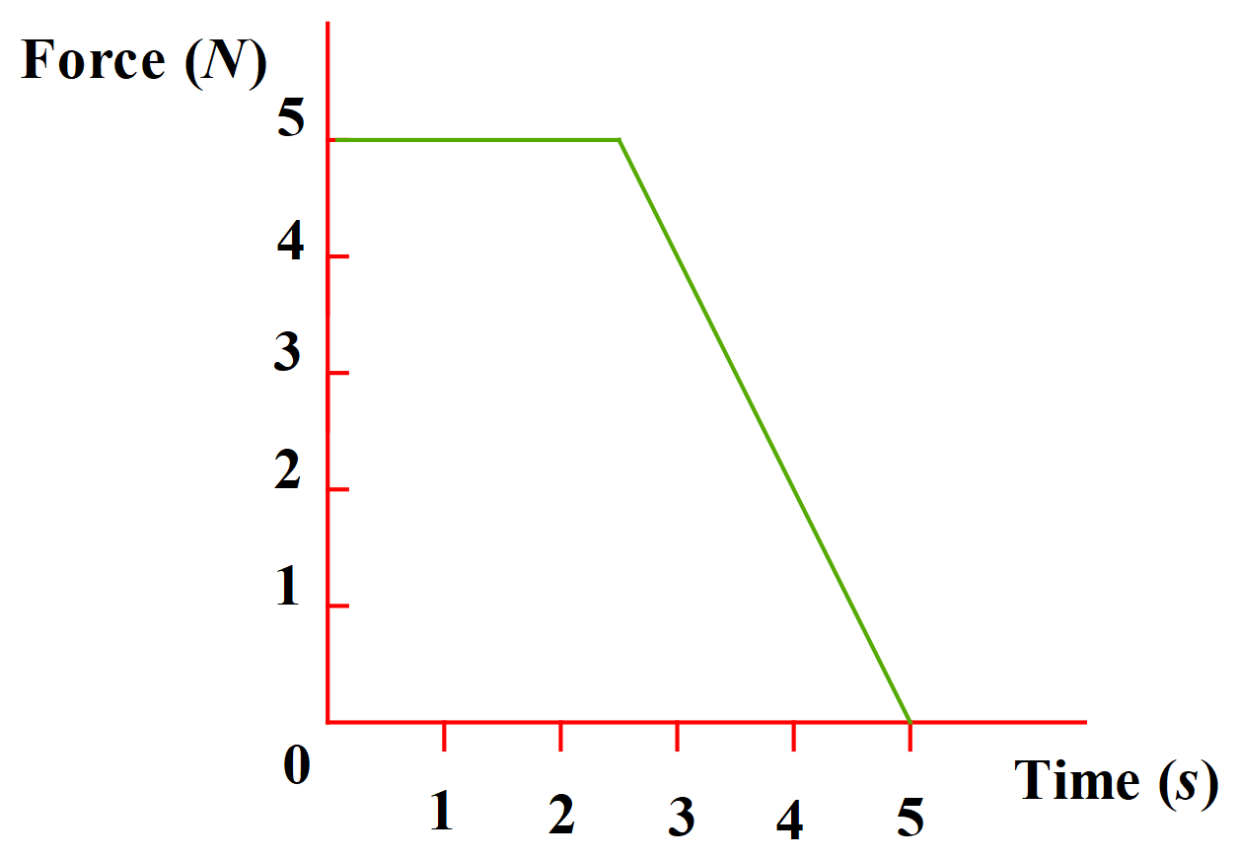A mass of 2 kg experiences a varying force as given in the diagram below. Determine the change in velocity of the mass. (10 m/s)

- In experimental tests run by the manufacturer, a car of mass 1500 kg travelling at 20 ms⁻¹ due east collides with an identical stationary car. If all the kinetic energy of the moving car is transferred to the stationary car during the collision, describe quantitatively and qualitatively the expected results of the collision. (See below question 8 for the answer – don’t look at it yet!)

- Laboratory Trolley Car A has a mass of 0.9 kg and Laboratory Trolley Car B a mass of 0.5 kg. For each of the situations below, describe quantitatively and qualitatively the expected results of the collision for Car A:
  - Car A moves east at 0.5 ms⁻¹ and collides but does not coalesce with Car B moving west at the same speed. After collision, Car B is moving east with a speed of 0.79 ms⁻¹. (Car A: v = 0.22 m/s west)
  - Car A moves east at 0.5 ms⁻¹ and collides but does not coalesce with Car B moving east at 0.3 ms⁻¹. After collision, Car B is moving east with a speed of 0.56 ms⁻¹. (Car A: v = 0.36 m/s east)
  - Car A moves east at 0.4 ms⁻¹ and collides but does not coalesce with Car B moving west at 0.3 ms⁻¹. After collision, Car B is moving east with a speed of 0.6 ms⁻¹. (Car A: v = 0.1 m/s west)
  - Car A moving at 0.3 ms⁻¹ east collides and coalesces with Car B moving at 0.5 ms⁻¹ west. (Car A & B: v = 0.014 m/s east)
(Hint: Use appropriate signs, +, -, to designate direction.)

- A car of mass 1300 kg travelling at 25 m/s collides head-on with a solid rock cliff face. If it takes 0.1 s for the car to come to rest, calculate the force applied to the car in the opposite direction to its original motion. (325,000 N)
- Go to the URL below and test out your answers to question 6 using the collision simulation provided there. Use 100% elasticity for parts a to c inclusive. Use 0% elasticity for part d.
https://phet.colorado.edu/sims/collision-lab/collision-lab_en.html

Answer to question 5: Upon collision, the car initially moving with a velocity of 20 ms⁻¹ due east will come to a complete stop. The car initially stationary will move off with a velocity of 20 ms⁻¹ due east.

