# PHYSICS COURSE – YEAR 11

**MODULE 2: DYNAMICS**

The area of Physics that is concerned with the motion and equilibrium of bodies in a particular frame of reference is called **“mechanics”**. The branch of mechanics called **Dynamics** deals with forces that change or produce the motions of bodies.

**FORCES**

**Inquiry Question:** How are forces produced between objects and what effects do forces produce?

**What is a Force?**

In simple terms a force can be defined as a push or a pull. We experience examples of forces every day. If we push a stationary lawn mower (with enough force) it begins to move – that is, it accelerates and its velocity increases. If we push on the brakes of a moving bicycle, it slows down – that is it decelerates (or undergoes negative acceleration). If we apply sufficient force to an aluminium can, by squeezing it with our hand, we can change the shape of the can.

So, a force can cause a change in the state of motion of an object or a change in the shape of an object. In fact, all accelerations (and decelerations) are caused by forces.

**Does every force cause acceleration?**

Again, from our everyday experience, we know the answer to this question is “no”. If a person pushes on the brick wall of a house, the house does not accelerate. Sometimes when we want to push or pull an object from one place to another we find that no matter how hard we push or pull, we just cannot move (accelerate) the object.

**What is the relationship between force and acceleration?**

We could perform an experiment to determine the relationship between the size of a force applied to an object at rest on a laboratory bench and the change in velocity experienced by the object over a set period of time (ie the acceleration). The same object would be used on the bench each time so that the mass of the object being accelerated is the same each time. Such an experiment would produce results as shown below.



The graph above shows that:

* The change in velocity does not happen instantaneously. A certain amount of force is required before the object begins to accelerate. This makes sense, since the force of friction between the bench and the object must be overcome before the object can move. So, we can say that **a net external force is required in order to change the velocity of an object.**
* **The acceleration produced is directly proportional to the force applied.** If we repeated the experiment on a frictionless surface (eg using a dry-ice puck on a very smooth, polished table top) the straight-line graph would even pass through the origin.

**What is the relationship between acceleration and mass?**

We could measure the accelerations produced when the same sized force is applied to different objects. Such an experiment would produce results like those below.



The graph above suggests that there is an inverse relationship between acceleration and mass. A plot of acceleration versus the reciprocal of mass, using the same data, would produce a graph similar to that below.



This graph clearly shows that:

* **The acceleration produced by a given force is inversely proportional to the mass of the object.**

From experiments such as those above, we can say that:

 and 

**FOR SOME FUN:** **View this video of** [**a person walking on eggs**](http://www.youtube.com/watch?v=Xckhg7Ns8so&feature=related).

**NEWTON’S LAWS OF UNIFORMLY ACCELERATED MOTION**

Sir Isaac Newton (1643-1727) was an English mathematician, astronomer, and physicist who is widely recognised as one of the most influential scientists of all time and a key figure in the scientific revolution.

**Newton’s First and Second Laws:**

By combining the results above, we obtain:

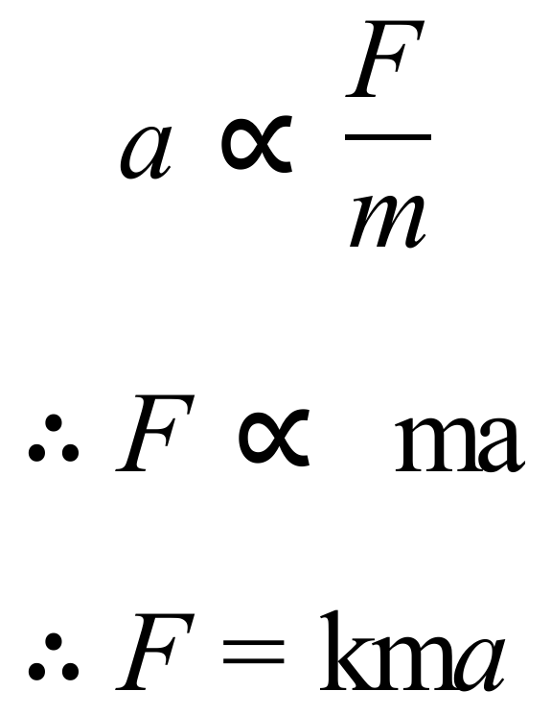

Note that in mathematics when you wish to replace a proportionality sign by an equal sign, you do so by including a constant as shown above. This constant is called the constant of proportionality, k, in the case above.

By defining our units of force appropriately, we can make the constant equal one. So, we define one unit of force to be that force which causes a mass of 1 kg to accelerate at 1 ms-2. Then k must equal one as well. It makes the equation simpler if k equals one. So, we have:

F̰ = ma̰

**This can be taken as a statement of Newton’s Second Law. The SI Unit of force is the newton (N), defined so that 1N = 1kgms-2.**

Note that in the above equation, **F** is the vector sum of all the forces acting on the object. This is called the **net force** or the **resultant force**. Note too that **m** is the mass of the object and **a** is its acceleration. To remind us of the fact that **F** is a vector sum, we use the Greek capital sigma to indicate “the sum of” :

Σ F̰ = ma̰

Note that if the resultant force on the object is zero, there is no acceleration. Therefore, in the absence of a resultant force (a net force), an object’s velocity will remain unchanged. **In other words, an object at rest will remain at rest, and an object in motion will remain in motion with uniform velocity, unless acted upon by a net external force. This is a statement of Newton’s First Law, which in fact is contained in the Second Law as a special case (for F = 0).**

Consider the following examples:

1. Consider a bridge, any bridge. Let’s say the Sydney Harbour Bridge. It is a very complex structure. The various girders and structural members that go into the construction of such a bridge experience and provide forces in various sections of the structure. Overall these forces add together to give a net force of zero. The bridge does not accelerate. It is **static** (stationary) and is said to be in **static equilibrium**. Note that forces are present, but they balance each other in such a way that there is no net force on the bridge. If you added all the forces together using vector addition you would get zero as the answer.
2. Consider a tug-of-war competition. If the two teams pulling in opposite directions each apply the same size force constantly, the middle of the rope, marked with a ribbon, does not move. This would be called a **static interaction** between the two teams. The force to the right equals the force to the left. No acceleration eventuates. If the team pulling to the right applies twice the force of the team pulling to the left, the middle of the rope accelerates towards the right. This would be called a **dynamic interaction** between the two teams because it results in a net acceleration in a direction.
3. Consider a drone in flight. If its motor applies a constant net force in a direction due East, the drone will accelerate due East for as long as the force continues. If we know the force applied and the mass of the drone we could use F = ma to calculate the net acceleration of the drone.

**Newton’s Third Law:**

Forces acting on a body originate in other bodies that make up its environment. Any single force is only one aspect of a mutual interaction between two bodies. We find by experiment that when one body exerts a force on a second body, the second body always exerts a force on the first. Furthermore, we find that these forces are equal in size but opposite in direction. A single, isolated force is therefore an impossibility.

If one of the two forces involved in the interaction between two bodies is called an **action force**, the other is called the **reaction force**. Either force may be called the action and the other the reaction. Cause and effect is not implied here, but **a mutual simultaneous interaction is implied**.

This property of forces was first stated by **Newton in his Third Law: “To every action there is always opposed an equal reaction; or, the mutual actions of two bodies upon each other are always equal, and directed to contrary parts.”**

In other words, if body A exerts a force on body B, body B exerts an equal but oppositely directed force on body A; and furthermore the forces lie along the line joining the bodies. Notice that **the action and reaction forces, which always occur in pairs, act on different bodies**. If they were to act on the same body, we could never have accelerated motion because the resultant force on every body would be zero.

Mathematically, we can write that the force of body A on body B, FAB = - the force of body B on body A, FBA.

That is: F̰AB = - F̰BA

Consider the following examples of Newton’s Third Law:

1. Imagine a boy kicking open a door. The force exerted by the boy B on the door D accelerates the door (it flies open); at the same time, the door D exerts an equal but opposite force on the boy, which decelerates the boy (his foot loses forward velocity). The force of the boy on the door and the force of the door on the boy is an action-reaction pair of forces.
2. When you walk, you apply a force backwards on the earth. Likewise, the earth applies a force to you of equal magnitude but in the opposite direction. So, you move forwards.   
   The force of the person on the earth and the force of the earth on the person is an action-reaction pair of forces.
3. Consider a body at rest on a horizontal table: ****Each of the pairs of forces above is an action-reaction pair of forces. (If you are not sure where the forces on the left side of the diagram come from – read below.)

Note that the forces in examples 1 & 2 above were applied by direct contact between two objects. The boy made contact with the door to kick it; the person made contact with the Earth’s surface to push it backwards. The forces in example 3, however, are applied seemingly at a distance – the Earth attracts the body on the table from a distance and the body on the table attracts the Earth from a distance. Forces can be applied in each of these ways.

**Force of Gravity**

The force of gravity is an example of a force that is **mediated** by a field, in this case the gravitational field. The word “mediated” here means “brought about by” or “conveyed by”, or “caused by”. A field in Physics is a region of influence of some kind. A gravitational field is a region in which a finite mass experiences a force due to the presence of another mass a certain distance away from it.

We shall refine and enhance our understanding of gravitational fields in Year 12. For now, it will suffice to understand that every mass exerts an attractive force on every other mass in the universe. The closer the masses are together, the stronger the attractive force.

Any mass near the Earth experiences a force due to the gravitational attraction of the Earth. This force is directed towards the centre of the Earth and causes the mass to accelerate towards the centre of the Earth. It is this force that keeps each of us firmly attached to the ground.

Close to the Earth’s surface this force causes masses to accelerate at approximately 9.81 m/s2. This value of acceleration, called the acceleration due to gravity, is the one that we use in most questions and problems in this course. We shall see in Year 12 how this value is calculated using a combination of Newton’s Law of Universal Gravitation and Newton’s Second Law equation.

For completeness, we should also state that the Earth experiences an equal but oppositely directed force of gravitational attraction towards the mass.

**Definitions of Mass and Weight:**

The **mass** of an object is a measure of the amount of matter contained in the object. Mass is a scalar quantity.

The **weight** of an object is the force due to gravity acting on the object. Weight is a vector quantity.

The weight, W̰, of an object is given by Newton’s 2nd Law as:



where **m** is the mass of the object and **g** is the acceleration due to gravity (9.81 ms-2 close to the earth’s surface).

**Normal Reaction Force**

Consider a wooden box sitting on level ground as shown below. The box is stationary. There is no relative movement between the box and the ground. Yet, it is true that the box experiences a force due to gravity acting on it downwards towards the centre of the Earth. So, there must be another force acting on the box upwards and balancing the force down due to gravity.

This upwards force is supplied by the Earth’s surface which pushes upwards on the box. This force is called the **normal reaction force**, often labelled **N̰** or **N̰R** and is equal to the weight of the box. It is the reaction force to the force exerted by the bottom of the box on the surface of the Earth. The word “normal” refers to the fact that the direction of the force is perpendicular to the surface on which the box is sitting.

Study the diagram below. Also have a look back at the diagram in example 3 under Newton’s Third Law.

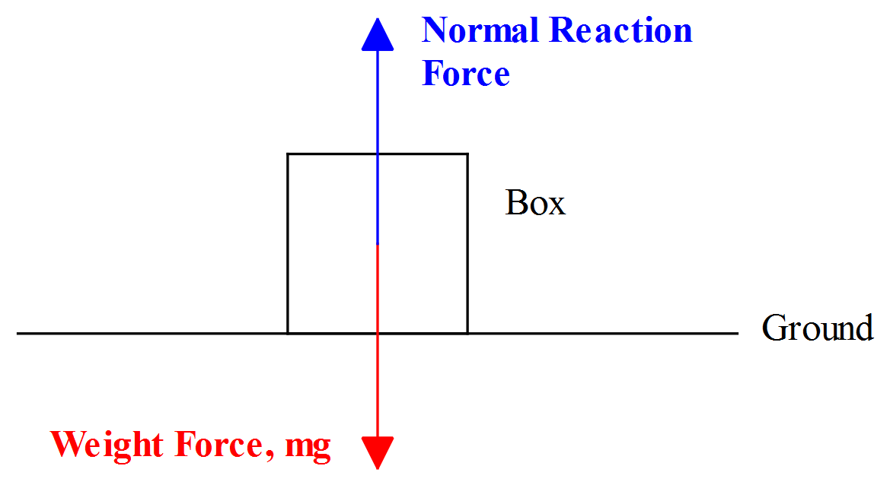

**Examples of Net Force and Equilibrium**

The net force acting on an object is the sum of all forces acting on the object. Algebraic or vector addition may be used to determine the net force acting on an object.

**Example 1:** Suppose a car was being pushed on level ground by three people applying forces of 100N, 120N and 140N respectively all in the same direction. Suppose too, that there was another person at the other end of the car pushing with a force of 110N in the opposite direction. The net force on the car can be determined by algebraic addition.

Net Force on Car = 100 + 120 + 140 – 110 = 250N

**Example 2:** Four children pull on a small tree stump firmly stuck in the ground. Looking down on the tree stump from above, the forces applied by the children are as shown below.



Determine the net force acting on the tree stump.

The quickest approach to this problem is probably to use the graphical method of vector addition. To do this we construct a vector polygon, using the rules stated in Module 1. Then we **measure** the size and direction of the resultant. See the diagram below.



## The net (or resultant) force, R, acting on the stump is found by measurement to be 3.1 N at an angle of 39o clockwise from the direction of the 4.5 N force.

# Example 3: You will remember from Module 1 that any vector may be resolved into two component vectors at right angles to each other. These components are called the rectangular components of the vector. The rectangular components of a vector add up to the original vector.

# Let’s imagine we are pushing another car. This time, however, we shall push with a force F̰ at an angle of  to the horizontal, as shown below. We may wish to know the net force acting on the car in the horizontal direction. This would be useful for calculating the acceleration of the car as a result of it being pushed.



The force F̰ may be resolved into its vertical and horizontal components as shown below. Clearly, when you apply a force at an angle as shown above, some of the force acts downwards and some of the force acts horizontally.



The magnitude of each component can then be calculated using simple trigonometry. The size of the vertical component of F is Fsin. The size of the horizontal component of F, the one that must overcome the force of friction if we are to move the car forward, is Fcos. So, if we were given the size of F̰ and the angle   we could calculate the net force acting on the car in the horizontal direction.

Example 4: Consider the diagram of a Force Board below.

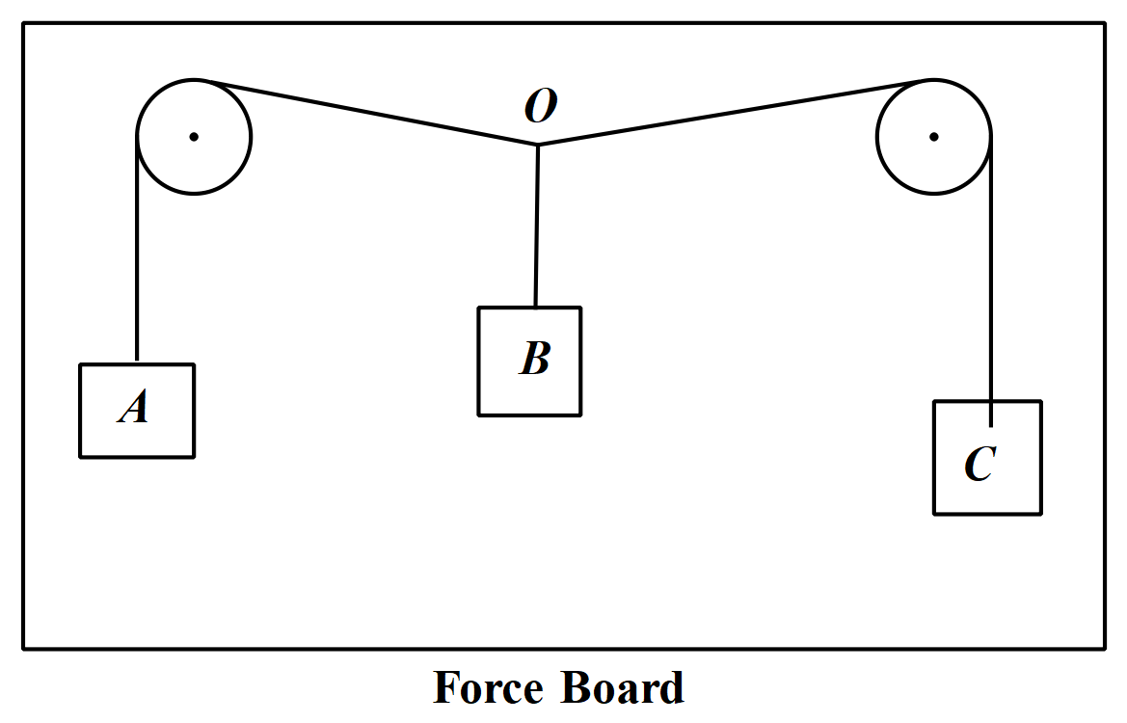

Among other things, Force Boards are useful for demonstrating an **equilibrium of forces**. You will almost certainly do this at some stage as a practical exercise in class.

Two masses, A and C, hang from the pulleys and one mass, C, hangs between the pulleys to achieve equilibrium in the system of three masses. The masses are stationary. A careful tracing is taken of the angles made by the strings at the point labelled O in the diagram above. A vector diagram is then drawn of the situation. Let’s imagine that in this case the angles are as shown below.

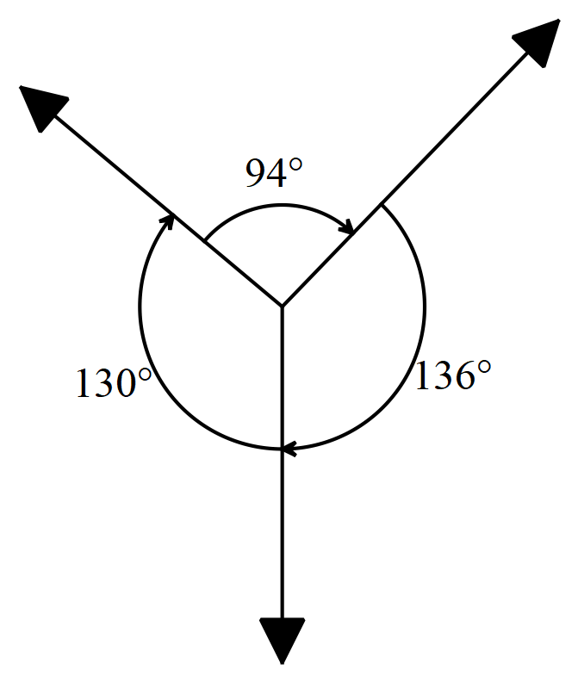

Let’s also imagine that mass A applies 0.70N of force downwards. This force is applied at point O via the tension in the string and acts back towards the pulley. Similarly, mass C applies a force at point O via the tension in the string that acts back towards its pulley. Mass B applies a force downwards at point O due to its weight. If mass B applies 1.00N force and the force applied by mass C is unknown, we can find this unknown force by using a vector diagram.

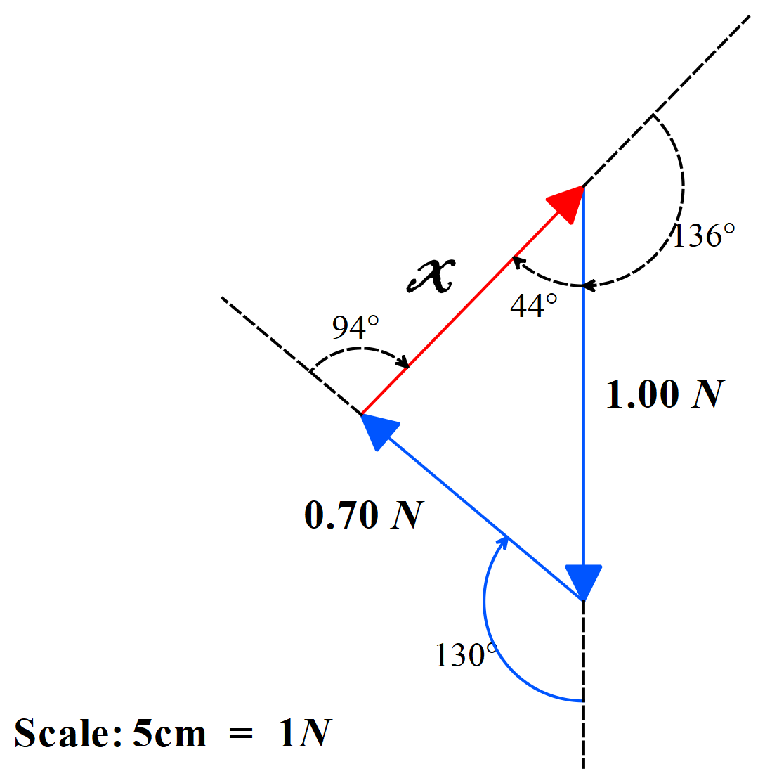

**Since the forces are in equilibrium they must add together to give zero.** That is, they must balance one another so that the net force acting on the system of masses is zero. That is what being in equilibrium means.

To draw the scaled diagram above, we started with the 1.00N force. We added the 0.70N force to it ensuring we used the correct angle between the directions of the two forces. The third vector, in red, is the equilibrant, which as you know from Module 1, closes the vector diagram in the same sense as the component vectors. By measuring the length of this vector and using the scale we can determine the size of the unknown force. It works out to be 0.77N.

Note that when you do this exercise as a practical, you need to be very careful with your measurements and especially with the trace of the angles made by the strings at point O. Otherwise, you will find that your vector diagram does not close, even though you know the system was at equilibrium.

**Example 5:** Two blocks are in contact on a frictionless table. A horizontal force is applied to the larger block as show in the diagram below.

1. If m1 = 2.3 kg, m2 = 1.2 kg and F = 3.2 N, find the magnitude of the force between the two blocks. (Ans: 1.1 N)
2. State the force (magnitude & direction) which mass 1 applies to mass 2 and which mass 2 applies to mass 1.
3. Show that if a force of the same magnitude F is applied to the smaller block but in the opposite direction, the magnitude of the force between the blocks is 2.1 N.
4. Explain the difference between the two values calculated for the force between the two blocks.

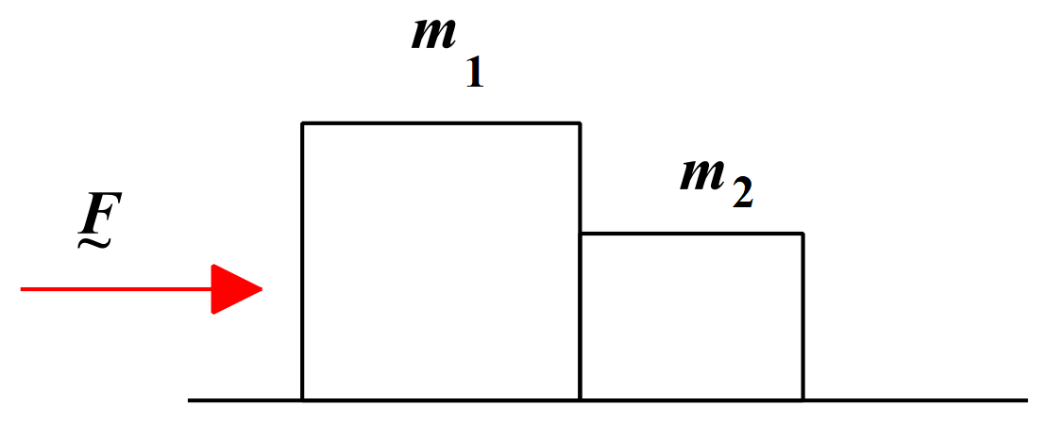

In order to solve these questions, we must understand that when mass 1 pushes against mass 2, as in part (a), mass 2 pushes back against mass 1 with the same force in the opposite direction. This is in accordance with Newton’s 3rd Law and can be expressed mathematically as F̰12 = - F̰21.

Intuitively, we can say that the force F̰ acts on a combined mass of (m1 + m2) = 3.5 kg to produce an acceleration. We can use Newton’s 2nd Law equation, F = ma, to calculate that acceleration. Then we can use the acceleration to determine the force that is acting on each mass.

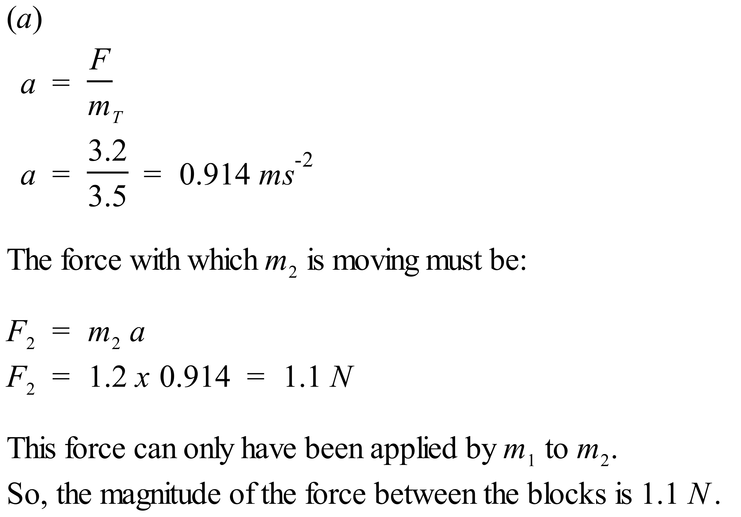

(b)

The force that mass 1 applies to mass 2, F̰12 = 1.1 N to the right.

The force that mass 2 applies to mass 1, F̰21 = 1.1 N to the left.

These forces are an action-reaction pair of forces and F̰12 = - F̰21

To solve part (c), we follow the same procedure as in part (a). Clearly, we shall get the same acceleration as in part (a) because we have the same sized force acting on the same total mass, just in the opposite direction.

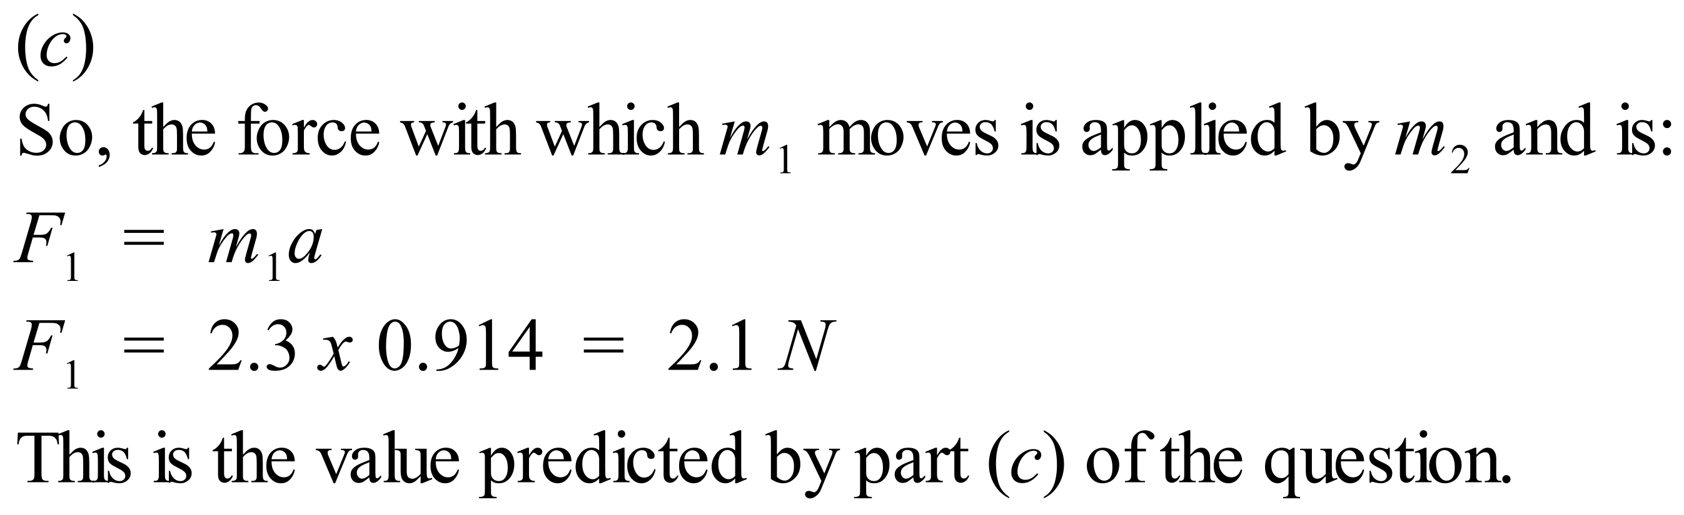

(d)

So, why the difference in values between (a) & (c)? It makes sense that the values would be different. As we have seen, the acceleration is the same whether we push from the left or from the right. In part (a) the action force acting to the right on mass 2 only had to move a mass of 1.2 kg with an acceleration of 0.914 ms-2. In part (c) the action force acting to the left on mass 1 had to move a larger mass of 2.3 kg with an acceleration of 0.914 ms-2. Hence the force between the blocks had to be larger in part (c) than in part (a).

The method we have used to solve this problem is often referred to as an intuitive method. We have applied the laws of physics and used very straight forward maths to solve the problem. Now is a good time to bring to your attention a more mathematically rigorous method of solving this problem. In this case it takes longer to solve this way, but it is important that you see that there are more ways than one to solve a physics problem. As problems become more complex, the mathematically rigorous method becomes the safest to use.

So, let’s have a look at how we would solve part (a) using a more mathematically rigorous method. Firstly, we draw what are called **free body diagrams** for each mass. These provide the details of the forces acting on each mass.

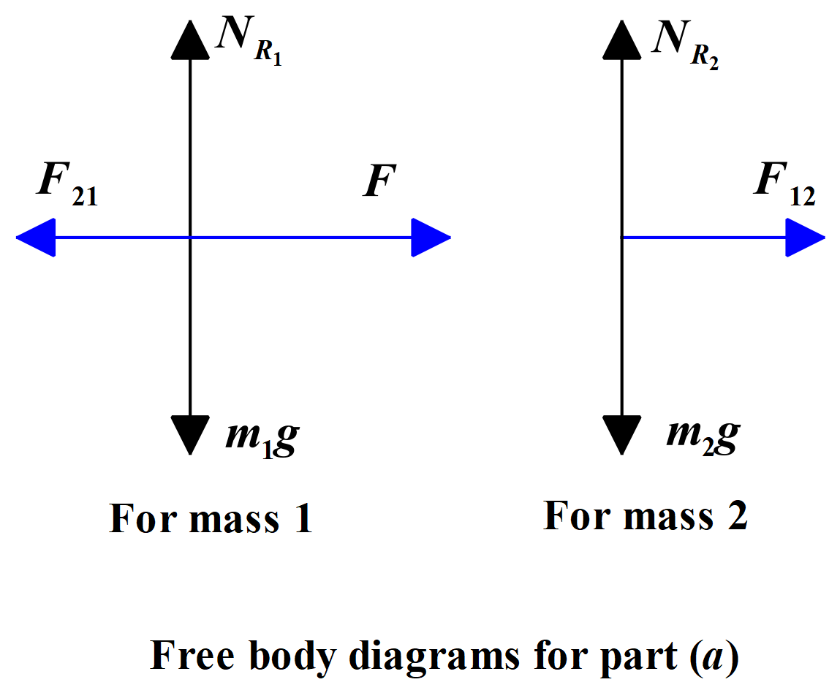

Vertically, each mass has its weight force and the associated normal reaction force. Horizontally, mass 1 is acted on by the applied force F̰ to the right and by the force of mass 2 pushing back against it to the left. Horizontally, mass 2 is acted on only by the force of mass 1 pushing against it to the right. From these free body diagrams, we can derive useful equations that allow us to solve the problem.

Solution follows on next page.

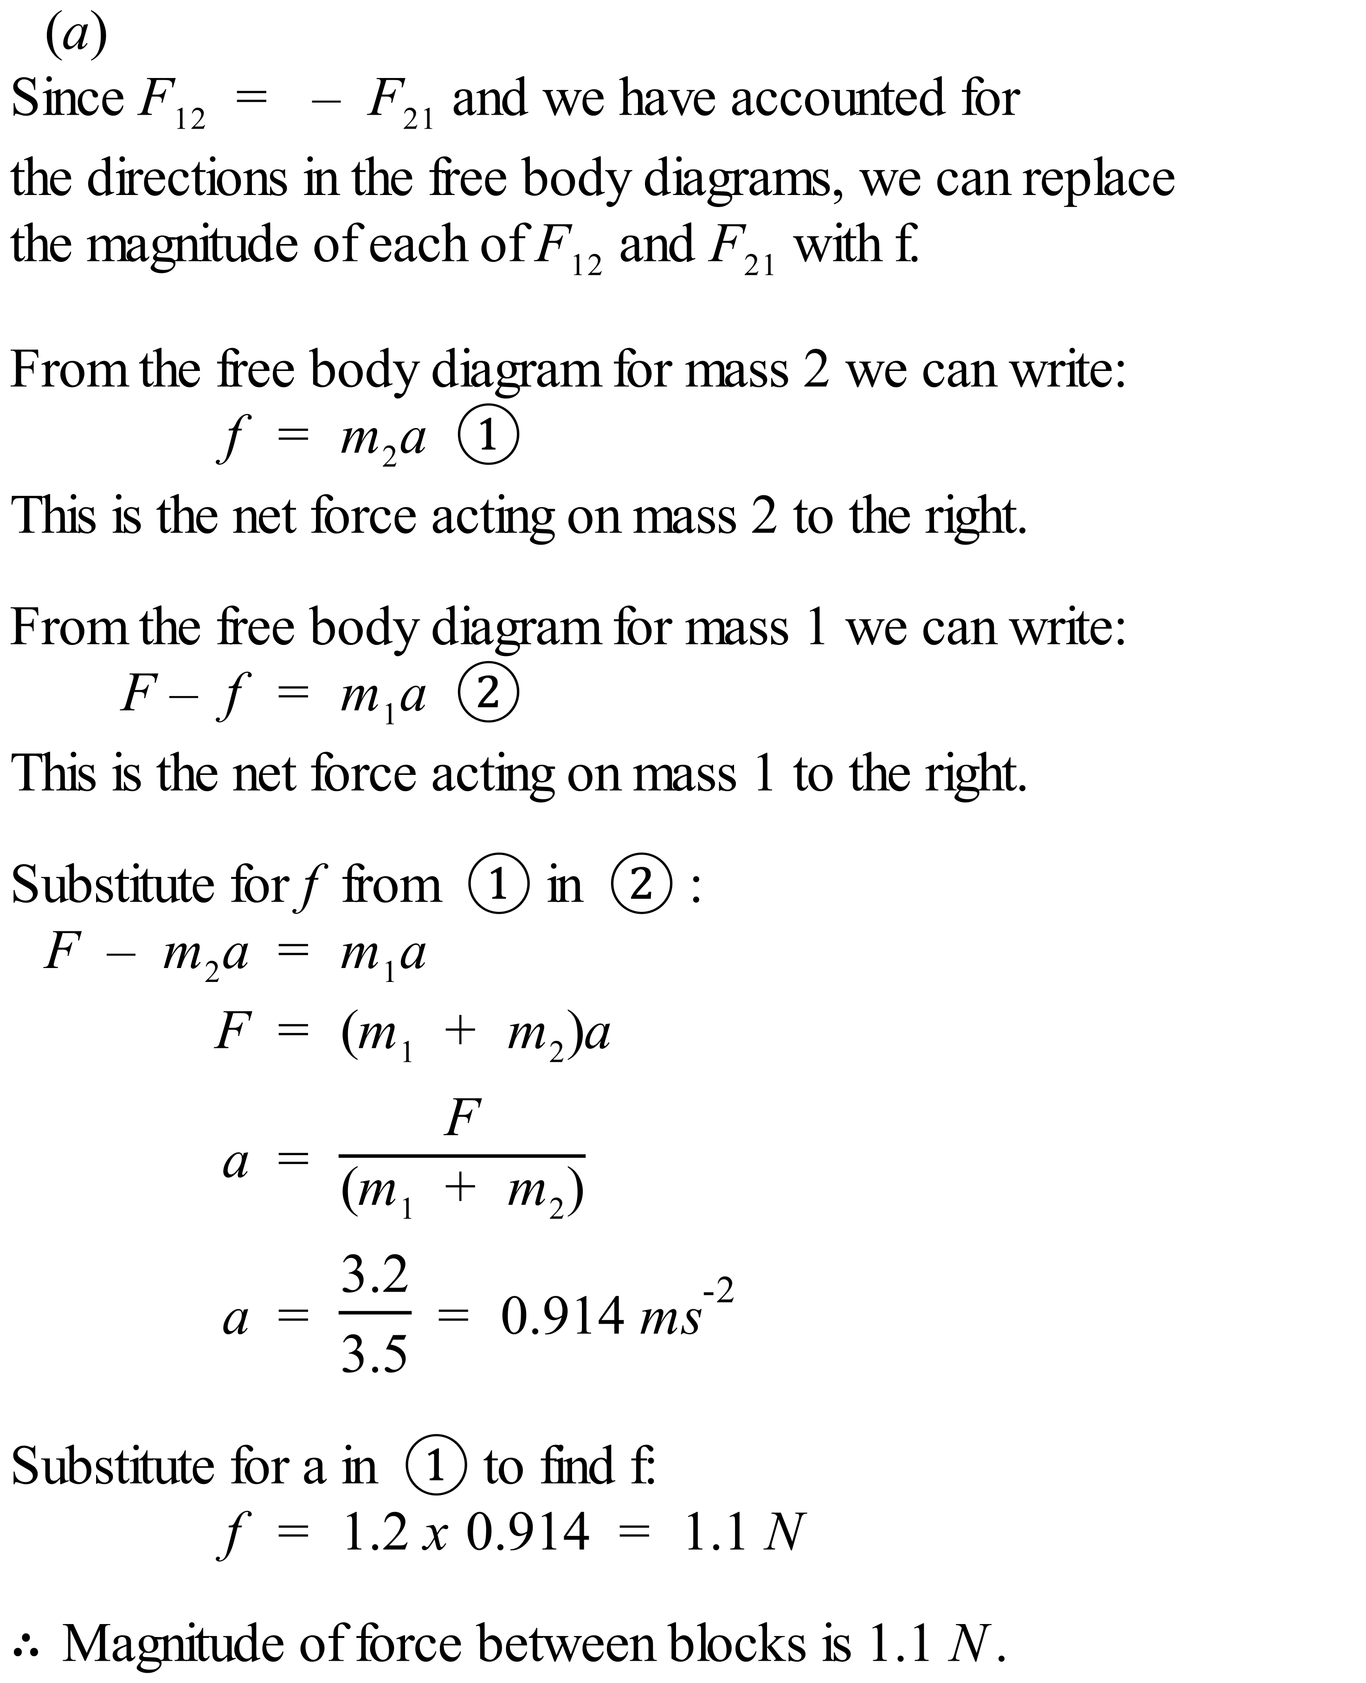

You should have a go using the more mathematically rigorous method to do part (c) of the question. You start by drawing free body diagrams for that situation and then writing down the equations that flow from these. Be careful – the applied force is now to the left and is therefore negative. Likewise, the acceleration produced is to the left and is therefore also negative. I have written out the solution to part (c) for you in case you need to refer to it. It is in a file called Block Question Part c.

**Objects on Inclined Planes**

An object sitting on an inclined plane experiences an acceleration down the plane. This acceleration is a component of the acceleration due to gravity. The forces acting parallel and perpendicular to the plane can be represented as shown below.

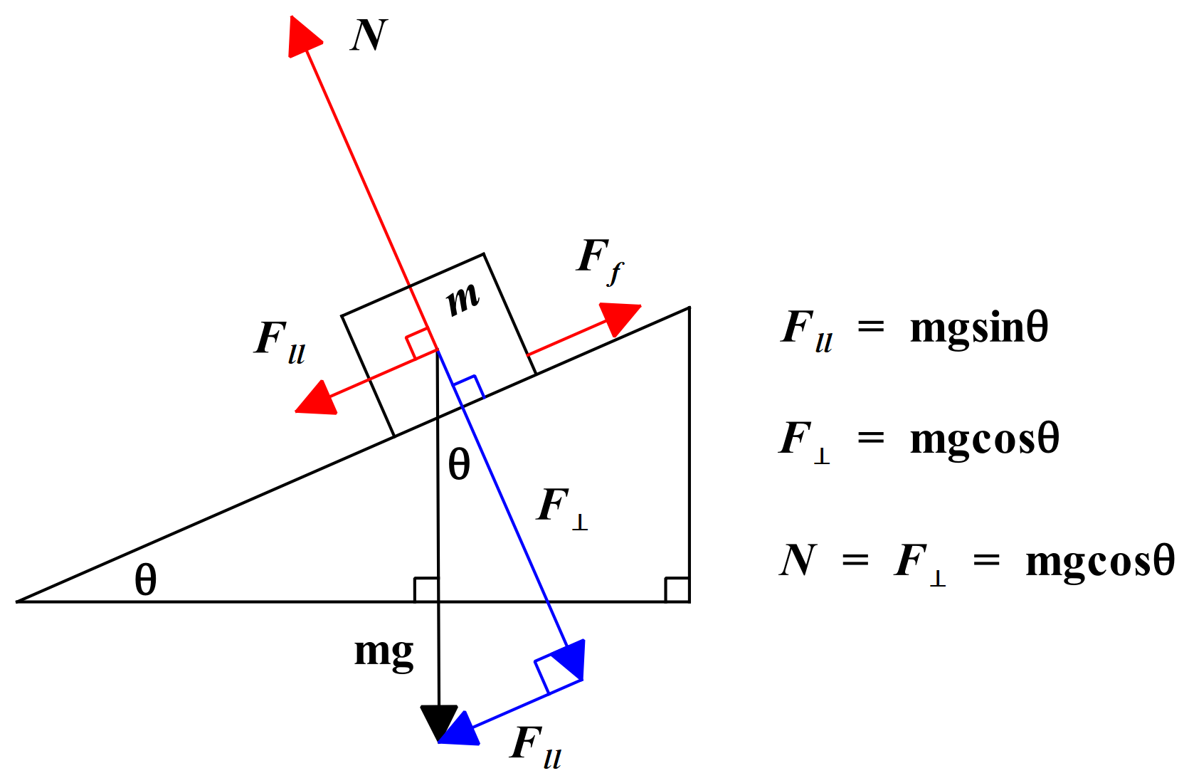

The plane above is inclined at an angle θ to the horizontal. The object sitting on the plane has a mass of m. The force due to gravity on this mass acts straight down towards the centre of the Earth and has a magnitude of mg. This weight force can be resolved into components parallel and perpendicular to the plane.

When we draw the vector diagram showing these components, it is a simple matter of geometry to show that the angle between the weight force vector and the perpendicular component of the weight force is also θ. Thus, the component of the weight force parallel to the plane, F∥, is found to be mgsinθ. This is the component that acts down the plane and when greater than the friction force, Ff opposing motion down the plane, it causes the mass to move down the plane.

The component of the weight force perpendicular to the plane, F⊥, is found to be mgcosθ. Since the mass does not sink into the plane, nor lift off the plane, this component and the normal reaction force, N, must balance one another.

So, N = mgcosθ.

We shall learn more about the friction force very soon. If present, it opposes the motion of the mass down the plane. Using our understanding of Newton’s Laws and the diagram above we can now write the **equation of motion** for the object on the plane:

ma = mgsinθ - Ff

If the plane is frictionless, Ff is zero, and the force down the plane is equal to the component of the weight force parallel to the plane.

See this [Phet link](https://phet.colorado.edu/en/simulation/legacy/ramp-forces-and-motion) for a simulation on inclined planes.

**FORCES, ACCELERATION AND ENERGY**

**Inquiry Question:** How can the motion of objects be explained and analysed?

**A Brief Note on Friction**

Friction can be defined in simple terms as the **resistance to motion** of two objects or surfaces in contact. Friction opposes motion. For example, two pieces of sandpaper rubbed against each other do not slide easily over each other. The friction forces between the papers are quite noticeable and you need to apply a noticeable force to keep the papers moving. A car driving on an icy road, however, may experience very little friction between the tyres and the ice, and so the car may slip and slide over the road surface because the tyres cannot grip the ice well enough to pull the car forward.

Friction is a very complex force. There are many ways in which friction occurs in our world. Physicists have discovered that the friction between two solid surfaces is caused by three main phenomena: (i) molecular adhesion - electromagnetic attraction between charged particles in the two surfaces that are in contact; (ii) surface roughness – bumps & hollows in the surface that apply resistive forces when we try to slide the surfaces over one another; and (iii) deformations - these form when soft materials deform under pressure and lead to an increase in resistance to motion eg a refrigerator sitting on thick carpet.

Note that friction also occurs in fluids, where it produces the effect we call viscosity.

**Coefficient of Friction, µ**

As has been stated earlier, when you push against a heavy object, it does not necessarily start to move immediately. Imagine trying to push a large refrigerator which is not on castors across a vinyl kitchen floor. The refrigerator will not move until the force you apply is of a certain size. This is because as you increase the applied force, the friction also increases, until it reaches the maximum frictional force between the surfaces. Once the applied force exceeds this maximum frictional force, the refrigerator begins to move.

Once the refrigerator is moving, part of the force you are applying overcomes friction and the remainder, the **net force** applied to the refrigerator, produces the acceleration.

The friction force, usually denoted F̰f, varies according to how hard the surfaces in contact are pressed together. This is often determined by the weight of the object that is pressing down on the surface below it. The degree of roughness of the two surfaces in contact also plays a part.

The force pressing two objects together can be determined by calculating the **normal reaction force, N**. The degree of roughness can be determined experimentally for different combinations of surface materials in contact and can be denoted by the **coefficient of friction,** **µ**, for the two materials. The coefficient of friction is dimensionless, meaning it does not have any units.

F̰f = µN̰

**Friction causes energy to be lost in the form of heat from moving objects.** That is one reason why a machine with moving parts gets hot. Although friction opposes motion, and wastes energy, do not get the idea that it is not a useful force. We could not walk, ride a bike or drive a car if it were not for friction. When you walk, friction stops your foot from slipping backwards and enables the action-reaction interaction between your foot and the Earth’s surface that allows you to walk forward. See the example in Newton’s Third Law section of these notes.

**Every Day Examples of Newton’s Laws in Action**

Newton’s First Law is often referred to as the Law of Inertia. It has this name because it describes the fact that objects cannot change their own motion. They must be acted upon by a net external force to change their motion. In this sense, objects have inertia, a resistance to changes in their state of motion. The next two real life examples illustrate this point.

Example 1: A man is driving a car at a constant speed along a straight, flat road. There is a box on the seat next to him. A kangaroo bounds across the road directly in front of him and he slams on the brakes bringing the car to a stop. The box on the seat slides off the seat and onto the floor. Analyse this situation in terms of Newton’s Laws.

This is an example of Newton’s First & Second Laws in action. When the man applies the brakes, the brakes apply a net external force to the car, and this force changes the car’s state of motion from constant velocity to zero velocity, in accordance with Newton’s 1st Law. The net external force is also applied to anything attached to the car, for instance the seat and the man in his seat belt. The net external force on the car, the seat and the man produces an acceleration in the opposite direction to motion. This acceleration is negative (a deceleration) and slows the car, the seat and the man to a stop. This is described mathematically by Newton’s 2nd Law equation, F = ma.

The box on the seat is not firmly attached to the car. If we ignore any friction between the seat and the box, the box experiences no force. So, in accordance with Newton’s 1st Law, the box continues to move at constant speed in the same straight line, while the seat slows down very quickly. The result is that the box moves forward faster than the seat and ends up with no seat under it to support its weight.

At this stage, the box experiences a net external force downwards due to its weight and accelerates to the floor (Newton’s 2nd Law again). Its collision with the floor brings its downward motion to an end.

It is worth commenting that some people in this situation would suggest that the box must have experienced a force that knocked it off the seat. That is what it would look like to the driver. Such a force is called a fictitious force (or pseudoforce) because it is not real. The real force was applied by the brakes to the car. Newton’s 1st Law then explains why the box slipped off the seat.

We should note that in a real-life situation there would be some friction between the seat and the box. This friction would resist the forwards motion of the box and if the brakes were applied more gently would stop the box from slipping off the seat.

Example 2: A girl is standing in a train carriage stopped at a station. As the train starts to move off, the girl starts to fall backwards and must quickly grab hold of the seat near her to stop herself from falling over. Explain the girl’s motion in terms of Newton’s First & Second Laws.

When the train starts to move, it applies a net external force to the girl’s feet, which changes the state of motion of her feet in accordance with Newton’s 1st Law. The net external force causes her feet to accelerate in the direction of this force, in accordance with Newton’s 2nd Law. Unfortunately, the rest of the girl’s body is not attached to the train and so experiences no such force. In accordance with Newton’s 1st Law, the girl’s body stays where it is, stationary. So, quite literally, the girl’s feet move out from under her while her body remains behind due to its inertia. This causes her to lean backwards and she saves herself by grabbing a nearby seat. Having now reconnected her body with the train, her whole body is travelling at the same speed in the same direction. If you have ever had this sort of experience, you will know that your sense of balance can also correct such a situation, provided you are ready for it when the train starts to move or stops.

Friction plays an important part in this example. It is the friction between the train carriage’s floor and the girl’s feet that allows the net external force to be applied to the girl’s feet. If there was no friction between the floor and the girl’s feet, she would stay where she was; the floor would slide under her feet and eventually the end wall of the carriage would collide with her. Not a good experience! 😊

Example 3: A woman is about to push a refrigerator that is not on castors (wheels) across a concrete floor in her garage. The woman stands behind the refrigerator and begins to push. She pushes harder and harder but to no avail. The refrigerator will not move. She then enlists the help of her sister. The two women stand behind the refrigerator and push. The refrigerator begins to move. The women notice that once the refrigerator is moving it requires slightly less force to keep moving than it required to get moving in the first place. Explain this situation in terms of Newton’s First & Second Laws.

Clearly, when the woman was pushing the refrigerator by herself, she could not apply sufficient force to overcome the friction between the refrigerator and the concrete floor. As she increased the applied force, the friction force acting against motion increased as well. There was therefore no net external force and in accordance with Newton’s 1st Law, the refrigerator remained at rest.

Once her sister joined her, the two women together were able to apply sufficient force to overcome the maximum static friction between the refrigerator and the concrete floor. At this point a net external force begins acting on the refrigerator in the direction required and the refrigerator begins to move in that direction according to Newton’s 1st Law. If the women produce a constant net force on the refrigerator, it will accelerate at a constant rate in accordance with Newton’s 2nd Law and its velocity will increase as it moves forward.

The total force applied by the women is larger than the net force moving the refrigerator. Some of the applied force overcomes the friction force and the rest of the applied force supplies the net force that accelerates the refrigerator.

I suggest you have a look at the Phet simulation available on [“Forces and Motion: Basics”](https://phet.colorado.edu/sims/html/forces-and-motion-basics/latest/forces-and-motion-basics_en.html). It is quite useful for getting your head around forces and motion.

Now the women also noticed that it got easier to push the refrigerator once it was moving. This is because once it is moving, the friction opposing motion becomes a dynamic (or kinetic) friction. Dynamic friction forces are smaller than static friction forces for the same surfaces in contact. This is a general rule.

The reasons for this are quite complex but basically it is because when an object sits at rest on a surface, it sinks into that surface at a molecular level. The bottom surface of the object and the top of the surface that the object is sitting on, mesh at a molecular level. The more massive the object, the more it sinks. So, when you try to push that object over the surface, you must first overcome both the microscopic bumps and hollows of both surfaces that mechanically impede movement and the electrostatic forces associated with molecular adhesion that also impede movement by “sticking” the surfaces together, in a manner of speaking.

Once movement is achieved, the surfaces are slipping over one another, the object is not sunk as far into the surface as it was before motion commenced and the mechanical and electrostatic forces operating between the surfaces are less in magnitude.

Have a look at an excellent explanation of the difference in size between static and dynamic friction that is available on this [Khan Academy video](https://www.khanacademy.org/science/physics/forces-newtons-laws/inclined-planes-friction/v/intuition-on-static-and-kinetic-friction-comparisons).

The next two examples are a little more mathematical in nature but each of these is easily set up in a laboratory to examine first hand.

**Example 4:** In the diagram below a block of mass 25kg rests on a plane inclined at 30° to the horizontal. The weight force, W̰, of the block has been resolved into its components parallel and perpendicular to the plane. The normal reaction force for the block has also been labelled. The coefficient of friction for the surfaces in contact is 0.35.

1. Calculate the force of friction, F̰f, acting on the block. Use g = 9.8 m/s2.
2. Determine if the block will remain stationary or commence moving down the plane. If it will move, determine the magnitude of its acceleration.

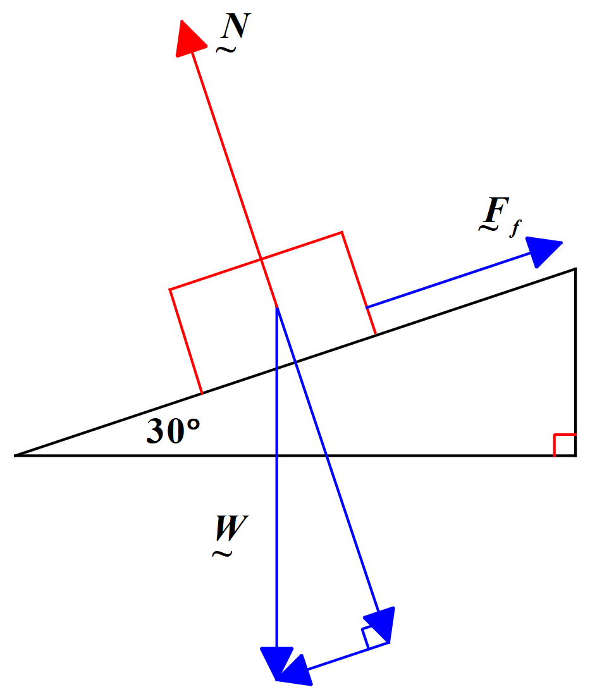

(a) Firstly, determine the normal reaction force.

N = mg cos 30° = 25 x 9.8 x cos 30° = 212.18 N

Then, Ff = µN = 0.35 x 212.18 = 74.3 N

Thus, the force of friction acting on the block is 74 N up the plane.

(b) Find the size of the force acting on the block down the plane. That is the component of the block’s weight parallel to the plane.

F∥  = mg sinθ = 25 x 9.8 x sin 30° = 122.5 N down the plane.

Clearly, as the force down the plane is larger than the force of friction up the plane, the block will accelerate down the plane.

So, net force down the plane = 122.5 – 74.3 = 48.2 N

a = F/m = 48.2/25 = 1.9 m/s2

The acceleration of the block down the plane is 1.9 m/s2.

**Example 5:** A block of mass 20 kg is being pulled up an inclined plane by a rope inclined at 30o to the plane’s surface, as shown in the diagram below.



The plane is inclined at 45o to the horizontal. There is a friction force, F, of 10.0 N opposing the block’s motion up the plane. Determine the tension, T, in the rope if the net acceleration, a, of the block up the plane is 4 ms-2. Use g = 9.8 m/s2.

You will observe that we have resolved two vectors in the diagram into rectangular components – the tension, T, in the rope and the weight, W, of the block. The rectangular components we have chosen are those acting parallel to and perpendicular to the inclined plane. These components are the most useful ones in a situation like this.

Now the total force acting down the plane is the sum of the friction force, F, and the component of the weight force of the block acting down the plane (W sin. So, from the diagram we have:

FD = F + mg sin (since W = mg)

FD = 10 + 20 x 9.8 x sin 45o

FD = 148.59 N

Total force acting up the plane must be:

FU = ma + FD

FU = (20 x 4) + 148.59

FU = 228.59 N

Note that the logic we have used to obtain an expression for FU is as follows. The force up the plane MUST be sufficient to overcome the 148.59 N force down the plane and to provide the required force of 80 N to give the block the correct acceleration up the plane.

Now we can calculate the tension in the rope. The total force up the plane FU is the component of the tension force parallel to the plane.

Therefore, we have:

cos 30o = FU / T

T = FU /cos 30o

T = 228.59 / cos 30o

T = 263.95 N

So, the tension in the rope works out to be 264 N.

Tensions in Strings & Elevator Examples

There are many other examples that could be given of Newton’s Laws in action. There are situations in dynamics where we need to analyse a variety of systems undergoing vertical acceleration (eg elevators, aircraft, rockets) or systems involving ropes and pulleys where we are interested in the tension produced in the rope and the net acceleration of the system. I have provided a brief set of notes on Tensions in Strings on the Dynamics Module page of the website.

Acceleration of a Single Object Subjected to a Constant Net Force

As should now be very clear, Newton’s 2nd Law tells us that an object subjected to a constant net force, will accelerate at a constant rate. Our understanding of the equations of uniformly accelerated motion allows us to realise that the velocity of such an object will increase at a constant rate. The displacement of the object will increase quadratically, as the displacement equation contains a t2 term (see Module 1 if you are not sure).

The [Forces in 1 Dimension Phet](https://phet.colorado.edu/en/simulation/legacy/forces-1d) is a good simulation that allows you to examine graphical relationships and relationships involving vectors in simple motion scenarios in one dimension. You will notice as you graph the various relationships for an object subjected to a constant net force: (i) force v’s time is linear and constant; (ii) acceleration v’s time is linear and constant; (iii) velocity versus time is linear and increasing; and (iv) displacement is parabolic and increasing.

In Module 1 we derived the equations of uniformly accelerated motion algebraically. By graphing velocity versus time for an object undergoing constant acceleration we can very quickly derive the same equations graphically. The first equation v = u + at is derived by a simple rearrangement of the definition equation of acceleration. For the second equation, however, the graphical method is much quicker than the algebraic. Study the graph below of velocity versus time for an object undergoing constant acceleration.

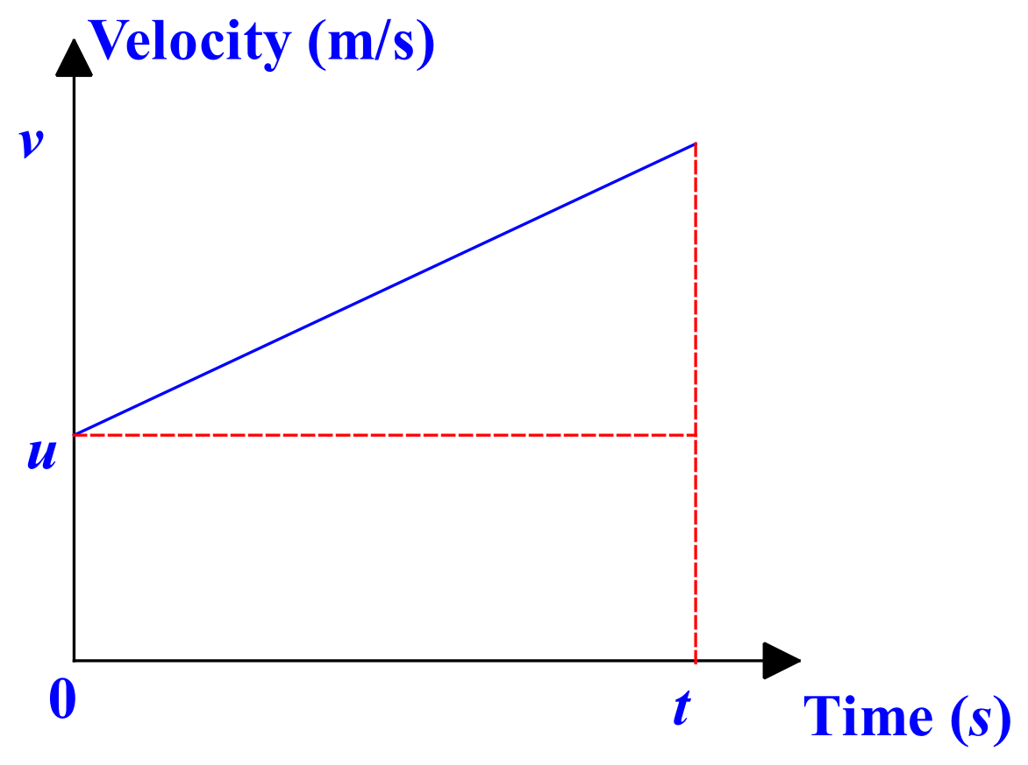

The object has an initial velocity of, u, and undergoes constant acceleration, a, for a time, t, at which its final velocity is, v. As the area under a velocity-time graph is equal to the displacement, s, travelled by the object, that displacement is clearly given by:

S = ut + ½ at2

since ut is the area of the rectangle and the area of the triangle is half the base x the height:

area of triangle = ½ (v – u) t and (v – u) = at from definition of acceleration

Hence, S = ut + ½ at2

Exercise: Derive the 3rd equation of uniformly accelerated motion by graphical means: v2 = u2 + 2as. Hint: Use the same graph as above. Calculate the area this time using the formula for the area of a trapezium. Use the definition equation for acceleration to eliminate t from the resulting equation. (I have done this for you, in case you need it, in a document called Derivation of Third Equation on the website.)

Clearly, graphs can be very useful for deriving relationships between variables.

At the start of this module, we discussed the relationship between force, acceleration and mass. We used graphs of acceleration versus force and acceleration versus mass to determine these relationships:

 and 

Then we combined these proportionality relationships to produce the equation for Newton’s 2nd Law:

Σ F̰ = ma̰

It is important that you investigate the relationships above experimentally and have a go at deriving the 2nd Law equation from graphs of the data. Your teacher will almost certainly ask you to do such an investigation. Examples of suitable experiments are Practicals 4 & 5 in the Dynamics Practicals document provided on the website.

**WORK**

A **net force** applied to an object can move that object through a certain **distance**. Whenever this happens we say that **work has been done on that object**.



**Work** is a **scalar quantity** defined mathematically as:



where W = work done on object, F = net force acting on object along the line of motion and s = net displacement of object caused by the force along the line of motion.

The SI unit of work is the **joule (J)**. 1J = 1 Nm

**EXAMPLE:** Calculate the work done when an object is moved through a displacement of 20m north by a force of 10N north.

**ANSWER:** **W = F.s and so W = 10 x 20 = 200J (Note that there is no direction, since work is a scalar quantity.)**

**ENERGY**

Energy and work are closely related quantities. An object can do work only if it has energy. **Energy, then, is the property of a system that is a measure of its capacity for doing work. The amount of energy an object has is equal to the amount of work it can do. Like work,** **energy is a scalar quantity with an SI Unit of the joule (J).**

Energy has several forms: electric energy, chemical energy, heat energy, nuclear energy, radiant energy (ie EM radiation such as light), mechanical energy and sound energy (ie the kinetic energy of the vibration of the air). **In a closed system (ie one in which no mass enters or leaves), energy can neither be created nor destroyed, although it may be transformed from one form into another. This is called the Law of Conservation of Energy.**

**KINETIC ENERGY (KE)**

**Kinetic energy** is the name given to the energy associated with a moving body. It is the work that a body can do by virtue of its motion. It can be shown that the amount of kinetic energy possessed by a body is given by:



where m = mass of the body and v = velocity the body.

Moving vehicles have kinetic energy. Consider a small car of mass 920 kg moving at a constant speed of 60 km/h (16.67 m/s). The kinetic energy of the car can be calculated as:



Ek **=** 0.5 x 920 x 16.672

Ek **=** 1.28 x 105 J

**To change the velocity of a moving body, or to set a body at rest into motion, a net force must be applied to it and work must be done on it. The work done on the body by the net force is always equal to the change in kinetic energy of the body. This fact is called the Work-Energy Theorem.**

**POTENTIAL ENERGY (PE)**

Stored energy is called **potential energy**, since it has the potential to do work for us. This definition will suffice for now. The complete definition of potential energy is a little more complex. Examples of potential energy include: the energy stored in a stretched (or compressed) spring; the chemical energy stored in a car battery; the energy stored in the water in a damn above a hydroelectric power station; and the energy stored in the chemical bonds holding compounds together.

**MECHANICAL ENERGY**

Mechanical energy is the sum of the potential and kinetic energies in a system.

**GRAVITATIONAL POTENTIAL ENERGY (GPE)**

When we lift an object from the ground to a height above the ground we must do work against the gravitational field of the earth. This work goes into increasing the gravitational potential energy of the body. The amount of work done is equal to the change in gravitational potential energy (GPE) of the body. Study the diagram below, which shows a block of mass m, sitting on level ground. We are going to lift the block vertically to height h.

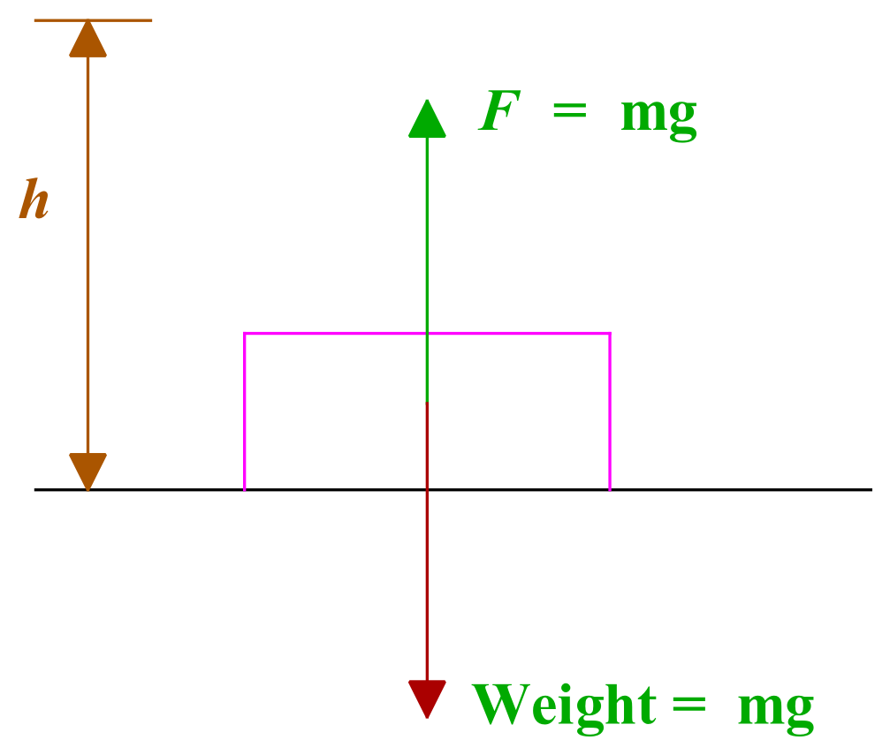

The work done to lift the block through h metres is: W = F . s = mgh.

In doing this amount of work on the block, we increase its potential energy by mgh joules.

**So, for objects near the Earth’s surface, where the acceleration due to gravity is fairly constant, the GPE of an object is given by:**

**Ep = mgh**

where m is the mass of the object, g is the acceleration due to gravity and h the height through which the object is moved vertically. **In this situation we define the ground level to be the zero-potential energy level. We also assume that the gravitational field is a uniform field (ie has the same value at all points in the area under consideration).**

Note that we are interested usually in changes in potential energy. So, the formula:

**ΔEp = mgΔh**

is often used, where the Δ (capital delta) stands for the change.

In the Syllabus document, this formula is given as: **ΔU = mgΔh**. The **U** is often used to represent potential energy in both Physics and Chemistry.

**ENERGY TRANSFORMATIONS**

The Law of Conservation of Energy states that energy can neither be created nor destroyed. It can be transformed (changed) from one form into another. An electric jug for instance transforms electrical energy into heat energy; a wind turbine transforms mechanical energy (kinetic energy of the wind) into electricity.

No transformation process is ever 100% efficient. In every case some energy is wasted, usually as heat. A wind turbine has moving parts which get hot. It also makes noise as its blades cut through the air. So, not all of the kinetic energy of the wind ends up as electrical energy.

**POTENTIAL ENERGY & KINETIC ENERGY TRANSFORMATIONS FOR FALLING OBJECTS**

Consider an object of mass m, raised through a distance h, perpendicular to the level ground.

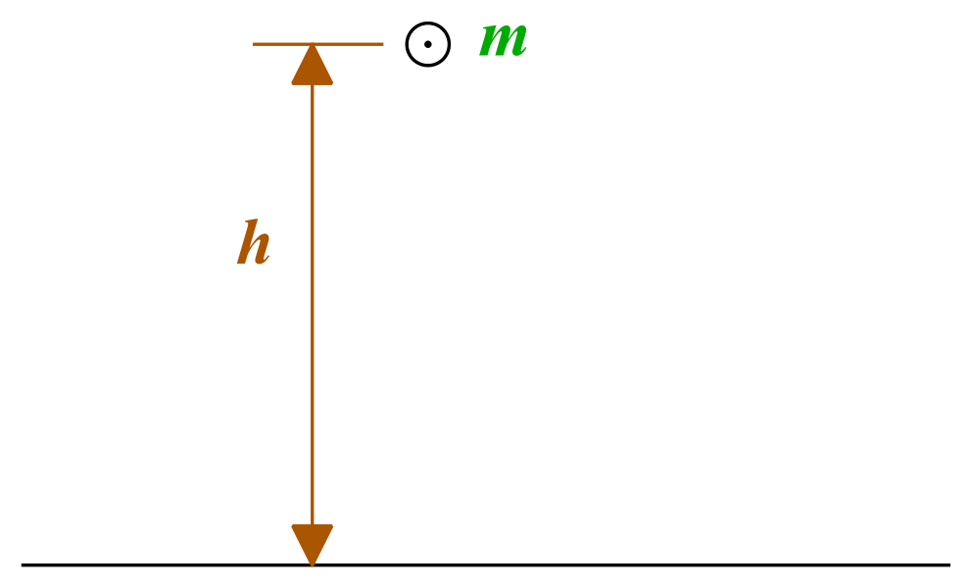

If this object fell from its position, its velocity on striking the ground would be:

**v2 = u2 + 2as, where u = 0 m/s, a = g m/s2 and s = h metres**

**v2 = 2gh**

Thus, the kinetic energy Ek of the object on striking the ground is:



**Ek = ½ . m. (2gh) = mgh = EP** (the potential energy of the mass above the ground)

So, the kinetic energy gained by the object on falling to the ground is equal to the potential energy the object has lost by falling to the ground.

Thus, we have for a falling object:

**Ek + EP = constant**

**This statement holds true only when all forces acting are conservative.**

**A conservative force is independent of the path taken between the start and end points of the motion.** If a brick is lifted from level ground onto the top of a 2-metre-high wall, the amount of work done on the brick against gravity is given by EP = mgh, where h = 2 m, although the brick may have travelled higher than 2 m as the brick-layer initially lifts it above the wall and then places down onto the wall. The work done on the brick only depends on its start and end points. If the brick is initially lifted higher than 2 m, the extra work to do this is then given back by the brick to the gravitational field as the brickie lowers it onto the top of the wall.

A good way to think of conservative forces is to consider what happens on a round trip. **If the kinetic energy is the same after a round trip, the force is a conservative force,** or at least is acting as a conservative force.

Consider gravity; you throw a ball straight up, and it leaves your hand with a certain amount of kinetic energy. At the top of its path, it has no kinetic energy, but it has a potential energy equal to the kinetic energy it had when it left your hand. When you catch it again it will have the same kinetic energy as it had when it left your hand (assuming air resistance is negligible). All along the path, the sum of the kinetic and potential energy is a constant, and the kinetic energy at the end, when the ball is back at its starting point, is the same as the kinetic energy at the start, so **gravity is a conservative force**.

Kinetic friction, on the other hand, is a non-conservative force, because it acts to reduce the mechanical energy in a system. Note that non-conservative forces do not always reduce the mechanical energy; a non-conservative force changes the mechanical energy, so a force that increases the total mechanical energy, like the force provided by a motor or engine, is also a non-conservative force.

Let’s just clarify our assumption above that “air-resistance is negligible” in the example given. In many problems we find that although some of the individual forces are not conservative, they may be so small compared to other forces that we can neglect them. For example, air resistance may be present but may have so little effect on the motion that we can ignore it.

**Example 1:** A mass of 3 kg is dropped from a height of 5 m and falls to the ground below. Find: (a) the potential energy of the mass above the ground at h = 5 m; (b) the greatest kinetic energy the mass can gain by falling; and (c) the maximum speed of the mass as it reaches the ground. Use g = 10 ms-2.

1. **EP = mgh = 3 x 10 x 5 = 150 J**
2. **EkMax = EP = 150 J**
3. **½ m v2 = 150  
     
   ⸫ v2 = 2 x 150/3 = 100  
     
   ⸫ v = 10 m/s** is the maximum speed

**Example 2:** A 1 kg mass sits at the top of a plane inclined at 30° to the horizontal, so that its centre of mass is 1 m above the ground. Assuming the plane is frictionless and using g = 10 ms-2 calculate: (a) the potential energy lost by the mass by the time it reaches the bottom of the plane; (b) the maximum kinetic energy gained by the mass; and (c) the speed of the mass at the bottom of the plane.

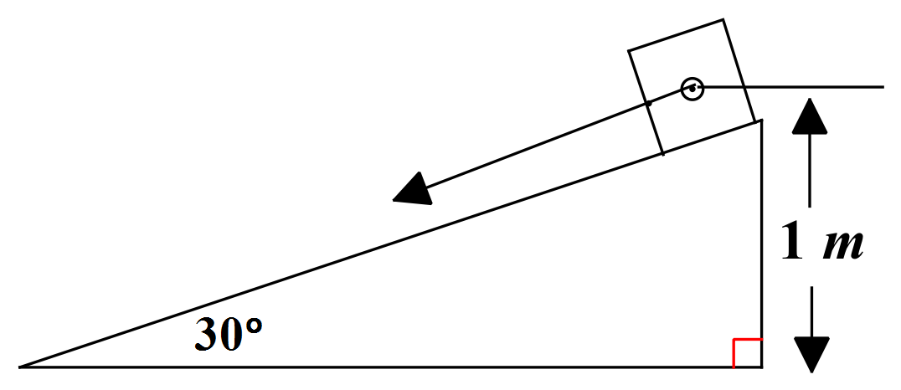

Note that the term “centre of mass” here means a point representing the mean position of the matter in a body or system. In an extended body like a block, we can think of the force on the block being applied to the block at the centre of mass. When the block moves, we can just study the motion of the centre of mass – in this case as it travels down the slope.

1. **EP = mgh = 1 x 10 x 1 = 10 J** is lost.
2. **EkMax = EP = 10 J**
3. **½ m v2 = 10  
     
   ⸫ v2 = 2 x 10 / 1 = 20  
     
   ⸫ v = 4.5 m/s** is the maximum speed

Your teacher will probably ask you to conduct some investigations to determine the relationship between the height from which an object is dropped and its resultant speed (and hence KE) on landing to highlight the relationship between KE and GPE. You can also use the [skate park simulation](https://phet.colorado.edu/sims/html/energy-skate-park-basics/latest/energy-skate-park-basics_en.html) to verify the relationship between GPE and KE.

**POWER**

In many instances it is useful to know the rate at which work is being done or energy is being used. Power is a scalar quantity defined as the rate at which work is done.

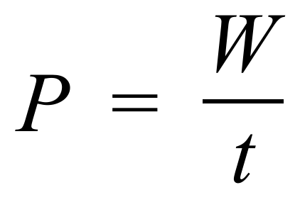

Where P = power, W = Work done, t = time taken to do the work.

The SI unit of power is the **watt (W)**. Clearly, 1 W = 1 J / s.

As the work done above is the total work done over a time period, the power is an average value.

It is easy to see that since W = F . s, we can also write that:

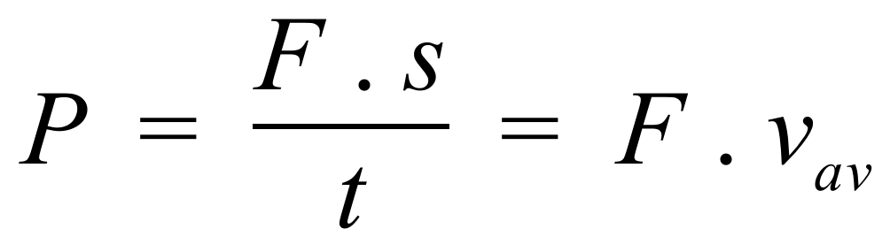

Where vav is the average velocity.

And since the work done on a body is equal to the change in kinetic energy of the body or to the change in potential energy of the body, we can write:

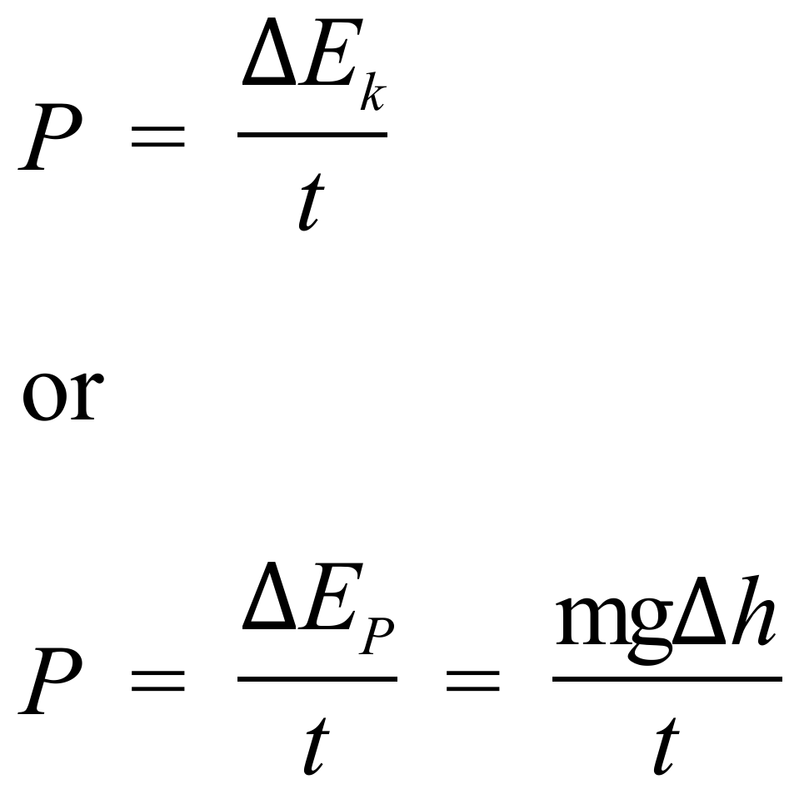

Again, your teacher will provide some practical exercise(s) on power. Note that a slight variation of **Practical 4** in the Dynamics Practicals document provided on the website offers a method to determine experimentally the value of **the work done against motion by the friction forces present**. See the end of Practical 4 for a note on how this can be done.

**MOMENTUM, ENERGY AND SIMPLE SYSTEMS**

**Inquiry Question:** How is the motion of objects in a simple system dependent on the interaction between the objects?

**MOMENTUM**

Everyday experience tells us that both the **mass** and **velocity** of an object are important in determining things like (i) how hard it is to stop the object or (ii) the effect the object has in a collision with another object. An 85 kg man running at 5 m/s is a lot harder to stop than a 15 kg six year old child running at the same speed. A 50 gram bullet fired from a rifle with a muzzle velocity of 500 m/s will do a lot more damage than an identical bullet thrown at the target by hand.

Isaac Newton spoke of the **“quantity of motion”** of an object. **Today we define the momentum of an object to be the product of mass (m) and velocity (v).**



Momentum is a **vector** quantity with SI Units of kgms-1 (or Ns, since 1N = 1kgms-2).

Newton’s 2nd Law can be re-written as follows:

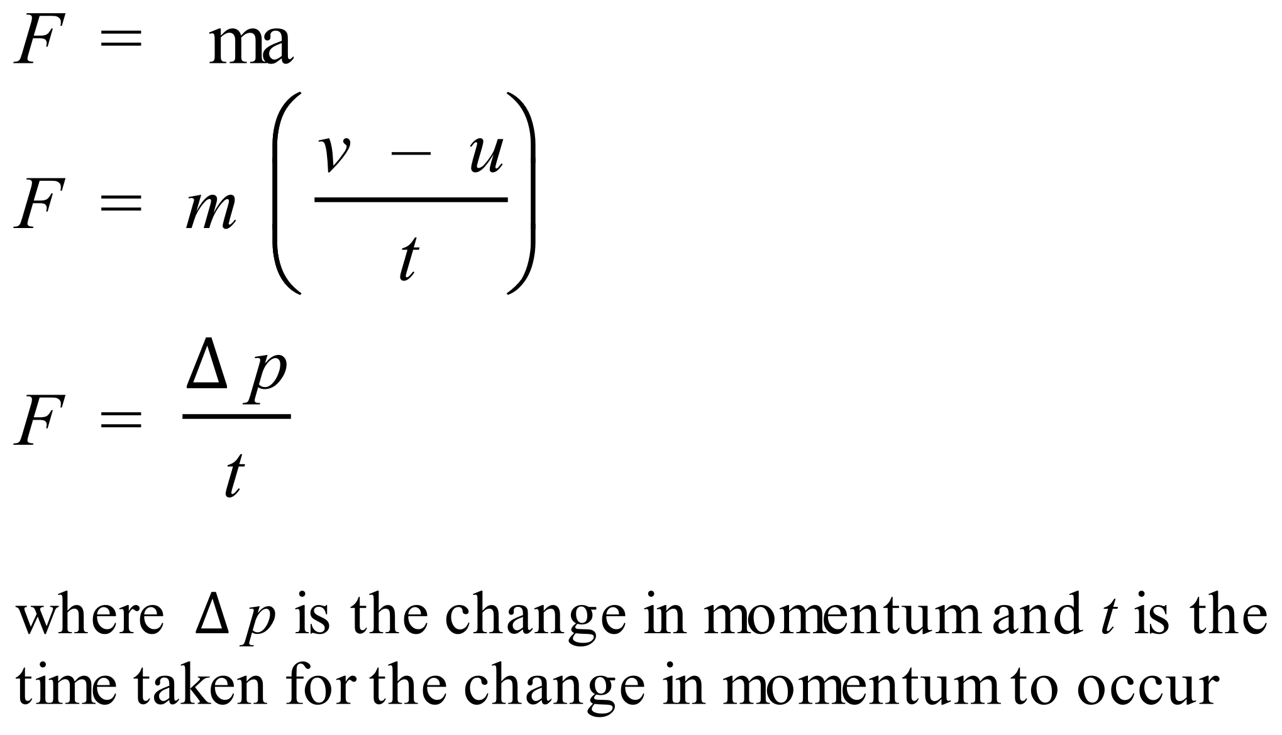

This is a very common way to express **Newton’s 2nd Law**. In words it states: **the net external force acting on an object is equal to the rate of change of momentum of the object**. Learn this off by heart.

**The quantity p (the change in momentum) is given the name impulse. Clearly, from the above equation, impulse, I, is defined as the product of force and time** and has SI Units of Ns. Impulse is a **vector** quantity.



**CONSERVATION OF MOMENTUM**

According to **Newton’s 1st and 2nd Laws of motion**, there is no change in momentum without the action of a net external force. **Thus, if no net external force acts on a system, the total momentum of the system must be constant.** This is known as **the principle of the conservation of linear momentum** and is one of the most important principles in Physics.

In Physics, a system on which the net external force is zero is given a special name. Such a system is called an **isolated system**. **So, another way to express the principle of the conservation of linear momentum is to say that within an isolated system the total momentum is a constant.** This principle is applicable to many important physical situations.

**CONSERVATION OF MOMENTUM DURING COLLISIONS**

One important physical situation to which the principle of the conservation of linear momentum is applicable is the case of collisions between bodies. In such a case, if we assume that no external net force acts during the collision, we can say that **the total momentum of the system before collision equals the total momentum of the system after collision**. This proves to be an extremely useful starting point for analysing many collision situations.

**To see that momentum is conserved during collisions we can use Newton’s 3rd Law.** Consider a collision between two particles, **A** and **B**, as shown below.



During the brief collision these particles exert large forces on one another. At any instant FAB is the force exerted on **A** by **B** and FBA is the force exerted on **B** by **A**. **By Newton’s 3rd Law these forces at any instant are equal in magnitude but opposite in direction.**

The change in momentum of **A** resulting from the collision is:



in which the **bar** above the FAB indicates that we are taking the **average value of** FAB during the time interval of the collision, t.

The change in momentum of **B** resulting from the collision is:



in which the **bar** above the FBA indicates that we are taking the **average value of** FBA during the time interval of the collision, t.

Note that it is necessary to take the **average value** of the collision forces since the magnitudes of both forces will vary over the duration of the collision.

**If no other forces act on the particles**, then **pA** and **pB** give the total change in momentum for each particle. But we have seen that at each instant:

FAB = - FBA

So that 

And therefore that **pA** = - **pB** .

If we consider the two particles as an isolated system, the total momentum of the system is:

**P = pA + pB**

And the total change in momentum of the system due to the collision is zero, that is:

**P** **=** **pA** + **pB = 0.**

Thus, using **Newton’s 3rd Law** and our knowledge of **impulse** we have shown that **if there are no external forces, the total momentum of the system is not changed by the collision**. Therefore, as we said before, if we assume that no external net force acts during the collision, we can say that **the total momentum of the system before collision equals the total momentum of the system after collision**.

How accurate is it though to assume that no external net force acts on a system during a collision? When a golf club strikes a golf ball surely there are external forces that act on the system of club + ball? Indeed, there are: **gravity** and **friction** are two obvious forces that act on both club and ball. So how can we simply ignore these forces?

**The answer is that it is safe to neglect these external forces during the collision and to assume that momentum is conserved provided, as is almost always the case, that the external forces are negligible compared to the impulsive forces of collision.** If the external forces are negligible compared to the impulsive forces, then the change in momentum of a particle during a collision arising from an external force is negligible compared to the change in momentum of that particle arising from the impulsive force of collision.

In the case of the golf club striking the golf ball, the collision lasts only a tiny fraction of a second. Since the observed change in momentum is large and the time of collision is small, it follows from the impulse equation:

**p = F t**

that the average impulsive force F is relatively large. Compared to this force, the external forces of gravity and friction are negligible. During the collision we can safely ignore these external forces in determining the change in motion of the ball; the shorter the collision time, the more accurate this assumption becomes.

**In practice, we can apply the principle of momentum conservation during collisions if the time of collision is small enough.**

**Example 1:** Two marbles, A of mass 8 g and velocity 1 ms-1 to the right and B of mass 5 g and velocity 1.2 ms-1 to the left travel towards each other along level ground and collide head-on. If the velocity of A is reduced to 0.1 ms-1 to the right, find the velocity of B after the collision.

In solving all problems involving change of momentum, draw a before and after diagram. Why? It helps solve the problem correctly.

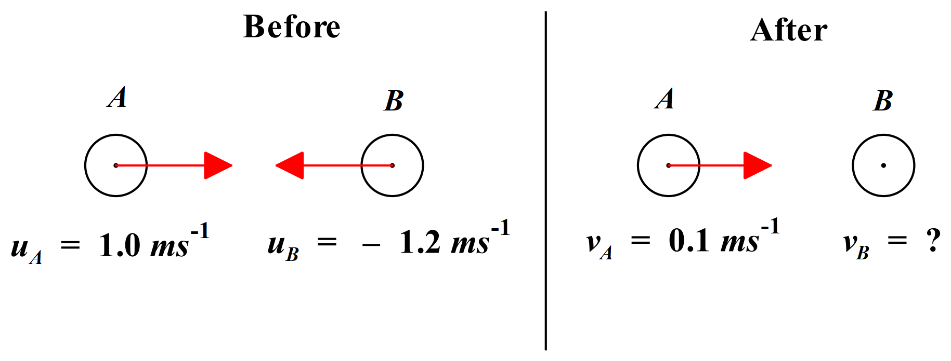

Note that we use u for initial velocities and v for final velocities. It cuts down the number of subscripts needed.

From the law of conservation of momentum:

Momentum before = Momentum after

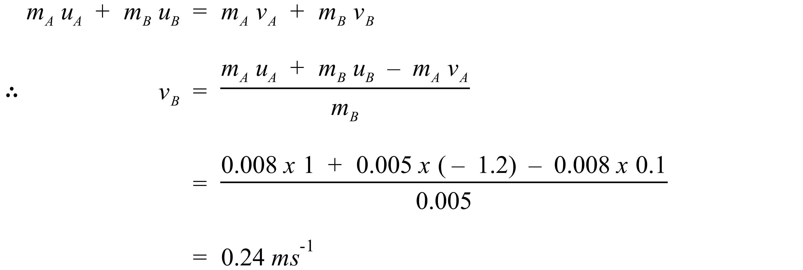

Velocity of B after collision is 0.24 m/s in the opposite direction to its original motion.

We know it is now moving to the right since its velocity is now positive and we assigned “right” to be “positive”. Note the importance of being correct and consistent with your signs.

Note also, that we could solve this problem algebraically because both marbles were travelling in one dimension, along one straight line. If objects travelling at angles to each other collide, we must use vector algebra to solve the situation.

**Example 2:** A 7500 kg truck travelling at 5 ms-1 east collides and coalesces with a 1500 kg car moving at 20 ms-1 in a direction 30° south of west. With what speed and in what direction does the wreckage begin to move? (The word “coalesce” means “stick together”.)

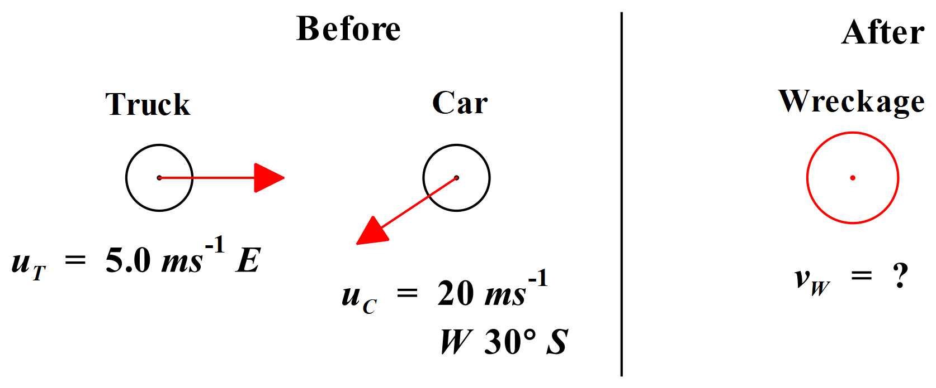

Before Collision: pT = 7,500 x 5 = 37,500 Ns East

pC = 1,500 x 20 = 30,000 Ns W30°S

After Collision: mW = 7,500 + 1,500 = 9,000 kg

vW = ?

By law of conservation of momentum: P̰B = P̰A

P̰T + P̰C = P̰W

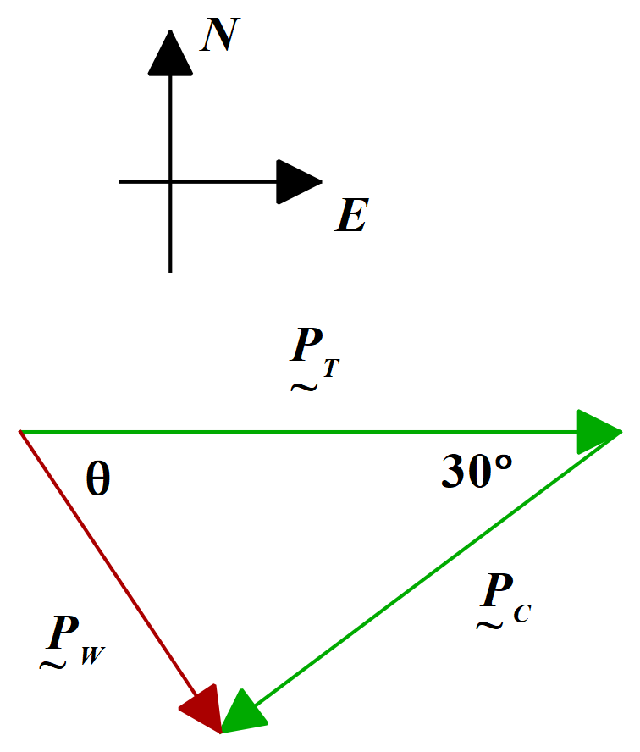

By cosine rule:

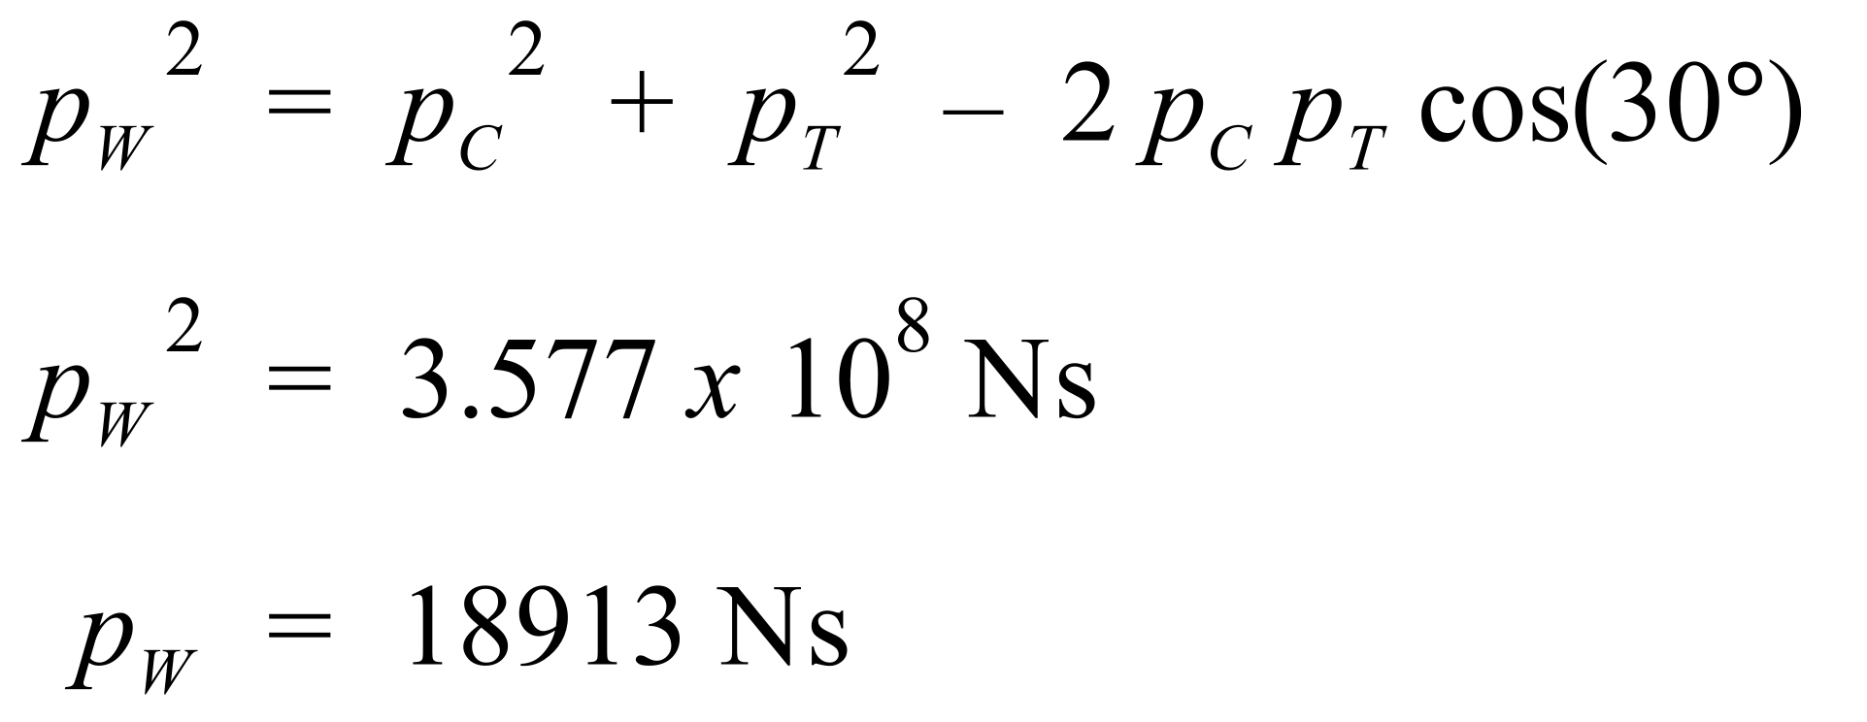

By sine rule:

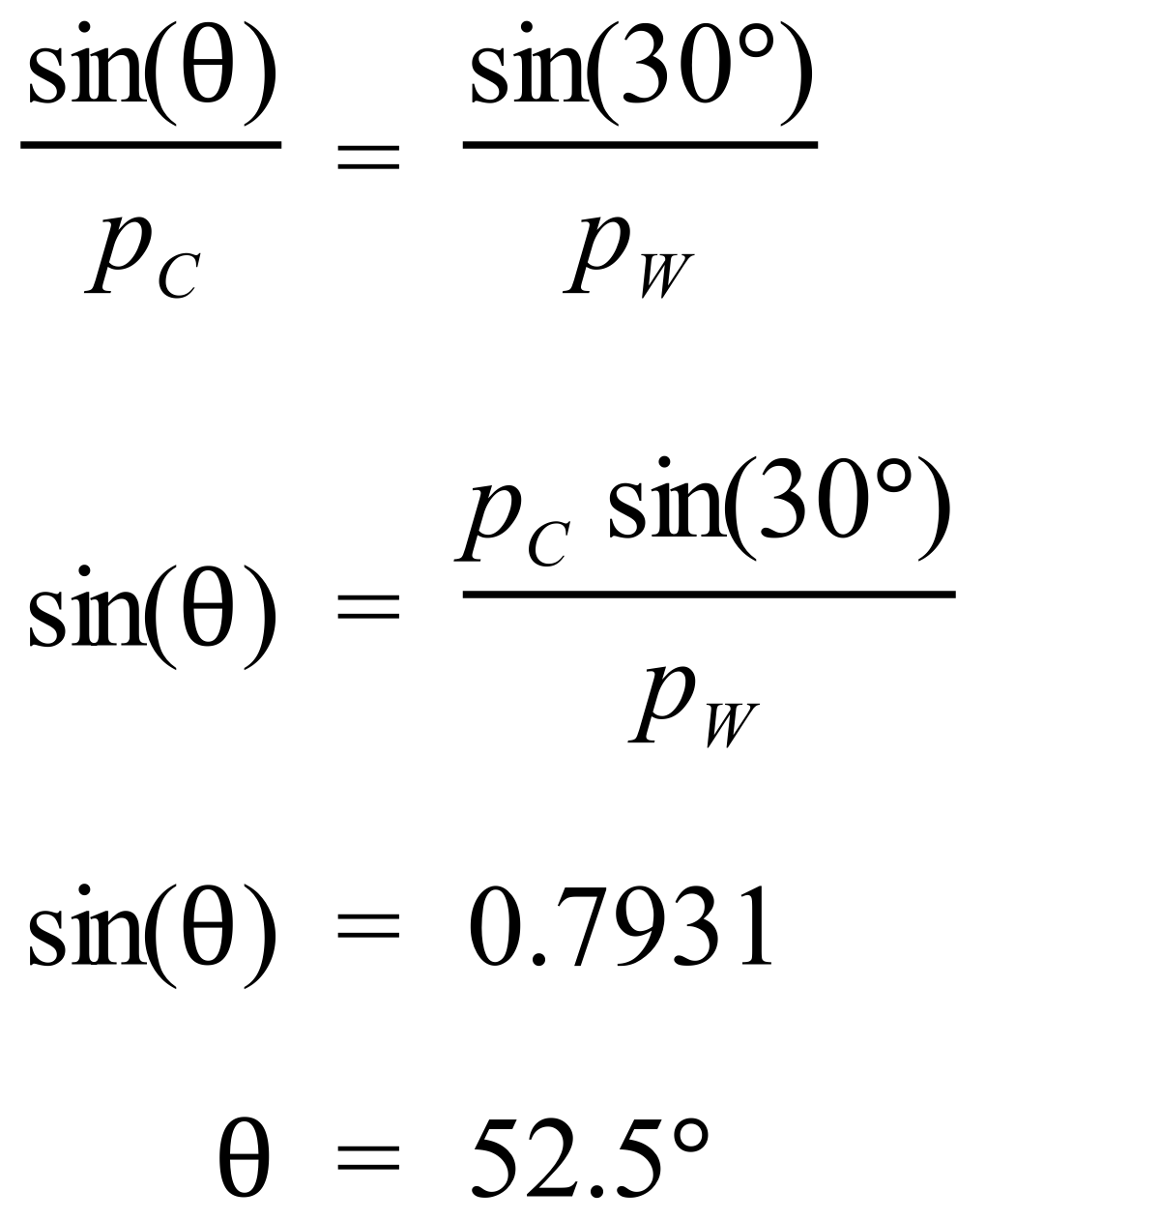

Now, from p = mv, v = p/m = 18913 / 9000 = 2.1 m/s.

Therefore, the wreckage moves off at 2.1 m/s in a direction of E52.5°S.

**Simulation:** Use the [collision lab simulation](https://phet.colorado.edu/sims/collision-lab/collision-lab_en.html) to investigate the nature of collisions in one and two dimensions.

**Practicals:** Your teacher will provide you with an appropriate practical experience where you will describe and analyse one-dimensional (collinear) and two-dimensional interactions of objects in simple closed systems. This may involve collisions between balls or trolley cars. Practical 6 in the Dynamics Practicals document on the website explores the conservation of momentum using a linear air track.

**Note:** A **closed system** cannot exchange matter with the surroundings, but can exchange energy.

**ELASTIC COLLISIONS**

In most collisions kinetic energy (KE) is not conserved. Usually, some energy is transformed into other forms of energy eg heat, sound, light, etc.

In some collisions, however, KE is conserved. Such collisions are called elastic collisions. In an elastic collision between two masses m1 and m2:

KEbefore = KEafter

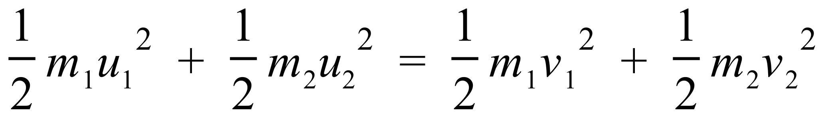

**So, in an elastic collision, both momentum and kinetic energy are conserved.**

In the macroscopic world there are no real examples of elastic collisions because every such collision involves some energy transformation. We hear the crash; sparks fly as metal hits metal; objects are deformed during a collision; and so on. So, why study elastic collisions? Well, some collisions in the real world are close enough to being elastic that we can make that approximation and simplify the mathematics describing the collision. Also, in the atomic world, many atomic collisions can be considered elastic. So, the Physics of elastic collisions is very useful.

**Example:** Two marbles sit on a level, smooth surface. Marble 1 approaches marble 2 head-on, from the left at 5 ms-1. Marble 2 is stationary. Both marbles have the same mass of 0.05 kg. Assuming the collision between the marbles is elastic, determine the velocities of the two marbles after the collision.

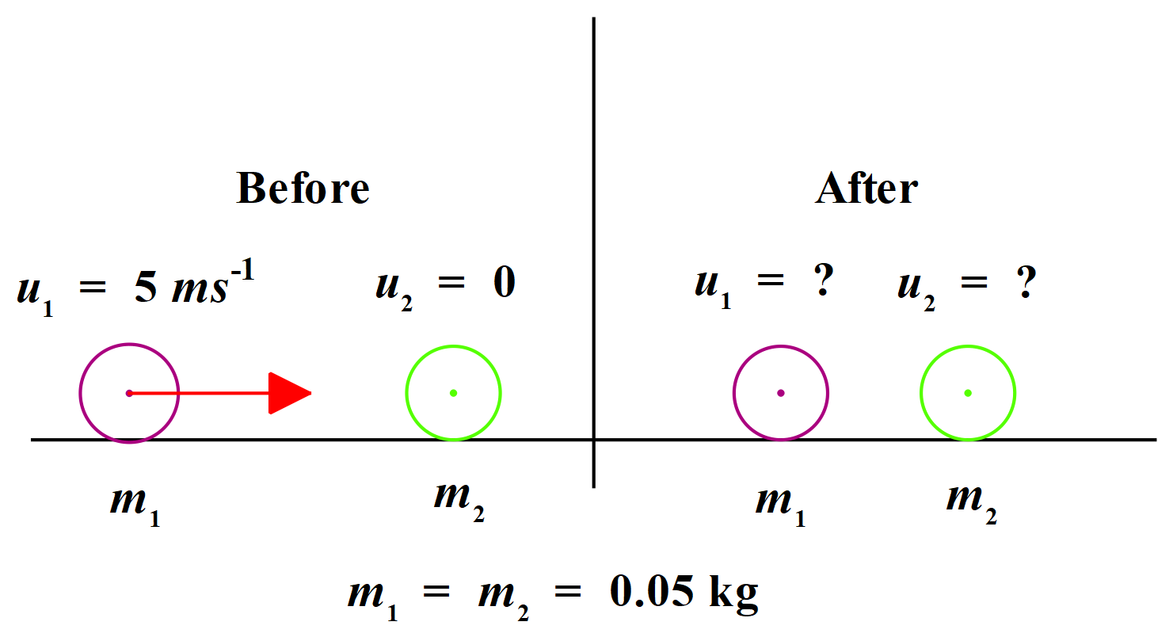

By conservation of momentum (along a straight line):

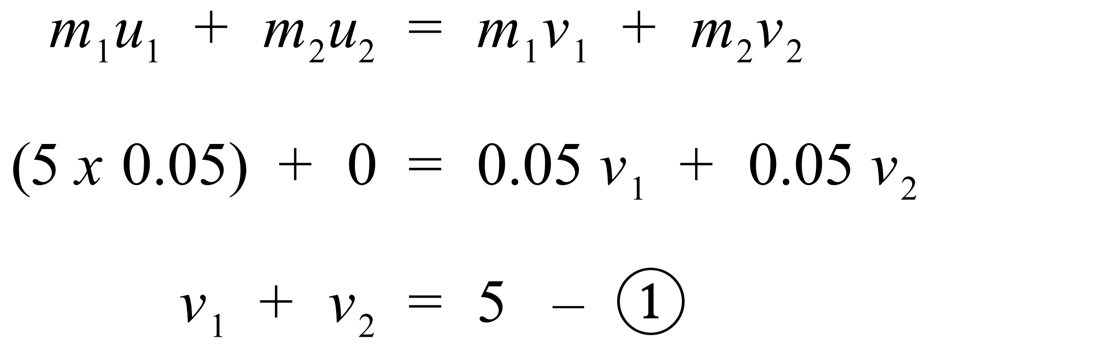

Since collision is elastic, KE is conserved:

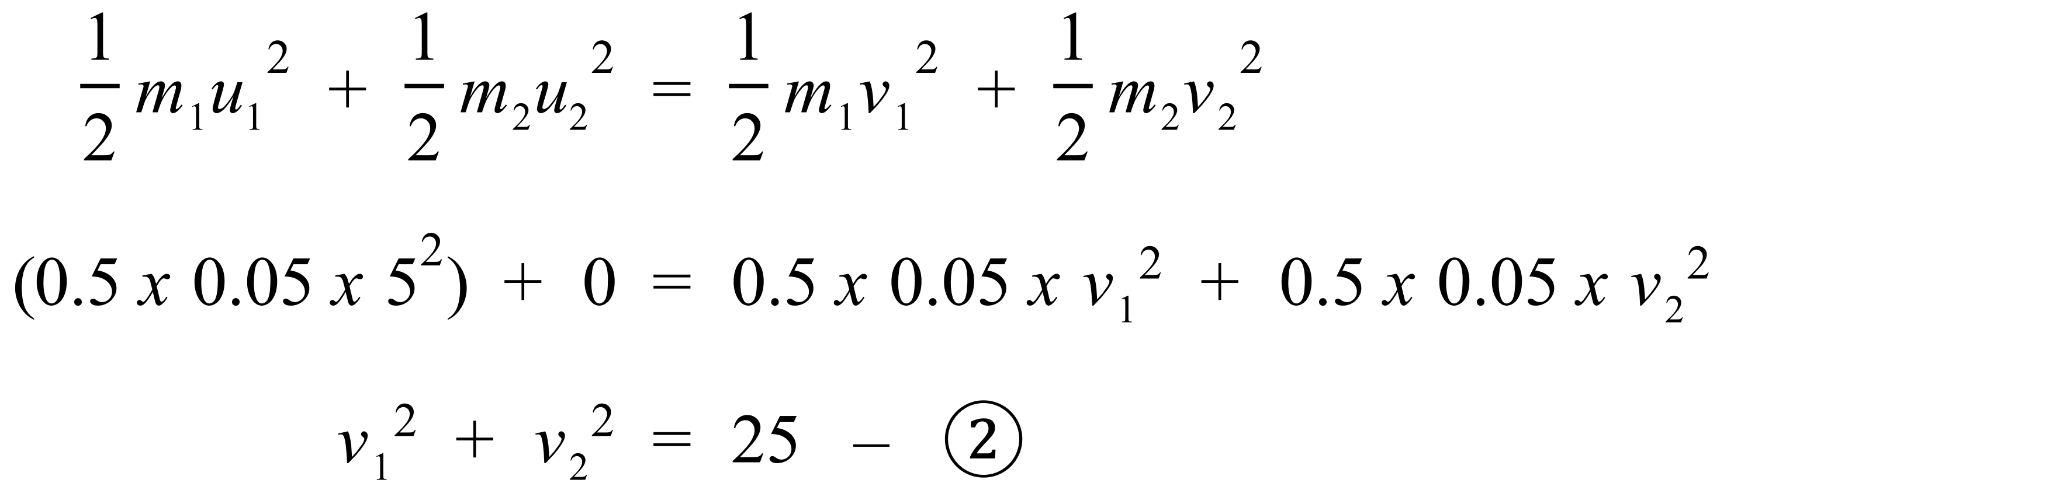

Now solving (1) and (2) simultaneously:

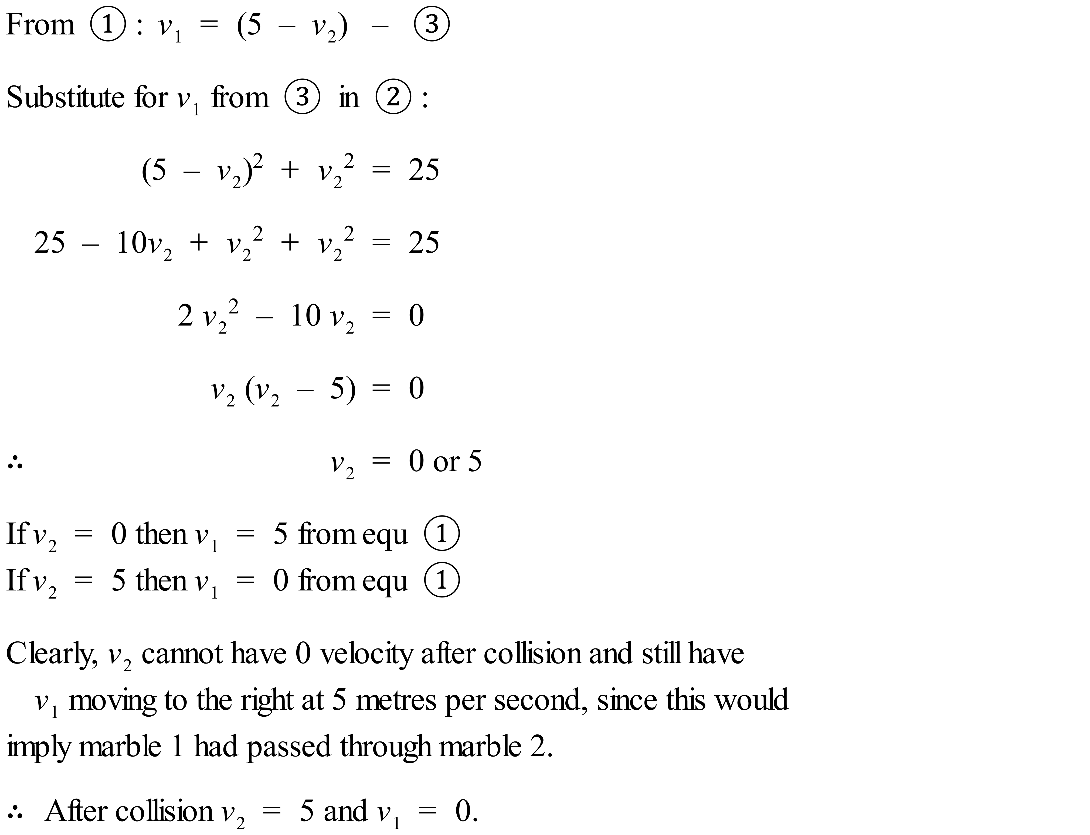

So, after the collision, marble 1 is stationary and marble 2 is moving at 5 m/s in the same direction as marble 1 was originally travelling.

Practical: Your teacher may show you a Newton’s Cradle and ask you to do some thinking about the momentum and energy interactions occurring when it is in operation. If not, have a look at the following two videos. (i) [The Physics of Newton’s Cradle](https://www.youtube.com/watch?v=kA2vjXHnySU) and (ii) [Newton’s Cradle Simulation](https://www.youtube.com/watch?v=WnOe3vgmbPQ).

**Impulse or Change in Momentum**

As we saw earlier, Newton’s 2nd Law asserts that to change the momentum of an object, a net force must be applied to the object over a period of time. The change in momentum, **p**, or impulse, **I**, as it is also called, is related to the net force, **F**, and time, **t**, by the equation:



The process of minimizing an impact **force** can be approached from the **definition** of **impulse**: If an impact stops a moving object, then the change in momentum for that object is a fixed quantity. Extending the time of the collision will decrease the time average of the impact **force** by the same factor. In other words, if we increase the time it takes for the object to come to rest, we must decrease the net force required to bring the object to rest, because the change in momentum to bring the object from its initial speed to rest, can only have one value.

A couple of examples will help here. Firstly, an airbag in a car is designed to inflate during an accident and increase the time it takes to bring the driver’s momentum to zero. By increasing the time to bring the driver to a stop, the airbag causes a reduction in the force applied to the driver, since force x time = change in momentum, which is constant for a given situation. So, if you increase time taken, you must decrease force applied in order for the change in momentum to remain constant in value. With a lower force applied to the driver than would have been the case without the airbag, the driver suffers less injury. Crumple zones at the front and back of cars work in a similar fashion.

A second example comes from cricket. When a fieldsman catches a ball, he or she moves his or her hands in the direction of travel of the ball as the ball contacts the hands. This increases the time it takes for the ball to come to rest in the hands. This reduces the force acting on the hands because the change in momentum of the ball is constant. Failing to adopt this technique usually results in sore hands and a ball that bounces out of the hands and is dropped, much to the annoyance of teammates.

**Force versus time graphs** are extremely useful for calculating change in momentum (impulse).

**Example 1**: A mass of 4 kg experiences a varying force as given in the diagram below. Determine the change in velocity of the mass.

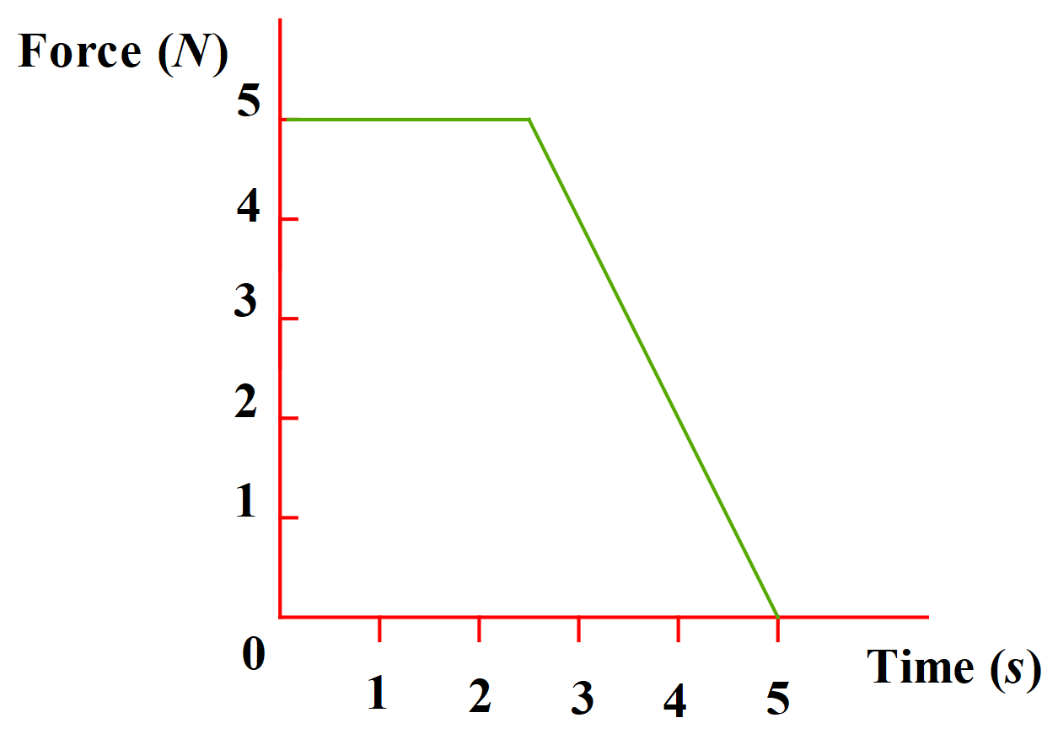

**The area under a Force v’s Time graph represents the change in momentum or impulse. Clearly, the area has the units of Ns, which are the units of momentum and impulse.**

So, to answer this question, we simply need to calculate the change in momentum of the mass (using the area under the graph) and then use **p** = **m** **v** to determine the change in velocity of the mass.

Area under graph (trapezium) = change in momentum = ½ x 5 x (3 + 5) = 20 Ns

So, from, **p** = **m** **v**, we have **v = p / m = 20 / 4 = 5 m/s**

Change in velocity of mass is 5 m/s in the direction of the applied force.

**Example 2:** A billiard ball of mass 300 g strikes the cushion along the edge of the table at 1.5 m/s at an angle of 30°. The ball rebounds at 1 m/s at 45° to the cushion. Calculate the impulse of the ball.

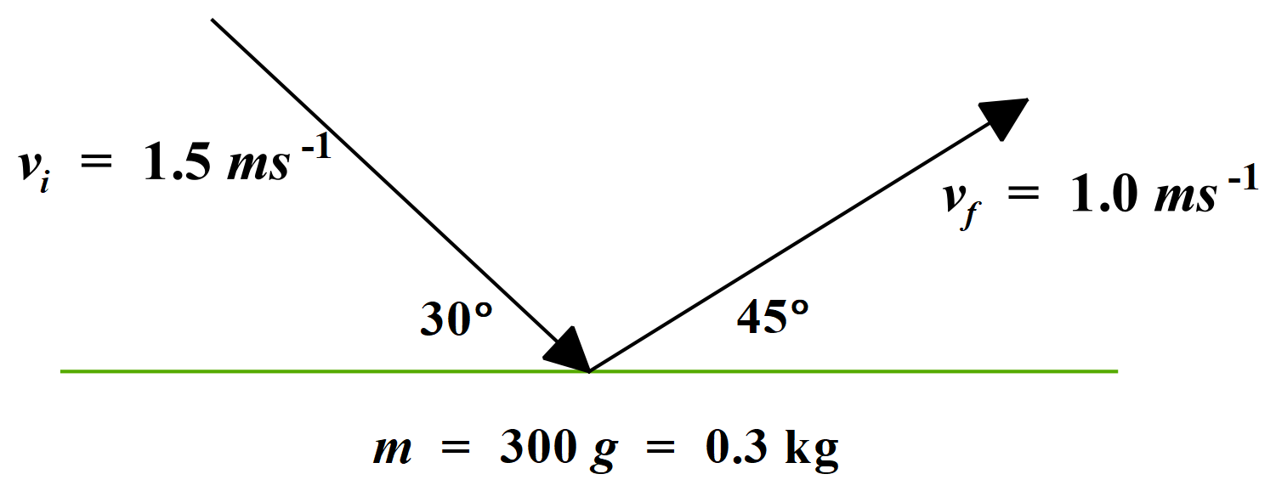

**Ḭ = P̰ = P̰f - P̰i**

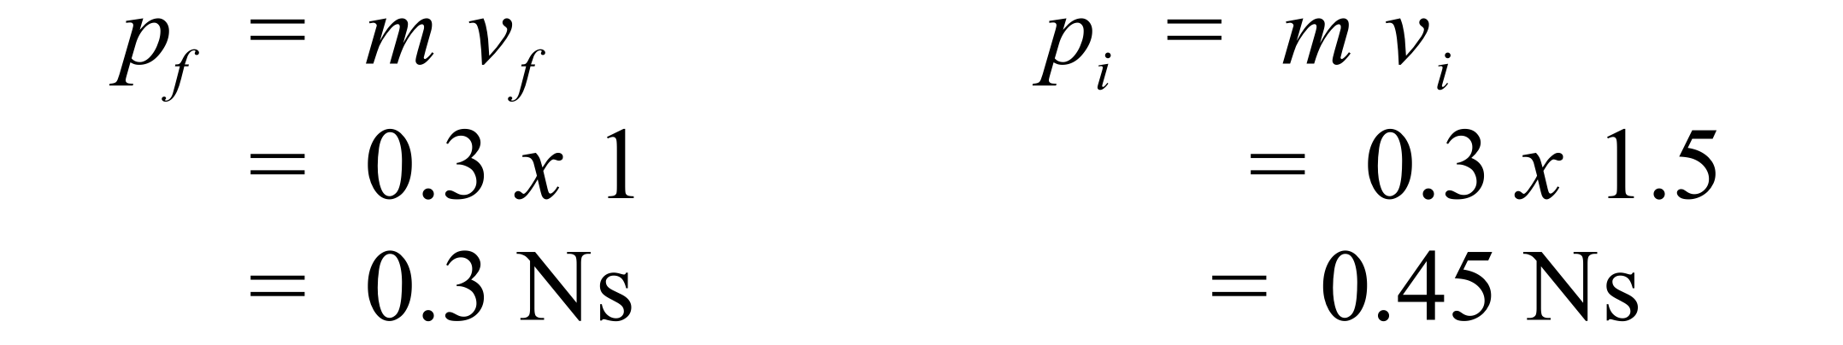

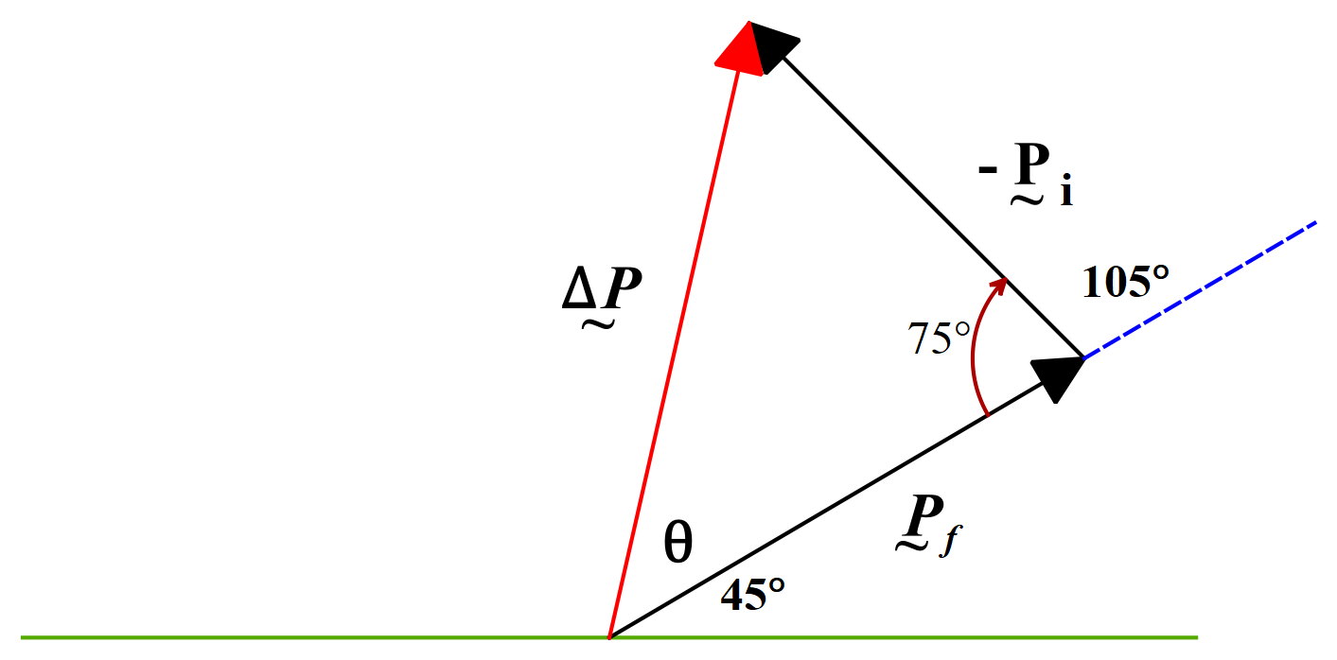

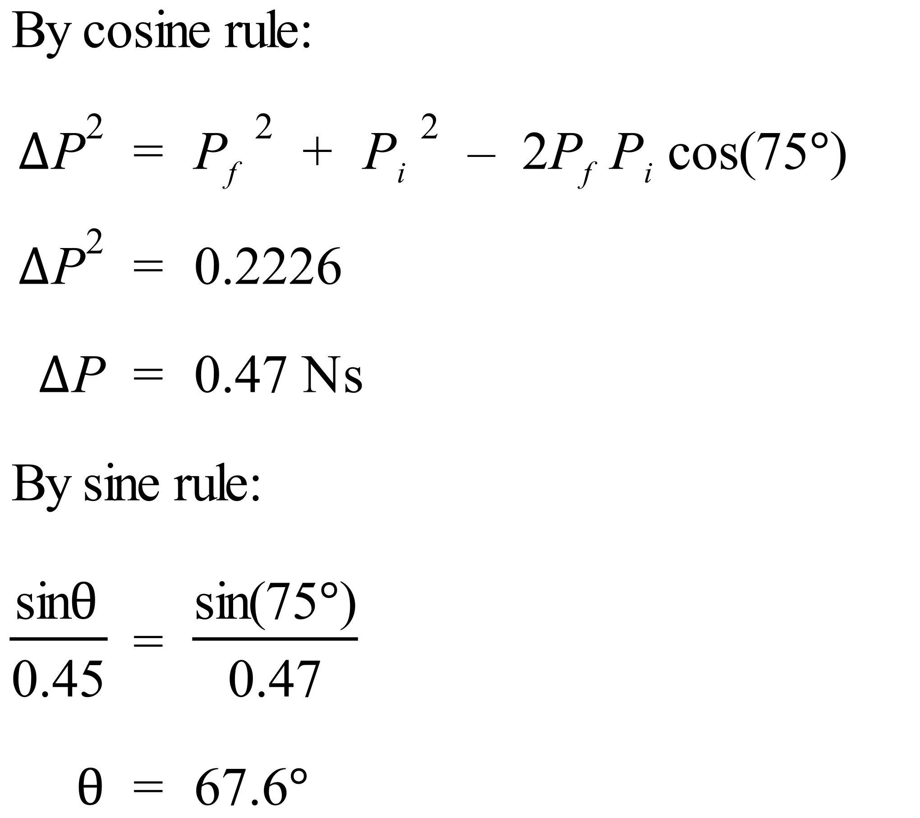

Therefore, the impulse of the ball is 0.47 Ns at 113° to the cushion.

**Exercise:** Use the [collision lab simulation](https://phet.colorado.edu/sims/collision-lab/collision-lab_en.html) to examine elastic and inelastic collisions and their impacts on initial, final and total momentum and KE.

**Extension Topic:** Also, students who wish to extend their knowledge and skill in the analysis of forces could do the **Tensions in Strings** extension topic available on the website. This extension topic would fit into the Syllabus in the Forces, Acceleration and Energy section as an extension of the first two dot points.

### **APPENDIX A**

**Statement of Syllabus Content Covered in these Notes**

The following indicates the specific content from the **Stage 6 Physics Syllabus** that has been covered in the notes, worksheets & practicals provided on the Dynamics Module web page.

The resources on this website are meant to supplement the work you do in class NOT replace it. The notes will always provide you with a comprehensive and accurate set of notes on the Module under study. The worksheets will provide some introduction & practice to appropriate problem-solving skills for the topic. You will need to do much more problem-solving practice than just what is provided on this website. The practicals section will provide some experiments relevant to the topic but again you will need to do more than just what is suggested here. Your teacher should provide you with much more problem-solving & practical experience than you will find on this website.

The content statements that are **ticked** have been covered. Those left without a tick have either not been covered at all or have been only partially covered. These are mainly content statements requiring practical work of some kind.

### Content

#### Forces

**Inquiry question:** How are forces produced between objects and what effects do forces produce?

Students:

* using Newton’s Laws of Motion, describe static and dynamic interactions between two or more objects and the changes that result from:
  + a contact force ✓
  + a force mediated by fields ✓
* explorethe concept of net force and equilibrium in one-dimensional and simple two-dimensional contexts using: (ACSPH050)  Information and communication technology capability icon Numeracy icon
  + algebraic addition ✓
  + vector addition ✓
  + vector addition by resolution into components ✓
* solve problems or make quantitative predictions about resultant and component forces by applying the following relationships:  Information and communication technology capability icon Numeracy icon
  + ✓
  + , ✓
* conduct a practical investigation to explain and predict the motion of objects on inclined planes (ACSPH098) Critical and creative thinking icon  Information and communication technology capability icon **The relevant theory work has been covered.**

#### Forces, Acceleration and Energy

**Inquiry question**: How can the motion of objects be explained and analysed?

Students:

* apply Newton’s first two laws of motion to a variety of everyday situations, including both static and dynamic examples, and include the role played by friction () (ACSPH063) Critical and creative thinking icon ✓
* investigate, describe and analyse the acceleration of a single object subjected to a constant net force and relate the motion of the object to Newton’s Second Law of Motion through the use of: (ACSPH062, ACSPH063)
  + qualitative descriptions Critical and creative thinking icon ✓
  + graphs and vectors  Information and communication technology capability icon Numeracy icon ✓
  + deriving relationships from graphical representations including and relationships of uniformly accelerated motion  Information and communication technology capability icon Numeracy icon ✓
* apply the law of conservation of mechanical energy to the quantitative analysisof motion involving:  Information and communication technology capability icon Numeracy icon
  + work done and change in the kinetic energy of an object undergoing accelerated rectilinear motion in one dimension () ✓
  + changes in gravitational potential energy of an object in a uniform field ( ✓
* conduct investigations over a range of mechanical processes to analyse qualitatively and quantitatively the concept of average power ( ,), including but not limited to:  Information and communication technology capability icon Numeracy icon
  + uniformly accelerated rectilinear motion ✓
  + objects raised against the force of gravity ✓
  + work done against air resistance, rolling resistance and friction ✓

#### Momentum, Energy and Simple Systems

**Inquiry question**:How is the motion of objects in a simple system dependent on the interaction between the objects?

Students:

* conduct an investigation to describe and analyse one-dimensional (collinear) and two-dimensional interactions of objects in simple closed systems (ACSPH064) Critical and creative thinking icon **The relevant theory work has been covered.**
* analyse quantitatively and predict, using the law of conservation of momentum () and, where appropriate, conservation of kinetic energy ), the results of interactions in elastic collisions (ACSPH066)  Information and communication technology capability icon Numeracy icon ✓
* investigate the relationship and analyse information obtained from graphical representations of force as a function of time ✓
* evaluate the effects of forces involved in collisions and other interactions, and analyse quantitatively the interactions using the concept of impulse ()  Information and communication technology capability icon Numeracy icon ✓
* analyse and compare the momentum and kinetic energy of elastic and inelastic collisions (ACSPH066)  Information and communication technology capability icon Numeracy icon ✓