**Worksheet 5 – Module 7 – The Nature of Light**

**Light and Special Relativity**

1. Distinguish between inertial and non-inertial frames of reference. Use examples to explain your answer.
2. Two observers, A and B, are travelling through space. B is receding from A with a speed of 0.8c, where c is the speed of light in a vacuum. A transmits a pulse of light and sees it travel toward B with speed c. With what speed does B see the light pulse pass?
3. Collisions between high energy cosmic rays and atoms in the Earth’s atmosphere produce unstable particles. Suppose that such a particle is produced 9.0 km above Earth’s surface and travels toward the Earth at a velocity of 0.998c, where c is the speed of light in a vacuum. The lifetime of such a particle is 2.00 x 10-6 s (proper time).  
     
   (a) How far does a particle with velocity 0.998c travel in 2.00 x 10-6 s?

(b) Explain quantitatively why this particle is able to reach the Earth’s surface before it  
 decays.

1. An astronaut travels to a star 250 light years from Earth at a speed of 0.999999c. As seen by observers on Earth, the astronaut would:  
     
   (A) not age compared to those left behind  
     
   (B) age approximately 0.35 years  
     
   (C) age approximately 250 years

(D) age 177,000 years

1. Two physicists, Daniel and Emma, observe a supernova (stellar explosion) at X, as shown in the diagram below. As the initial light wavefront from the explosion reaches Daniel, he is stationary and located at D in the diagram below. As this same wavefront reaches Emma at E, she is moving at 0.5c radially inward toward the centre of the explosion, as shown.

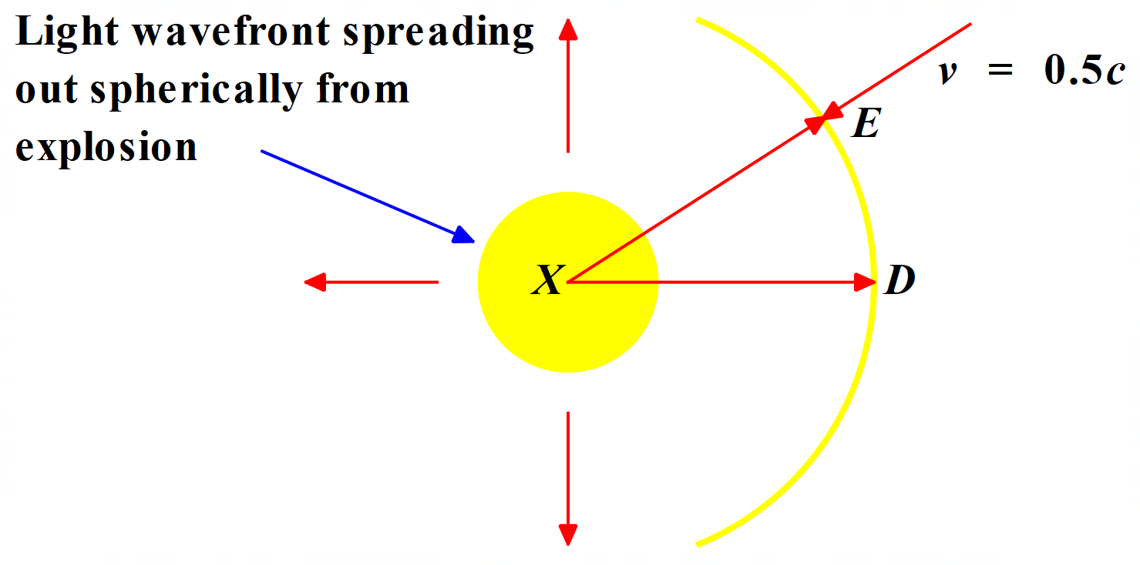  
  
(a) Identify the implications of the constancy of the speed of light for our understanding  
 of the nature of space and time.

(b) Daniel knows that he is 1.08 x 1012 m from X, the centre of the explosion.  
 Determine the time taken in hours for the light to travel from X to D as calculated  
 by Daniel.

(c) As seen by a stationary observer, the distance from X to E is also 1.08 x 1012 m.  
 Calculate the distance from X to E as seen by Emma.

(d) Calculate the total time in hours for light from X to reach E as seen by Emma.  
  
(e) The Super Giant star that exploded had a mass of 5 x 1031 kg and 35% of this mass  
 was converted to energy during the explosion. Determine the amount of energy  
 released in this process.

1. The primary branch of the proton-proton chain reaction, PP I, produces 85% of the Sun’s energy. PP I consists of three steps:

  
  
The total energy released in one complete PP I cycle is 26.7 MeV. How much mass  
is converted to energy in each PP I cycle?

1. The relativistic momentum equation is:  
     
    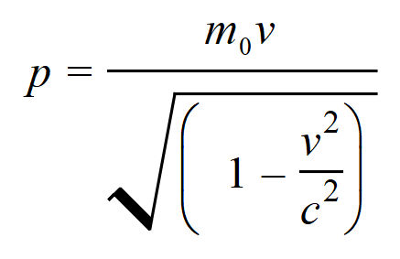  
     
   where p = relativistic momentum of particle, m0 = rest mass of particle, v is the velocity of the particle relative to a stationary observer and c = speed of light.  
     
   Describe the consequence of relativistic momentum for the maximum possible velocity of a particle of matter.
2. Provide and evaluate two pieces of evidence confirming Einstein’s first postulate of Special Relativity: that all inertial frames of reference are equivalent.
3. Observations of cosmic-origin muons at the Earth’s surface have been used as evidence supporting the reality of time dilation and length contraction. In 1963, at Mount Washington Observatory, Frisch of MIT and Smith of the University of Illinois performed experiments to compare the rate of detection of muons at that altitude with that observed near sea level at Cambridge, Massachusetts. Using the data provided below from the Frisch & Smith experiment, answer the following questions.  
     
   Speed of muons with respect to Earth = 0.994c  
   Average lifetime of muons measured in a laboratory = 2.2 x 10-6 s  
   Height of Mount Washington Observatory above sea level = 1900 m
4. Calculate the average distance travelled by muons at 0.994c during their normal average lifetime of 2.2 x 10-6 s.
5. Determine the average lifetime of muons travelling at 0.994c as measured in the Earth observer’s reference frame.
6. Find the average distance that muons could travel in the average lifetime calculated in (b) above at 0.994c.
7. Compare the distances calculated in (a) and (c) above.
8. Determine the distance “seen” by muons travelling at 0.994c from Mount Washington Observatory to sea level.
9. Compare the distance calculated in (e) to the height of Mount Washington Observatory above sea level.
10. Evaluate the evidence provided by the Frisch and Smith experiment in support of the reality of time dilation and length contraction.

**Answers & Solutions**

1. An inertial frame of reference is one which has a constant velocity. This includes reference frames which have zero velocity. An example is a car travelling at 27 ms-1 in one direction.  
     
   A non-inertial reference frame is one which is accelerating. An example is a cricket ball falling under gravity toward the ground.
2. B sees the light pulse pass with a speed c, the speed of light in a vacuum. This is the second postulate of Einstein’s Special Relativity Theory - The speed of light in free space has the same value c, in all inertial frames, regardless of the velocity of the observer or the velocity of the source emitting the light.
3. 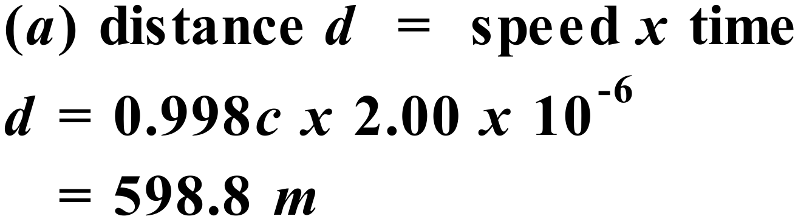   
     
    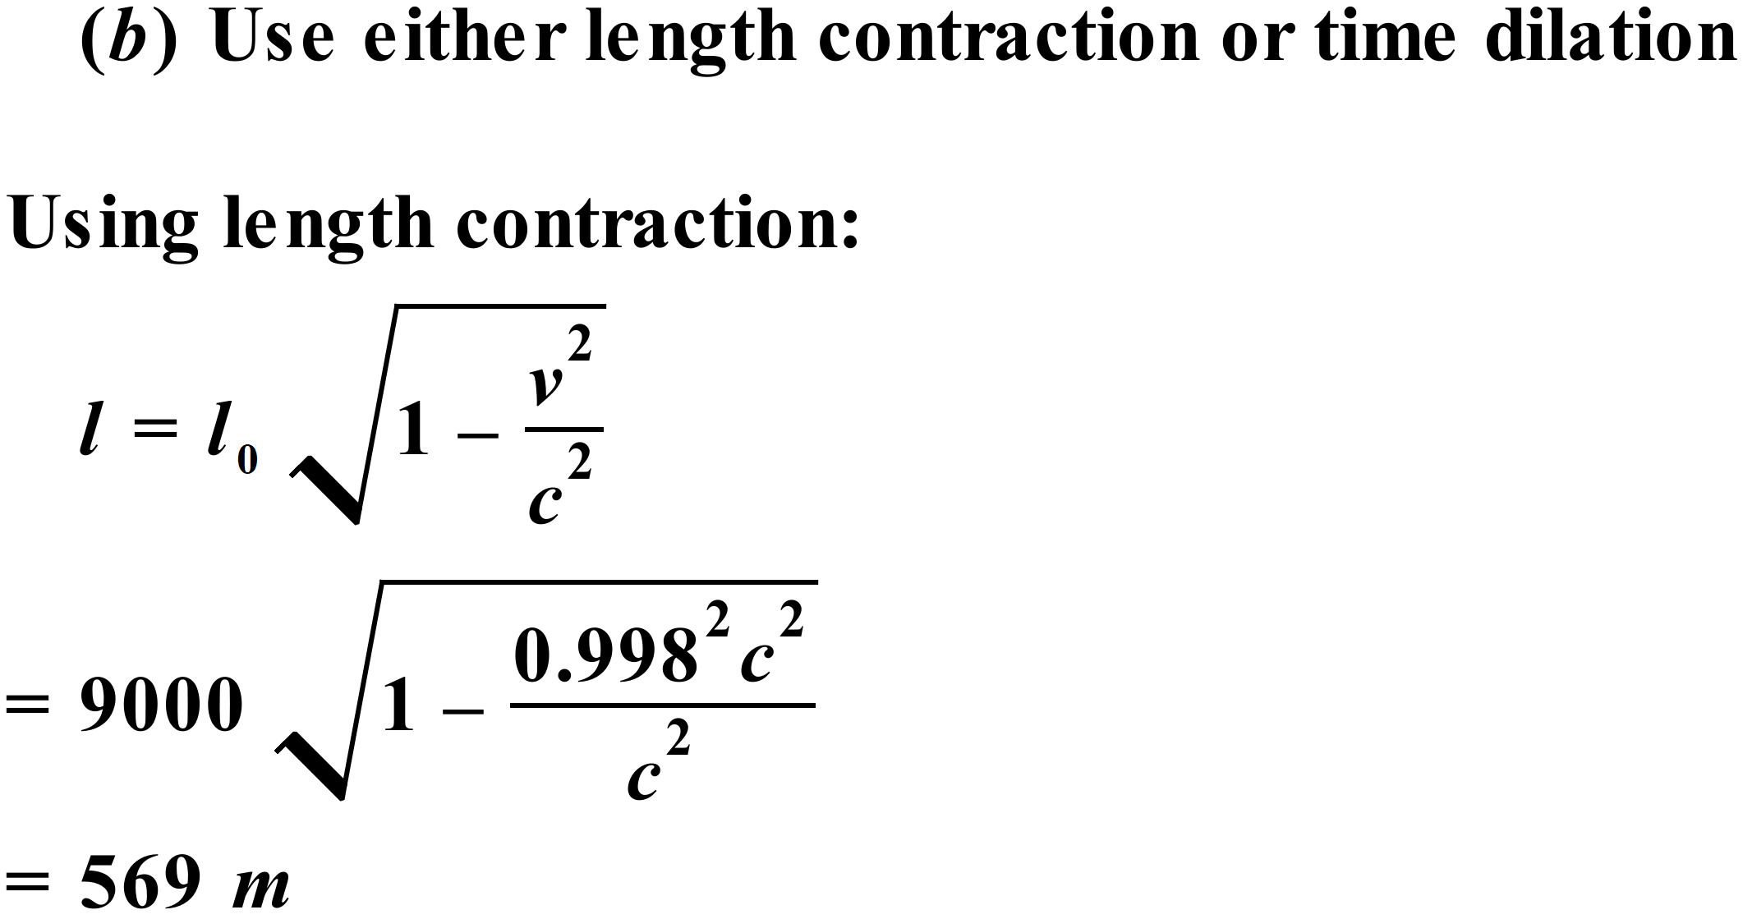   
     
   Due to length contraction, the distance to the surface that the particle “sees” (569 m) is less than the distance it can travel before it decays (599 m). So, it reaches the surface of the Earth.  
     
    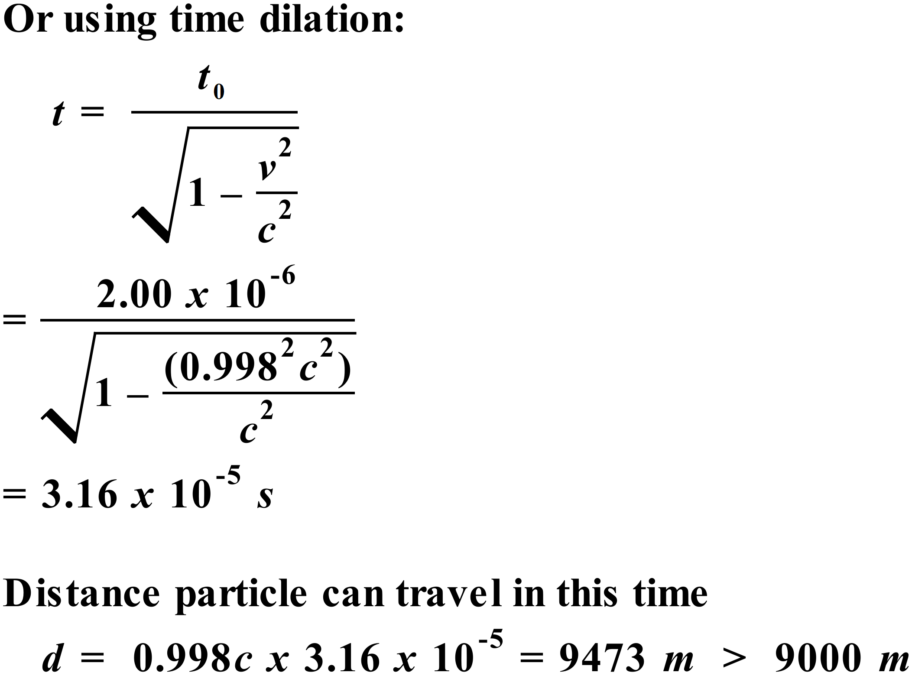   
     
   So, due to time dilation, the particle can travel further (9473 m) than the distance to the surface (9000 m). So, it reaches the surface of the Earth.
4. C – the astronaut is travelling at close to the speed of light and will therefore take almost the same time as light to reach the star, as seen by observers on Earth. To the astronaut of course, the distance to the star is much shorter than that seen by observers on Earth due to length contraction and therefore the time taken to reach the star is much less that the 250 years observed from Earth. Doing the time dilation calculation and taking 250 years as the time experienced by Earth observers, time for the astronaut works out to be 0.35 years (or about 4.2 months).
5. (a) Both space and time are relative quantities rather than absolute quantities.  
     
   (b) 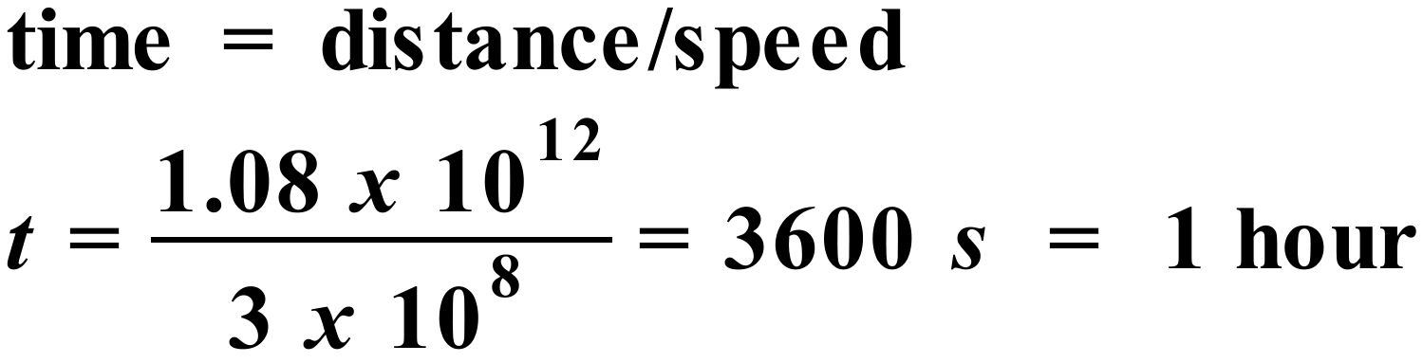

(c) 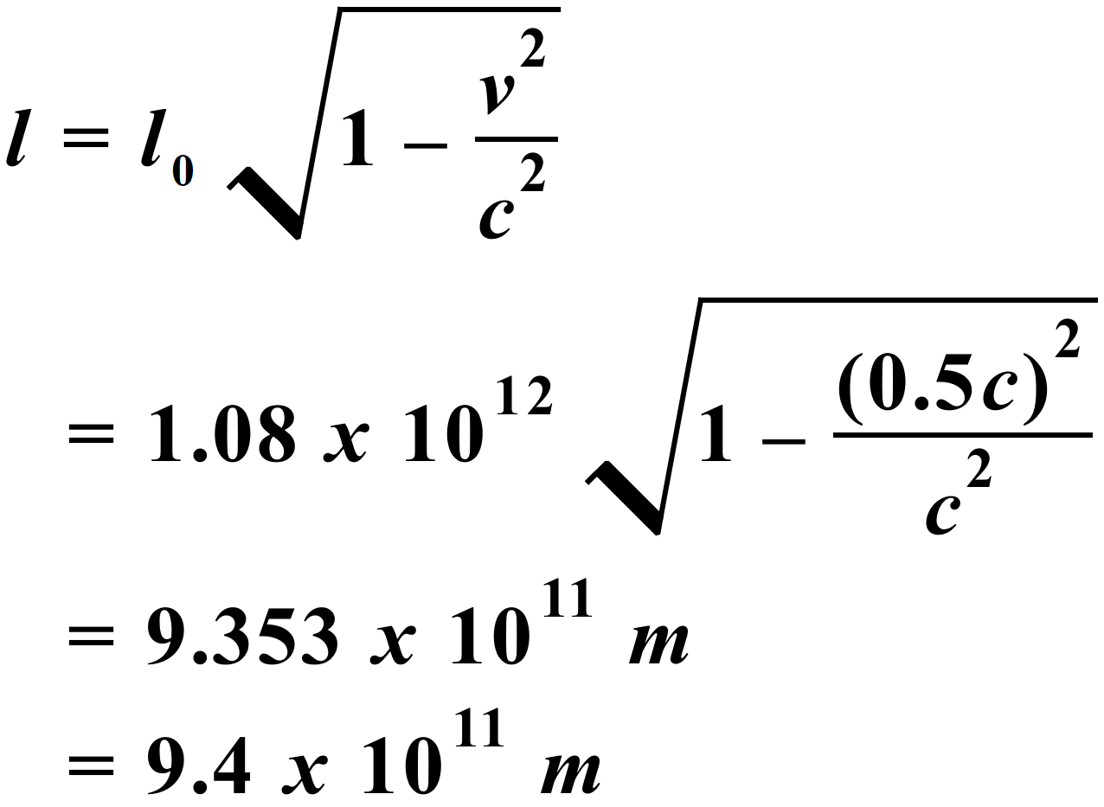   
  
(d) 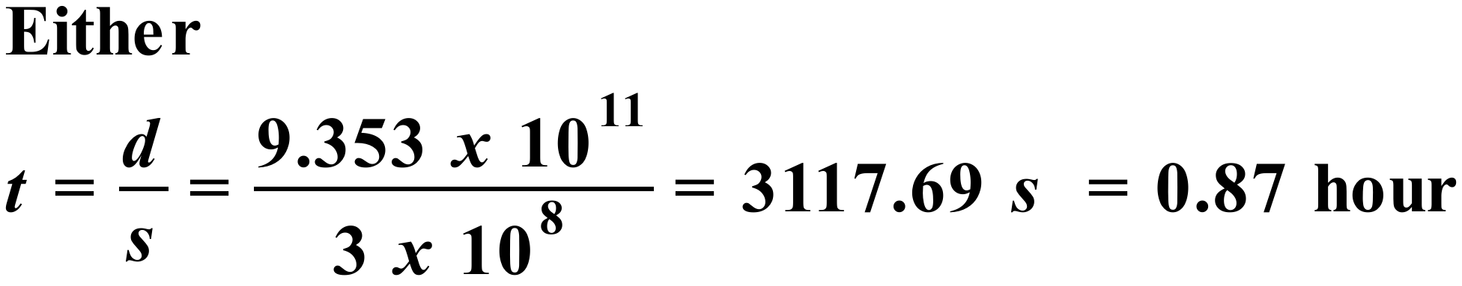   
  
  
 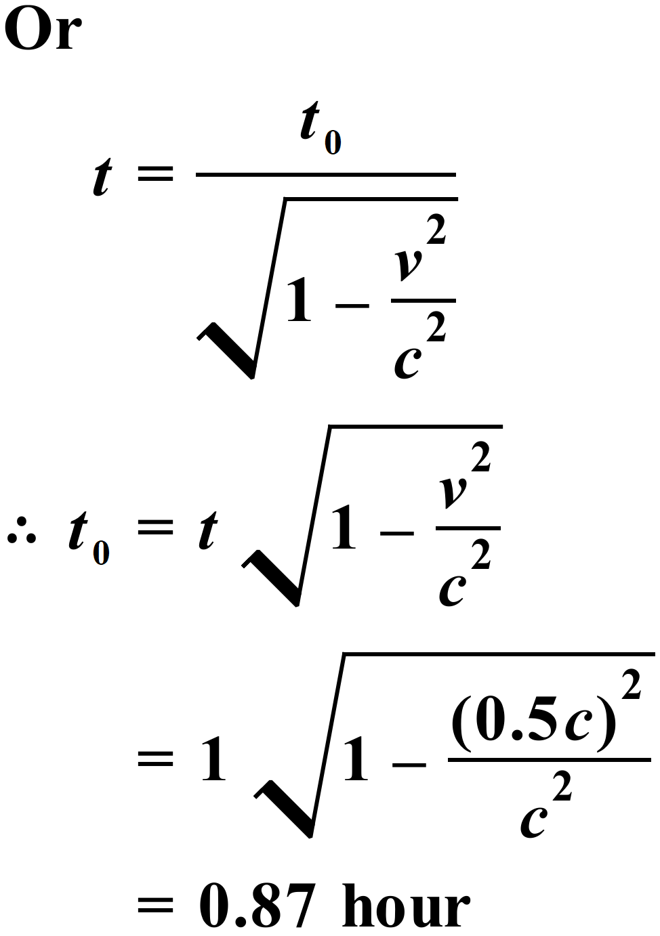   
  
The t = 1 hour in the second method is because a stationary observer located at E would  
 see the time taken for light to travel from X to E as 1 hour (from part b).  
  
 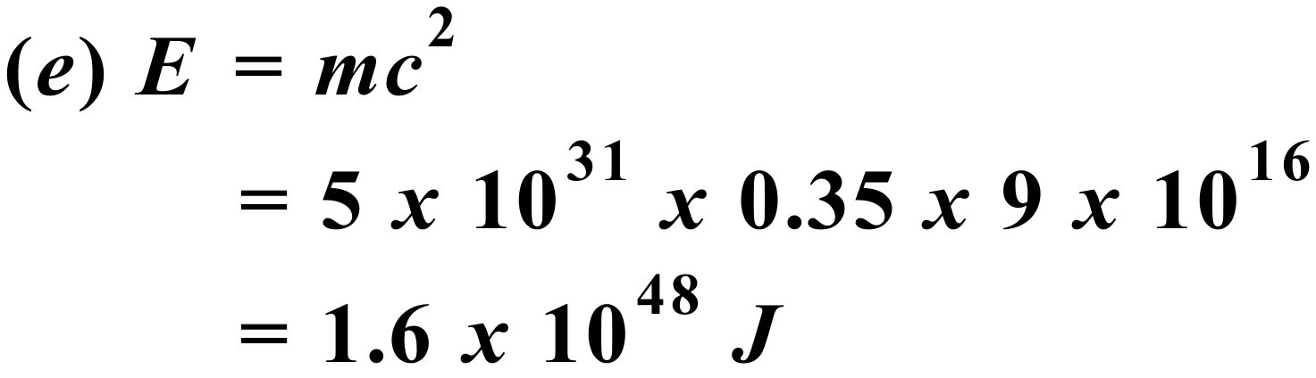

1. 1 MeV = 1.6 x 10-13 J

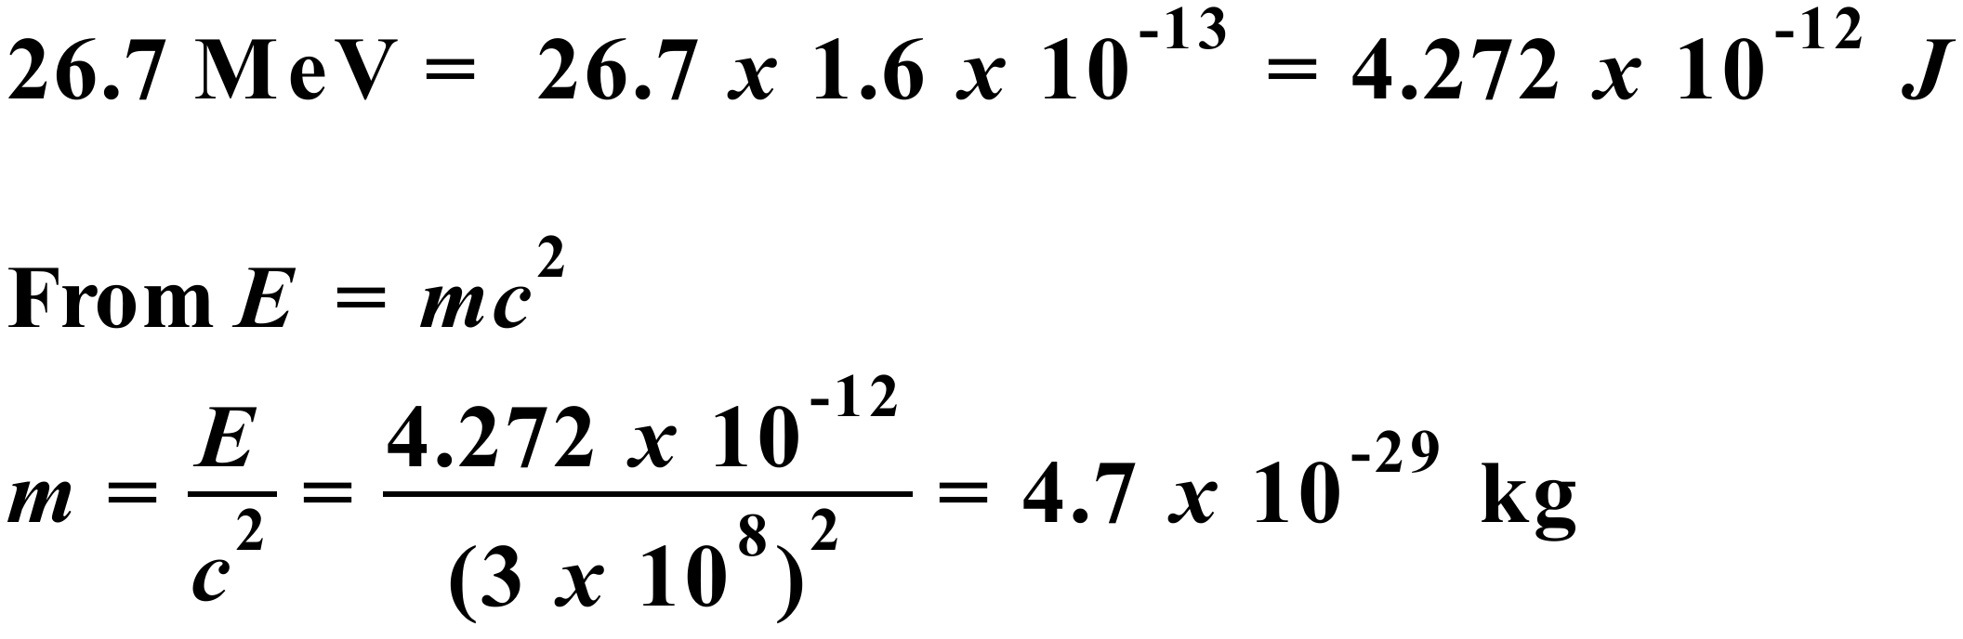

1. Clearly, from the relativistic momentum equation, as v 🡪 c, p 🡪 ∞. This effectively places a limit on the maximum velocity a matter particle can acquire. To accelerate a particle up to the speed of light would require providing the particle with infinite momentum, which would require an infinite amount of energy. As this is not possible, all matter particles are limited to travel at speeds lower than the speed of light. The limiting speed is the speed of light, which no material particle can attain.
2. At present, there is no peer-reviewed, accepted experimental evidence that refutes the Theory of Special Relativity. It is an extremely well supported and established theory. Evidence confirming the equivalence of inertial reference frames (first postulate of Special Relativity) includes: (i) Observations of cosmic-origin muons at the surface of the Earth; and (ii) Evidence from particle accelerators – verification of time dilation.  
     
   (i) Since the early 1940’s many experiments have been conducted measuring the number of muons at certain heights in the Earth’s atmosphere and the number reaching ground level. In every case it was found that the number of muons reaching the ground significantly exceeded the expected number based on how far they should be able to travel in their lifetimes. Eg In 1941, Rossi and Hall conducted experiments at different altitudes that demonstrated that the lifetimes of muons travelling near the speed of light appear longer, in qualitative agreement with the prediction of the special relativity. These and subsequent quantitative results have been taken as strong evidence for the reality of time dilation and length contraction. The fact that the results are consistent whether calculated in the muon’s reference frame or the Earth observer’s reference frame gives very strong support to Einstein’s first postulate.

(ii) In 2014, physicists conducted one of the most stringent tests of time dilation ever performed. To test the time-dilation effect, physicists compared two clocks — one that was stationary and one that moved. To do this, the researchers used the Experimental Storage Ring in Germany. The scientists made the moving clock by accelerating lithium ions to one-third the speed of light. Then they measured a set of transitions within the lithium as electrons hopped between various energy levels. The frequency of the transitions served as the ‘ticking’ of the clock. Transitions within lithium ions that were not moving served as the stationary clock. The researchers measured the time-dilation effect more precisely than in any previous study. Again, the fact that the results are consistent whether calculated in the reference frame of the moving ions or that of the Earth observer gives very strong support to Einstein’s first postulate. The laws of Physics are the same in all inertial reference frames.

1. 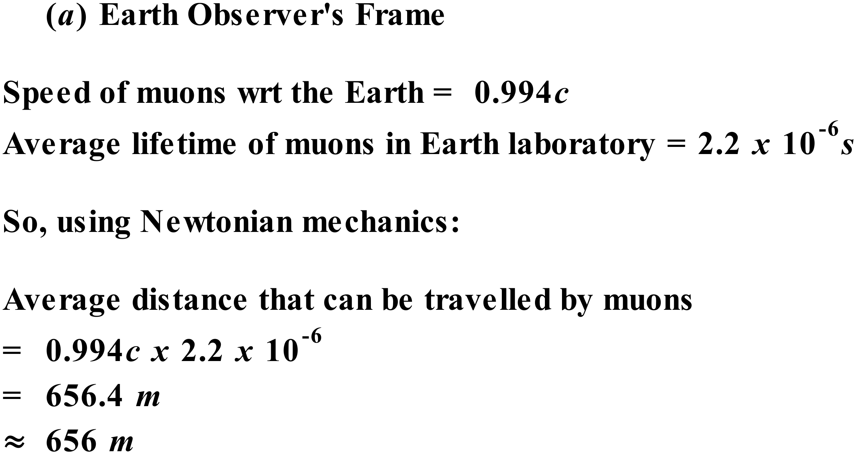

(b) The muon’s mean lifetime in the Earth observer’s reference frame will be:  
  
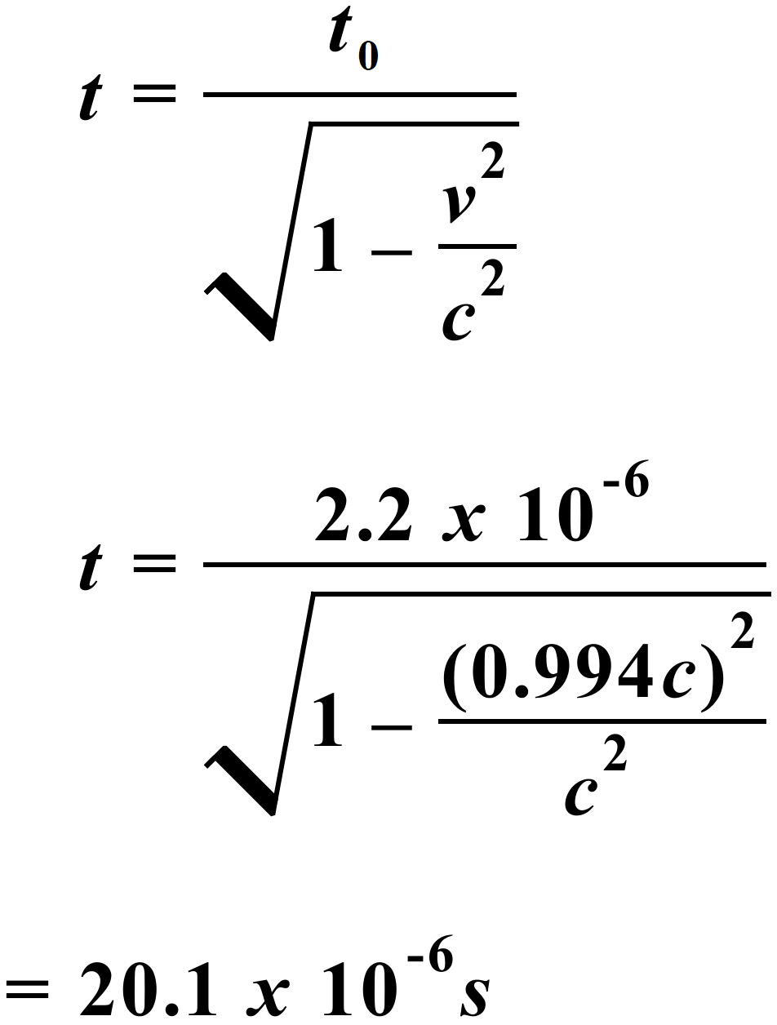  
  
  
  
  
(c) ⸫ Average distance muon can travel in its extended lifetime  
 = 0.994c x 20.1 x 10-6 = 5994 m

(d) Distance that can be travelled by muon in Earth observer’s frame is 9 times the  
 distance muons can travel in their proper lifetime.

(e) 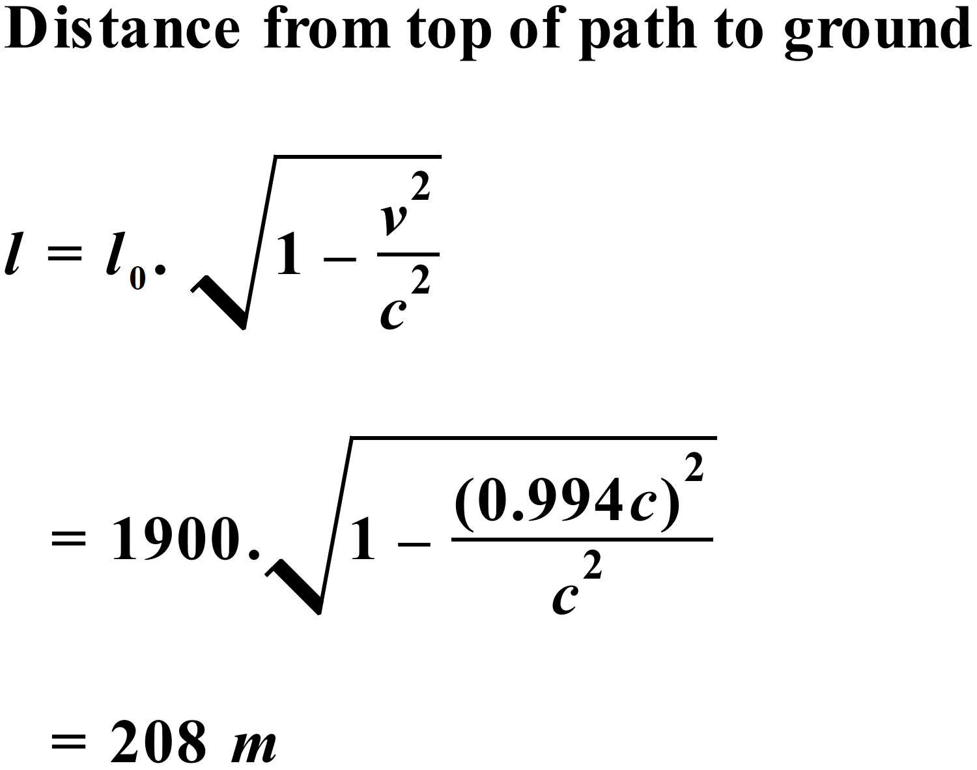

(f) So, the muons experience a distance of 208 m from the top of their path to the ground,  
 instead of the 1900 m as seen by the Earth observer. That is, they experience a  
 distance of about 1/9 that seen by the Earth observer.

(g) From our analysis above, the time dilation calculation indicates that the average  
 lifetime of the muons is increased in the Earth observer’s frame. The length  
 contraction calculation indicates that the distance from top to bottom of their path is  
 shortened in the muon’s frame of reference. In this and many similar experiments  
 over many years, the measured number of muons reaching ground level can only be  
 explained, using time dilation and length contraction analysis similar to that shown  
 above, to accurately describe the mechanics of the muon’s journey. The results of  
 these experiments provide extremely strong evidence in support of the reality of both  
 time dilation and length contraction.