GRAVITATION QUESTIONS

Solutions to these questions are available on the Advanced Mechanics webpage. Answers are supplied at the end of each question.

- 47 Ursae Majoris is a yellow dwarf star approximately 46 light-years from Earth in the constellation of Ursa Major. As of 2011, three extrasolar planets are believed to orbit the star. One of those planets, 47 Ursae Majoris b (47 UMa b), orbits its star at a distance of 2.10 AU and has a mass of 4.80 x 10²⁷ kg. If the star has a mass of 2.148 x 10³⁰ kg calculate the force of gravitational attraction with which 47 UMa b is held in orbit. G = 6.673 x 10⁻¹¹ Nm²kg⁻² and 1 AU = 1.496 x 10¹¹ m. Answer: 6.97 x 10²⁴ N.
- Determine the escape velocity for the planet Mercury, given mass of Mercury = 3.285 x 10²³ kg, radius of Mercury = 2.44 x 10⁶ m and G = 6.673 x 10⁻¹¹ SI units. Answer: 4.24 km/s
- The International Space Station orbits Earth at an altitude of approximately 330 km. Another satellite, Meteosat, is in geostationary orbit at an altitude of 36 000 km. Which of the following correctly compares the orbital velocity and orbital period of these satellites? Answer over page.
Option | International Space Station | Meteosat
A | Greater orbital velocity | Shorter orbital period
B | Lesser orbital velocity | Shorter orbital period
C | Greater orbital velocity | Longer orbital period
D | Lesser orbital velocity | Longer orbital period

- The gravitational potential energy of a rocket of mass 100 kg at a distance of 1 x 10⁷ m from Earth’s centre is – 4.0 x 10⁹ J.
  - What is the minimum kinetic energy which must be given to the rocket, which has just stopped at this height, to allow it to escape from the Earth?
  - By what factor has the gravitational potential energy of the rocket changed when it is 1 x 10⁹ m from the centre of the Earth?
  - What is the “weight” of the rocket at this distance of 10⁹ metres? Mass of Earth = 5.97 x 10²⁴ kg and G = 6.673 x 10⁻¹¹ Nm²kg⁻².
  - What is the magnitude of the acceleration of a satellite of mass 100 kg, travelling in a stable circular orbit around the Earth at a distance of 10⁹ metres?
Answers: (a) 4.0 x 10⁹ J; (b) 10⁻²; (c) 4.0 x 10⁻² N; (d) 4.0 x 10⁻⁴ ms⁻².
- A satellite is placed in orbit around Mars so that its period is 24.6 hours. Given that the mass of Mars is 6.39 x 10²³ kg and that the universal gravitational constant, G = 6.673 x 10⁻¹¹ SI units, calculate the radius of the orbit of the satellite. Answer: 2.04 x 10⁴ km
- The planet Neptune is 4.48 x 10⁹ km from the Sun. Neptune has a mass of 1.024 x 10²⁶ kg and the Sun has a mass of 1.989 x 10³⁰ kg. Determine the orbital velocity of Neptune around the Sun. G = 6.673 x 10⁻¹¹ SI units.
Answer: 5.44 km/s
- Determine the mass of the Sun given the Earth’s distance from the Sun as 1.5 x 10¹¹m.
G = 6.673 x 10⁻¹¹ SI units. Answer: 2.0 x 10³⁰ kg.
- Suppose all the mass of the Earth (5.97 x 10²⁴ kg) were compacted into a small spherical ball. What radius must the sphere have so that the acceleration due to gravity at the Earth’s new surface was equal to the acceleration due to gravity at the surface of the Sun? Mass of Sun = 1.989 x 10³⁰ kg and radius of Sun = 6.96 x 10⁸ m. Answer: 1.21 x 10⁶ m.
- An asteroid of mass m is in circular orbit of radius r around the Sun with a speed v. It has an impact with another asteroid of mass M and is kicked into a new circular orbit with a speed of 1.5v. What is the radius of the new orbit in terms of r. Answer: 0.44r
- Extension Question – for the adventurous: At what distance from the Earth will a spacecraft travelling directly from the Earth to the Moon experience zero net force because the Earth and the Moon pull with equal and opposite forces? Answer: 3.460 x 10⁸ m
Hint: Consider the set-up of the question carefully. See diagram below. The red dot labelled S represents the spacecraft at the point of zero net force and m_{S} is its mass.
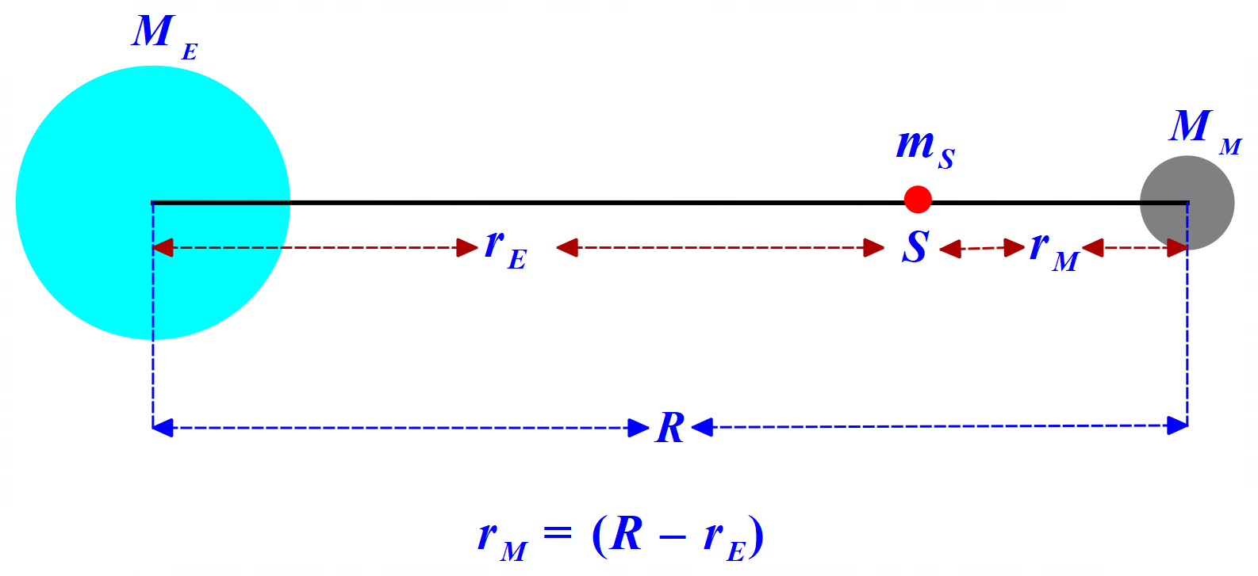
Data: Mass of Earth (M_{E}) = 5.97 x 10²⁴ kg; Mass of Moon (M_{M}) = 7.35 x 10²² kg; Average distance Earth-Moon (R) = 3.844 x 10⁸ m; and G = 6.673 x 10⁻¹¹ Nm²kg⁻²
Answer to Q3: C

