**WORKSHEET 3 – FORCES – SOLUTIONS**

1. 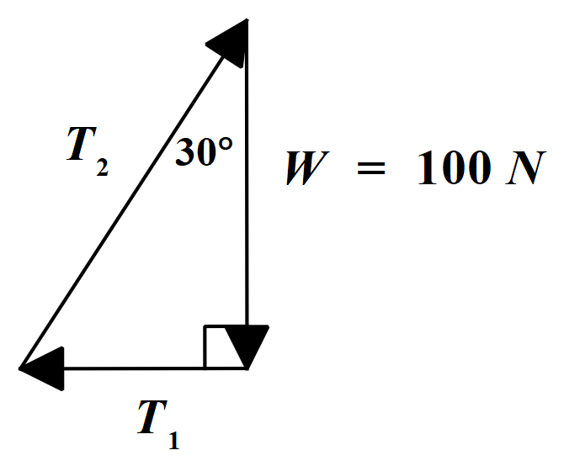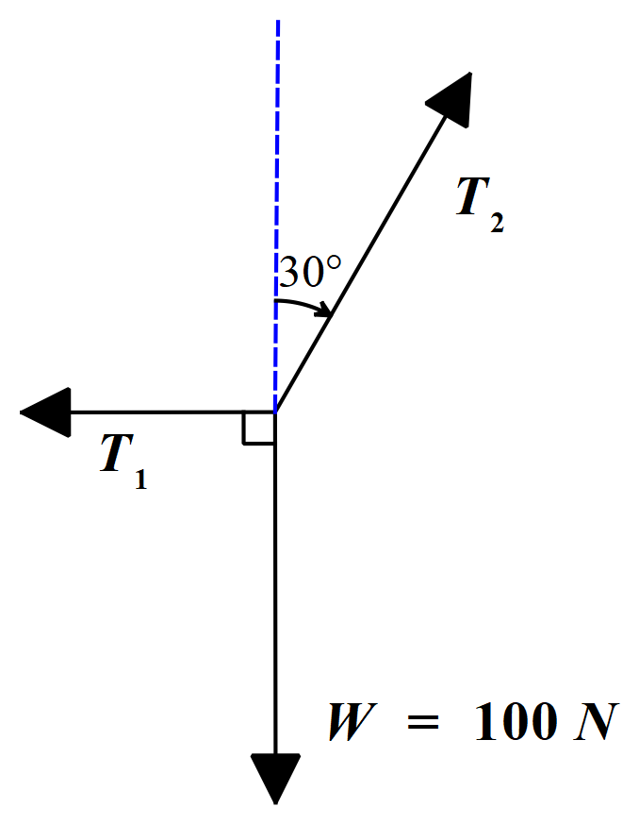A weight of 100 N is supported in equilibrium by two ropes, as shown in the free body diagram below.  
     
     
     
     
     
     
     
     
     
     
     
     
     
   One of the ropes pulls in a horizontal direction and the other in a direction of 30° with the vertical. Calculate the tension in each rope. (T1 = 57.7 N, T2 = 115 N)  
     
     
   **Solution:**  
     
   Since these forces are in equilibrium, they must add together to give zero – that is, to give a closed vector triangle. This triangle will also clearly be right angled.  
     
     
     
     
     
     
     
     
     
     
     
     
   From the triangle:  
     
   tan 30° = T1 / W and cos 30° = W / T2  
   T1 = W tan 30° = 57.7 N T2 = W / cos 30° = 115.47  
    So, T2 = 115 N (to 3 significant figures)  
     
   Note also that this problem can be solved by vector resolution.
2. 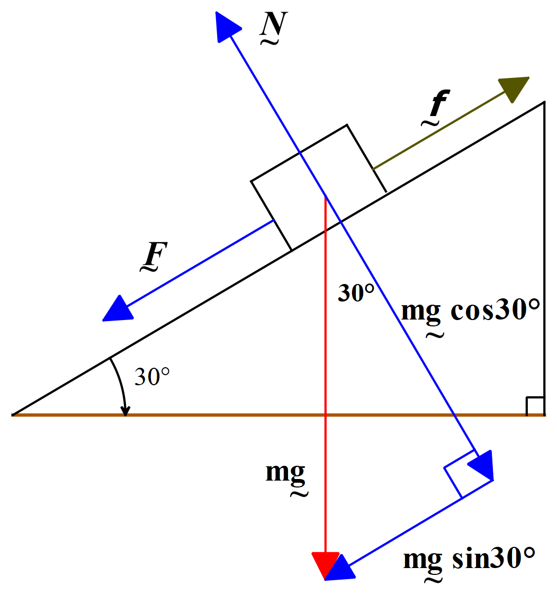In the diagram below a block of mass m is sliding down a 30° incline. The coefficient of sliding friction is 0.20. Take g = 9.8 ms-2. Find the acceleration of the block down the incline. (3.2 ms-2)  
     
   **Solution:**  
     
     
     
     
     
     
     
     
     
     
     
     
     
     
     
     
     
     
     
     
     
     
     
     
     
     
   From the diagram:  
     
   Unbalanced force on block down incline, ma = F – f  
     
   F = mg sin30° and f = µN = 0.2 mg cos30°  
     
   ⸫ ma = mg sin30° - 0.2 mg cos30°  
     
    a = 9.8 x 0.5 – 0.2 x 9.8 x cos30°  
     
    a = 3.2 ms-2 down the incline  
     
   Note that the acceleration is not dependant on the mass of the block. The mass of the block cancelled out of the equation of motion.
3. Assuming the acceleration due to gravity is 9.8 ms-2, determine the force that a 90 kg woman exerts on the floor of an elevator when it:
   1. Is at rest
   2. Rises with constant velocity 1.5 m/s
   3. Descends with constant velocity 1.5 m/s
   4. Rises with constant acceleration 1.5 ms-2
   5. 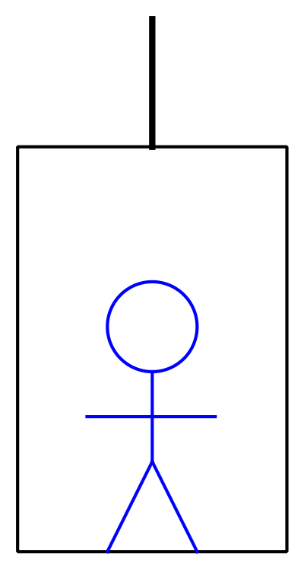Descends with constant acceleration 1.5 ms-2  
        
        
        
        
        
        
        
        
        
        
        
        
        
        
        
      Answers: (a), (b) & (c) are all 882 N; (d) 1017 N; (e) 747 N  
        
      **Solution:**  
        
      By Newton’s Third Law, the force that the woman exerts downwards on the floor of the elevator is equal to the force with which the elevator floor pushes upwards on the woman. Since in this problem we are given the woman’s mass, we shall consider the forces acting on the woman.  
        
      The woman’s weight, W = mg = 90 x 9.8 = 882 N.  
        
      a, b & c – If the woman is at rest or is ascending or descending with constant velocity, the upwards push of the floor is equal to the weight of the woman, 882 N. Since there is no acceleration, there can be no unbalanced force.  
        
      d – Since the acceleration is upwards, the net force is directed upwards.  
        
      Unbalanced force upwards on woman = mass x upwards acceleration of  
       woman  
        
      ⸫ the upwards push, F, of the floor – weight of woman = ma  
        
      ⸫ F – 882 = 90 x 1.5  
        
      F = 1017 N and ⸫ the force exerted on the floor by the woman is 1017 N.  
        
        
      e – Since the acceleration is downwards, the net force is directed downwards.  
        
      Unbalanced force downwards on woman = mass x downwards acceleration of  
       woman  
        
      ⸫ the weight of woman – the upwards push, F, of the floor = ma  
        
      ⸫ 882 – F = 90 x 1.5  
        
      F = 747 N and ⸫ the force exerted on the floor by the woman is 747 N.
4. 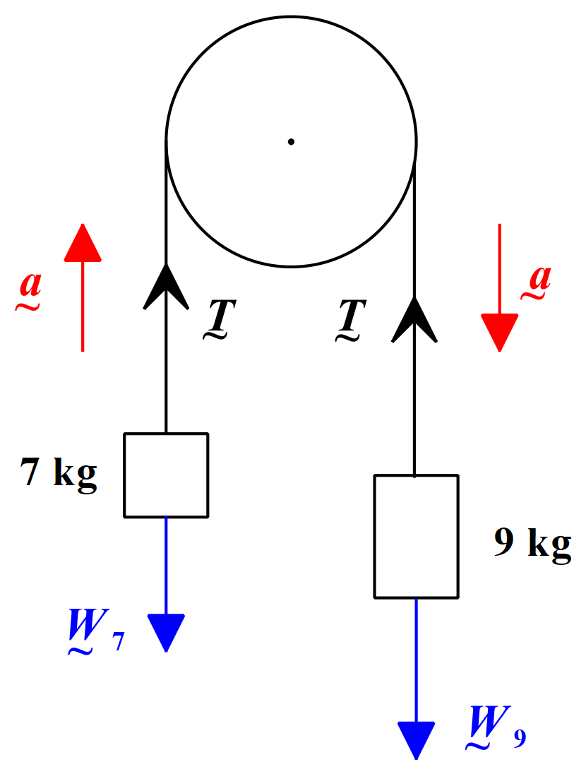A cord passing over a pulley has a 7 kg mass tied to one end and a 9 kg mass on the other. Determine the acceleration of the masses and the tension in the cord. Neglect friction and the mass of the cord. Take g = 9.8 ms-2.  
     
     
     
     
     
     
     
     
     
     
     
     
     
     
     
     
     
     
     
     
     
   **Comment:**  
     
   The diagram above shows all the forces present in this situation. Clearly, the 9 kg mass will move down under gravity on the right hand side of the pulley, pulling the 7 kg mass upwards on the left. There is one cord connecting the masses and therefore only one tension present.  
     
   There are two standard approaches to solving this type of problem. One approach is to consider the forces acting on each mass separately, write the relevant equation of motion for each and solve these simultaneously to obtain the values of **a** and **T**. This method is the best one to use in complex situations involving multiple masses and/or pulleys.  
     
   In cases like the one above, we can simply consider the forces acting on the entire system all at once. This is usually quicker and easier, and is the method we shall use here.  
     
   **Solution:**  
     
   Unbalanced force on entire system = total mass of system x acceleration of  
    system  
     
    ⸫ W9 – W7 = (9 + 7) a  
     
    (9 x 9.8) – (7 x 9.8) = 16 a  
     
    ⸫ a = 1.225 ms-2 = 1.23 ms-2 (to 2 decimal  
    places)  
     
   To find the tension, use either one of the masses and write the equation of motion for it. We shall do it for both masses here just to show that you get the same answer either way. It does not matter which mass you choose.  
     
   For 7 kg mass (the tension must be sufficient to support the weight of the mass and to move it upwards with an acceleration of 1.23 ms-2):  
     
   T = mg + ma = 7 x 9.8 + 7 x 1.225 = 77.2 N (we use the full computed value of acceleration here to avoid compounding rounding errors)  
     
   For 9 kg mass (the tension must be sufficient to support the weight of the mass, less the force moving the mass downwards with an acceleration of 1.23 ms-2):  
     
   T = mg - ma = 9 x 9.8 - 9 x 1.225 = 77.2 N  
     
   **Note:** As I mentioned above, for simple situations like the one above, this method is certainly the quickest. As you can see, once you get the method, it only involves 4 to 5 lines of working.
5. 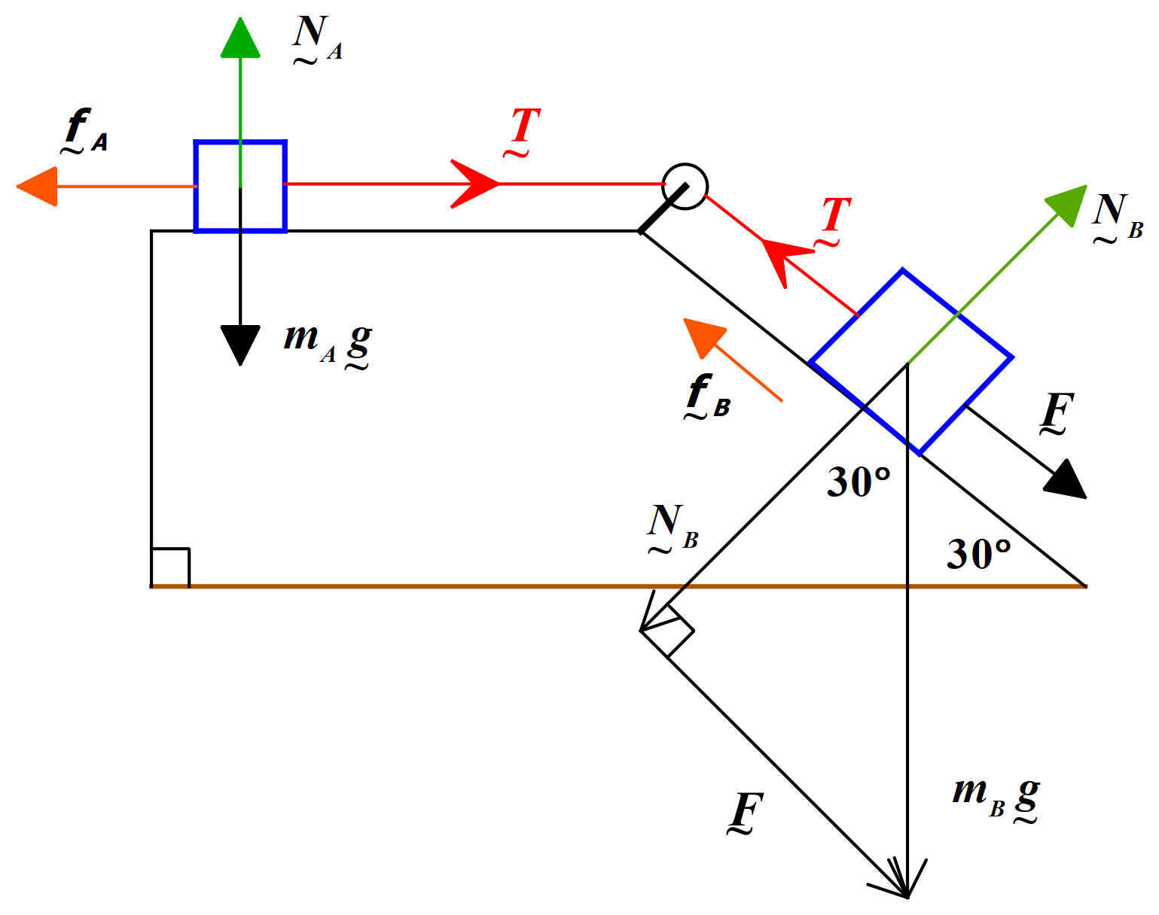  
     
     
     
     
     
     
     
     
     
     
     
     
     
     
     
     
     
     
     
     
     
     
     
     
     
   In the diagram above, block A has a mass of 20 kg and block B has a mass of 30 kg. The two blocks are joined by a thin, inextensible, cord. The cord passes through a pulley as shown. When released, the system of masses accelerates. The coefficient of friction for the surface is 0.2. Assume that the acceleration due to gravity is 9.8 ms-2 and that the mass of the cord is negligible. Find the acceleration of the system and the tension in the cord.  
   (1.14 ms-2, 62 N)  
     
     
   **Comment:**  
     
   First thing to do is to draw in all the relevant forces. Clearly, the force due to gravity on block B is responsible for accelerating the whole system to the right. We need to resolve the force due to gravity on block B into components parallel and perpendicular to the plane. It is the component parallel to the plane that provides the unbalanced force that accelerates the system. Be careful to consider both components of the friction force that opposes motion to the right.  
     
   This problem is still simple enough to apply the same method we used in question 4.  
     
     
   **Solution:**  
     
   Force due to gravity on B parallel to plane, F = mBgsin30° = 30 x 9.8 x 0.5  
    = 147 N  
     
   Friction force on block A: fA = µNA = µmAg = 0.2 x 20 x 9.8 = 39.2 N  
     
   Friction force on block B: fB = µNB = µmBgcos30°  
    = 0.2 x 30 x 9.8cos30° = 50.92 N  
     
     
   Unbalanced force acting on system = total mass x acceleration  
     
    F - fA - fB = (20 + 30) a  
     
    (147 – 39.2 – 50.92) = 50 a  
     
    ⸫ a = 1.14 ms-2  
     
   Now to calculate the tension, T, in the cord, we can use either mass, write the relevant equation of motion and solve the equation for T. Block A is the easiest to use.  
     
    T - fA = mA a  
     
   ⸫ T = (20 x 1.14) + 39.2 = 62 N  
     
     
   **Note:** If you wish to use block B to calculate T, the relevant equation of motion is:  
     
   T + fB – F = – mB a, which gives T = 61.9 N (the difference to the T value already calculated is due to rounding error)